Blessing …………………………………………………… page 86
Closing Hymn: Let Us with a Gladsome Mind #398

Dismissal:
V: The Lord be with you; R. And with thy Spirit.
V. Go in peace to love and serve the Lord.
R. Thanks be to God.

Choral Response (printed in back of hymn book)
Postlude
Please note: The Anglican Church of the Apostles provides our Sunday Services as a livestream on Facebook.

In our prayers
Worldwide
The Church of South India (United)

Our Diocese – Chebucto #6
St. Mark’s, Halifax, NS
Church of the Apostles, Halifax, NS
St. Peter’s Birch Cove, NS

Our Parish
Jim, Florence, Peggy, Roger, Nancy, Maverick, Connie

Notices

15th Anniversary Celebrations – July 1, 2026 marks the 15th anniversary of this parish. Celebrations and special events are being planned for this Fall. If you would like to get involved, speak to Allyson Dye or Fr. Jonathan.

The Anglican Church of the Apostles
6670 Bayers Road
Halifax, NS B3L 2B5
902-455-7142
www.apostlesanglican@bellaliant.com
Rector: Rev’d Jonathan Rowe

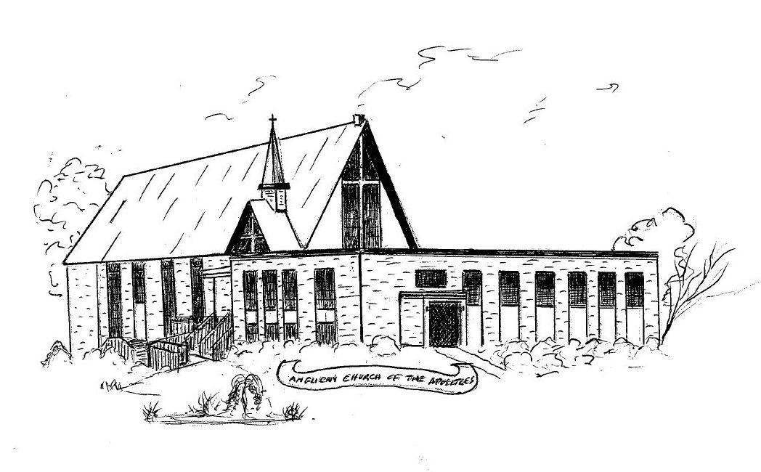

Fourth Sunday after
Pentecost

National Indigenous Day of
Prayer

June 21, 2026

Celebration of Holy Communion
10:30 a.m. Service

CELEBRATION OF HOLY COMMUNION
According to the Rite of the Book of Alternative Services
(Hymns are from the Book of Common Praise)
Prelude

THE GATHERING OF THE COMMUNITY
Opening Hymn: Ye Watchers and Ye Holy Ones #320
The Gathering of the Community page 185
The Gloria page 186
Kyrie Eleison page 186
The Collect
Creator God, from you every family in heaven and earth takes its name. You have rooted and grounded us in your covenant love, and empowered us by your Spirit to speak the truth in love, and to walk in your way towards justice and wholeness. Mercifully grant that your people, journeying together in partnership, may be strengthened and guided to help one another to grow into the full stature of Christ, who is our light and our life. Amen.

THE LITURGY OF THE WORD
First Reading: Genesis 21:8-21 (Allyson Dye)
Psalm: 86:1-10, 16-17 (Daniel Owolabi)
Refrain: Turn to me; save the child of your handmaid.
Bow down your ear, O Lord, and answer me, for I am poor and in
misery. Keep watch over my life, for I am faithful; save your servant
who puts his trust in you.
R
Be merciful to me, O Lord, for you are my God; I call upon you all the
day long. Gladden the soul of your servant, for to you, O Lord, I lift up
my soul. For you, O Lord, are good and forgiving, and great is your
love toward all who call upon you.
R
Give ear, O Lord, to my prayer, and attend to the voice of my
supplications. In the time of my trouble I will call upon you, for you
will answer me.
R
Among the gods there is none like you, O Lord, nor anything like your
works. All nations you have made will come and worship you, O Lord,
and glorify your name. For you are great; you do wondrous things; and
you alone are God.
R
Turn to me and have mercy upon me; give your strength to your servant;
and save the child of your handmaid. Show me a sign of your favour, so
that those who hate me may see it and be ashamed; because you, O
Lord, have helped me and comforted me.
R
Glory be to the Father, and to the Son,
and to the Holy Spirit:
as it was in the beginning, is now,
and ever shall be, world without end. Amen.

Second Reading: Romans 6:1b-11 (Jonathan Lownds)
Gradual: Take Up Your Cross, the Saviour Said (vs 1-3) #431
The Holy Gospel: Matthew 10:24-39
Gradual: Take Up Your Cross, the Saviour Said (vs 4-5) #431
Sermon
The Nicene Creed page 188
Prayers of the People (Garth Watt)
Confession and Absolution page 191
The Peace page 192

THE LITURGY OF THE EUCHARIST
The Offertory
Offertory Hymn: Where Cross the Crowded Ways of Life #592
Prayer over the Gifts:
Creator, you bless us with many good gifts returned to you from
your creation. Feed us with the Bread of Life, your Son Jesus Christ
our Lord. Amen.
Eucharistic Prayer No. 3 page 198
The Lord’s Prayer ……. page 211
The Breaking of the Bread #1 page 213
Agnus Dei
THE COMMUNION
The Communion ………………………………………… page 213
Communion Hymn: The Head That Once Was Crowned #491
Prayer after Communion
Great Creator, you have fed us with bread from heaven. Continue
to renew us in your truth, to give light to our minds, strength to our bodies, and seal us with your Holy Spirit. We ask this in Christ’s name. Amen.

