Home Communion Training
Administration of Communion from the Reserved Sacrament

The Diocese of Nova Scotia & Prince Edward Island
An initiative of the Missional Program Team
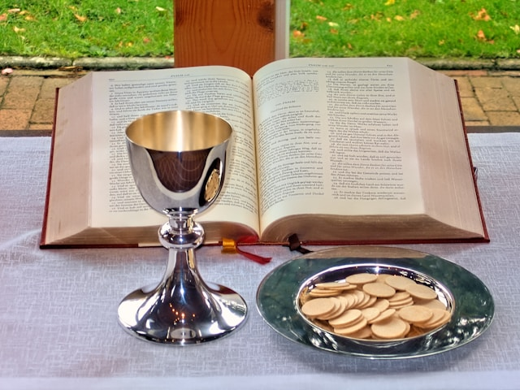

INTRODUCTION

Welcome to the Home Communion Training Program

In the Diocese of Nova Scotia and Prince Edward Island, the celebration of the Eucharist is a sacred and communal act—an expression of our unity in Christ and our shared life as the Body of Christ. Yet, we recognize that not all members of our community are able to gather physically for this celebration. Whether due to illness, age, or circumstance, many faithful members remain deeply connected to our worshiping life, even from afar.

The practice of bringing the consecrated sacrament to those who are shut-in, hospitalized, or living in care facilities is a cherished and ancient tradition of the Church. It is a ministry of love, hospitality, and inclusion—an extension of the gathered community’s worship into the homes and hearts of those unable to be present.

This training program is designed to equip deacons, Licensed Lay Ministers and other lay leaders, in accordance with Bishop’s Policy 1.1.4, to carry out this ministry with reverence, care, and pastoral sensitivity. Through this ministry, communicants are not only receiving the sacrament—they are being spiritually included in the worship of the Sunday congregation.

Whether you are new to this ministry or seeking to deepen your understanding, we thank you for your willingness to serve. May this training program guide you in offering Christ’s presence with grace and compassion, and may those you visit feel the embrace of their church family through your faithful service.

To be clear, this is not the only training program that may be used in our Diocese. Other courses may also be suitable. The expectation of the Bishop (Policy 1.1.4: Administration of Communion from the Reserved Sacrament) is that all those who are engaged in home communion ministry be prayerfully selected, trained and officially approved for this ministry.

This kit is designed to be used by individuals, small groups in parishes or in regions to offer a fulsome educational background and practical pastoral guidance for ministering to those who are not present at Sunday worship. Leaders who are being trained for the first time in this important pastoral work would benefit from a session or two to practice a full visit – from the first greeting, preparing the sacred vessels, leading the worship service, administering communion, etc.

The entire Home Communion training package takes approximately 5 hours or more to complete. For training purposes and hosting group learning sessions here’s a suggested order and timing for each resource:

- Bishop’s Policy 1.1.4: Administration of Communion from the Reserved Sacrament
Read in advance (20-30 minutes)
Reflect and discuss (20-30 minutes)

- CHECKLIST: Home Communion Ministry - Permissions & Protocols
Read and discuss how this program can be implemented in your parish (10-15 minutes)

- Preparatory Questions and Reading
Reflect on the questions and write down responses (20 minutes)
Read: “Eucharist”, Being Christian. Baptism, Bible, Eucharist, Prayer, by Rowan Williams (20 minutes)
Small group discussion

- Video teaching on Eucharistic Theology – Rev. Ian Wissler
Watch and discuss (30-40 minutes)

- Video teaching on Pastoral and Practical implications – Rev. Tammy Hodge Orovec
Watch and discuss (30-40 minutes)

- Liturgy Resources
The Book of Alternative Services – including instructions in rubrics
The Book of Common Prayer – including instructions in rubrics
Bulletin Outline #1 - Order of Service from the B.A.S.
Bulletin Outline #2 – Order of Service from the B.A.S., B.C.P. and other prayers
Review and briefly discuss (10-30 minutes)

- PREPARING for Home Communion Visits – prayers, visit checklist, devotions
Review this and discuss (15 minutes)

- Concluding Questions
Reflect on the questions and write down responses (20 minutes)
Discuss with the group and/or with your rector/priest-in-charge/pastoral leader
(30 minutes)

OTHER RESOURCES are supplied for use:
- Letter of Permission Request form (for the Bishop’s Office)
- OPTIONAL: Lay Pastoral Visiting resource

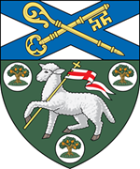
Prepared by
Missional Program Team
Rev. Canon Lisa Vaughn, Director of Mission and Ministry Development
Presenters: Rev. Ian Wissler and Rev. Tammy Hodge Orovec
Reviewed by Diocesan Bishop Sandra Fyfe
Video Production: Michael Winslow

Autumn 2025

