PREPARING for Home Communion Visits

EUCHARISTIC VISITOR PRAYER for SUNDAY WORSHIP:

Typically, the minister for Home Communions will go to the holy table (altar) to be commissioned following the administration of Communion and before the Blessing and Dismissal. The priest will hand the blessed sacrament to the Eucharistic visitor with these words:

In the name of this congregation, I send you forth bearing these holy gifts, that those to
whom you go may share with us in the communion of Christ’s Body and Blood. We who
are many are one, because we all share one bread, one cup. Amen.

PERSONAL DEVOTIONS WHEN PREPARING FOR A VISIT:

When making a pastoral visit, including for home communion, the minister needs to be spiritually and emotionally prepared. Central in that preparation is praying beforehand to ensure that you are grounded in faith, recognizing that it is God’s Spirit at work within us that enables our ministry to be effective. Take time to pray that anything that may be troubling you may be set aside in order to be fully present to the person you are visiting. Be sure to include a prayer of personal forgiveness and also for the presence of the Holy Spirit during the visit.

Lord God, bless the person(s) whom I will be visiting today. May I have your spirit of compassion so that I may enter places of pain and hurt with sensitivity and bring to others who suffer a presence that comforts, sustains and heals. Amen.

Guide me Lord God, and help me to accept my own imperfections and brokenness, and to share in the imperfections and brokenness of others. May I share their needs for healing and wholeness. Amen.

Heavenly Father, may my presence, my touch, my eyes, my tone of voice, my whole being echo Your love, assurance, and peace. May I be an agent of Your support and comfort. Above all may he/she/they turn to you for spiritual, emotional and physical strength and comfort. Amen.

Healer's Prayer
I am here only to be truly helpful.
I am here to represent You who sent me.
I do not have to worry about what to say or what to do,
because You who sent me will direct me.
I am content to be wherever You wish, knowing You go there with me.
I will be healed as I let You teach me to heal. Amen.

Prayer Attributed to St. Francis
Lord, make me an instrument of your peace.
Where there is hatred, let me sow your love;
where there is injury, pardon; where there is discord, union;
where there is doubt, faith; where there is despair, hope;
where there is darkness, light; where there is sadness, joy.
Grant that I may not so much seek to be consoled as to console;
to be understood as to understand; to be loved as to love.
For it is in giving that we receive; it is pardoning that we are pardoned;
and it is in dying that we are born to eternal life. Amen.

HOME COMMUNION MINISTRY VISIT CHECKLIST:
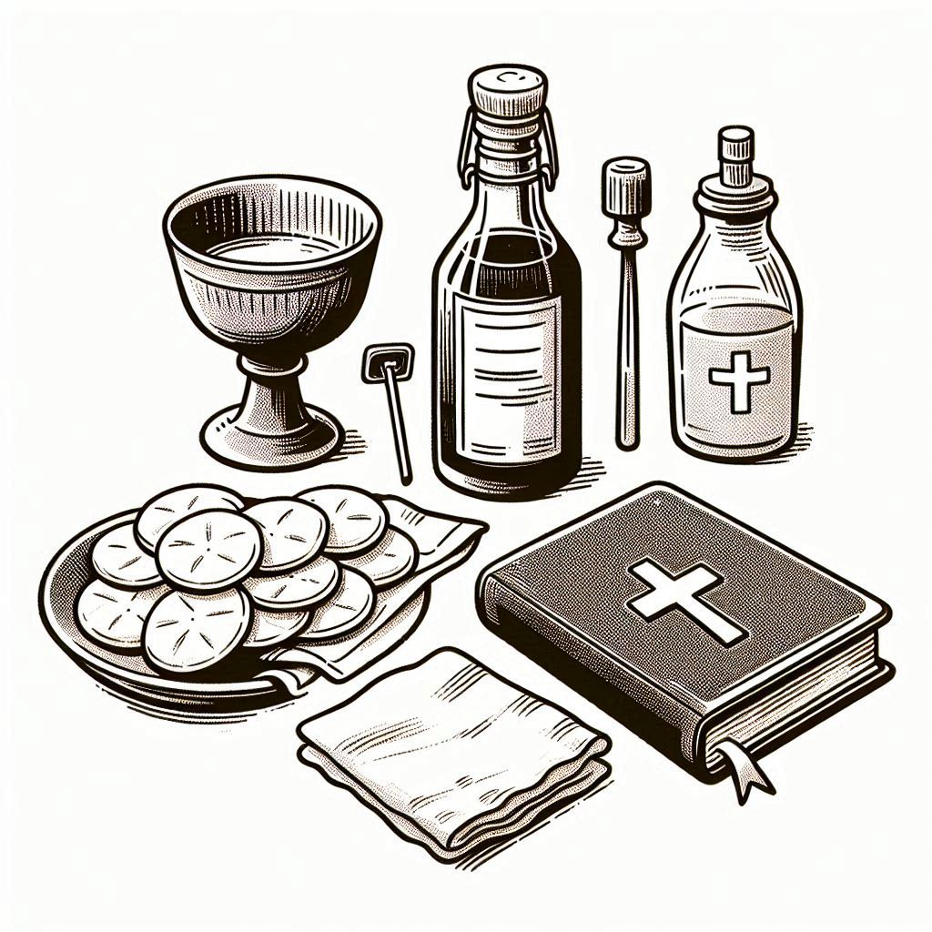
- Communion Kit containing a corporal, purificator, chalice and paten, and vessels containing blessed elements of Bread and Wine

- Copies of the Home Communion order of service for each participant

- Lectionary readings of the day, printed or marked in your Bible

- Sunday service bulletin or other printed material from the Parish

- Hand sanitizer
- Parish name badge (optional)

AFTER THE VISIT

• Reflect on how God was present in your visit and thank the Lord for the privilege of serving
your siblings in the power of Christ’s name and being part of a holy encounter.

• Pray for the person/people you visited, especially that they will grow in faith and deepened love of God.

• Follow the guidelines set by your parish for recording your visit (Vestry Book). Make sure to share any special needs or pastoral concerns noted during the visit with the clergy.

