November 14. 2023
Facebook: https://www.facebook.com/groups/101542159983749
Website: https://www.nspeidiocese.ca/ministries/diocesan-environment-network
Email: endionspei@gmail.com
Pray with us every Monday Evening at 7 pm. Email us for the zoom link.
“To strive to safeguard the integrity of creation and sustain and renew the life of the earth”.
DEADLINE FOR INITIAL APPLICATIONS IS TODAY!
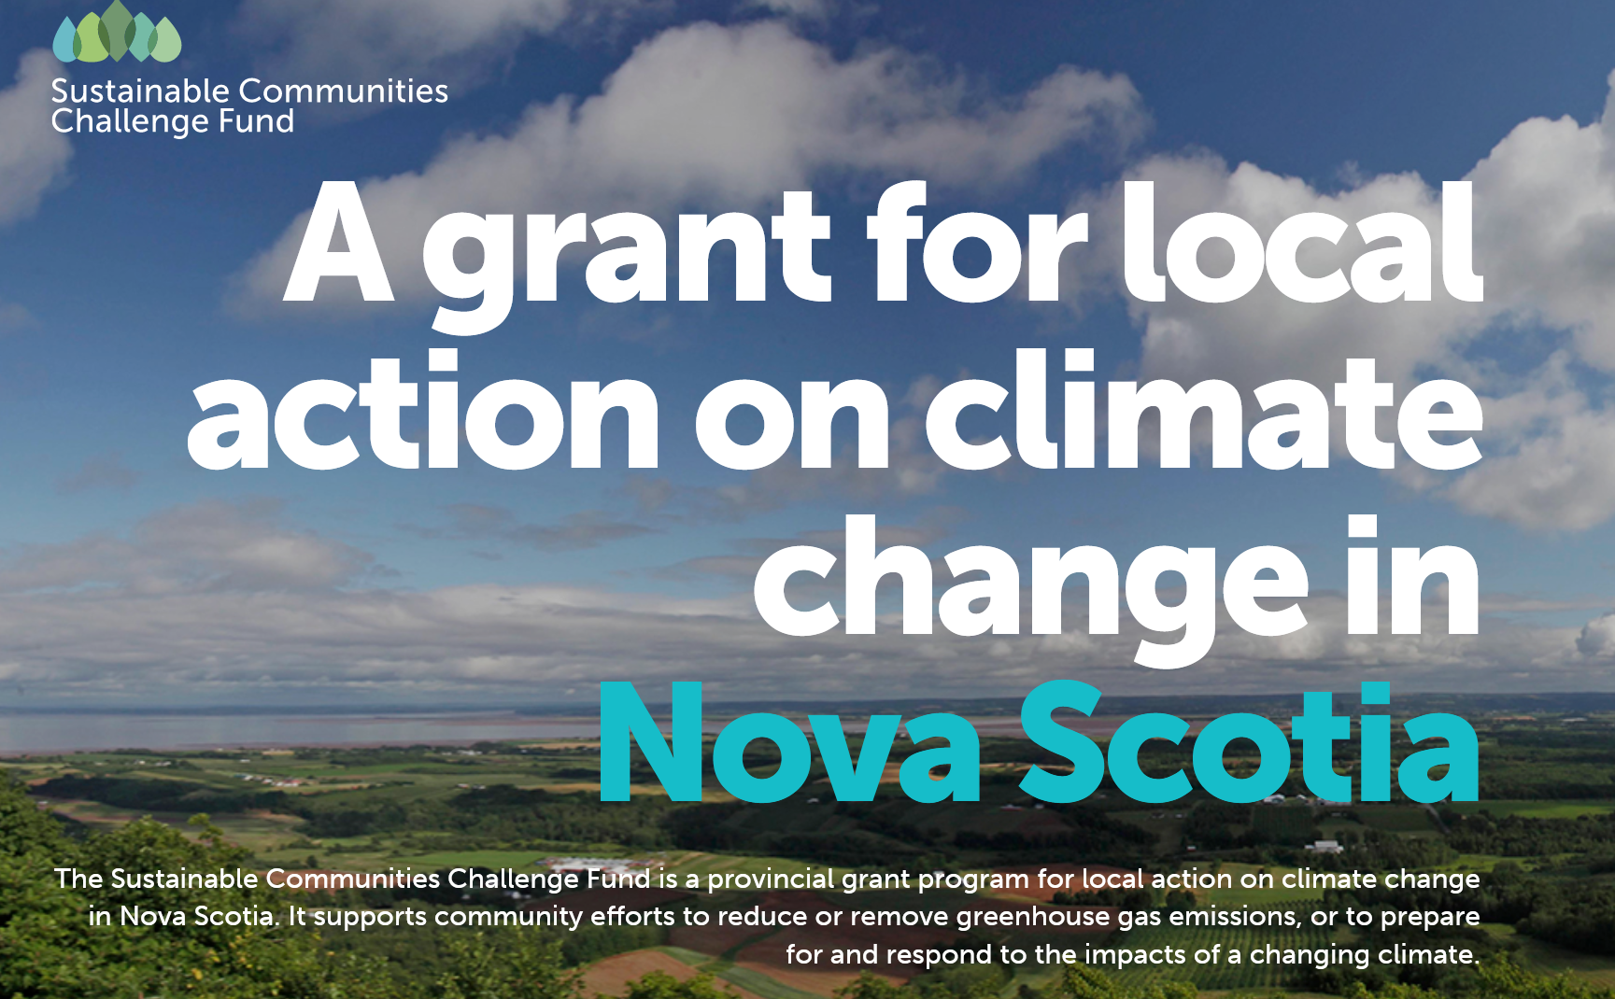
With thanks to Paul Jennings: This is anew and very short-term initiative. They are offering 80% subsidies on projects up to $250,000 (and smaller percentages above that
The challenge is the short-term deadline: Nov 14 for initial pre-screening, and Nov 28 for the full application. If there are churches who have been considering this, they would just need to get some estimates for the work and fill out the online application. Click on "Climate change Adaptation Stream" halfway down the page.
For more info: https://nschallengefund.ca/
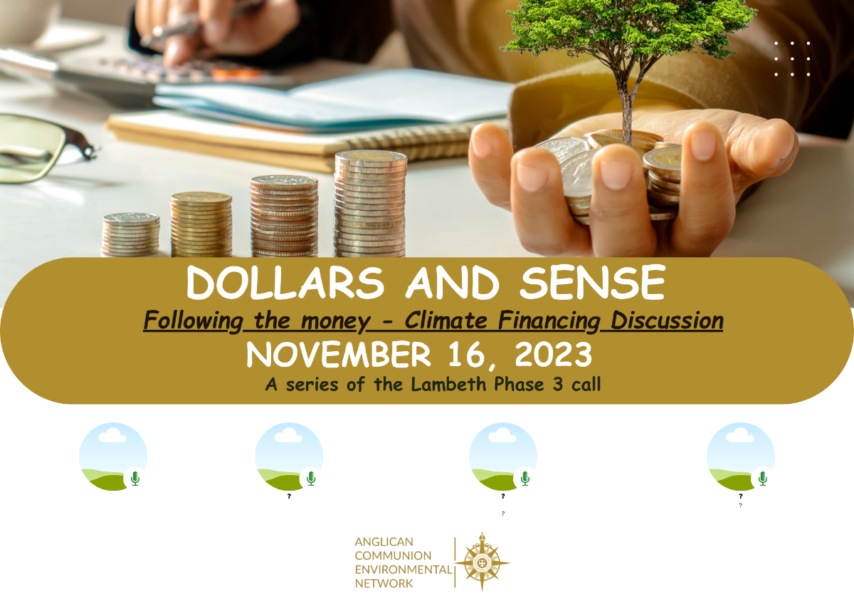

Dollars and Sense - Following the money - Climate financing discussions.
This interactive webinar will give input about different ways finances can be used to push forward climate change advocacy. Four speakers from around the globe will share their insights. We will have breakout groups linking Anglicans from near and far. Two webinar time slots allow access from all global time zones.
16 November - English Only - 8 AM UTC (10 AM Joburg)
https://bit.ly/ACEN16NovAM
16 November - English, French, Spanish, Portuguese - 4 PM UTC (6pm Joburg)
https://bit.ly/ACENPM16Nov

Sounds like fun! Click ion the link for more info: https://nsenvironmentalnetwork.app.neoncrm.com/np/clients/nsenvironmentalnetwork/event.jsp?event=109&&secureIdCustomer=1&fbclid=IwAR1M6aD8nLN7mIwDAzSlbvNg6EsC2ibVFg-WA7DMX825FBOMxVokWrLoymI

For their latest newsletters, please click on the links below. There are a number of events and blogs.

https://secure.kairoscanada.org/index.php?q=civicrm/mailing/view&reset=1&id=1671&cid=44856&cs=633c70e326fbfbb1d826939e471a1685_1699887844_168
https://secure.kairoscanada.org/index.php?q=civicrm/mailing/view&reset=1&id=1663&cid=2015&cs=d29ba58ad388aa11956007be68e9c1da_1698932621_168

If you are thinking ahead to Advent, this is an interesting resource from Eco Congregation Scotland called Advent - Keep Awake. It includes short videos for each day in the season.
https://www.ecocongregationscotland.org/advent-keep-awake/

Stop funding climate chaos with youroney - Ecojustice | Ecojustice
Canada’s banks and insurance firms are among the world’s largest funders of oil, gas, and coal. They are funding carbon pollution, which is putting all of us at risk and making daily life increasingly unaffordable. These financial institutions have made commitments to reach a net-zero emissions future. This amounts to greenwashing as long as they continue to invest in fossil fuels. Write a letter today to our country’s banks and insurers (RBC, CIBC, BMO, Sun Life, Manulife, TD, Intact and Scotiabank) telling them it’s time to end their financial support of carbon pollution.
Tell Coca-Cola: Bring Back Refillable Bottles (biologicaldiversity.org)
The Coca-Cola Company is the world's largest consumer-facing seller of plastic. Their plastic packaging pollutes the environment on every continent. However, a century ago, Coca-Cola pioneered the use of the refillable bottle. They received 96% of bottles back for reuse by offering customers a bottle deposit. Between the 1950s and 1970s, this beverage giant switched to single-use bottles. This pushed their packaging pollution to the public and planet. A new report reveals that as early as the 1970s, Coca-Cola knew switching to single-use containers would be worse for the environment. To make matters worse, they have fought state and federal legislative efforts to ban single-use bottles and other throwaway containers. Instead of continuing to bury our world in waste, we can demand that Coca-Cola bring back refillable bottles and embrace their capacity for industry leadership.
Canada's worst polluting sector must do its fair share
In November 2021, Prime Minister Trudeau proudly announced his government would develop a new federal policy to cap the oil sector’s emissions, on the world stage at the 26th global climate Conference of Parties. Two years later, the emissions cap for oil & gas is unreleased.Heavy lobbying by Canada’s biggest oil sands companies has delayed the policy and attempted to majorly weaken the target, despite poll after poll showing a huge majority of Canadians support a fair and strong cap on oil emissions., inside sources are saying Ministers could bow to oil sector pressure and announce an emissions cap before this year’s global climate conference that is less than the national climate target and even less than what was projected for the sector without regulation. A decision on the emissions cap needs to go through all 38 Cabinet Ministers before approval. Send a message to all 38 Ministers now and drive home the message that the desires of a few loud profit hungry CEOs shouldn’t trump the wishes and wellbeing of Canadians.

Sign the Emergency Petition to Protect Wolves Now! - Action Network
The persecution of wolves in Idaho continues and is even worse than feared. There are now plans to start funding private out-of-state contractors to trap, snare, and aerial gun wolves. This targeting will happen in US national forests across the state, including in the Wood River Wolf Project area. Idaho recently approved allocating over $140,000 to private contractors. This decision was made with no opportunity for public comment or review. We can use this petition as a way to create public comment, momentum, and support against this brutal persecution. Canadians can join in on asking Secretary Haaland to end the nightmare by signing an emergency listing petition for wolves in the US northern Rockies.
Avaaz - Stop Financing Oil & Gas
Climate leaders, including Greta Thunberg, are calling on Philippe Brassac and CEOs of the banking sector to stop financing fossil fuel projects that are destroying the planet. This is a fight for the future that belongs to all of us, it does not belong to companies, corporations, or banks. Philippe Brassac is the chief executive of Crédit Agricole, which is also called the green bank. They are a main funder of TotalEnergies, a French oil giant whose projects have been terrorizing and tearing up African land. TotalEnergies is behind the East African Crude Oil Pipeline project, which has been opposed by environmental and human rights groups. TotalEnergies needs to be stopped and its management held accountable. Please add your name to this petition, making it clear that funding TotalEnergies is not acceptable.
Pledge to reduce holiday waste Greenpeace Canada
This holiday season, Canada’s waste production will rise by more than 25% and reach an astonishing 50 kilograms of trash per person. Take the pledge and get access to a low waste checklist and weekly email tips that will inspire you in your low waste journey!

Zombie fires
I expect many of us watch the same TV News show but just in case you missed it, I was taught two new terms this week: Ghost forests and Zombie wildfires.
I knew about Zombie wildfires, but we called them Hibernation Fires long ago. I remember a fire one autumn started with a lightening strike that burnt its way to a lake back of our house. Snow came soon after and everyone thought that was the end of it.
Hunters saw patches of ground without snow in the fire area. Snow would be several feet deep usually, but still, they didn’t pay too much attention to it. Not in the spring but closer to summer, when things started to dry up, the fire started up again. Luckily it spread between two lakes and went out again.
Not to have this happen again, Dad on his tractor and men with pikes, axes and shovels made a fire break where it was thought it may start up again. Sure enough, smoke rolled out of the ground as the tractor ploughed the land.
The wildfire smouldered underground, ready to erupt when the conditions proved ripe.
Ghost forests is a new term. We know that the sea level is rising. We also know that many beaches have a saltwater march on the other side of the beach bank.
Seawater is coming over the bank in a large enough amount that it is polluting the marshes and killing the trees on the edge of the marshes. We always saw this.
The next type of Ghost Forest is further inland. Salt gets in the water system and kills any trees feeding off underground springs miles inland. To make it seem more eerie, these dead trees will be surrounded by lots of greenery. The greenery feeds off surface water from rains where the tree roots can go underground as far down as the tree is tall.
Video
https://scrippsnews.com/stories/ghost-forest-dying-trees-show-climate-change-s-advance/
https://globalnews.ca/news/3638788/climate-change-rising-sea-levels-canada-ghost-forests/

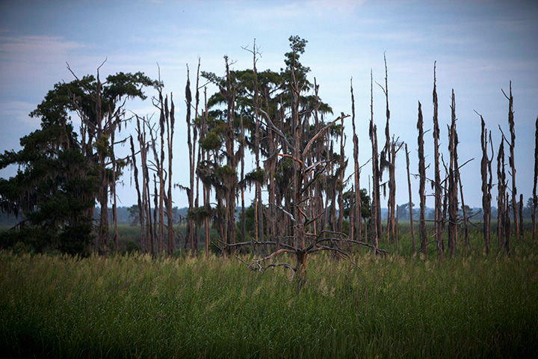
Christmas Prep - Plan for overnight guests
Does Grandma or Uncle Joe stay over and go home on Boxing Day? If so, think now of where they sleep and what blankets etc. you have.
If you just put away the summer sleeping bags, pull one or two over to the Christmas side of the attic. When shopping, if you see those $5 towels (like the beach towels I saw this summer at that price) pick up one with a new facecloth for each person who stays over. Then Christmas Eve or Christmas night bring out sheets for the coach with a pillow, pillowcase and towel and facecloth. Want to be super organized? Find them now and put them in the pillowcase to grab later.
Extra toothbrushes wouldn’t hurt to have and maybe spray deodorant in the bathroom. Consider pampering your guest as part of their Christmas gift.

Cardboard and string angel
I like a craft that you can make with just the basics. In this case it is cardboard, a wooden bead (bigger than I used preferably), two bits of tape (or glue) and string, (crochet cotton, embroidery thread etc.).
Make a circle about 3 inches from a cardboard box. Cut it in half. These are the wings for the angel.
Cut about two feet of string and thread it through a wooden bead. Tie a knot and line it up in the middle of the cardboard wings, allowing the strings to hang down. This will be used to tie a belt under the wings once her “dress” is made, so you might want to use a different colour.
Roll two bits of tape in a circle (unless you have double sided tape) and stick the two wings of cardboard together with the bead strings hanging straight down.
Now cut 20-30 pieces of string and lay half on the left and half on the right of the bead head. Finding the bead strings wrap the string under the wings to make a belt.
Cut the bottom of the dress even.
Take another piece of string through the bead head to make a hanger for the tree.
A wooden bead with cardboard and string is all that is needed to make a Christmas angel. Have fun!
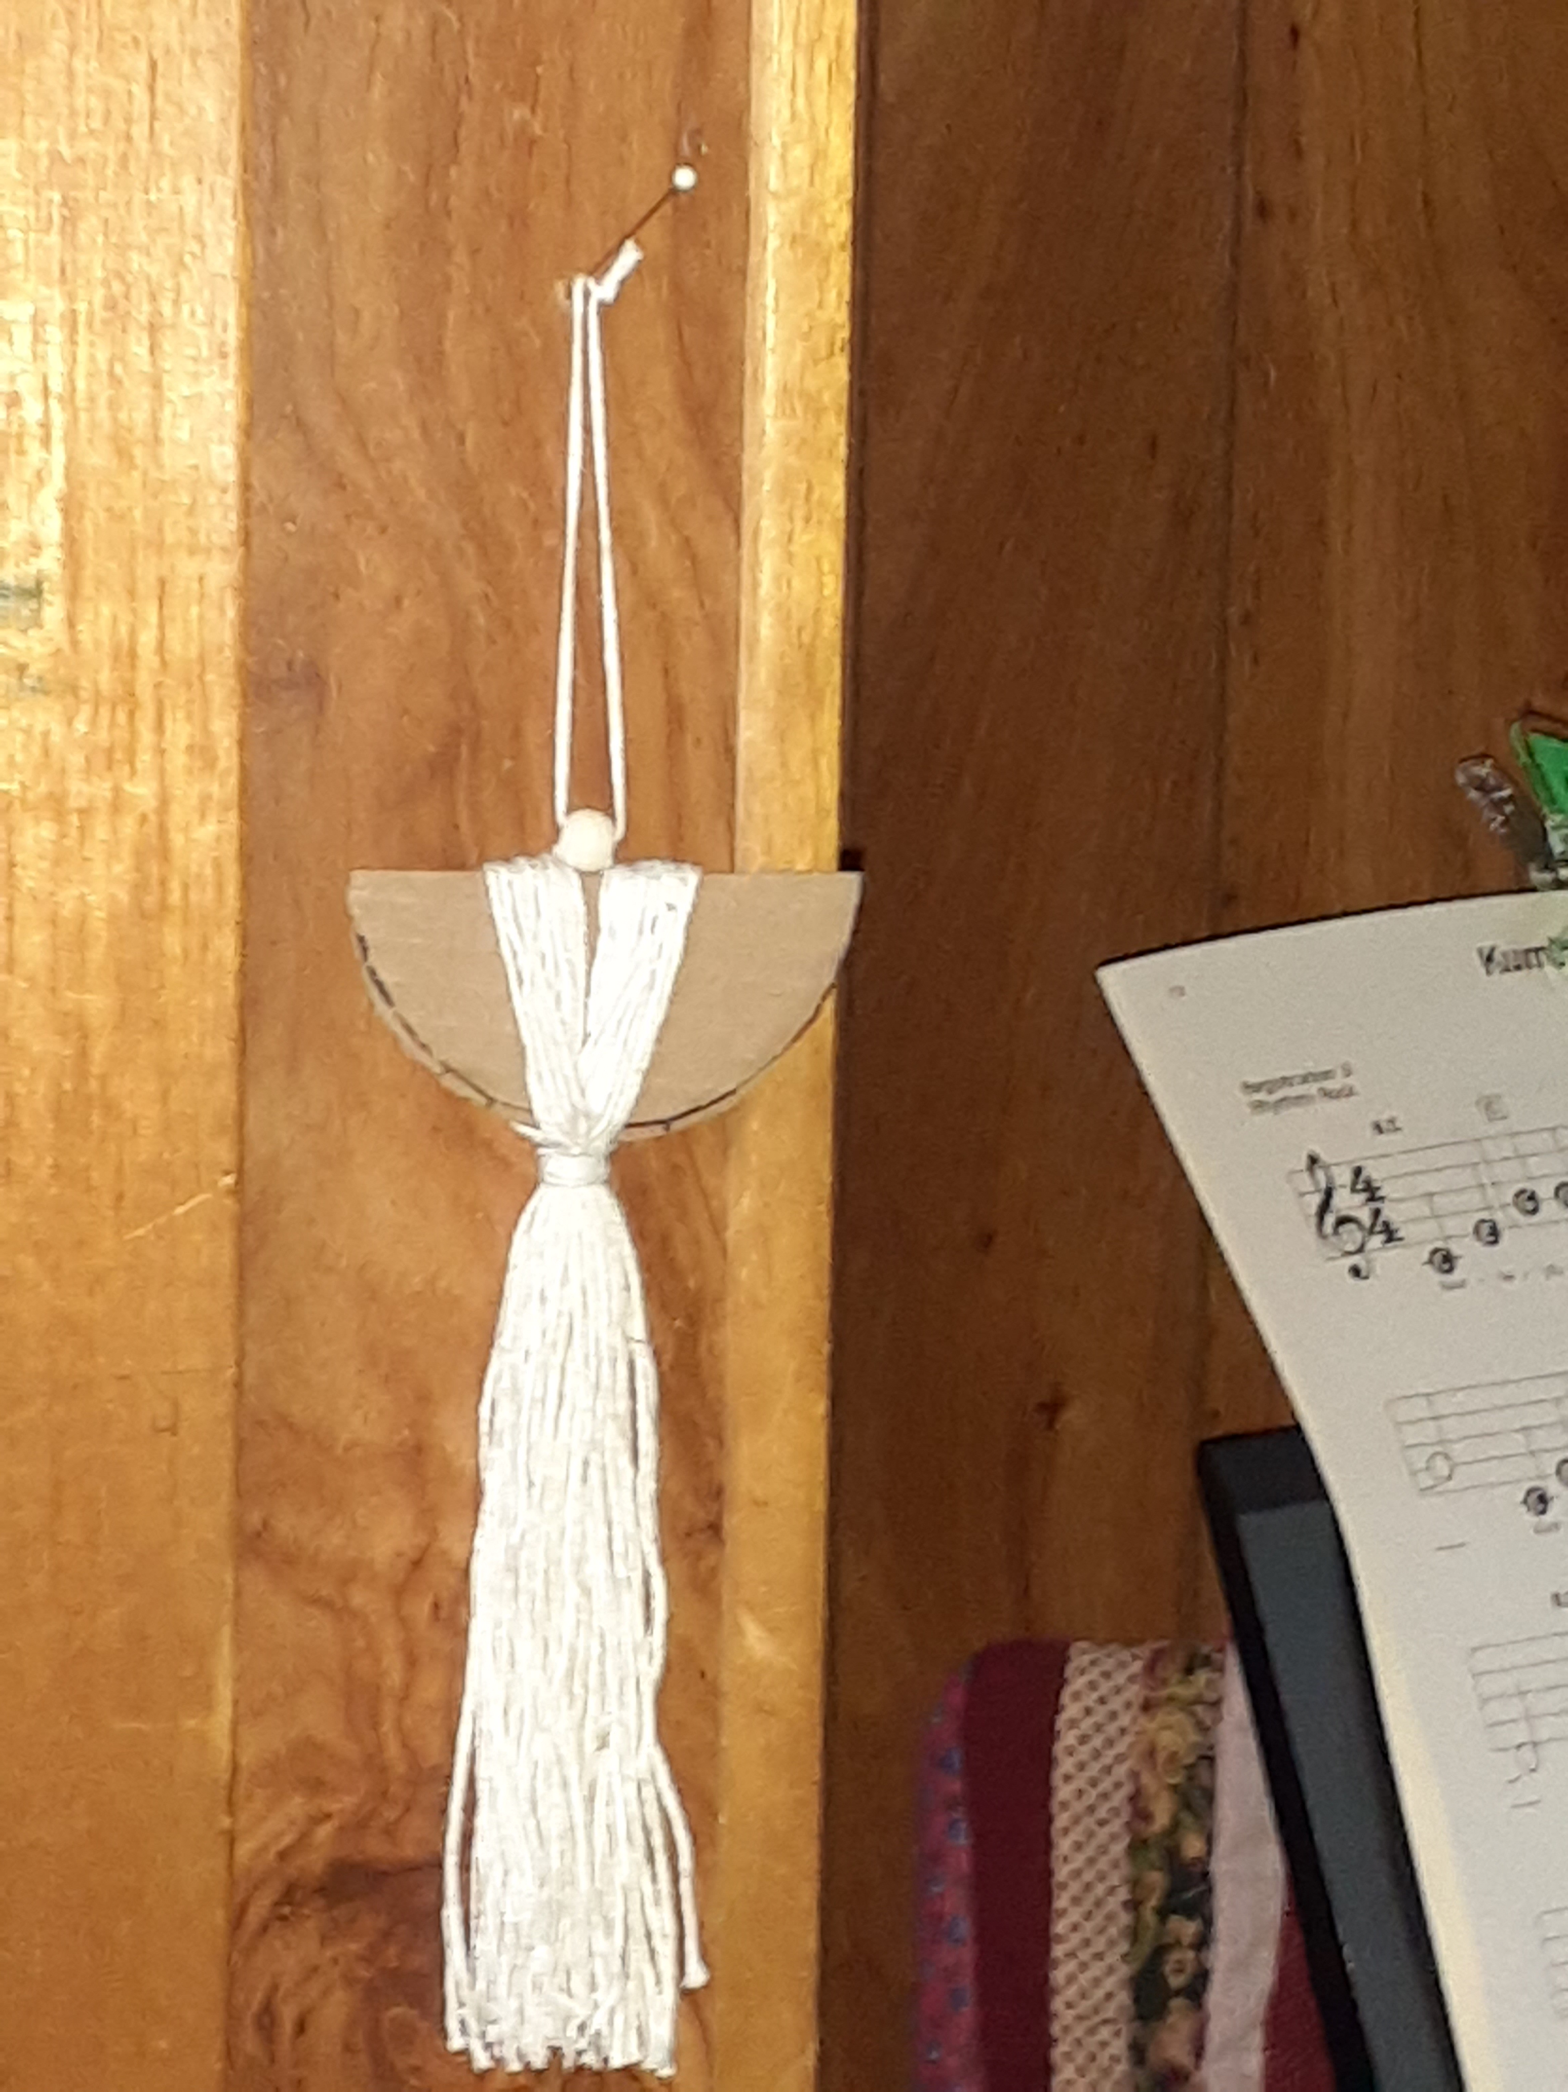
When I think of cinnamon rolls or pinwheels, I think of a tea biscuit recipe with the middle being butter, brown sugar and cinnamon. Molasses Pinwheels are sometimes called Gingerbread Rolls. They use a yeast base but follow the same spread out the middle, roll up the entire dough and cut the pinwheels. At that point let them rise half an hour before baking at 350F for 20-25 minutes. This is a Christmas favourite at our house.

Molasses Pinwheels
1 tbsp yeast (half an envelope)
½ cup warm water
¼ cup sugar
1 tsp. cinnamon
1 tsp cloves
½ tsp cloves
3 ½ cup flour
1 cup milk
2 tbsp butter
1 egg
2 tbsp. molasses
(5-6 tbsp) butter, (1/2 cup) brown sugar and (1/2 tsp of each spice) for filling.
Proof the yeast with sugar, water and butter. Add the rest and mix. Put on a floured surface and roll about half an inch or more thick. Spread butter, sugar and spices (like buttering a slice of bread and dropping brown sugar and shaking spices on the dough.) Using the longest edge, roll the dough into one long strip. Cut portions of dough. Let rise for half an hour or more. Bake 350F for 20 minutes.

The world is in need of so many prayers. Fill this image with what is in your heart.

.

