November 28. 2023
Facebook: https://www.facebook.com/groups/101542159983749
Website: https://www.nspeidiocese.ca/ministries/diocesan-environment-network
Email: endionspei@gmail.com
Pray with us every Monday Evening at 7 pm. Email us for the zoom link.
“To strive to safeguard the integrity of creation and sustain and renew the life of the earth”.
This DEN Enews will be our last full newsletter until after the New year. We will only be offering short reflections with tips for each week of Advent.
The First Sunday of Advent – December 3.2023
Image from: https://www.ministrymatters.com/all/entry/3267/worship-connection-november-28-2021
December 3, 2023 • 1st Week of Advent
“And what I say to you I say to all: Keep awake!” –Mark 13:37. How easy it is to forget or disregard our impact on the environment! This week, “stay awake” and reflect on specific ways to decrease your negative effects on the environment. Could you bike or walk somewhere instead of driving? Could you bring a re-usable water bottle so you don’t have to buy one? As uncomfortable as it may be, stay awake to the choices you make which hurt our common home. © The Pastoral Center / PastoralCenter.com. All rights reserved.
If you are looking for last minute ideas for Advent, this is an interesting resource from Eco Congregation Scotland called Advent - Keep Awake. It includes short videos for each day in the season.
https://www.ecocongregationscotland.org/advent-keep-awake/
This Advent, commit to Simplicity
This website offers you the opportunity to sign up for the Simplicity Challenge. You will receive regular emails and an Advent calendar for daily inspiration to live simply and heal the earth.
https://ignatiansolidarity.net/advent-simplicity-challenge/?utm_source=ISN+Updates+List&utm_campaign=66c051db25-INSTITUTIONAL_UPDATE_072220_COPY_05&utm_medium=email&utm_term=0_f721035495-66c051db25-257417536&goal=0_f721035495-66c051db25-257417536&mc_cid=66c051db25&mc_eid=01633dc060
Creation Care Tips 2024
Published by The Pastoral Center, this $12.00/ parish booklet offers “Weekly Prompts to Care for Our Common Home”. It is provided in Word of PDF formats and is free to disseminate within your parish. We will be sharing these weekly tips in our Enews for the rest of the year.
https://pastoral.center/creation-care-tips-2024
How the Longing of Advent Points Us Toward Creation Care
A quick Google search for “Advent & Environment” or “Advent & Creation“ will offer many resources. Here is one blog with reflection and questions on how we might bear witness.
https://www.faithward.org/how-the-longing-of-advent-points-us-toward-creation-care/

Pray and Act: An Advent in Action for Our Common Home
2023 Advent Calendar with reflections for each Sunday
https://laudatosimovement.org/advent2023/?utm_source=advent&utm_medium=email&utm_campaign=EN

Circling Through Celtic Advent
A meditation and circling prayers:
https://godspacelight.com/2023/11/20/meditation-monday-circling-through-celtic-advent/?fbclid=IwAR2J2NECSfP7cmFcfeugH4_xhQ6RHZNSY_m8i8qWNy20IJbWcBWzqQeoNDU
Wild Advent – A Preacher’s Environmental Resource
https://www.salalandcedar.com/wildlectionary?fbclid=IwAR2azXdbhjZ980Sz2Sul_5gfO1J_OJT0kOkA227GYzugSwPqOiKuymopktg
From Mother Susan at The Contemplative Cottage
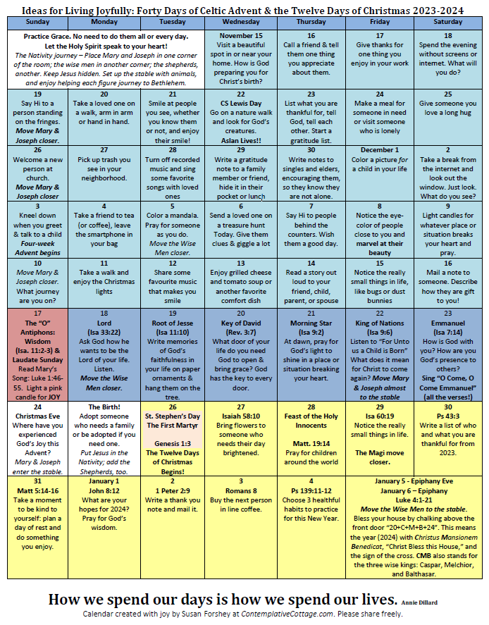
https://contemplativecottage.com/celtic-advent-calendar/

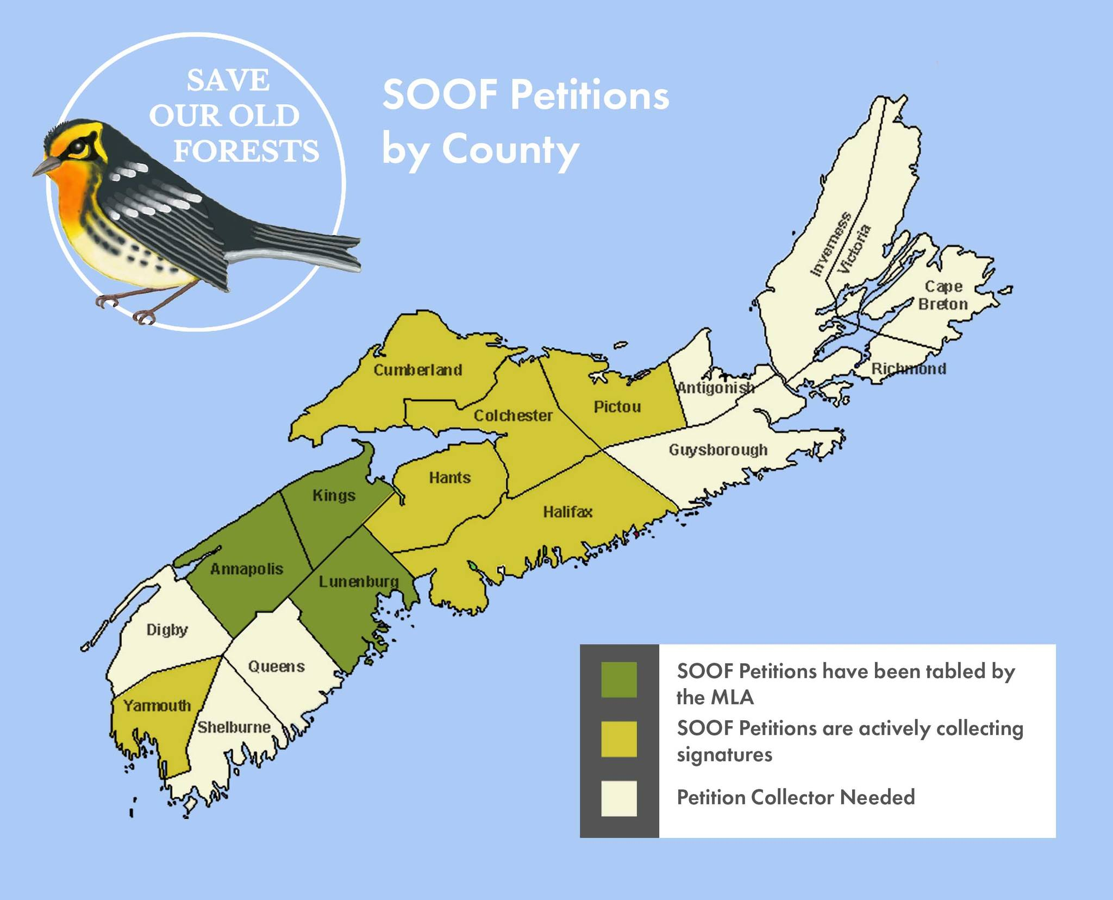
From the Save Our Old Forests Facebook page:
It's pretty amazing to see how many Counties have jumped on board to the Save Our Old Forests campaign since our initial launch of just the Annapolis County petition in March 2023 at the Bridgetown Legion!
As you can see from the map though we still need help to spread the campaign and petitions across Nova Scotia. We are actively seeking people to volunteer as Petition Collectors in Digby, Queens, Shelburne, Guysborought, Antigonish, Inverness, Victoria and Richmond Counties.
We are also looking for volunteers to help as Signature Collectors in Cumberland, Hants, Colchester, Pictou, Yarmouth and Halifax Counties.
By the way we aren't expecting people to go door to door to collect signatures! We find talking with friends, family, neighbours and co-workers, or talking to the owner of the local coffee shop more effective than knocking on strangers' doors. Each petition has 18 signature lines and they fill up pretty quickly!
If you're interested in volunteering in your County, please comment below or send us a DM!
#saveouroldforests
https://www.facebook.com/SaveOurOldForests
How to get Involved: https://www.arlingtonforestprotection.ca/soof/how-to-get-involved

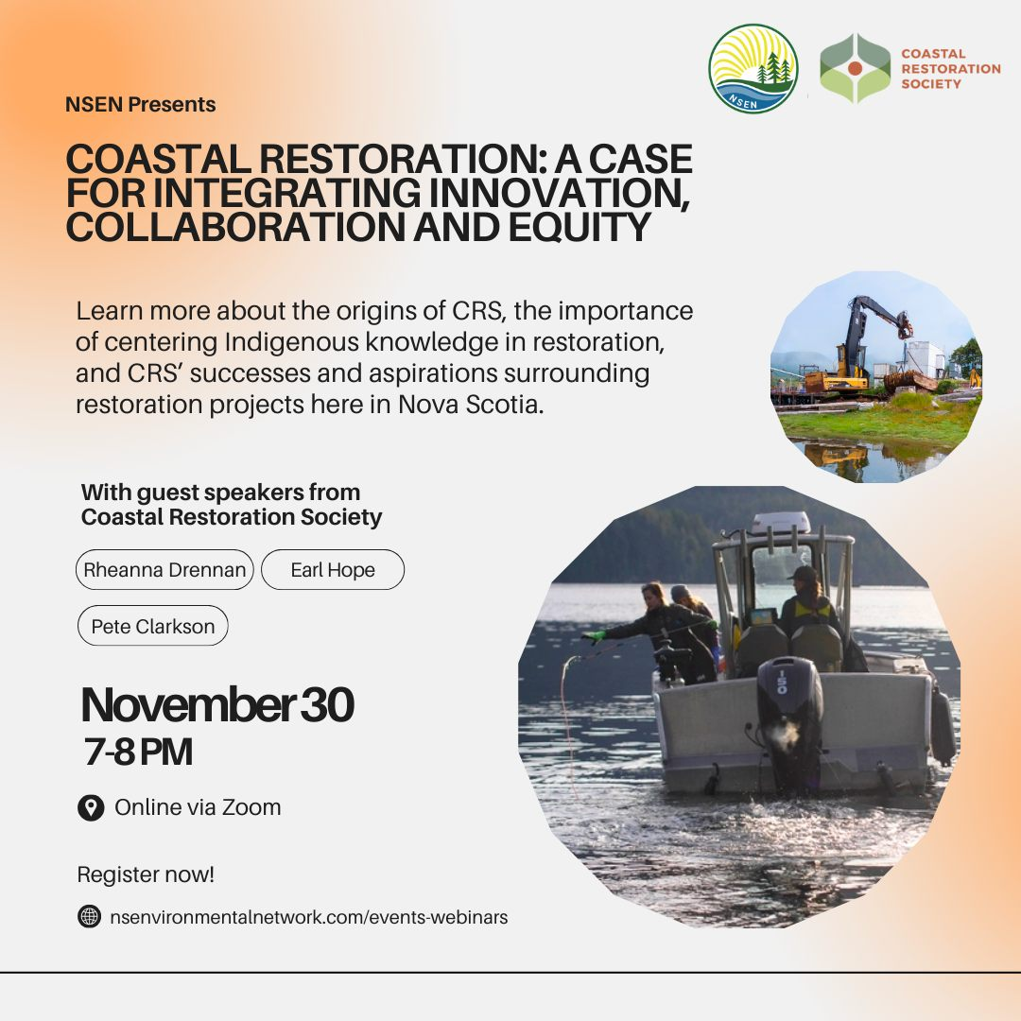
7:00 - 8:00 PM AT on November 30th, 2023 (online via Zoom)
Join the Nova Scotia Environmental Network for a free, educational event about environmental restoration efforts in Nova Scotia! Explore the success, resilience, and Indigenous ways of knowing behind Coastal Restoration Society's initiatives in the aftermath of Hurricane Fiona.
Click here to register:
https://nsenvironmentalnetwork.app.neoncrm.com/np/clients/nsenvironmentalnetwork/event.jsp?event=114&fbclid=IwAR1zb7MHwmm9PUZQNBtn-2dOnilZjqi90FDOrnlrHOIxzzDb_EGm7JRdvuY
For the Love of Creation has two webinars upcoming concerning COP28 – Unite. Act. Deliver.
For further information, see their newsletter in their browser link below. There is also a request to hold Candlelight vigils between Dec. 8-10. More details are also in the link below.

https://mailchi.mp/bc484371e977/for-the-love-of-creation-update-may22-13551677?e=3bc85e8dd7

From the Ecology Action Centre:
Help Advance EV Adoption in Nova Scotia
Do you have an electric vehicle (EV)? Have you thought about buying one? Or have you experienced any roadblocks in purchasing an EV? WE WANT TO HEAR FROM YOU!
The aim is to capture the authentic stories of individuals who have embraced an EV or are considering the shift. We want to bring attention to problems related to EV availability and long wait times through real experiences and bring attention to those accountable for change. Your participation in the survey and support in sharing your story is greatly appreciated. Please click on the link below to complete the survey. https://forms.office.com/Pages/ResponsePage.aspx?id=B4ytwUMUokqYQUBKkBSIlmTYdeEsLTFBn0zNfAuAKYBUMUxEOUc1TjQwRlpORjQ3M0w4VVlGSktLTi4u
With thanks to Advocacy Editors Eva Evans and Jesse Hamilton
Canada must step up at the UN Climate Conference! - 350 World leaders are about to make critical, future-impacting decisions at the upcoming UN Climate Conference in Dubai (COP28). This conference is a chance for our world and our country to get back on track. Canada has recently been called out for having the widest gap of any country between climate commitments and implementation. We can work to change that by setting a target to triple renewable energy by 2030, by phasing out fossil fuels, and by getting closer to the goal of 100% renewable energy. Add your name to demand our leaders lead Canada into being a true climate champion at COP28!
DR Congo: Stop the destruction by miners and loggers in Tshopo! - Rainforest Rescue (rainforest-rescue.org)
The Democratic Republic of the Congo is home to the second largest area of rainforest on our planet. It absorbs about 4% of global annual carbon emissions, sustains rainfall as far away as Egypt, is home to 80 million people, and has a vast spectrum of rare animals, insects, and flora. Its preservation is deemed key in the fight against global heating. What is happening there is destructive logging, toxic impacts of mining, cleared forests, polluted rivers, fish species disappearing, skin disease and health problems rising, and human rights abuses. A chairman of an environmental protection organization says, "What we need now is international pressure". Even though it’s a far away place, we can use this petition to support the fight for human rights, a healthy environment, and a liveable future.
Sign now: Protect old growth forests from logging (stand.earth)
Old-growth forests are irreplaceable. In B.C., they create a home for many species, including endangered western screech-owls. They have an unparalleled ability to keep carbon out of the atmosphere. They provide us with essential services such as clean water and flood protection. Without immediate protection, many of these ancient giants will not survive. Protecting old growth forests is one of the most effective things we can do to mitigate the impacts of climate change. A draft biodiversity and ecosystem health framework was recently announced as a way to implement recommendations from the Old Growth Strategic Review. This framework is expected to be finalized in early 2024. Some conservationists are hopeful that the proposed shift in B.C. policy could result in revolutionary change for forest protection. Add to the momentum by affirming logging in at-risk old growth forests needs to be banned and that these ancient trees need our protection.
Follow Australia’s lead and reject forest biomass as a false climate solution (stand.earth)
It’s almost been a year since Australia became the first major economy worldwide to commit to an end to subsidies for biomass and reverse itself on the renewable classification for woody biomass burned to make energy. Canada and the US can follow suit. We can declare that logging forests for electricity has no place in a renewable energy future and has no place receiving federal clean energy subsidies. This money could instead be invested in scaling up genuine clean energy solutions. Let’s tell Trudeau and Biden that logging old growth and primary forests to burn for electricity is not a climate solution.
Now that you've signed 4 petitions, I'm going to share some discouraging news and what YOU CAN DO about it. You probably were one of the thousands who called on our federal government to ban many single use plastics. We succeeded! However the chemical companies that produce plastics (from fossil fuels) were not happy and took it to court. Within the last fortnight, Justice Angela Furlanetto ruled in the companies' favour and denied that all the single use plastic items listed in the ban were harmful. Environment and Climate Change Canada is considering appealing the decision. The Minister, Steven Guilbeault, needs to hear from each of us. Please phone his Ottawa office at Telephone: 613-992-6779 and leave a message that you support the single use plastics ban, the ban should remain in place while the appeal is ongoing, and we need policy and legal changes to stop companies from overruling the voices of Canadians. Thanks.

Christmas
Everywhere I go I hear “Christmas is going to be different this year.” Different doesn’t have to mean bad. Different is experiencing anything in another way. Maybe a better way.
Let’s see how this works. What do we need for Christmas?
Well, first we need Jesus. Remember, “the reason for the season.” There is not any way that you can’t have Jesus unless you decide to turn him off. Even then it is difficult. Jesus is always going to be with us. We can’t lose him.
When I think of that young couple traveling days to get to the City of David, it amazes me. Here is Mary, nine months pregnant sitting on a donkey traveling over rough terrain. Joseph is leading the donkey and walking all day long. Then there are no hospitals, not even another woman to help Mary as they are turned away from a decent hotel and told to go to the barn. That barn was a kindness, but what a humble place for the son of God to be born. How many young husbands today could assist in such a birth?
Remembering the story is the main reason for this holiday. It is a great idea to talk about with the family any night from now on. Remembering where Nazareth and Bethlehem are in relation to Israel and the Gaza strip really makes a great talk.
Next thing needed for Christmas is the people that surround you. Our “different” this year is that Nana, due to health, just can’t travel to our children. We aren’t sure how the day will play out, yet, but however it does, we will be fine. There are zoom meetings and telephone calls if we can’t physically be somewhere.
Food. That will probably be different too. If there is just the two of us, I will finally have a chance to get one of those boxed turkey breasts. Of course, we will have all the veggies and dressings. There will always be plenty to eat, thanks be.
Maybe you can’t afford a big turkey. Buy a couple chickens if just one chicken a pay day right now. Maybe you want to try duck or goose that may be better priced. There is nothing wrong with a good pork roast with dressings and all the fixings. Don’t get hung up on one meat.
Besides the meat and veggies, you will need a few sweets. Either get the ingredients now or if possible, make and freeze things for the celebration. Think what special food you could have for the Eve meal.
One year when my daughter was not working, we had the big Christmas meal on Christmas Eve. I made homemade pizzas for Christmas Day. It really reduces the work and let us play with a new grandbaby that year.
If there is any suggestion, it is to go with the flow and just enjoy what is going on.
Presents. Oh, we all want them. One of my friends gets the family and extended family together around September. All names go into the hat and you pull a name out. That is your person to get a gift for Christmas Day, not the whole family. You buy inside your house all you want but you don’t need a dozen gifts for outside the house.
Decorations. Some people like half a dozen things out and others be-dangle and be-glitter like I do. Whatever you like, enjoy the decorations out.
In our house at 3PM on Christmas Eve, all work stops. No more fuss. We get ready and go to church. The story is told, the children bring the animals up the aisle, we sing Advent songs with a couple Christmas carols, and we all pile out of the church yelling Merry Christmas.
That is the point at our house we settle into celebration. Good Food. People we care about around us. Just happiness to be here to enjoy another Christmas season.
I want to leave you with a story I found in a Christmas cookbook. I can’t quote the author, but I will try to paraphrase her message.
“In November I contact the local nursing home and ask for the names of three people who usually don’t get visitors. I ask for ideas of what they may need. Each of my three children go and purchase gifts. They wrap them. We add little Christmas candy and small decorations to their gift. On Christmas Day after we open our gifts, we drive to the nursing home to deliver the gifts. The children visit with each resident for an hour and hear stories of Christmas past. It does brighten the resident’s day, but it teaches my children that Christmas isn’t all about them.” Merry Christmas! Then I found this on Facebook:
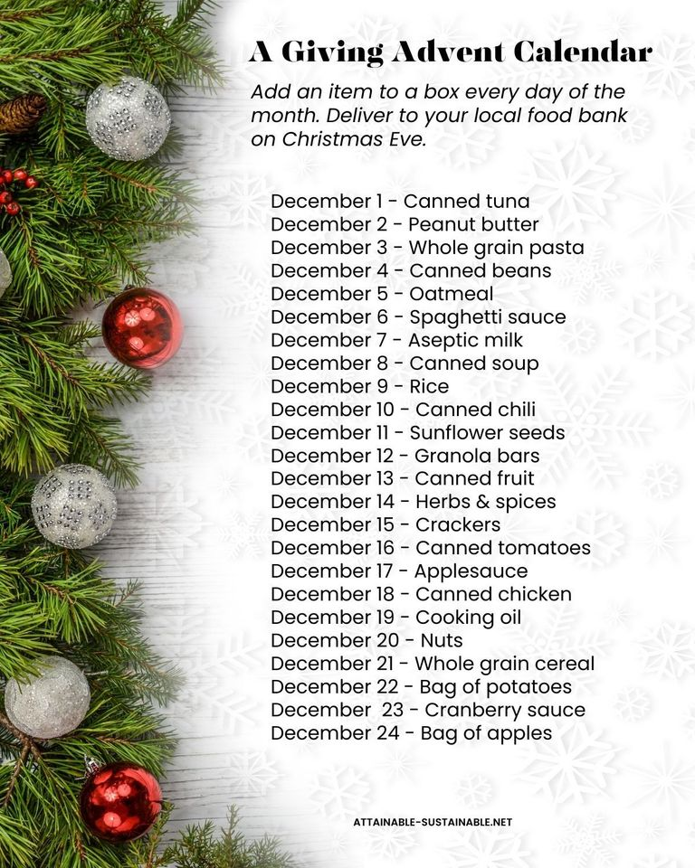
Silver Bells

If you are lucky enough to have a child as small as maybe 10 months on, consider making silver bells with them.
Our silver bells started this year when I opened a new box of crackers for lunch. The inside of the wrapper was a beautiful silver. On the counter were two empty pudding cups washed and waiting to go to the recycling bag.
I measured how much paper I would need with a napkin. Punched a hole in the pudding cups with a steak knife. Wrapped a piece of silver paper around the pudding cup and taped the edges under. A piece of cord was put down through the cup and tied and there is your silver bell.
Sounds a bit simple doesn’t it. Nothing big. My Emily and Ben look for their silver bell every year to put on the tree. They talk of how Grandma made the bells with them. They tell the story every year. Maybe that is our tradition, or a fond family memory made with a cracker box liner and a plastic pudding cup. It just proves that it doesn’t take much to make Christmas.

Something to Eat
When my daughter (Anne) was 8 years old, we made her first gum drop cakes. She decorated the smaller cake (there always were several) and put it in a tin as a gift to her grandmother. When my granddaughter (Emily) was 8 years old, I received my first gum drop cake from her. A small tradition that is so delicious.
You can find plenty of great gum drop cake recipes on the internet. These days I don’t make gum drop cakes (since I will get one at Christmas). I make gum drop cookies. I thought I would share this recipe. The hardest part is cutting the gumdrops into tiny pieces. Hint: use scissors.
Gum Drop Cookies
2 ½ cups flour
1 tsp. baking powder
½ tsp baking soda
Dash of salt
1 cup butter
1 cup sugar
1 egg
1 tsp. Vanilla
Put the dry ingredients in one bowl. I add my gumdrops in the flour mixture.
Mix butter, sugar, egg and vanilla together. Add the dry ingredients adding a bit of milk if needed. I roll these into inch balls and flatten with a fork (dipped in flour when it gets sticky) Kids love doing the flattening part.
Bake at 350 for 8-10 minutes.
Wishing you all from the Parish of Blandford, a very Merry Christmas
Grandma is sending hugs.
May God bless us not with clean air alone,
— But the will to keep our air clean.
May God bless us not with a vision of a healthy planet alone,
— But with the will to do all in our power to restore and maintain our planet's health.
May God bless us not with a change of heart in the great world leaders alone to save our planet,
— But with a change in our own heart to use our own power to save the planet.
May the blessing of God not bring to us saints alone,
— But make of us saints greater than any we imagine.
https://www.spiritualityandpractice.com/explorations/topics/climate-change/prayers-mantras?utm_source=google&utm_medium=cpc&utm_campaign=awareness&gclid=CjwKCAiAmZGrBhAnEiwAo9qHiV8xTs7Aa64LBuSMsUhix3wK6V6PUs-KKpxtG9Qih00XmK8QpR7ThBoCUIQQAvD_BwE

