November 07. 2023
Facebook: https://www.facebook.com/groups/101542159983749
Website: https://www.nspeidiocese.ca/ministries/diocesan-environment-network
Email: endionspei@gmail.com
Pray with us every Monday Evening at 7 pm. Email us for the zoom link.
“To strive to safeguard the integrity of creation and sustain and renew the life of the earth”.

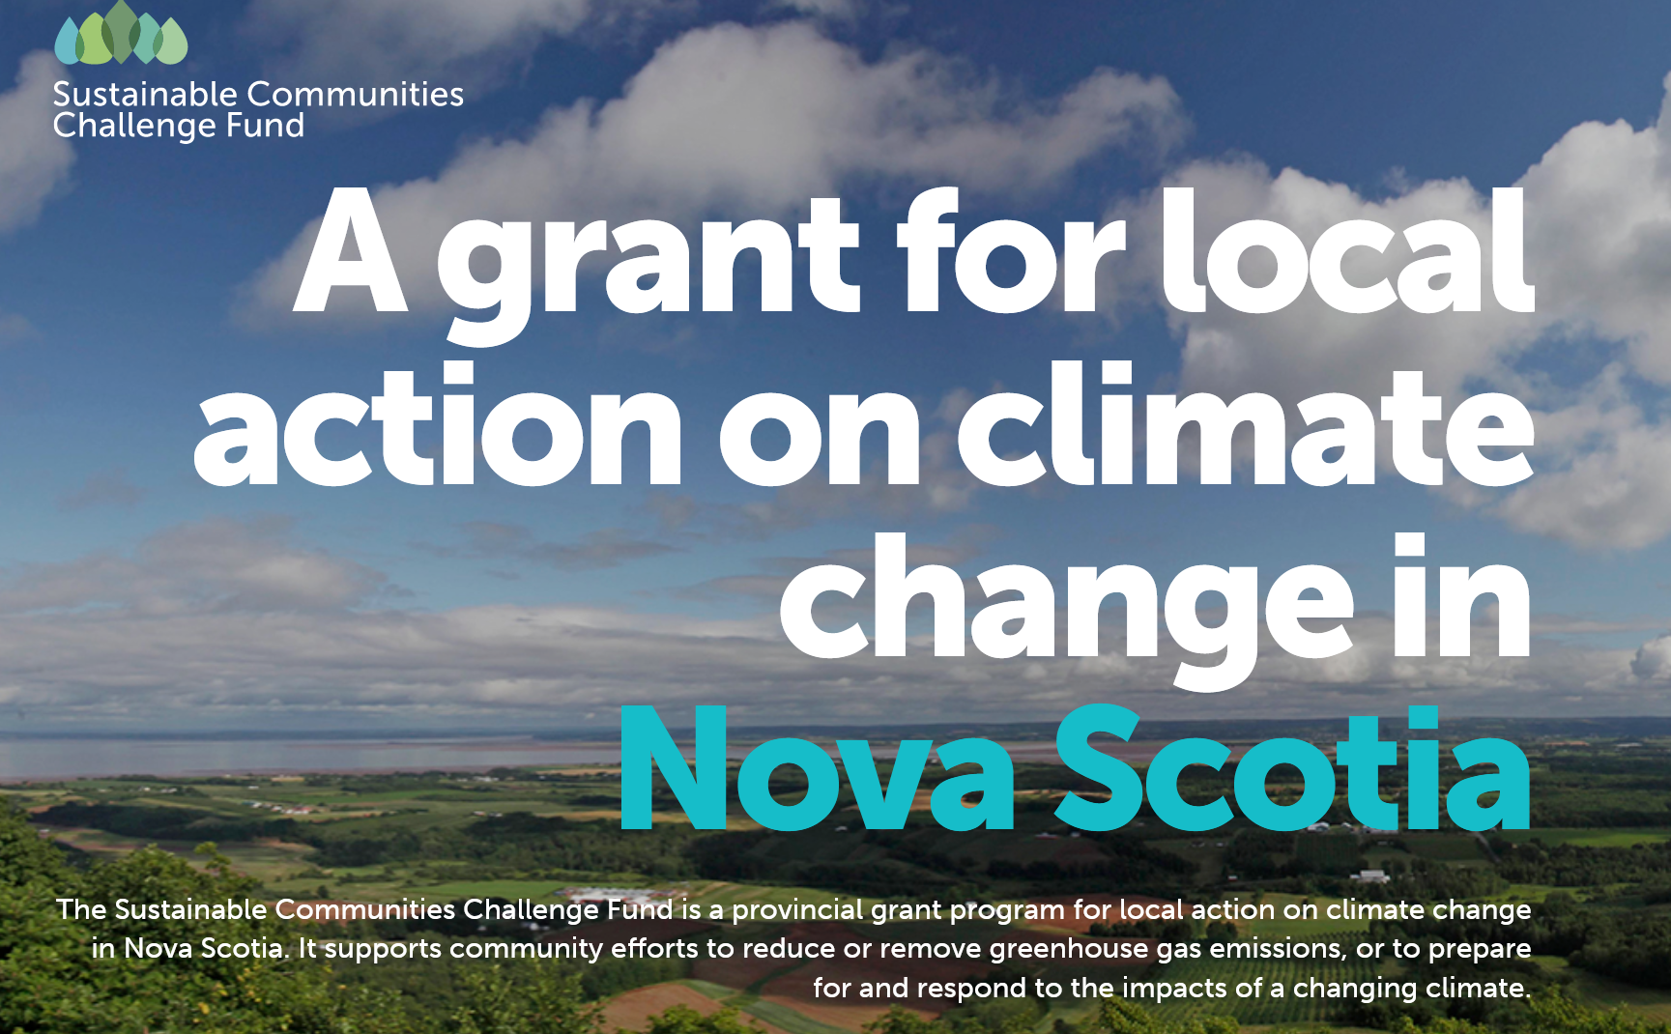
With thanks to Paul Jennings: This is anew and very short-term initiative. They are offering 80% subsidies on projects up to $250,000 (and smaller percentages above that
The challenge is the short-term deadline: Nov 14 for initial pre-screening, and Nov 28 for the full application. If there are churches who have been considering this, they would just need to get some estimates for the work and fill out the online application. Click on "Climate change Adaptation Stream" halfway down the page.
For more info: https://nschallengefund.ca/
Sounds like fun! Click ion the link for more info: https://nsenvironmentalnetwork.app.neoncrm.com/np/clients/nsenvironmentalnetwork/event.jsp?event=109&&secureIdCustomer=1&fbclid=IwAR1M6aD8nLN7mIwDAzSlbvNg6EsC2ibVFg-WA7DMX825FBOMxVokWrLoymI

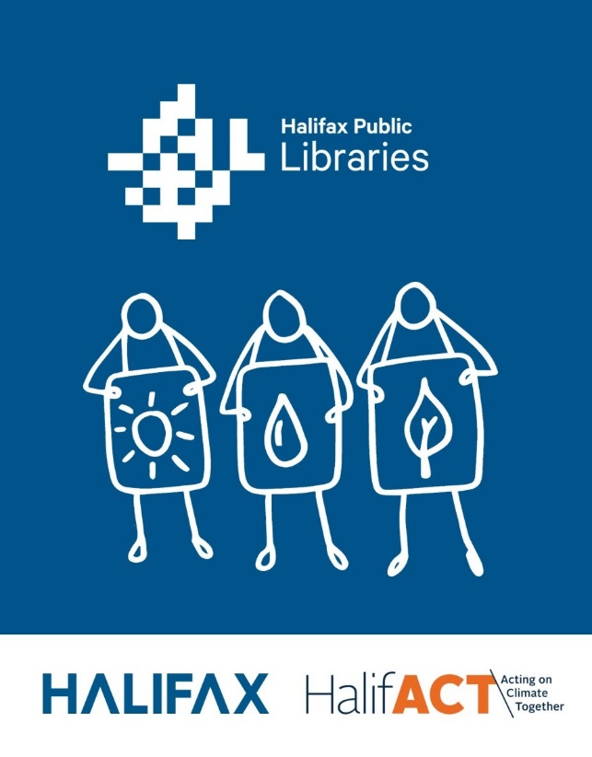
A Call to Climate Action: Halifact Human Library and Ideas Fair

Where:
Paul O'Regan Hall, Halifax Central Library
5440 Spring Garden Rd, Halifax

When:
Friday, November 10, 2023
From 3:30-8:30 p.m.

https://www.halifax.ca/about-halifax/energy-environment/halifact-2050-acting-climate-together/halifact-hpl?fbclid=IwAR01mzVYwLObGz9JjXoD13sJmLv9geIHaqvlifozW8fTTqFRFgdZGeGlYUA
Climate Action Week
Churches’ Advocacy on Loss and Damage Webinar
View these subjects and more in their newsletter:
https://secure.kairoscanada.org/index.php?q=civicrm/mailing/view&reset=1&id=1666&cid=2015&cs=b3a94fb132856f01a7b70e0deef0c093_1699305842_168

From Grandma. Aka Claudia Zinck:
I just need to brag! I wanted one of those waist high gardens like the ones I use in the summer down at the community centre. It is so easy to plant, water, weed and harvest.
Although our church did a DIO (Do It Ourselves) Carpentry course a few years back, I do not claim to be anywhere near skilled labour.
Nevertheless, with the base of a box garden already there, I added walls. I nailed a few uprights into the base and added these beautiful repurposed red boards a neighbour gave me.
I put old rotting campfire wood inside for a base. Next will come the cardboard boxes and paper products that will fill in and naturally decompose. Ever wonder how to get rid of old bills you want no one to see? Bury them under a couple feet of topsoil and compost. At 5% ink per page, they help the garden while they deteriorate. I had fun! Hopefully this is one down and another garden to be made in the spring. My brilliant partner mentioned how my neighbour gave me this odd pallet her barrel sauna arrived on. Instead of trying to remove the semicircle add on part of the pallet, I will leave it to deteriorate and make fertilizer. Then just add walls.

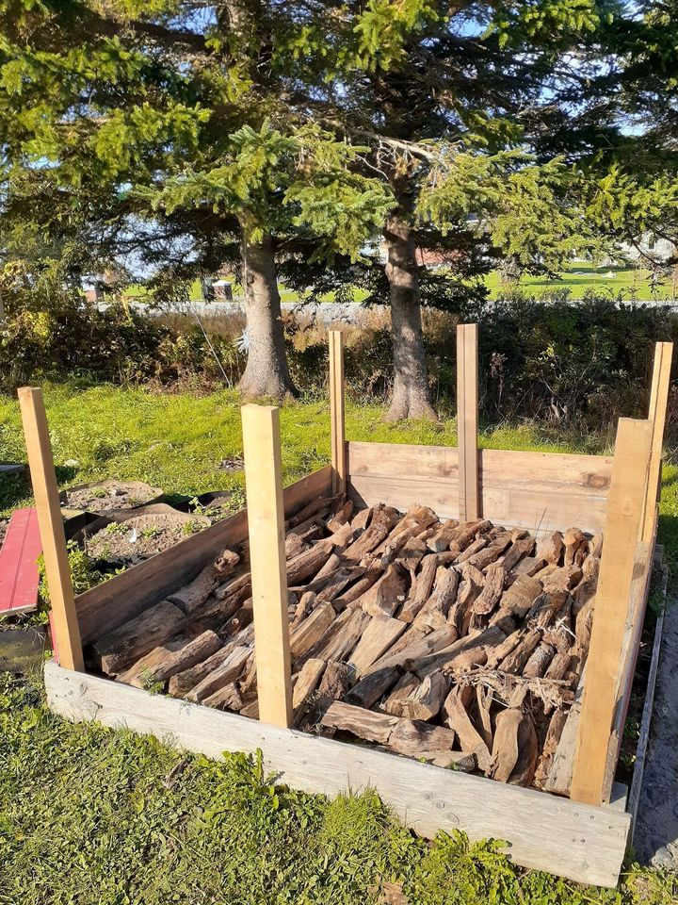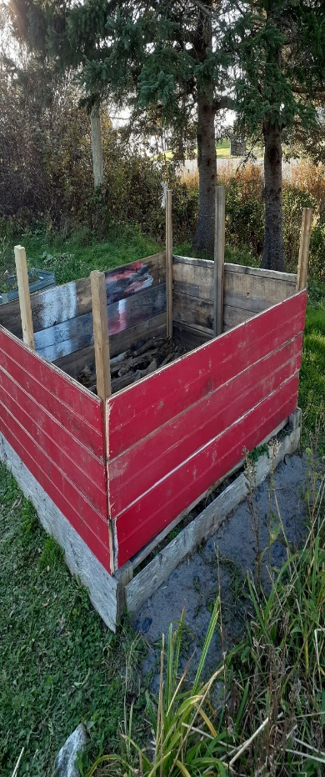

With thanks to our Advocacy Editors Eva Evans and Jesse Hamilton
Petition to Stop Fossil Fuels - We want justice! (greenpeace.org.uk)
Fossil fuel companies are driving the climate crisis - causing death, destruction, and displacement around the world. Entire countries are in jeopardy and people who have done the least to cause the climate crisis are paying the highest price. The fossil fuel industry can no longer get away with their countless crimes against nature and humanity. This petition has 3 demands. Fossil fuel companies need to stop their climate-wrecking activities and involvement in new fossil fuel projects, admit and apologise for their crimes, and repair and pay for the damage they have caused. Add your name if you would like to see climate justice for a safer and fairer world.
This industry is key to solving the climate crisis (stand.earth)
While the world asks global leaders to invest in bold climate action, some industries slide under the radar. A shocking 8% of global climate pollution is coming from the fashion industry. Fashion production uses up resources, dries up water sources, and pollutes rivers and streams. The vast majority of textiles produced end up in landfills. Some types of clothing even release thousands of microplastics into the water when they’re washed. Fashion has a serious footprint, but it also has a changing room for hope and the power to make a difference. Some companies are using their brand, product, and operations to reflect the values of their consumers. We can help push for change by calling on the fashion industry to accept their responsibilities and their waste, and to do better.
ON all supporter survey 2023 (typeform.com)
Add your input with a survey aimed at understanding how to better protect Ontario's environment and reduce the harm caused by urban sprawl. The survey by Environmental Defence takes approximately 7 minutes to complete. It gives the opportunity for Canadians to express values, offer suggestions, and contribute in building a more sustainable future.
The world demands an ambitious global treaty to end the age of plastic - Action Network
Significant, progressive, and mandatory targets to cap and dramatically reduce virgin plastic production. Legally binding, time-bound, and ambitious targets to implement and scale up reuse, refill, and alternative product delivery systems. A legally-binding agreement that covers the entire lifecycle of plastics. A just transition to safer and more sustainable livelihoods for affected workers and communities. Provisions that hold polluting corporations and plastic producing countries accountable. None of this is impossible to achieve. We can urge governments to step up these needed measures and reach the historic opportunity to finally end the plastic pollution crisis. Breaching limits on pollution, climate change, and biodiversity loss are not realities our world can accept. Sign your name to say you support an ambitious global treaty to end the age of plastic!

What is needed at COP28 (Greenpeace)
COP28, also known as the United Nations climate change conference, is starting on November 30th. Steven Guilbeault, Minister of Environment and Climate Change of Canada will be present at COP28, and this is our opportunity to tackle the root causes of the climate crisis – fossil fuels – and address the unavoidable damage that the climate crisis will provoke. This is your time to help! Will you ask Ministers Guilbeault and Freeland to commit to a full, fast and fair phase-out of fossil fuels. And to make Canadian fossil fuel polluters pay a climate damages tax to finance the UN Loss & Damage fund. Did you know that Canada is the fourth largest oil producer in the world?

Grocery Shopping
As I write this it is a Friday morning, and I am taking a break between putting away the groceries and starting the cooking/baking.
Having enough groceries or just the cost of groceries is always a news item and a worry to most. I am one of the lucky ones. My children joke that in a national disaster they are packing their trailer and moving home as I could feed them for a good length of time.
I worry about rising gas prices, mortgages that might balloon next year when mine is due, and especially worry about oil prices this winter. I don’t worry much about food. Why?
Forget about what I already have stocked and just concentrate on what I bought for my $118.42 in six bags after 2 stores and how am I different? Do I have any tricks that might help others? Do you know of more tricks that I do. Please tell us.
It was a toss up for the chicken today. A rotisserie chicken was 50% off $12 where fresh whole chicken had 30% off $13. Rotisserie won and I don’t even need to cook it. With only 2 of us I also got enough haddock for a meal for $5.
Frozen spinach was $3.49 where a big tub of 50% off fresh spinach came to $2.50. The fresh spinach is in a pot waiting for me to cook.
Perogies were down to $2.49, and I couldn’t resist one of those packs of small potatoes marked down to $2 even though I still have some from the garden. These carbs finish out so many meals.
The big sausage patty regularly priced at $3.25 made 4 smaller patties that we put with an egg on an English muffin (2 packs for $6) for breakfast.
I bought an extra 2% milk with a 50% sticker mainly for the bread pudding I am making from stale bread. I may as well whisk up a couple milk puddings or make tapioca since I have extra milk.
Berries were priced 2 for $6. I often put half a sandwich on our lunch plates with berries, pickles, bits of cheese and other finger foods. Speaking of cheese there was a (seldom seen) pack of shredded cheese marked down. I threw that in the freezer till I make pizza next week.
Cranberry juice (not drinks) was 2 for $6. Salad dressings was on sale for $2.99. It is always a matter of getting the sales while we can and stocking up for when we can’t (within reason) (I worry I may hoard in some areas)
I don’t always like to cook so I always look at the meals section and when the price is right, I get something. Today was a noodle, meatball, and sauce dish that when marked down came to $4. I couldn’t cook that plate for $4 or $2 for each of us for a meal.
I agree that “best before” does not mean “bad after”. My mother was one to “stick it in the freezer” to keep anything from spoiling. I have canned fruits and veggies and even soups, stews, when extra is available. Maybe it is that “island mentality” that helps me now.
I sure don’t know it all so if you have a little trick that helps, send Carole or myself a message and we will gladly include it. My daughter makes a “Frugal Ham” meal from a tin of luncheon meat. She sticks it with cloves with brown sugar on top and baked in an oven. The kids think it is a special treat when it was a staple when they were going through hard times.
I know I have it better than many when it comes to food. Hang in there. Grandma is sending hugs.
Christmas Prep
Do you get a family Christmas picture to put in your digital Christmas letter. Ask your kid’s friend that is always at your house, to snap a picture on your phone. Then do a letter saying what year the kids turned on their birthdays or their grades in school. Is there is a new job, hobby, evening exercise group, etc. you have done. Did you have a garden this year even if it was the bean pot by the back door where three plants gave you fresh veggies for 2 meals. Did you take a trip, even a day trip? There isn’t much space left on a single letter size page with a picture on it. If you have a lot to say do a double-sided page.
Then think about your Christmas dishes. I am not asking you to wash up your china dish cupboard, just look at it.
Check for that pack of disposable plates, bowls, bamboo cutlery that you have for back up or simply get some if you don’t have them now. They don’t need snowflakes or poinsettias on them, in fact you may prefer plain when you need them next summer at the family reunion.
Just think what you might need so when the time comes you know where you are stocked for the holidays.
Ribbons and Beads
This looks simple to make but, it takes making a few to get the hang of doing them.
Knot a string and bring it up through a piece of ribbon. Add a bead. Make your first turn and come back to the middle making the first half bow somewhere between 1.5 and 2 inches wide. Add a bead. Make the turn on the other side the same size. Add a bead. Make another half bow a bit smaller and match the second side adding your beads each time the ribbon comes back to the middle.
If you are lucky to have stars (buttons, sequins, or anything) that can be added to the top, it makes a nice finish, but the plain ones look nice.
This is a great way to REPURPOSE last year’s ribbons.
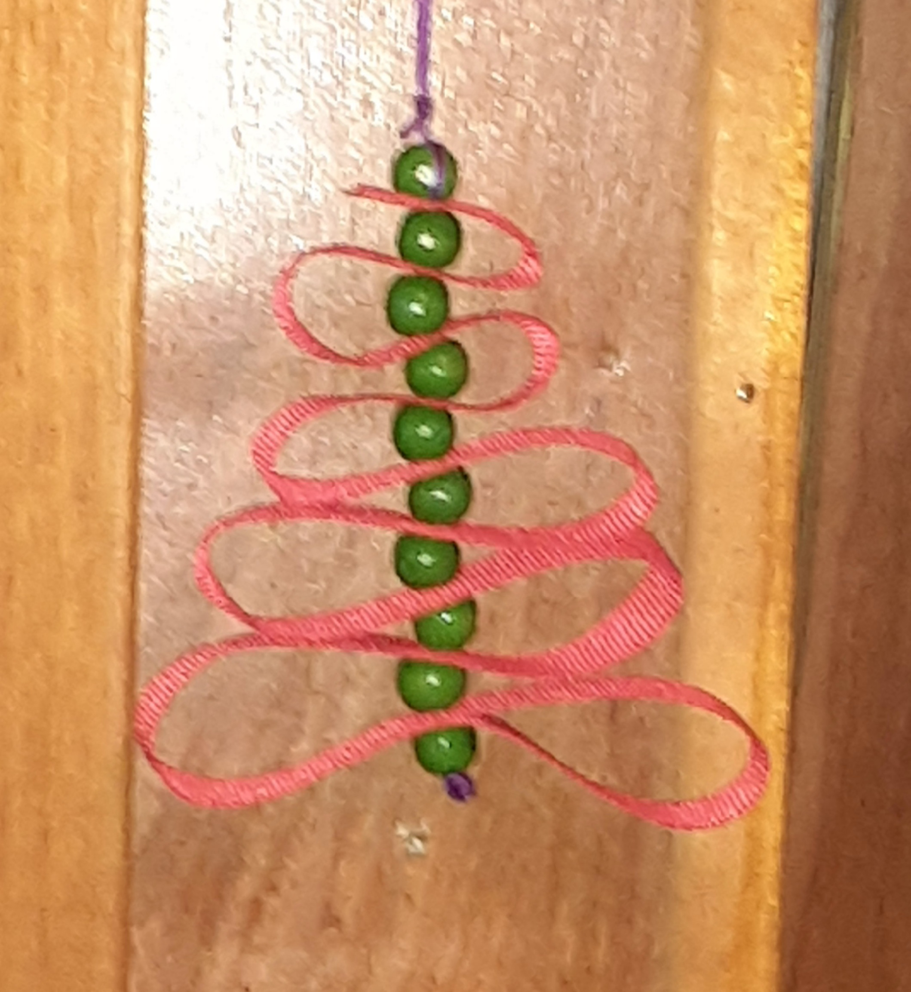
Bread pudding
Any type of dried bread, cookie, cake, even English muffins, or bagels
An egg or two according to how much bread (and eggs) you have
1 tsp. cinnamon
Milk, enough to make it soggy looking.
Mix, put it in an oven dish and bake at 350 for maybe 25 minutes.
This recipe is one of the reasons I keep a little carton of cream in the house. A drizzle of cream over warm bread pudding is a delight.

The world is in need of so many prayers. Fill this image with what is in your heart.

.

