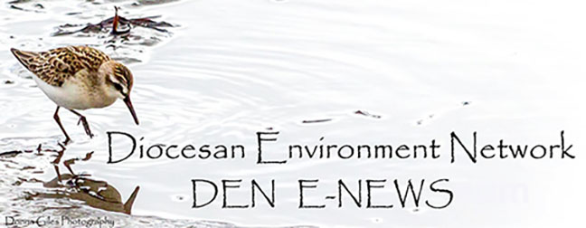
September 26. 2023
Facebook: https://www.facebook.com/groups/101542159983749
Website: https://www.nspeidiocese.ca/ministries/diocesan-environment-network

Email: endionspei@gmail.com
Pray with us every Monday Evening at 7 pm. Email us for the zoom link.
“To strive to safeguard the integrity of creation and sustain and renew the life of the earth”.

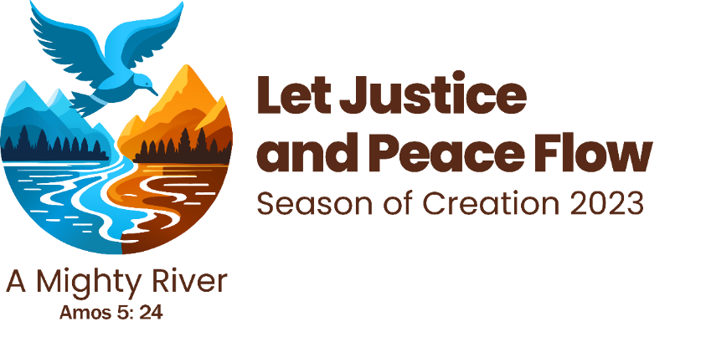
How are you celebrating?
We would love to share your ideas with others.
From the Season of Creation newsletter, here are some highlights from around the world:

This week's featured events:
- The Columban community of Essendon, Australia, together with friends working for peace, ecology and justice in Melbourne, held a prayer service.
- Over 100 people planted mangroves in Zamboanga, Philippines.
- The Divine Salvation Society of Pakistan organized a prayer for the Earth with 30 young people committed to environmental conservation.
- In Wirral, UK, they made a pilgrimage for the planet reflecting on lifestyles and water use, and prayed for the East African Oil Pipeline (EACOP).
- The Catholic University of Santos, in Sao Paulo, Brazil, held student meetings to discuss Laudato Si' and the socio-environmental crisis.
- Students from the San Francisco de Asís High School in Formosa, Argentina, held a workshop to raise awareness and reflect on environmental care.
- In Badajoz, Spain, adoration of the Blessed Sacrament was held as a contemplative prayer for the Care of Creation.
Every day more stories are posted on our social networks. If your community is also celebrating the Season of Creation, share your story via this form.

The Anglican Church has church parking lots throughout the province. The Diocesan Environment Network (DEN) has been engaged in research on the possibility of installing EV charging stations in our church parking lots. We have also offered our church parking lots to municipalities throughout the province as locations for the installation of the charging stations. Any information that people connected to DEN have to offer would be appreciated. We can be contacted at endionspei@gmail.com
Thank you,
Rev Marian
From the Save Our Old Forests Newsletter:

THANK YOU CITIZEN SCIENTISTS!
We are excited to announce that the Arlington Forest Protection Society is the 2023 winner of the Ecology Action Centre's Tooker Gomberg Award!

The Arlington Forest Protection Society was nominated "for saving a place with science! In fall 2022 the group sounded the alarm that an area of Crown land was beginning to be cut by forestry company Westfor at Goldsmith Lake. The group hosted a "bioblitz" on the land and identified 8 species at risk at the site, including Black Ash, and Blue Felt Lichen, which is Nova Scotia's provincial lichen and an indicator of old forests. The company and Province had not previously noted these species which are supposed to be protected by law against the impacts of forestry. The Society's documentation, communications, and public outcry led to the Province pausing the clearcut and requiring more species at risk surveys. Arlington Forest Protection Society did an outstanding job of conducting citizen science and then using their findings to call on government and companies to at least follow the minimal environmental protection processes we have in place in Nova Scotia."

Congratulations from DEN and all those in our network for this most deserved recognition.

The first Session is tomorrow!  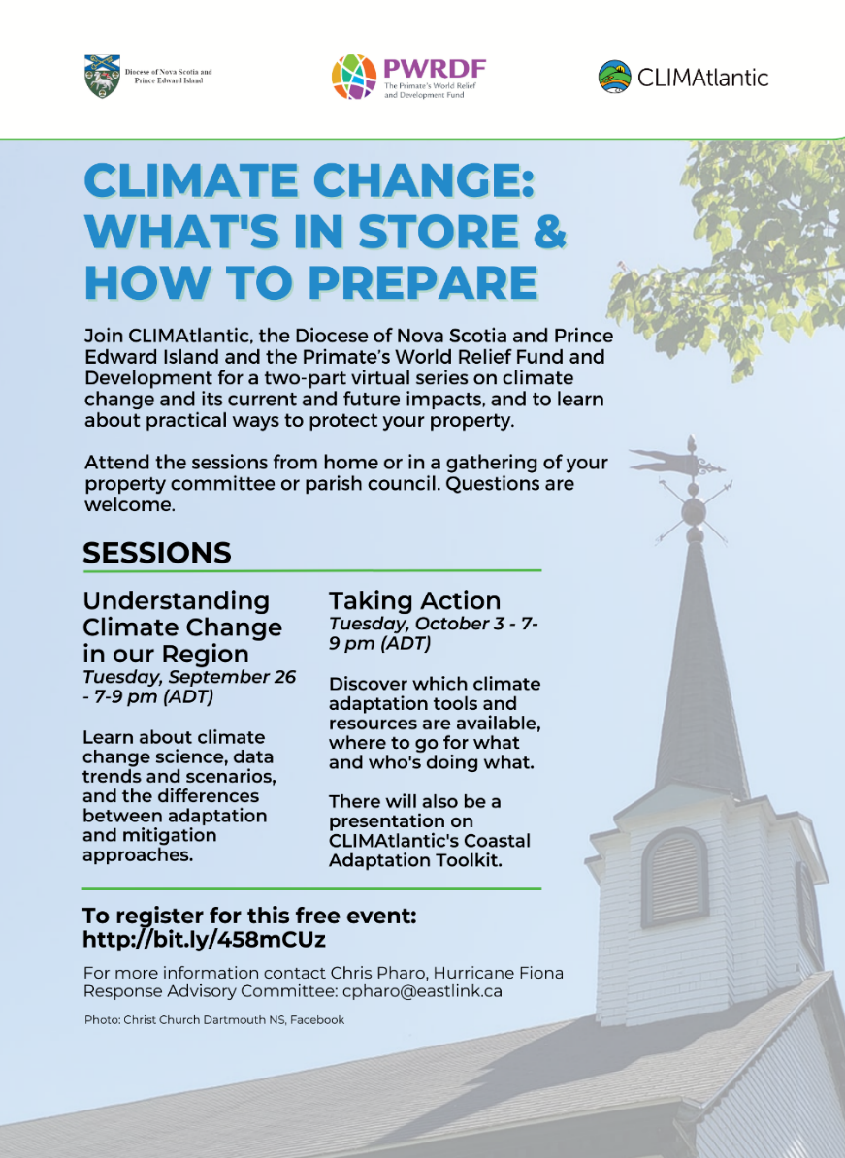 | 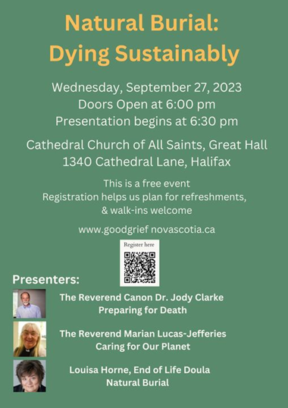  This session is a part of a week of events from September 23 to 30 designed to support grievers in our communities and to grow grief literacy across Nova Scotia and beyond. To learn more about this initiative visit Good Grief, Nova Scotia.

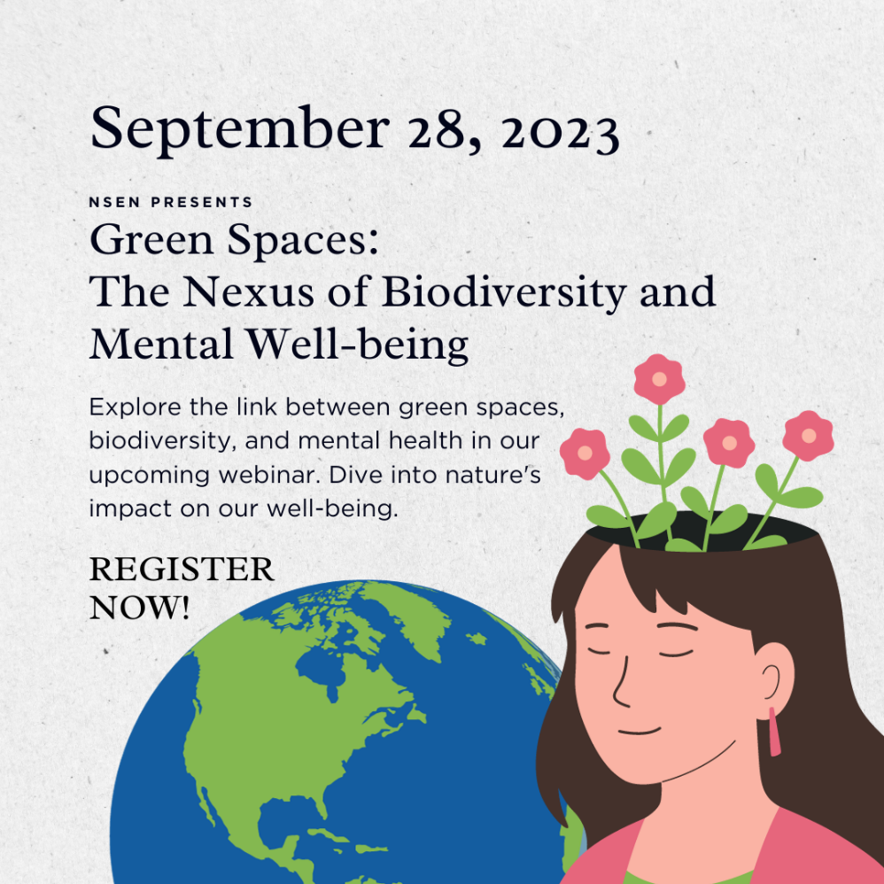
Register here:
https://nsenvironmentalnetwork.app.neoncrm.com/np/clients/nsenvironmentalnetwork/event.jsp?event=104&secureIdCustomer=1&

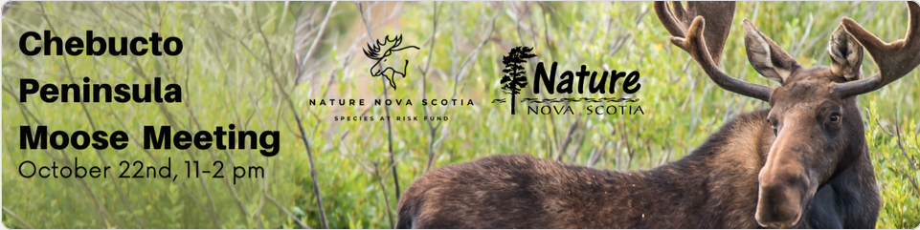

Join Nature Nova Scotia for an educational community event, the Chebucto Peninsula Moose Meeting. Nestled in the picturesque French Village, NS, this event is a celebration of nature and a platform to raise awareness about the vital importance of moose conservation. For more information and to register:
https://docs.google.com/forms/d/e/1FAIpQLSemTGBq0aIINZVPiLAUqyqI8J9N3bNfuE6VuPJNadaedsBh0A/viewform

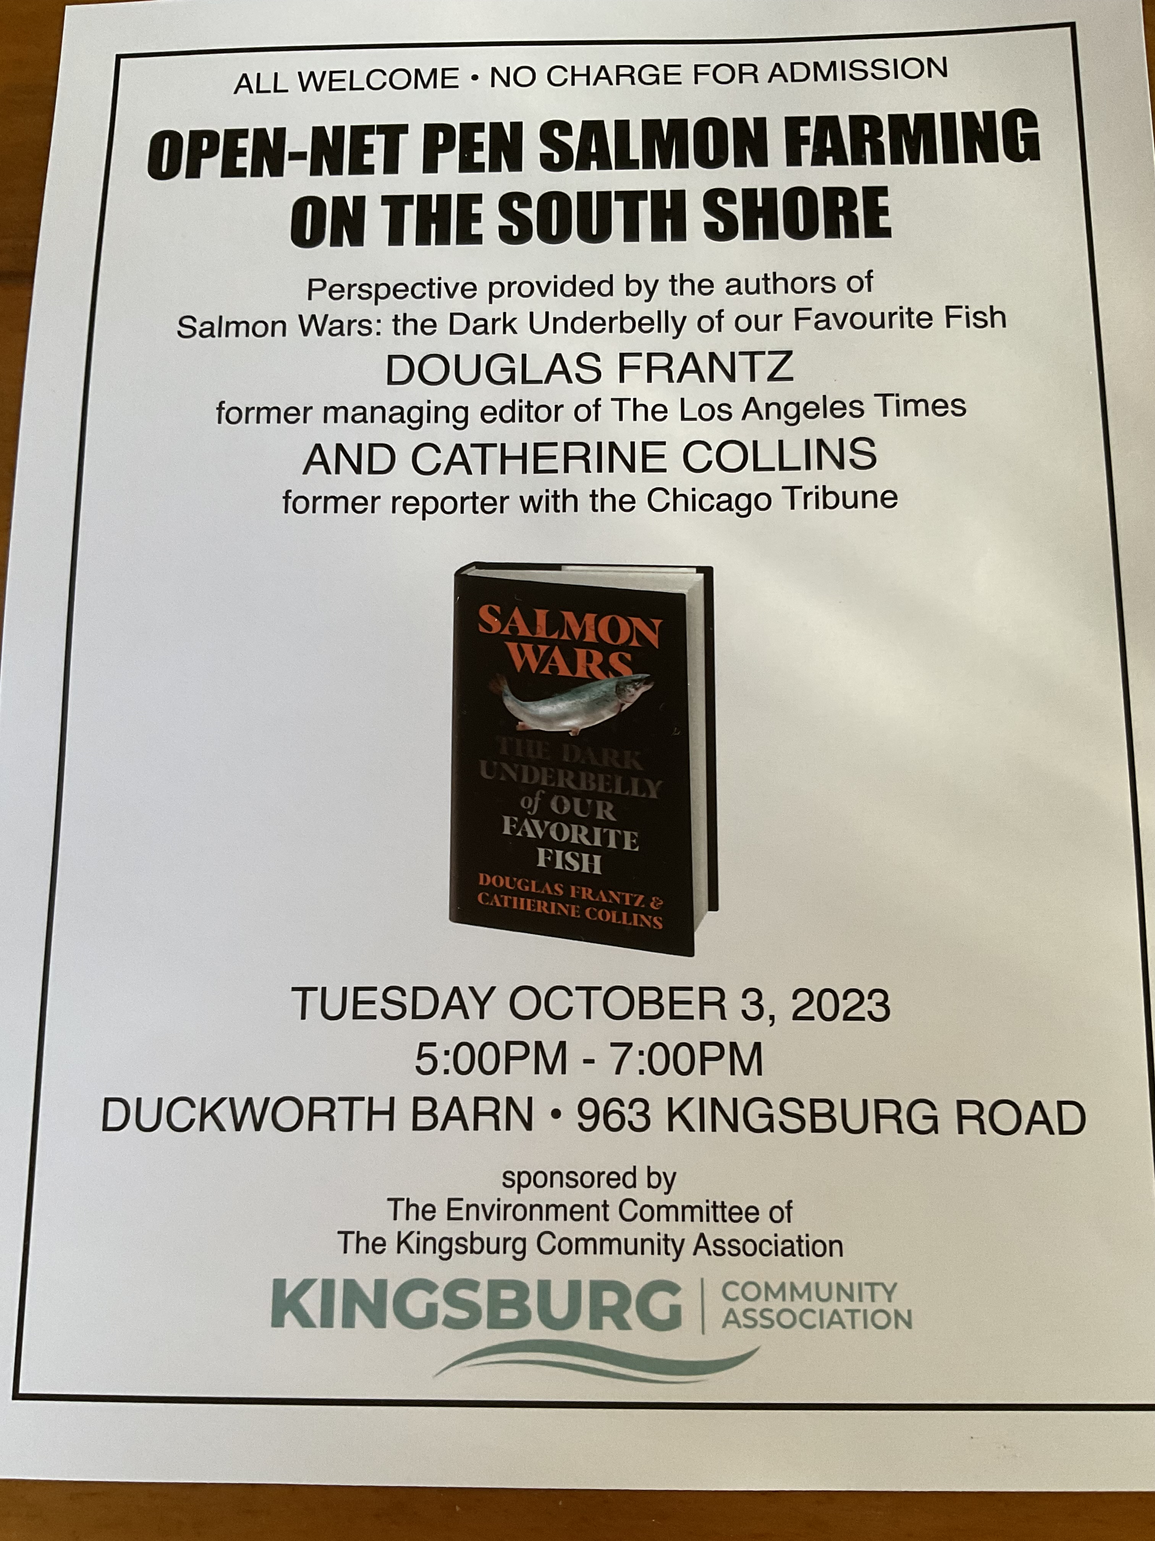  An invitation from the South Shore Council of Canadians:  Over the summer our chapter has worked with and supported community members to host events to discuss the issue of Open-Net Pen Salmon Farms. We are delighted that one of our supporters Diana Pepall is hosting an event at the Duckworth Barn in Kingsburg, , October 3, 5 to 7 pm, 963 Kingsburg  Everyone is welcome | 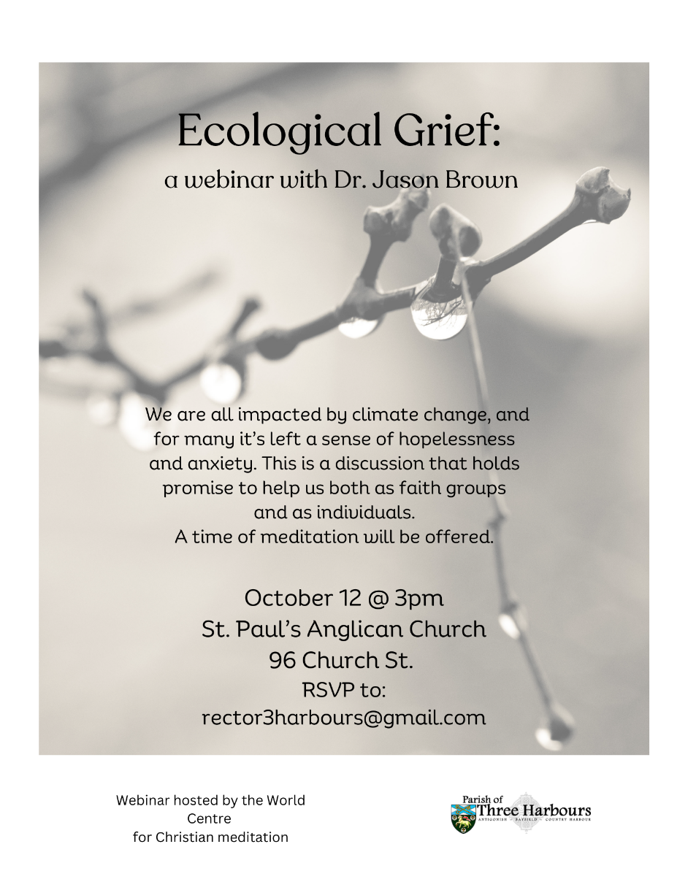

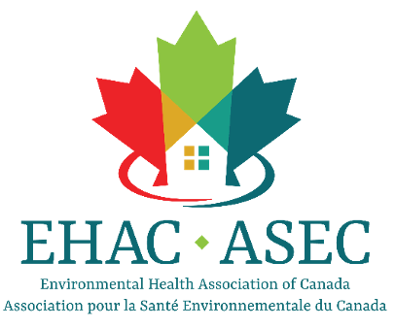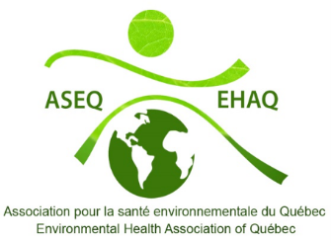
On behalf of the Environmental Health Association of Quebec (EHAQ), the Environmental Health Association of Canada (EHAC), the ARCH Disability Law Center, NB Lung, the Council of Canadians with Disabilities, and the Canadian Environmental Network (RCEN), we are pleased to invite you to attend our upcoming workshops on Multiple Chemical Sensitivities (MCS), as part of the 'Empowering Community and Removal of Barriers (ECRoB)' project. The ECRoB project, funded in part by the Government of Canada’s Social Development Partnerships Program – Disability, was created to educate and raise awareness on the disability of MCS.

How many Canadians are diagnosed with MCS
- Over 1.1 million
- 72% of whom are women
- Close to 50% are over 55
- One in 34 Canadians experience MCS (Statistics Canada, 2020).

Workshops for the legal community, civil society and people with MCS
Workshops Details:
*Nova Scotia: October 10, 2023 - 6:30 to 8:00 PM ADT
- New Brunswick: October 11, 2023 - 6:30 to 8:00 PM ADT
- Prince Edwards Island: October 18, 2023 - 6:30 to 8:00 PM ADT
- Newfoundland and Labrador: October 25, 2023 - 6:30 to 8:00 PM NT
For more information, email Anaïs Lemoine
Community and Outreach Coordinator Environmental Health Association of Canada Tel : 514.332.4320 |office@aseq-ehaq.ca

