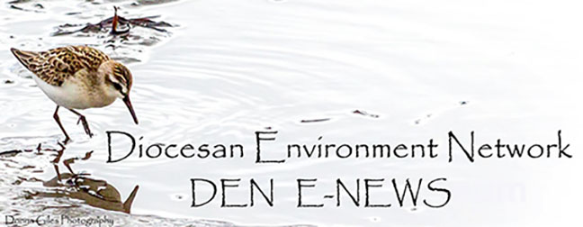
August 29. 2023
Facebook: https://www.facebook.com/groups/101542159983749
Did you know you can follow us on Facebook without having a Facebook account?
Website: https://www.nspeidiocese.ca/ministries/diocesan-environment-network

Email: endionspei@gmail.com

Lord, our world is on fire. Please wake us up to the urgent need to fulfill our baptismal covenant:
“To strive to safeguard the integrity of creation and sustain and renew the life of the earth”.
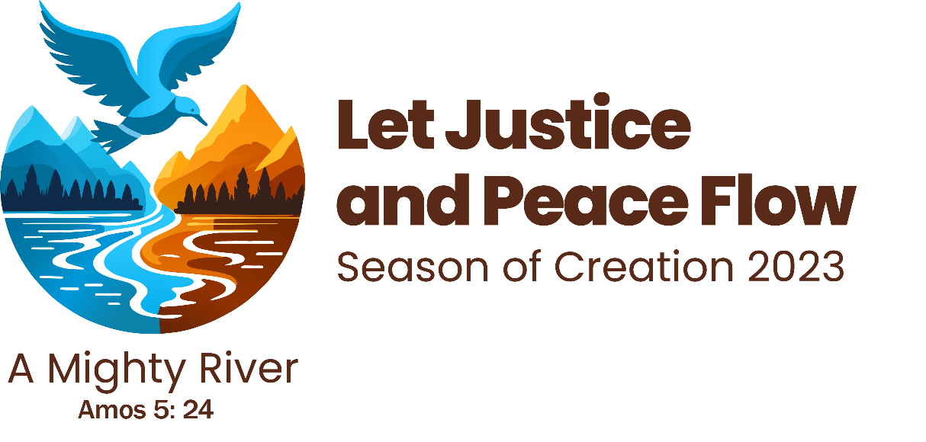
SIX DAYS UNTIL THE LAUNCH OF THE SEASON OF CREATION
Season of Creation 2023 has been launched: https://seasonofcreation.org/2023/03/03/we-are-launching-season-of-creation-2023-let-justice-and-peace-flow/
Anglican Communion: https://acen.anglicancommunion.org/
Episcopal Guide: https://acen.anglicancommunion.org/media/503311/ACEN_Season-Of-Creation-Episcopal-Liturgical-Guide-2023.pdf
Sunday School Guide: https://acen.anglicancommunion.org/media/503332/ACEN_Season-of-Creation_Sunday-School_Christian-Aid.pdf
Resource from For the Love of Creation:

Mennonite Prayer Series
Season of Creation: Year A - Let Justice Roll Down
To mark the Season of Creation, Mennonite Church Saskatchewan has prepared a series of prayers, fitting a theme in one of the passages in the Revised Common Lectionary for that day. Download the prayer series.
There are also PowerPoint slides that can be used to assist your congregation. The prayers
may be read in unison or by designated leaders. These resources will also be available on the Mennonite Church Saskatchewan website.

Are you ready to experience the Season of Creation? We are approaching the ecumenical season that invites us to contemplate God's creation as sisters and brothers, this year especially praying that "justice and peace may flow" like a "mighty river".

Participate in the Season of Creation opening prayer that will take place on September 1st, the day we celebrate the Feast of Creation:

Join on Zoom. To Register: https://us06web.zoom.us/webinar/register/WN_s6x-_ULjRZWRyzUYGNAhAg#/registration
Join on Youtube: https://www.youtube.com/watch?v=W--_icrnuBI

From the Ecology Action Centre Newsletter:
Global Youth Climate Strike - Sept. 15 at 12:30 p.m.
As the devastating effects of the fossil-fuelled climate crisis continue to play out across the country, it's more important than ever to come together, hold our leaders accountable and demand action for climate justice at all levels of government. The youth are calling for all of us to join them in the fifth global youth climate strike on Friday, Sept. 15, 2023. EAC is proud to stand in solidarity with the youth of School Strike 4 Climate Hfx and we hope you will join us! We will meet at Grande Parade/Halifax City Hall at 12:30 p.m. for opening remarks before marching through downtown Halifax and returning to City Hall for speeches.
We need your help to make this event powerful. Please take a moment to share the Facebook event with your friends and family. Let's make this huge: https://www.facebook.com/events/1000729997820728
If you have any questions or wish to be involved, email schoolstrike4climatehfx@gmail.com or message @schoolstrike4climatehfx on Instagram.

EV Boost is accepting Requests for Proposal (RFP) starting today, August 14, 2023.The EV Boost RFP Document and RFP Applicant's Template can be found on our website.
Timelines, important milestones, and other information can be found in the EV Boost RFP Document. If this is your third time applying, the format remains mostly the same. We will continue to accept applications via our online portal. The Long/Lat of the stations will now be included in your Applicant’s Template.

Any questions/inquiries about the RFP document are to be sent to this email address (evboost@cleanfoundation.ca). There is no deadline for our Q&A period – this is a rolling intake of applications. This means we will accept applications up until all funding is awarded.

Thank you for your interest in this program, we are looking forward to receiving your project application.

Best,
Julia Anctil (She/Her) Clean Transportation Program Coordinator www.cleanfoundation.ca

So much happening since this initiative was launched one year ago. To learn more:
https://www.communionforest.org/

https://www.communionforest.org/wp-content/uploads/2023/08/2023-Communion-Forest-First-Anniversary-Article.pdf

Register here:
8AM UTC(GMT) option: https://bit.ly/Treesandspirituality0800
4PM UTC(GMT) option: https://bit.ly/Treesandspirituality1600
Sandy Lake is worthy of preservation and protection of its 2800 acres of wildlife and aquatic habitat. The Ecology Action Centre tells us the “point of no return is quickly approaching for development of this area. HRM’s website lists it as shovel ready for spring 2024.”
For more: https://www.facebook.com/sandylakebedford

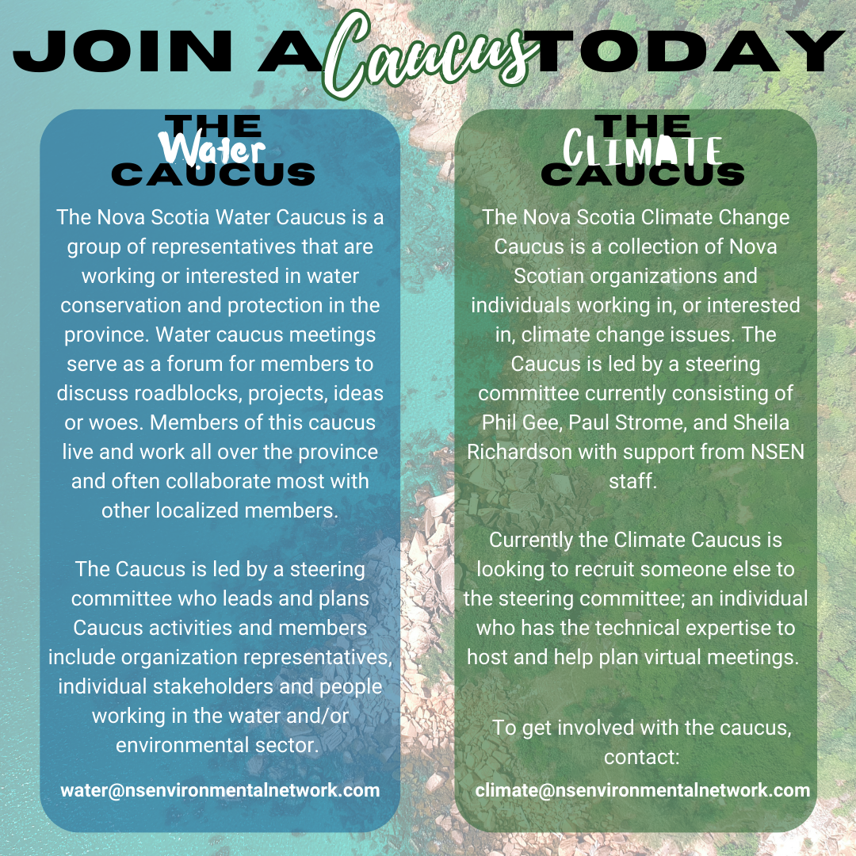

From the CPAWS NS Facebook page:
Great news! Archibald Lake Wilderness Area is now officially protected! This ecological hotspot in Guysborough County contains lots of old growth forest and rare species. Fieldwork led by CPAWS-NS over the past three years has identified 37 rare species, including seven that are listed under the Endangered Species Act. Thank you to the St. Mary’s River Association and local volunteers who worked so hard to make this new protected area possible. Read the full CPAWS-NS news release here: https://cpawsns.org/archibald-lake-wilderness-area.../

“Never doubt that a small group of thoughtful, committed citizens can change the world; indeed, it's the only thing that ever has.” Margaret Mead
Read all about Mary’s Garden in Grandma’s article below.
Have a parish garden? How is it growing? We’d love to be a link from you to other parishes in the diocese. Let’s encourage and be an inspiration to each other.
With thanks to our Advocacy Editors Eva Evans and Jesse Hamilton
Greenpeace Letter to Federal Leaders and Your MP Urging a Strong Cap on Emissions
This link takes you to a site which explains why Canada needs a strong cap on emissions and also answers many questions, for example what about jobs? what will be the effect on gas prices? what if I heat with oil or gas? It references the help low income Nova Scotians can get towards buying heat pumps. The letter to sign is at the end.

Polluting Pathways Alliance members must pay for damage caused by extreme weather (greenpeace.ca)
Fossil fuels are by far the largest contributor to global climate change, which is making extreme weather events worse. We know that while this industry is making record profits, the world faces record fires, massive floods, and killer heatwaves. Canada’s six largest oil sands producers, members of Pathways Alliance, collectively booked a record profit of over $35 billion in 2022. While our country burns, this damage and the toxic fire smoke ends up putting the health of millions of people at risk. Why is it ok for this industry to profit from causing such damage? Add your name in telling the polluting Pathways Alliance members that they are causing climate damage and need to be held accountable.

petition: Politicians Are Attacking the Endangered Species Act on Its 50th Anniversary (thepetitionsite.com)
The Endangered Species Act has helped save species from the brink of extinction, protected entire ecosystems from pollution or industrial development, and is responsible for many success stories. Anti-wildlife politicians are trying to gut the Act, despite the fact that - or perhaps because - it's one of the most important pieces of US environmental legislation. In one week alone, right-wing members of Congress proposed horrific changes such as slashing funding for the Act's enforcement by over $200 million, and removing and preventing protections for numerous species, including the beloved gray wolf. These dangerous proposals also include blocking programs that facilitate reintroduction of species to the wild. Biodiversity is disappearing at alarming rates; we cannot afford to back off from safeguarding vulnerable animals! Canadians can sign and tell Congress that the Endangered Species Act must be protected and strengthened, not weakened.

Environmental Defence Canada
The Great Lakes are a global treasure. Lake Erie is the shallowest of the five lakes and the smallest lake by volume, and yet it still provides a source of drinking water for around 11 million people. Climate change, invasive species, harmful chemicals, extensive loss of forest cover in the Lake Erie watershed, and coastal wetland degradation are all threats and dangers that impact the lake. One of the biggest issues affecting Lake Erie is too much phosphorus entering the watershed and making its way to the lake itself. This is mainly caused by runoff from farms during rains which spreads fertilizer and manure into streams. Lake Erie’s algae blooms are caused by this runoff pollution. The provincial and federal government have committed to reducing phosphorus levels by 40% by 2025, but how they plan to achieve this is still unclear. Let’s tell our government they need to take action and explain what's being done to protect Lake Erie.

Ban fossil fuel corporations from climate talks! (eko.org)
This summer has brought an overwhelming amount of climate chaos across our planet. The 7 hottest days in our civilization occurred this July. Heatwaves and records are still being made in many places. South America and Antarctica are suffering heatwave temperatures - in the middle of their winter. It's too hot. We all know that fossil fuels are to blame, yet reckless companies like Shell and BP are planning to send an army of lobbyists to hijack UN climate talks in November. They will stop at nothing to block meaningful climate action, all to protect their billion-dollar profits. However, it’s the UN in charge of these talks. This petition is showing support to Simon Stiell, a leader with the United Nations Framework Convention on Climate Change. He is from Grenada, a small Caribbean island whose people know first hand the threat posed by rising seas and more violent storms. Let’s support the UN in banning fossil fuel corporations from attending the upcoming climate talks in Dubai.

Dry August - Mary’s Garden
Mary is a new gardener but when it was suggested that there were extra garden boxes behind the Blandford Community Centre, she saw an opportunity. Why not grow cucumbers and make pickles to be used at the fund-raiser suppers put on by the Board of Directors of the Blandford Community Centre.
One day in June cucumber transplants appeared in a waist-high garden box.
As weeks went by those plants grew and grew. Mary checked on them but we didn’t need to water much this year. With tall boxes, the soil drained well preventing mold.
In mid-August, large beautiful cucumbers were ready to harvest. As a first-time pickle maker, Mary was a bit anxious as to how this would turn out.
Everything went well with the pickles but there was one slight problem; the garden still had many cucumbers.
Mary announced on the Blandford Facebook page that anyone was welcome to come get the cucumbers. I announced in church that Mary had opened her garden to all and I had plenty of lettuce if any wanted it.
I stopped by after church and picked two beautiful cukes for home. Cucumber sandwiches, German cucumber salad, or just plain sliced cukes.
At supper time I was thinking again about those cukes. Many were turning yellow but they could be made into mustard pickles. I went back to the community gardens to gather up at least seven so they wouldn’t be wasted. All that was left was ONE cucumber in the box.
I congratulated Mary on her garden and how all the cucumbers found homes. I mentioned that I had tucked the long trails of cucumber vines back in the box to keep them safe from frost. If she left them there maybe two weeks, she would have another crop. There were so many blossoms.
“More cucumbers!?!”, she said
I think, “Success!”
A Dry August?
“When I was young” (and I am not sure if I am a ‘grown-up’ yet), August was hot. It was spent picking blueberries and blackberries, making jam, and pickles. Mornings saw the big corn boiler full of forty 10-ounce cans of whatever was harvested from the garden the night before. By afternoon I just waited to see my buddy Darlene walking “through the land” to go swimming. Begging Mom, it took me 2 minutes to get in my swimsuit and catch up to Darlene before she got to the shore.
Those were hot Augusts when dug wells went dry but we used the rust-filled “artisan” well to keep the gardens going till harvest. Dad would pump saltwater into a puncheon and spread it on the cabbage crop
The hottest days arrived in full force and we almost waited eagerly for school.
Bounce ahead 50 years and there sits my water drip bottles.
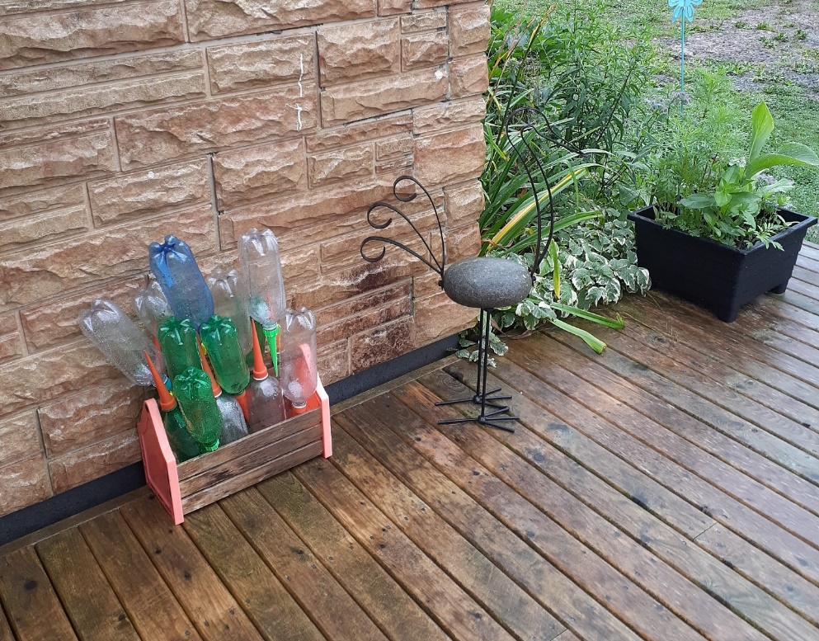
In May and early June, I used them to cox plants to grow in the heat. The rains came often by July that I pulled them all and sat them on the deck near the hose to wait for August. I even bought extra drip caps and saved plastic bottles to have a large amount of drip bottles.
PLEASE, use my picture and anything else of mine to convince people that climate change is REAL. Many still don’t believe it. Wildfires are just a fluke after the hurricane blew down the trees. Floods were just because we didn’t clean drains The constant rains are just an odd year.
In DEN we know better.
The one thing this year has taught me is that gardens need to be built high. In our waist-high community gardens, the plants grew so well. In ground-level gardens, they molded or otherwise died off.
This sure isn’t your regular dry August. I somehow don’t feel we will ever see that again.
Something to eat
Growing up we called this dish Dutch salad. It isn’t Dutch. When my ancestors came across the ship Ann in September 1750, they were German. They considered themselves Deutsch. To the English ear, that was Dutch. This simple salad was on the supper table every second day most summers.
So easy
Deutsch Cucumber Salad
Slice up a cucumber (or more) and a good-sized onion.
Sprinkle salt. Find a rock and place it in a cup or bowl on top of the cucumbers making a simple press. Set aside even overnight.
Drain off the excess water and add a spoonful or two of mayonnaise.
Put in the fridge till supper.

A Collect for Season of Creation
Source of all life, we give thanks to you for your wondrous creation made manifest in the environment that surrounds us; strengthen us in the mission of stewardship and care towards nature, the work of your hands, encouraging us to preserve life in all its precious forms. All this we ask through Jesus Christ, who lives and reigns with you, in the unity of the Holy Spirit, one God, now and forever. Amen. (Source: Rev. Luiz Coelho, Episcopal Church of Brazil, 2018).
https://www.ontario.anglican.ca/resources/worship-resources/pages/season-of-creation#:~:text=A%20Collect%20for%20Season%20of,in%20all%20its%20precious%20forms.

.

