

**August 15. 2023**

**Facebook:** **https://www.facebook.com/groups/101542159983749**

**Did you know you can follow us on Facebook without having a Facebook account?**

**Website:** **https://www.nspeidiocese.ca/ministries/diocesan-environment-network**

##### **Email:** **endionspei@gmail.com**

**Our Mission: “To strive to safeguard the integrity of creation and sustain and renew the life of the earth”.**



**Wetlands Appreciation Week – August 14 – 19.**

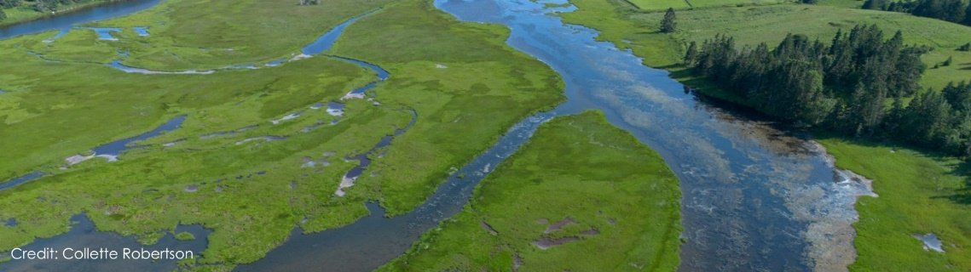  
Wetlands Appreciation Week will be taking place from Aug. 14- 19. This is a great opportunity to celebrate wetlands and reflect on their powerful climate change mitigation. Click on the link for a full schedule of events across the province. https://ecologyaction.ca/wetlands-appreciation-week?utm_source=civicrm&utm_medium=email&utm_campaign=waw_august2023

--------------------------------------------------------------------------------------------------------------------------------------------

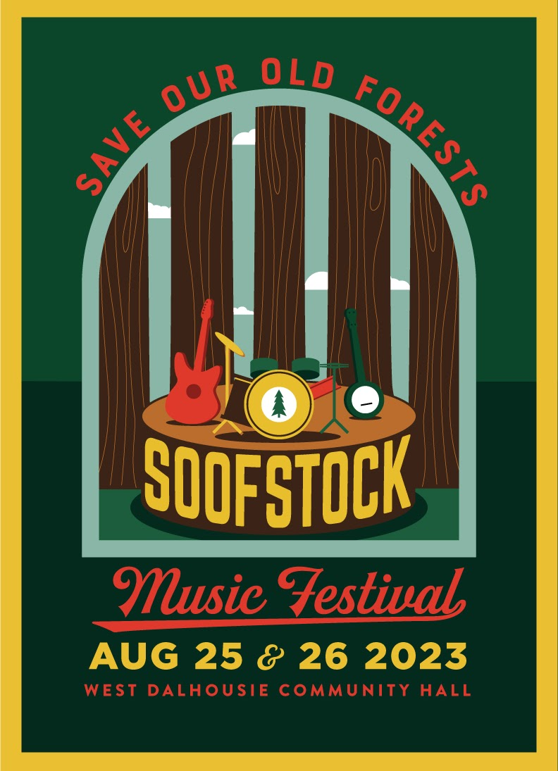

Click here for the story of the Arlington Forest Protection

https://www.arlingtonforestprotection.ca/afps-home/our-story

Click here for tickets to the Music Festival:

https://www.arlingtonforestprotection.ca/soof/SOOFstock

Why are they fundraising?

The government has made a legal commitment to protect 20% of Nova Scotia’s lands and waters by 2030. Fortunately, there is more than enough publicly owned land to do this and still have ample Crown land available for forestry and other uses. But the way things are going, the remaining old forests will be logged before they can be protected. This is why the SOOF campaign is asking our premier for a pause on logging and road-building in forests over 80 years old on Crown land until 20% of Nova Scotia has been protected.

For More information:

soof@arlingtonforestprotection.ca

**Aerial Spraying of Forests August 2023.**

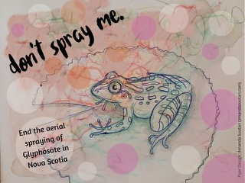

**The areas to be sprayed in Nova Scotia will soon be publicly announced by the** Nova Scotia Environment and Climate Change Department on their Pesticide Applications Approvals Page

**DON’T SPRAY NOVA SCOTIA FORESTS** is a rapidly expanding group of individuals who oppose the aerial spray of glyphosate in our local forests. There is convincing evidence that glyphosate and other ingredients in its various herbicide formulations, are highly toxic agents that are deadly to many organisms, harmful to ecosystems and threaten the biodiversity in our forests.  We are convinced that, with the support of Nova Scotian Environmental Non Government Organizations such as yours, we can encourage Municipal Councils to put pressure on the Houston government to finally put an end to this seriously harmful practice. The following letter outlines our position and we hope that you will sign on behalf of your group. TIME IS OF THE ESSENCE AND A PROMPT RESPONSE WOULD BE IMMENSELY APPRECIATED. Please consider signing and sending the letter attached to this enews to Minster Halman.

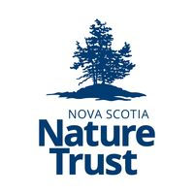

Learn more about their most ambitious effort yet to save Nova Scotia’s coastline and its islands:

https://nsnt.ca/

Follow them on Facebook:

https://www.facebook.com/novascotianaturetrust/

***Somethin’ Fishy’s Goin’ On***

***Somethin’ Fishy’s Goin’ On* will take place on Sunday, August 27th, from 2pm to 4pm at the Petite Riviere Fire Hall, 18 Petite Riviere Road, Petite Riviere.**

Many people think the struggle to stop open-net pen salmon farming ended a few years ago, when communities resisted and sent Cermaq packing. But the work to ensure our ocean is free from this polluting industry is far from over.

Recently, the provincial government announced that it is moving forward with a Classification System to designate areas of our coastline for sea cage salmon farming. While the government has instituted a moratorium on new applications until this classification system is in place, the moratorium does not apply to the 27 applications already submitted.

We feel that protecting our oceans from the impacts of feedlot salmon is too important to leave in the hands of industry and the government.  The damage caused by these salmon farms to our seaside environment, to the lobster fishery and other related fisheries, to our tourist industry and to the health of consumers is horrific.  We cannot allow this destruction to continue.

The South Shore Chapter of the Council of Canadians, supported by our allies in the Healthy Bays Network, is committed to holding community events to raise awareness and build resistance to this filthy industry that puts both human and environmental health at risk.

We are urging the Government to:

•         not approve any new leases, including no expansion of existing sites

•         follow a plan to get all existing pens out of the water.

For more information: southshore.coc@gmail.com



**Season of Creation 2023 has been launched:** https://seasonofcreation.org/2023/03/03/we-are-launching-season-of-creation-2023-let-justice-and-peace-flow/

**Celebration Guide** **https://drive.google.com/file/d/145WzDi32U8YdlyY9Peo1bn-aLqyi4cl6/view**



**With thanks to our Advocacy Editors Eva Evans and Jesse Hamilton**

**Stop Ecocide** This petition is collecting international support towards making ecocide an international crime. Ecocide is the mass damage and destruction of ecosystems, which has been committed repeatedly over decades and permitted by law, leading to global climate and ecological crisis. The Rome Statute of the International Criminal Court covers genocide, war crimes, and crimes against humanity. This framework provides a simple, effective deterrent for those in positions of responsibility and is enforceable within existing criminal justice systems. Including ecocide as a crime could create powerful change! This petition is remaining open. It will be used periodically both internationally and nationally to demonstrate to governments the level of civil support in making ecocide an international crime. This is a chance to give a voice to nature within international law, so please sign and share – the more signatures, the more pressure, the sooner it happens. https://www.stopecocide.earth/become

**Plastic in Grocery stores**

Most trips to the grocery store involve bringing home piles of unnecessary plastic packaging. It is close to impossible to avoid this in our food stores and much of it can not be recycled or reused. It’s no surprise that a survey of 54 large, high-traffic grocery stores across Canada, including Loblaws, Sobeys and Metro, found the majority of products on the shelves were packaged in plastic. Even the produce section has become a concerning source of single-use plastic waste. Plastic packaging is a major source of microplastic contamination, and it can contain harmful chemical additives such as bisphenols and phthalates. This petition is urging big grocery chains to phase out unnecessary single-use plastics and to instead scale up their reusable and refillable packaging systems. https://act.environmentaldefence.ca/page/125755/action/1

**Stop Approvals for New & Expanded Petrochemical/Plastic Facilities**

This petition is for the US President and officials, asking that they acknowledge the significant, harmful expansion of the petrochemical industry. This industry aims to increase North American plastics production by at least 35% by 2025. The new production of plastic resins and nurdles will be used to manufacture a ton of single-use items, such as food wrappers, packaging, shopping bags, and more. Petrochemical facilities continue to exacerbate the climate crisis, and while the production and refinement of plastics continue to harm frontline communities. Many of these communities have faced environmental racism for decades, if not centuries. This petition offers an exit from the pattern of hurting planet and people. It is asking Biden to stop approvals for new and expanded fossil-fueled petrochemical projects, and to stop locking our world into a dirty, unjust future that fuels the climate emergency. https://actionnetwork.org/petitions/stop-approvals-for-new-and-expanded-petrochemical-and-plastic-facilities?referrer=group-plasticpollutioncoalition&source=direct_link

**Please email the Paraguayan Authorities** The last uncontacted tribe in South America outside of the Amazon is holding out in an ever-shrinking island of forest. Bulldozers are closing in, clearing the land for cattle ranchers. The Ayoreo-Totobiegosode People have their home in the Gran Chaco, a biome that extends over Paraguay, Bolivia, Argentina, and Brazil. It is the second-largest forest in South America, and one of the most deforested areas on our planet. Every month, an area over 133 square miles is lost. The Ayoreo have fought a decades-long struggle to preserve their ancestral lands. Some have managed to remain uncontacted and they wish to remain that way in their forests. Well funded ranching operators are encroaching all around them, clearing forest, putting up cattle fences, and constructing huge reservoirs for livestock. The Inter-American Commission on Human Rights ordered Paraguay to protect the Ayoreo's land, but the core of this land is still in the hands of agribusiness companies. Please add your voice in telling Paraguay’s leadership to take immediate action to restore the land and to remove those who are destroying it. https://act.survivalinternational.org/page/102496/action/1

**Japan, Ban Elephant Ivory**

August 12th was World Elephant Day! Did you know elephants can communicate not only through trumpet sounds, scent, touch, and body language but through seismic signals - sounds that create vibrations in the ground which they may detect through their bones. These amazing creatures have faced many threats from humans. WWF says the greatest threat today is habitat loss and wildlife crime, primarily poaching for the illegal ivory trade. About a month ago, Canada introduced draft regulations to ban the sale and cross-border trade of elephant ivory. China made the historic ban of elephant ivory trade in 2017, and although there is still illegal trade it has significantly reduced ivory sales. This petition is asking Japan to do the same. As of early 2023, there were nearly 5,800 ivory retailers, wholesalers, and manufacturers registered with the Japanese government. This one country holds 31% of the world’s ivory stockpile. Send a message to the Japanese Ambassador to the United States, saying it’s time to finally ban cruel elephant ivory. https://actionnetwork.org/petitions/japan-its-time-to-finally-ban-cruel-elephant-ivory



**Vetiver Grass**

Did anyone else know about *Vetiver* Grass? I sure didn’t till recently. There is so much out there that could help us, and I had no idea it existed.

Vetiver grass is a “bunch” grass. Instead of the level height of individual pieces of grass, one against the other, this grass grows in a bunch or clump of grass up to five feet high. One clump isn’t far from the next but they are like individual families in a village.

It is not an invasive species. The grass does not have lateral shoots and does not spread naturally. You have to break up a clump into smaller clumps or roots and plant them. The roots can go down three meters.

Its oil repels insects. The grass smells like fresh hay and appears to reduce anxiety. It is an edible plant that is also used to flavor sherbet. It is even in canned asparagus.

The grass dots the land making large water runoffs slow down as it weaves around these clumps of grass in wetlands, conserving soil. When planted on the edges of terrace gardens, the grass holds the soil from erosion.

That simple long-rooted grasses protect the habitats. Nature-based solutions are the most affordable long-term solutions for climate change.

Does anyone in our readership have experience with vetiver grass? What other grasses might we be using here to do the same thing? Let us know so we can learn more together. claudiaazinck@gmail.com

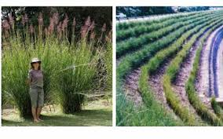

https://www.orchardofflavours.com/vetiver-a-miracle-grass

https://fleurluxesocialclub.com/pages/wholesale-preserved-roses

https://en.wikipedia.org/wiki/Chrysopogon_zizanioides

Once seeing one way to prevent erosion “in a far-off galaxy” I wanted to know what Nova Scotia and PEI are doing. For all I knew Vetiver grass could be common here. What else is being considered? I found an article over 150 pages long that is mainly a series of pictures with bullet point facts. It is an explosion of ideas without tiring your eyes from reading. Take a look at https://novascotia.ca/tran/works/enviroservices/ESCCourseMaterial/9_BMPs_for_Erosion_Protection.pdf

PEI is sort of the motherload of information on erosion, for very valid reasons. Their island is shrinking. So many ideas there but one thing I never thought of is the planting of a cover crop once the main harvest is finished. This prevents the wind from blowing the soil away. Simple and brilliant.

Want to learn more or protect your cottage? Like everything in PEI, there is a government agency to help you https://www.princeedwardisland.ca/en/information/environment-energy-and-climate-action/shoreline-stabilization

A great article on PEI erosion is https://www.cbc.ca/news/canada/prince-edward-island/pei-coasts-living-shorelines-erosion-1.6551344

I know this is but the very beginning of what we can learn about erosion, BUT, if you are reading this, then someone else just became a bit more aware. Have a great week folks.

**Update on Square foot garden.**

Some boxes didn’t grow anything and were re-seeded in cucumbers and a few spots are still empty. Here are my tallest tomatoes and my best beans so far. I need to learn more about this type of gardening. Like everything I have the info, now to find the time to study.

**Odds and Ends**

This isn’t my idea but it is so brilliant I had to put it in here. How many of us have a clothes hanger like this in our closet? How many of us have several balls of string and different gauge twine? I even have the eye screws and dowels. Now I need to make one for the hall closet, one for the shed, one for ….. Thank-you to https://contentinacottage.blogspot.com/2019/05/diy-twine-holder-from-wooden-hanger.html

I am unsure if anyone else does so, but I got a box of binder clips for my freezer items. I can never tie the half-bags of French fries, veggies, or fruit tight enough that they stay that way till I need them again. $3 of binder clips solved the problem.

Those without the proper heavy-duty plastic holder for spaghetti noodles will find they fit just as well in a Pringle container.

My favorite this week. I was complaining (yes, loudly) that I am getting rid of the last couple of blinds we have. They get so dusty and so long to clean each little layer. I was told to put small microfiber cloths on both sides of the kitchen tongs and wipe the blinds down. Still boring but so much faster.

**Something to Eat**

I feel I should apologize to any cook in the Cape Breton Region. Being retired I have started visiting the local Bookmobile. Although they carry many books, they offer a service where I can request books. Guess where the majority of my cookbooks come from? Yes, it is the Cape Breton Regional Library. My apologies for lowering the volume of books in your region; Eighteen (18) holds were waiting last Bookmobile Day and half of them were cookbooks from Cape Breton.

This week I made a soup on a bread day which paired so well.

Cabbage Soup (Vegetarian)

2 envelopes or 4 spoonfuls of chicken bouillion (or not if vegan).

1 can diced tomatoes

2 containers of broth (I used a quart of tomato juice and one broth)

Half a head of cabbage

1 cup celery if you have it

2-3 carrots peeled and sliced

1 onion

1 tsp oregano, basil, parsley, and black pepper

I put everything in a slow cooker for 4 hours. It is a thin soup so I add cornstarch and water, leaving the cooker on low for another half hour or so

Trying not to have leftovers I canned the leftover soup, 5 pints after we had our supper. Nana is still raving over this. It also took her sugar count down the next day.





DEN offers you the opportunity to pray with others for Creation. Join us Monday Evenings at 7 pm on zoom. Please email us for the link. **endionspei@gmail.com**

Walnuts 2023

.

|  |  |
| --- | --- |
|  |  |