August 01. 2023
Facebook: https://www.facebook.com/groups/101542159983749
Did you know you can follow us on Facebook without having a Facebook account?
Website: https://www.nspeidiocese.ca/ministries/diocesan-environment-network

Email: endionspei@gmail.com

Our Mission: “To strive to safeguard the integrity of creation and sustain and renew the life of the earth”.
Compassionate Lord, we pray for those who have been devastated by recent natural disasters. We remember those who have lost their lives so suddenly. We hold in our hearts the families forever changed by grief and loss. Bring them consolation and comfort. Surround them with our prayer for strength. Bless those who have survived and heal their memories of trauma and devastation. May they have the courage to face the long road of rebuilding ahead.
We ask your blessing on all those who have lost their homes, their livelihoods, their security and their hope. Bless the work of relief agencies and those proving emergency assistance. May their work be guided by the grace and strength that comes from You alone.
Help us to respond with generosity in prayer, in assistance, in aid to the best of our abilities. Keep our hearts focused on the needs of those affected, even after the crisis is over. We ask this in Jesus' name. Amen
https://www.xavier.edu/jesuitresource/online-resources/prayer-index/prayers-in-times-of-crisis/in-times-of-natural-disaster

DEN offers you the opportunity to pray with others for Creation. Join us Monday Evenings at 7 pm on zoom. Please email us for the link. endionspei@gmail.com

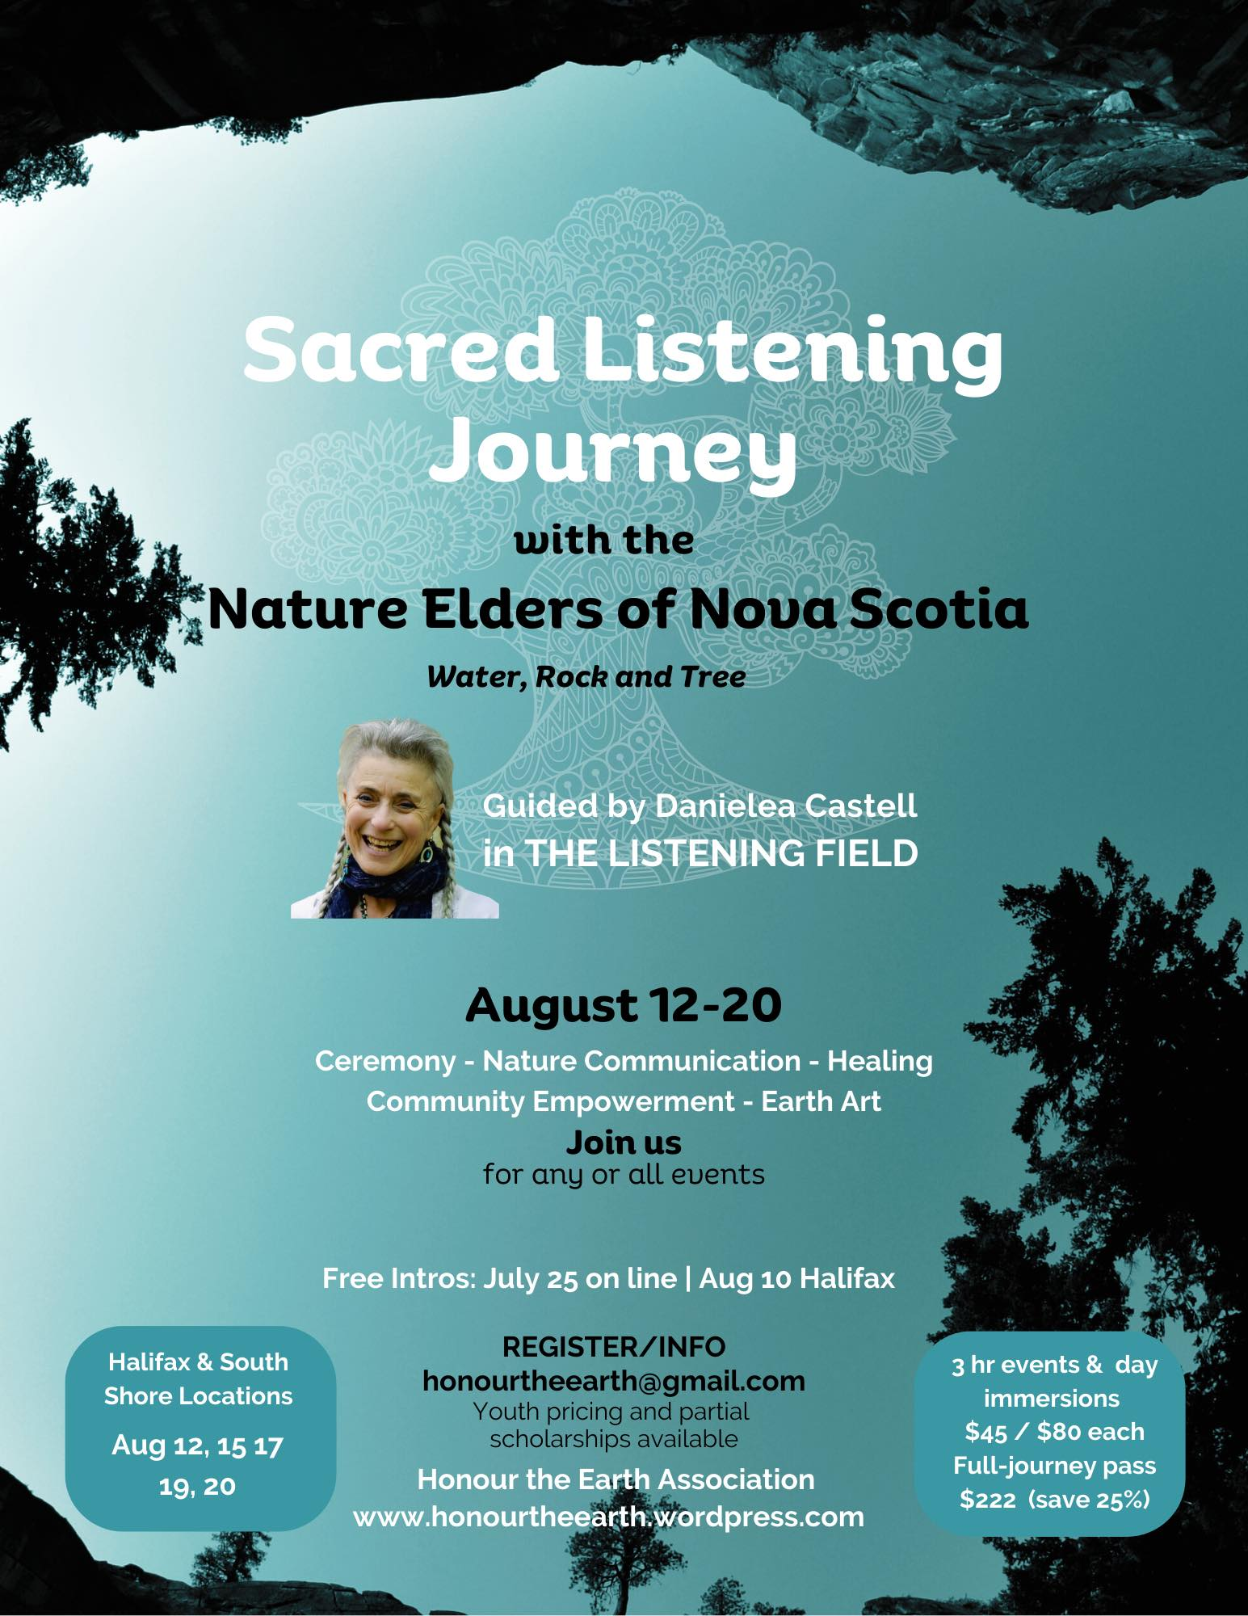

https://www.facebook.com/events/6365101246918914/?acontext=%7B%22ref%22%3A%2252%22%2C%22action_history%22%3A%22[%7B%5C%22surface%5C%22%3A%5C%22share_link%5C%22%2C%5C%22mechanism%5C%22%3A%5C%22share_link%5C%22%2C%5C%22extra_data%5C%22%3A%7B%5C%22invite_link_id%5C%22%3A1012273386879450%7D%7D]%22%7D

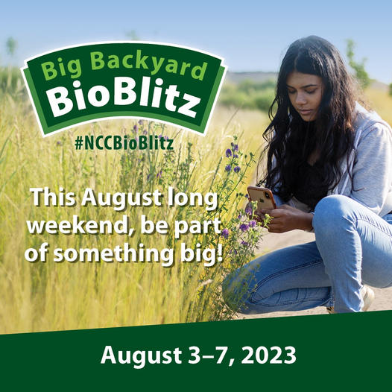
https://secure.natureconservancy.ca/site/SPageNavigator/BioBlitz_2023/BB_2023_landing.html?s_locale=en_CA&s_src=NAT_BIOBLITZ&s_subsrc=facebook_paid_en_static&utm_campaign=NAT_BIOBLITZ&utm_source=facebook&utm_medium=paid&utm_content=en_static&fbclid=IwAR0fKGtu_rFMbwQL2nRD-iuw-1MfwsRnmW-WoGZB2GofO6ndLCDo11xOLZk

Season of Creation 2023 has been launched: https://seasonofcreation.org/2023/03/03/we-are-launching-season-of-creation-2023-let-justice-and-peace-flow/
Celebration Guide https://drive.google.com/file/d/145WzDi32U8YdlyY9Peo1bn-aLqyi4cl6/view
What has your church planted this year? Please send us pics so we may share your Good News Greening Projects
News from around the global Anglican Communion can be found here https://mailchi.mp/e6a159804583/lambeth-conference-and-season-of-creation-5407086?e=0dd67e46dd
Of Particular Interest from this newsletter:

Re-imagining Our World Together: Contextual bible studies on the Anglican Marks of Mission and the Sustainable Development Goals
https://files.anglicanalliance.org/wp-content/uploads/2023/01/05100502/Re-imagining-our-World-Together-Contextual-Bible-Studies.pdf
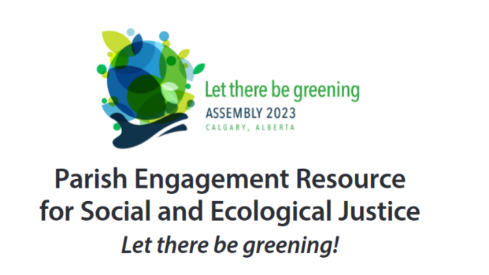
https://assembly.anglicanlutheran.ca/wp-content/uploads/Parish-Engagement-Resource-for-Social-and-Ecological-Justice_v2.pdf
Click on this link for articles on the Coastal Restoration Society, Back to the Sea Centre in Dartmouth, Guided Hikes with Hike NS, a new children’s book called “The magic of Greenleaf-Discovering Urban Green Spaces and the Mainland Moose Research Project.
https://api.neonemails.com/emails/content/KV3O9PEzm2K_DewxWhcr-y2jUxRp7VmKdTUV_X8m-Ps=
With thanks to our Advocacy Editors Eva Evans and Jesse Hamilton
Ecology Action Centre Petition for Sandy Lake

Sandy Lake and Sackville River form a popular nature space on the edge of Halifax's urban centre (home to an outstandingly biodiverse community of birds, bugs, flowers, mosses and more, all nestled among some of Nova Scotia’s last remaining old-growth forests.) But the provincial government’s Task Force on Housing in HRM picked the Sandy Lake – Sackville River area as one of its locations to fast-track for housing development, putting this unique and crucial ecosystem at risk. We still have time to come together and save Sandy Lake and Sackville River! HRM Councillors have recently shown an interest in keeping this important wild area safe, but their views were over-ridden by the provincial Task Force’s decision. Send a message to the provincial authorities who made this decision, AND who have the power to reverse it, and ask that the Sandy Lake “Special Planning Area” be removed from their housing development list in favour of a more suitable location. We must act to solve the housing crisis, but building lake-front properties in critical ecosystems is not the solution we need.

Nature Canada's Access for Information on Logging Industry Emissions Request
Nature Canada is submitting a formal Access to Information request to force the government to come clean on logging’s climate impact. The government's own data shows that logging is one of the highest emitting sectors in Canada. But they refuse to publicly state the true scale of emissions at the provincial and national levels. As a result,Canada has a 75-megatonne hole in its climate plan while our country’s greatest climate asset – its forests – are on fire and being clear cut at an alarming pace. Vast swathes of old-growth primary forest are burning, destroying habitat and releasing massive amounts of greenhouse gas emissions.

Petition to Tax Wealthy and Corporations to Save Lives and the Planet
Canadians for Tax Fairness have prepared a letter to our federal leaders: "Canada’s green investments should be funded by taxing big corporations and the wealthy who are responsible for nearly half of all emissions. Companies and their rich owners have profited from exploiting our earth and tax system. Their unjust profits and wealth should be redistributed to pay for a just, sustainable future. Without fair taxes, the burden will continue to fall on the vulnerable while leaving profitable polluters off the hook."

Avaaz Petition to Ban Shark Fin Trade
"Sharks have graced our planet for 450 million years and play an important role in ecosystems. Today, their numbers are dwindling rapidly, as a result of a sustained assault by profit-driven overfishing. Recently, Brazilian authorities seized fins from 10,000 of these majestic creatures -- many of them endangered. A disturbing loophole in Brazil's laws allows companies to make a fortune selling severed shark fins. So fishing fleets chasing massive profits pull in as many sharks as they can. The only way to save the sharks from slaughter is an absolute ban on the fin trade. And it can happen! The United States passed such a ban last year, followed by the UK this year. Now Brazil must urgently do the same. Brazilian lawmakers plan to hold a hearing in the coming weeks – but to move Congress to action we need to ignite a global outcry too loud to be ignored."

Greenpeace NZ Petition against Bottom Trawling
Right now the bottom trawling season is in full swing with trawlers dragging their heavy nets over biodiverse areas such as seamounts - home to coral forests and a vast array of marine life. The trawlers are out because it’s orange roughy breeding season and the deep water fish gather on seamounts to spawn. A new review from Fisheries New Zealand shows that orange roughy numbers are plummeting in certain areas, leading to serious sustainability concerns for the fish species.
Bottom trawling is a highly destructive fishing method that targets roughy while they are trying to breed. The Government needs to urgently act and ban bottom trawling from where it does the most damage.

Ecology Action Centre Statement on NS Flooding
As excess rain in recent weeks causes widespread flooding throughout the province, Nova Scotians are once again being called upon to pull together in the face of difficult times. ⁠These floods come on the heels of the worst wildfires Nova Scotia has ever seen, adding yet another unprecedented climate impact to a list that seems to grow with every month. ⁠ Our communities will do as we always do, and take care of one another. Now, more than ever, let's show compassion and empathy towards our neighbours. Reach out, check in, and offer a helping hand to those in need. ⁠The urgency of our situation is beyond clear. It is time for decision makers to end their political squabbling and do their part. We are calling on all levels of government to stop stalling and take the immediate and substantive actions needed to lower emissions, address the climate emergency and protect our communities. ⁠

Bioswales
The more I read, the more I study, it seems more and more people are doing the same thing and just calling them a different name.
In my course “Nature Based Solutions for Disaster ….” I came across the word Bioswales. They are these low-lying depressions in a vegetated area meant to hold excess rainwater till it can slowly soak into the ground. They keep the ground in place and prevent erosion and landslides.
The easiest example of a Bioswale is a ditch.
Rain falls and is diverted to the ditches on the sides of our roads.
They can also be a wet spot or a depression in a vegetated area where excess water can be held till it soaks into the ground.
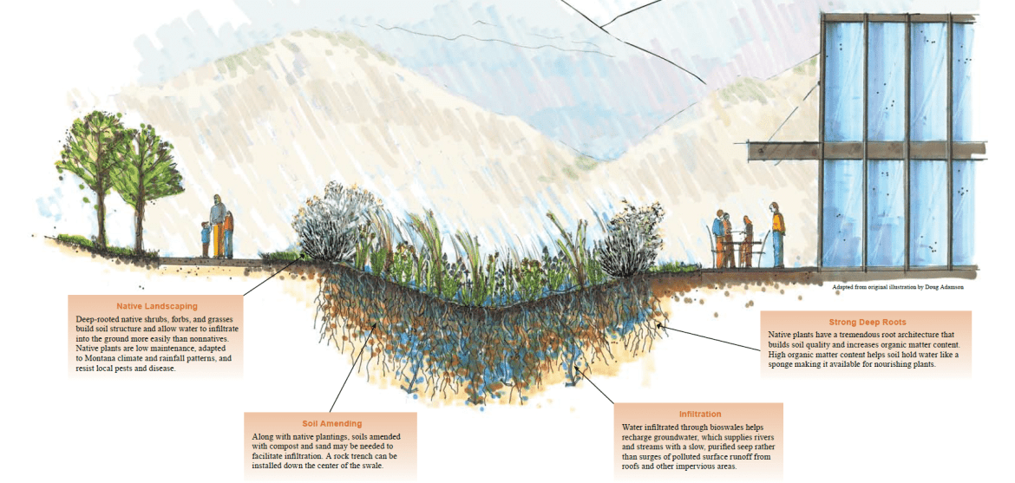
Bioswales are meant to be dry except when there is excess rainfall. They are sometimes called grassswales.
Some Bioswales have a runoff and are designed to catch pollution that is caught up in waterways and carried with the excess rainwater. Remember the Australian city of Kwinana? They put nets over their culverts that drained the excess water from their wetlands, catching pollution before it went to rivers and then the ocean.
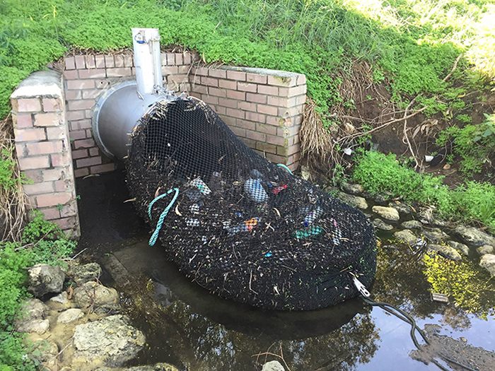
I realized that the half-moon garden is just another bioswale on a very small scale. It holds water and soaks it into the raised mound to keep the garden damp in dry spells. (I have never had plants grow so well as in that half-moon garden)
There even are clear directions on how to make a bioswale found in the reference below. A short description states: How To Build A Bioswale
- STEP 1: PICK YOUR SITE. A bioswale should be at least 10 feet away from your home, office, or any other structures. ...
- STEP 2: DETERMINE THE SIZE. Determining the size is one of the most important steps in creating your bioswale. ...
- STEP 3: DIG! ...
- STEP 4: SELECT YOUR PLANTS. ...
- STEP 5: SECURE THE SITE.
Whatever the name used, bioswales help with excess rainwater. Use native plants with deep roots and name your spot a Bee and Butterfly Flyway.

https://www.boredpanda.com/drainage-nets-catching-trash-kwinana-city/?utm_source=google&utm_medium=organic&utm_campaign=organic
https://theconstructor.org/water-resources/bioswale-design-applications-advantages/34380/
http://www.ppnenvironmental.com/build-bioswale/
Bird Bath
Pre-pandemic I purchased the largest bowl I had ever seen from a yard sale. I think it may have been a pasta serving bowl or maybe a fruit bowl for a table. Either way, it became my birdbath. A little fresh water every couple of days and a good-sized standing stone in the middle allows the birds to often come for drinks if not baths.

Odds and Ends 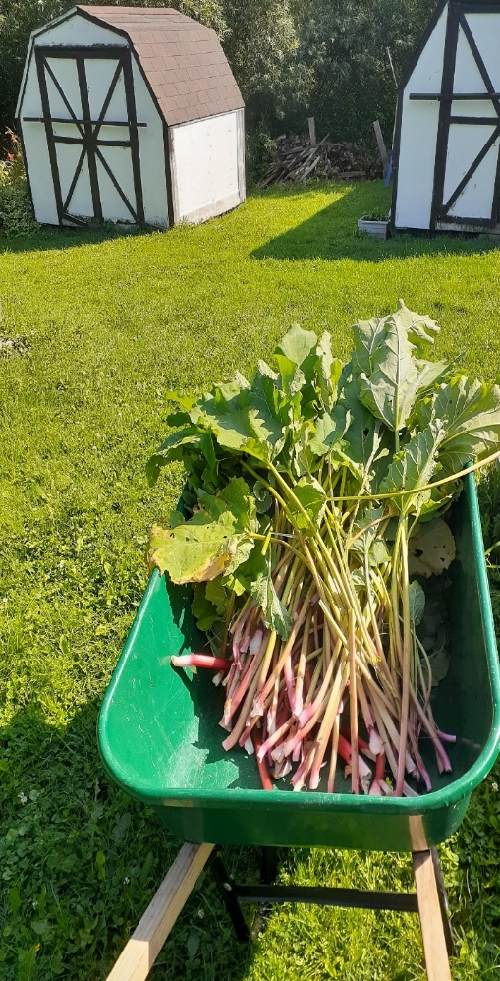 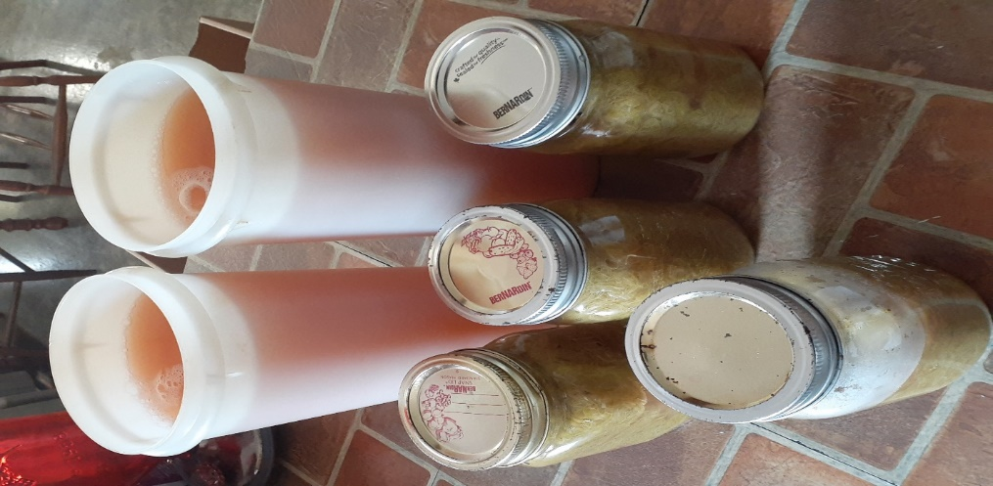
I harvested my second crop of rhubarb this week. It made another big pot full. I have learned to strain the rhubarb after boiling and add it back enough in bottles to make the preserves juicy. The rest of the water bcomes the best rhubarb juice.
A Small Cake – Join us in wishing Grandma a very Happy Birthday!!! Thank you Claudia for your dedication, your creativity and your commitment to creation.
The way the birthday celebrations went this year I wouldn’t have a cake on THE day. Grandma doesn’t like making her cake, but Nana was sure I needed one. I found the perfect one-pan cake in my food binders that suited the occasion. I used one-layer cake pan and it just fit right. Yes, Grandma loves sprinkles, rivers of sprinkles.
Lemon Butter cake
½ cup butter
½ cup sugar
2 eggs
1 tsp. lemon extract (or use vanilla but add lemon juice to the batter,1 tbsp)
1 cup flour
1 tsp. baking powder
Dash of salt (optional)
Cream the butter, eggs, and sugar, and add the rest of the ingredients. I find I need a splash of milk to make the batter look right. Bake 350 F for 20 minutes Use an 8 x 8 square pan or a round layer cake pan. 



