

**July 04. 2023**

**Facebook:** **https://www.facebook.com/groups/101542159983749**

**Website:** **https://www.nspeidiocese.ca/ministries/diocesan-environment-network**

##### **Email:** **endionspei@gmail.com**

**Our Mission:** “To strive to safeguard the integrity of creation and sustain and renew the life of the earth”.

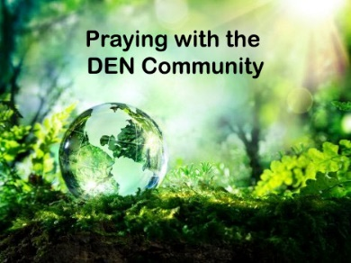DEN offers you the opportunity with others to pray for Creation. The time has changed and is now Monday Evenings at 7 pm on zoom. Please email us for the link. We hope to have you join us.



The DEN Enews will not publish next week, July 11th. See you on the 18th.



**Season of Creation 2023 has been launched:** https://seasonofcreation.org/2023/03/03/we-are-launching-season-of-creation-2023-let-justice-and-peace-flow/

**Celebration Guide** **https://drive.google.com/file/d/145WzDi32U8YdlyY9Peo1bn-aLqyi4cl6/view**

**There were problems with the Celebration Guide website but it appears to have been corrected.**



**Church of England to disinvest from fossil fuels this year**  
The Church of England Pensions Board said it had decided to divest its holding in Shell over what it said were insufficient plans to align its strategy to the goal of limiting global warming to 1.5 degrees Celsius.

Read in Reuters: https://apple.news/APZvWHurGQdmRms7SmJIlWg



From the Ecology Action Centre: "On July 1, 2023, the Federal Carbon Backstop (commonly referred to as the carbon tax) will come into effect in Nova Scotia. There’s been a lot of concerns and a great deal of misinformation surrounding the carbon tax, so we’ve put together this document covering some of the questions we’re seeing."

https://ecologyaction.ca/sites/default/files/2023-06/Carbon_tax_FAQ_2023.pdf







With thanks to Al Knox from the Collieries Parish:

Want a greenhouse? It’s possible to build your own with salvaged materials. With repurposing in mind, Al sourced used windows and created a 5’ x 7’ greenhouse for approx. $53 for some 2x4’s, screws and nails.

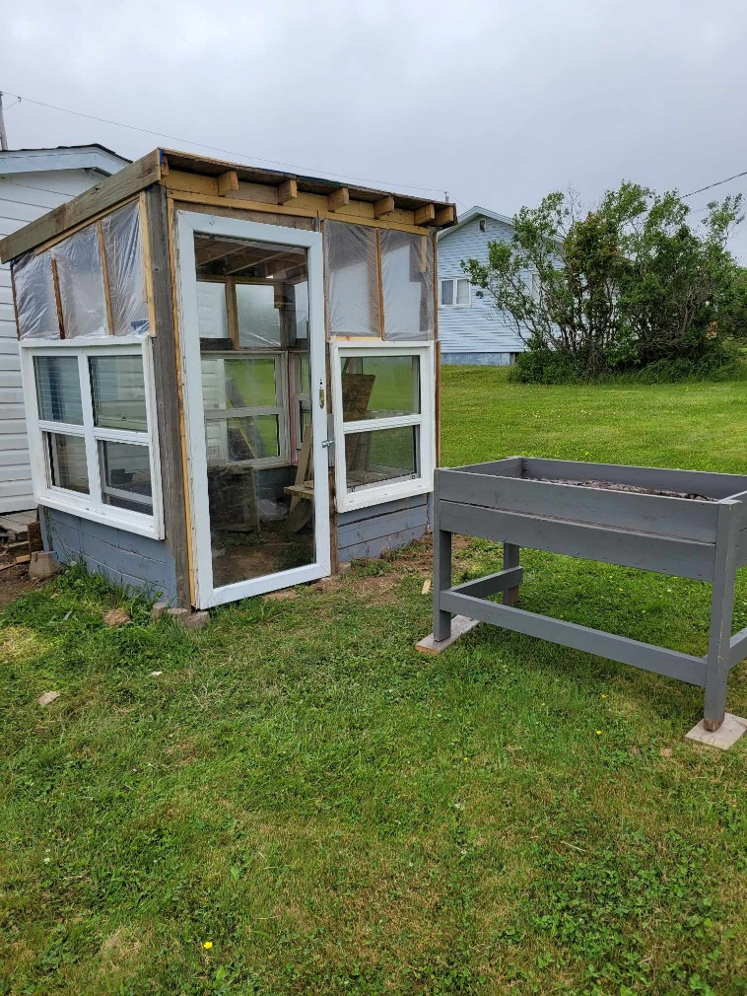

Words of wisdom from Al: *another one I discovered this day. Seems the crows like sprouting beans whether they like them or mistake then for worms in the earth. I found some old decorating flags, cut the cloth in strips and placed the flags around the bean plot. Appears they are not liking their movement and have not returned. One that I have read regarding organic fertilizer…. Banana peels left to soak in water makes an easy to use potassium rich fertilizer for cukes, tomatoes and peppers to name a few. Let the peels soak for a day or two and use. The leftover peel can go the soil or compost.*



**The Canadian Centre for Policy Alternatives-Nova Scotia and The Council of Canadians invite you to the launch of the recently released book,**

**The End of This World: Climate Justice in So-Called Canada**

Co-author, Emily Eaton, will discuss the book and be in conversation with local community leaders, water protector Michelle Paul and Council of Canadians co-executive director, Robin Tress.

 "Compelling roadmap to a livable future, where Indigenous sovereignty and climate justice go hand in hand. Together, the authors envision a near future where oil and gas stay in the ground; where a caring economy provides social supports for all; where wealth is redistributed from the bloated billionaire class; and where stolen land is rightfully reclaimed under the jurisdiction and sovereignty of Indigenous peoples."

**Date:** Join us Thursday, July 13th  
**Time:** 6:30 pm ADT  
**Location:** Glitter Bean Cafe, 5896 Spring Garden Rd, Halifax, NS

Accessibility information: Glitter Bean café has a wheelchair accessible entrance through the ramp on the patio.

https://www.facebook.com/events/287218577221926



**Petition for An Uncontacted Tribe in the Amazon**

In the Brazilian Amazon, the uncontacted Kawahiva Indigenous people are fighting for their survival. Invasions force the tribe to live on the run, fleeing violence from loggers and ranchers. Attacks and disease have killed their relatives. These are the Last of the Kawahiva, and their genocide will be complete unless their land is protected. In 2016, following pressure from thousands of supporters around the world, the Justice Ministry took a very important step and declared the Kawahiva’s forest an Indigenous Territory. But the land demarcation process has since been paralyzed following fierce opposition by politicians and agribusiness. President Lula has now committed to fully mapping out and protecting all Indigenous territories in the country. Let’s hold him to his promise – for the survival of the Kawahiva and all the uncontacted tribes in Brazil. **Please email the Brazilian President and key government officials now.**

**Take Action (ecojustice.ca)**

Wildfire smoke, like climate change, knows no borders. Canada's worst fire season on record continues to cause immense and wide-spread damage and harm.  Climate change, as a result of burning coal, oil, and gas, has created what experts call “supercharged” wildfire seasons. Firefighters have been bravely battling wildfires and doing everything they can to protect us and the places we love. Political leaders need to do the same, and we can help push them to act. This petition is asking for 3 things: to stop approving new fossil fuel projects,ban thermal coal exports immediately, and regulate our financial industry to stop billions from being poured into oil, gas, and coal developments. Ask your MP to protect our country and the places we love, by doing what they can towards action that protects our environment, health, home, and future.

**Write to the banks, tell them not to finance the East African Crude Oil Pipeline — #StopEACOP**

Should we be building the world’s longest heated crude oil pipeline in the midst of a climate emergency? French oil company Total and the China National Offshore Oil Corporation seem to think so. The East African Crude Oil Pipeline (EACOP) is massive and would rip through the heart of Africa – displacing communities, endangering wildlife, and fueling climate change. There are local protests and more than 260 organizations urgently trying to convince banks to stop support of this disastrous project. A $2.5 billion loan is needed to construct the pipeline. Send an email to the 5 banks most likely to consider financing it, telling them not to fund the EACOP!

**Defend 80% of the Amazon by 2025 | Amazon Watch**

80×2025 is the urgent call for a global pact to permanently protect 80% of the Amazon by 2025. By taking this action, we could avert an imminent Amazon tipping point and help address the planetary climate crisis. Indigenous Peoples of the Amazon Basin have lived in balance with the Amazon for centuries. Our collective future may depend on our ability to listen to the voices on the frontlines and to those with ancestral knowledge. Join this global push to make sure the needed balance is maintained and at least 80% of the Amazon remains protected. This petition also comes with a 2-minute video.

**Sign now: Tell RBC to stop funding climate destruction and respect Indigenous rights (stand.earth)**

The Royal Bank of Canada is the largest fossil fuel funder in the world. In 2022, they financed US$42.1 billion in fossil fuel projects. This includes new tar sand pipeline projects that infringe on the rights of Indigenous Peoples, funding the fracked gas Coastal GasLink pipeline, financing gas projects on the Gulf Coast that pollute the air of predominantly communities of color, and much, much more. RBC is threatening the planet and harming communities. This petition is demanding divestment from fossil fuels, and for RBC to start taking climate change and Indigenous rights seriously.



**My First Environment Worry** Grandma has always loved the outdoors. Being a Girl Guide in my teens added to the sense of looking after the environment. In the 70’s I would have been called a “tree hugger”. When the environmental concerns came along I organized community recycling programs, bottle drives, and even planting nights.

The story that changed my environmental life and has me supporting ANY environment program was the story about the Aral Sea.

It goes like this.

Once upon a time, there was the third largest inland lake in the world called the Aral Sea located just down from the Ukraine, part of it is in Northern Iran, and east of Turkey. China is just to the East.

This was a freshwater lake. It had a large fishing industry using large trawlers like you see around here.

Next door was China’s biggest agricultural land. It is like having Alberta, Saskatchewan, Manitoba, AND Ontario all together on a flat agricultural land. China needed to feed a growing population. Crops need water. To speed up growth, an irrigation system was installed for the *ENTIRE* China Basin. Guess where the water came from?

You guessed it, the Aral Sea.

The Aral Sea was so big and so deep and so wide that a little thing like irrigating a space the size of four big Canadian provinces couldn’t do much harm, right?

The pictures below give an idea. The first is a series of photos showing the Aral Sea drying up as years pass by. The next is showing a herd of camels using the sides of abandoned trawler for shade from the hot desert sun

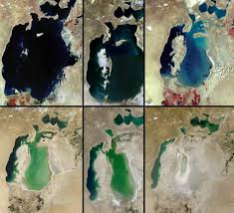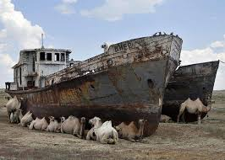

I see it as if the Atlantic dried up and we could walk to Sable Island. Only thing is that Sable Island would be a mountain like the one that showed up as the Aral Sea dried up.

I know. We have oceans rising, not drying up. These were fishing villages and I live in a fishing village so I just see it as if our trawlers were on a desert ocean floor.

That story shocked me, and darn near stopped me in my tracks for a bit.

Just think about how it changed life for the people living there.

These photos don’t show one thing. Before they started draining the sea there was a greenbelt around the lake. That is gone now.

A people’s entire livelihood is gone. Green turned back to the desert. People migrating out. Population increasing in other areas. Overcrowding. Food Shortages. Turning a place with economic prosperity into despair.

This was a MAN MADE problem. There were so many other ways this could have been done and caused so much less harm, OR, it could have been left alone.

There are other similar stories. One has a good ending. You may remember Lake Oroville in California.

Here are the before and after pictures there The good part of this story is that it has come back.

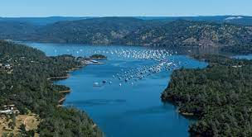

Oroville Lake is a man-made reservoir with a dam that has prevented floods in California when the Feather River overflows.

The reservoir dried up during the California drought. The rains have come back and the reservoir is filling again

See all those boats in the second picture. They all were pulled out before they sat on the dried river floor. I live near Yacht Clubs so I feel what problems this caused.

I am so glad to see water naturally flowing there. Climate change may have caused the drought but Mother Nature is bringing it back.

Want another example? Look up the Salton Sea in California for a similar tale. The list goes on.

The more any one of us grows even a single bean plant in a pot by our door or on our balcony, helps. Making a fog catcher, using your basement dehydrator water, or a tarp dew collector to water that bean plant is a help. Cooking one pot of fresh beans a year is a help. Baby steps grow into bigger ideas.

**Using up topsoil**

All my life I have drug home bags of Black Earth from stores and added them to my gardens. I emptied the compost bins and added that soil to my boxes.

Needing higher boxes, this year I ordered a dump truck load of topsoil.

With all the original garden boxes topped up, I still have about a third of the soil left. Now it is time to play.

I have filled big containers I had saved and just planted flower seeds after placing these giants around the yard.

Heavy cardboard boxes are being used to fill with soil next to outbuildings. The cardboard will degrade and leave me with a plain garden next year.

I found a wooden box that started as a fish box, was a woodbox at one time, and sat in the shed for years. The paint is starting to wear off just the way the gardening magazines like to show containers. That white wash look. It is wedged between two trees. I look forward to cucumbers hanging off the sides later

Trees are having cardboard laid down around the base and covered with topsoil. I haven’t decided if I will find shade-friendly plants to put there or cover with mulch.

It has been too dry at first and then too cold for the plants on my part of the South Shore for plants to come up well. I walked Jazz this morning and I think everything I planted has popped up after this rain. What I transplanted looks so healthy.

Oh, in case any of you are having trouble getting cornmeal to get rid of slugs. If you don’t want to waste a beer to get rid of them, I am told they like oatmeal just as well as cornmeal and it kills them just as well.

Any other ideas for using up topsoil besides adding another row of boards to my garden boxes which may happen in the fall, let me know. Happy Gardening.

**Kid Friendly recipes**

**Peanut Butter and Granola wraps**

Just as they sound. I get mini wraps and even when Ben was 4 years old he could butter them and sprinkle granola on the wraps. Roll them up and I get them to add one of those toothpicks with the cellophane on one end to look fancy.

Now to put away for lunch, I get them to make **ham and cheese wraps**. Cutting them smaller with a lettuce knife was such a treat when they were little but I see my teenage grandbabies still using the lettuce knife to cut wraps.

**Breakfast Parfait**

I get out fancy glasses that work to eat a dessert. The night before I lay out granola, usually berries and yogurt. They mix up what they want in a bowl. Then pick a glass and spoon in the mixture. My old punch cups seem to be a favorite. Cover and put in the fridge. If they come in the house before Grandma is up they can grab their breakfast.

**Snack mix**

Usually, a Friday Night job is making the snack mix. Peanuts, almonds, cheerios, those little goldfish, raisins, maybe small crackers, and if I am running low a few gumdrops or caramel or lemon chip drops. We have a good size, easy to get a hand into, jar, where the mixture is kept for when tummies get hungry during the weekend.

**Marshmallow sticks**

If it is a rainy weekend, make marshmallow sticks. Melt some chocolate. Put a stick in a big marshmallow and swipe it in the chocolate. While still warm add sprinkles. Sprinkles make everything great. Lay them on a parchment-covered tray while you make more.

Just have a fun summer no matter what you do. Being together is the prize.

|  |  |
| --- | --- |
|  |  |

**Gracious God, Creator of All, we raise our hearts in grateful praise for all the beauty that surrounds us.  May we learn to respect all as a sacred gift and do what we can to repair the damage we have caused through our consumerism, greed, and carelessness.  Grant us an ecological conversion so that we can leave our next generation with a future full of hope where there is enough for all.  We ask this in the name of Jesus. Amen.**

https://rscjinternational.org/news/prayer-climate-justice