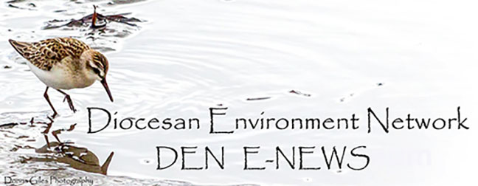
June 20. 2023
Facebook: https://www.facebook.com/groups/101542159983749
Website: https://www.nspeidiocese.ca/ministries/diocesan-environment-network

Email: endionspei@gmail.com
Our Mission: “To strive to safeguard the integrity of creation and sustain and renew the life of the earth”.

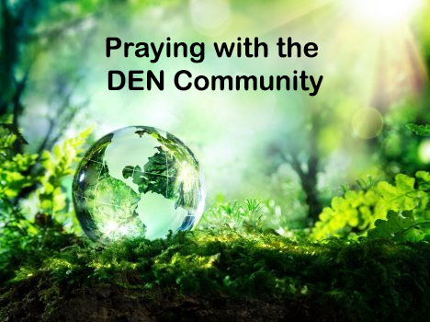
DEN offers you the opportunity with others to pray for Creation. The time has changed and is now Monday Evenings at 7 pm on zoom. Please email us for the link. We hope to have you join us.
Season of Creation 2023 has been launched: https://seasonofcreation.org/2023/03/03/we-are-launching-season-of-creation-2023-let-justice-and-peace-flow/
Celebration Guide : https://drive.google.com/file/d/1SuaxcpQXN5rlDvZFPawoCbMCTyJ7gFmW/view
NSEN announces the launch of their new documentary.
To read more: https://api.neonemails.com/emails/content/AiulccTN8BMoYg9LKwAN0kbCA7cVSOr0wq4884a0ph0=

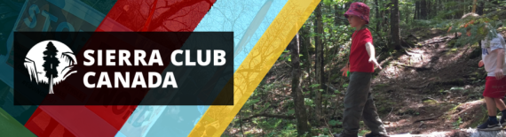
From their newsletter: Lindsay Lee, one of our activists in Nova Scotia who was forced to evacuate as a result of the fires, has been drawing attention in the news to the connections between the fires and climate change and how we can take action locally, nationally, and internationally.
Read more here:
https://www.cbc.ca/news/canada/nova-scotia/climate-change-n-s-wildfires-ecologists-climate-activists-tantallon-bedford-1.6861771?fbclid=IwAR3_udwvgozqxM0Z9Uq68FMVVg_7vcI49lF1y5R6slhSW4Xezacdg2UQ_qA
Missed The Ocean Day Celebration. Catch it on Youtube:
https://www.youtube.com/watch?v=-dTe0eRAlMY
𝗖𝗔𝗟𝗟 𝗧𝗢 𝗔𝗖𝗧𝗜𝗢𝗡 - 𝗛𝗘𝗟𝗣 𝗡𝗘𝗘𝗗𝗘𝗗 - 𝗣𝗟𝗘𝗔𝗦𝗘 𝗦𝗛𝗔𝗥𝗘!
The receipt of our Ministerial Appeal has been acknowledged and we are promised a written decision by August 8. We need as many people as possible to send letters supporting the appeal to Environment Minister Tim Halman!
𝗙𝗔𝗤𝘀 & 𝗛𝗢𝗪 𝗧𝗢 𝗛𝗘𝗟𝗣 𝗧𝗢𝗢𝗟𝗞𝗜𝗧:
The attached one-pager outlines some of the most recent goings on re: the Arlington Heights dump issue. There are instructions on how to send a letter along with several other ways to support our advocacy efforts. Please take a minute to write your letter today, and don't forget to include your personal testimony!
Have questions? Get in touch!
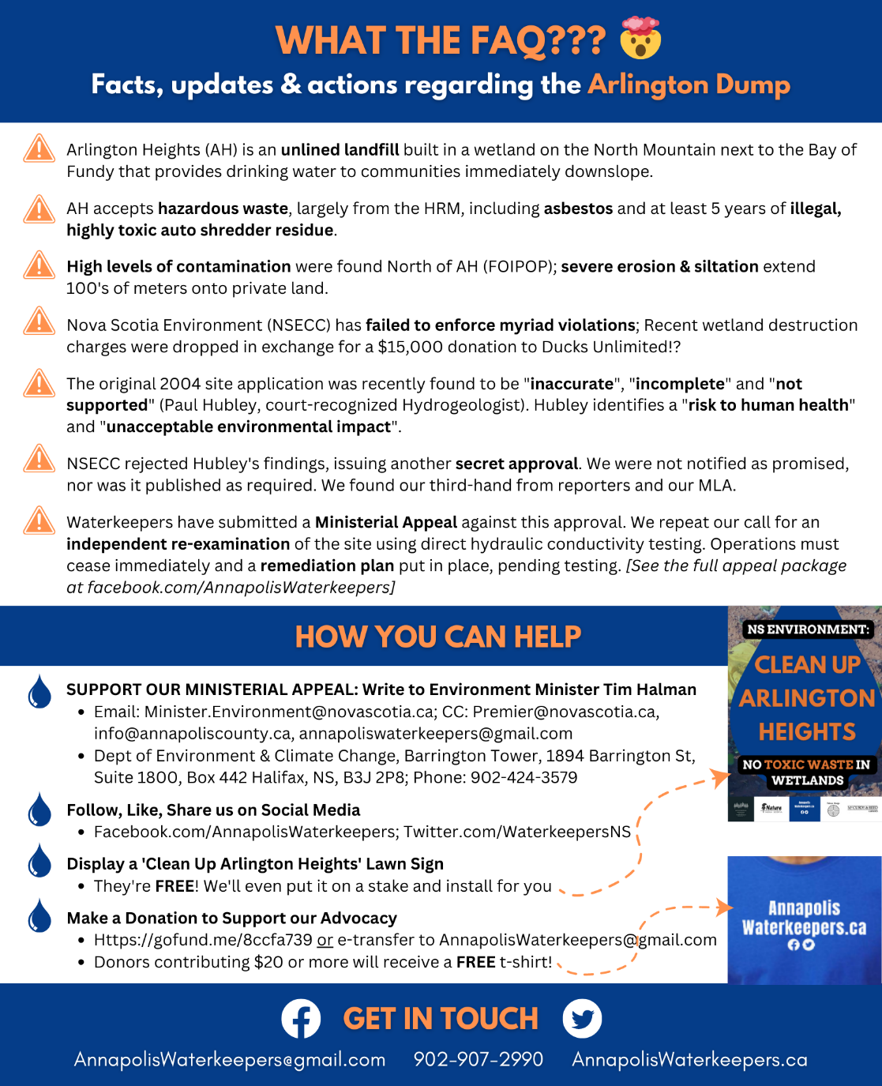
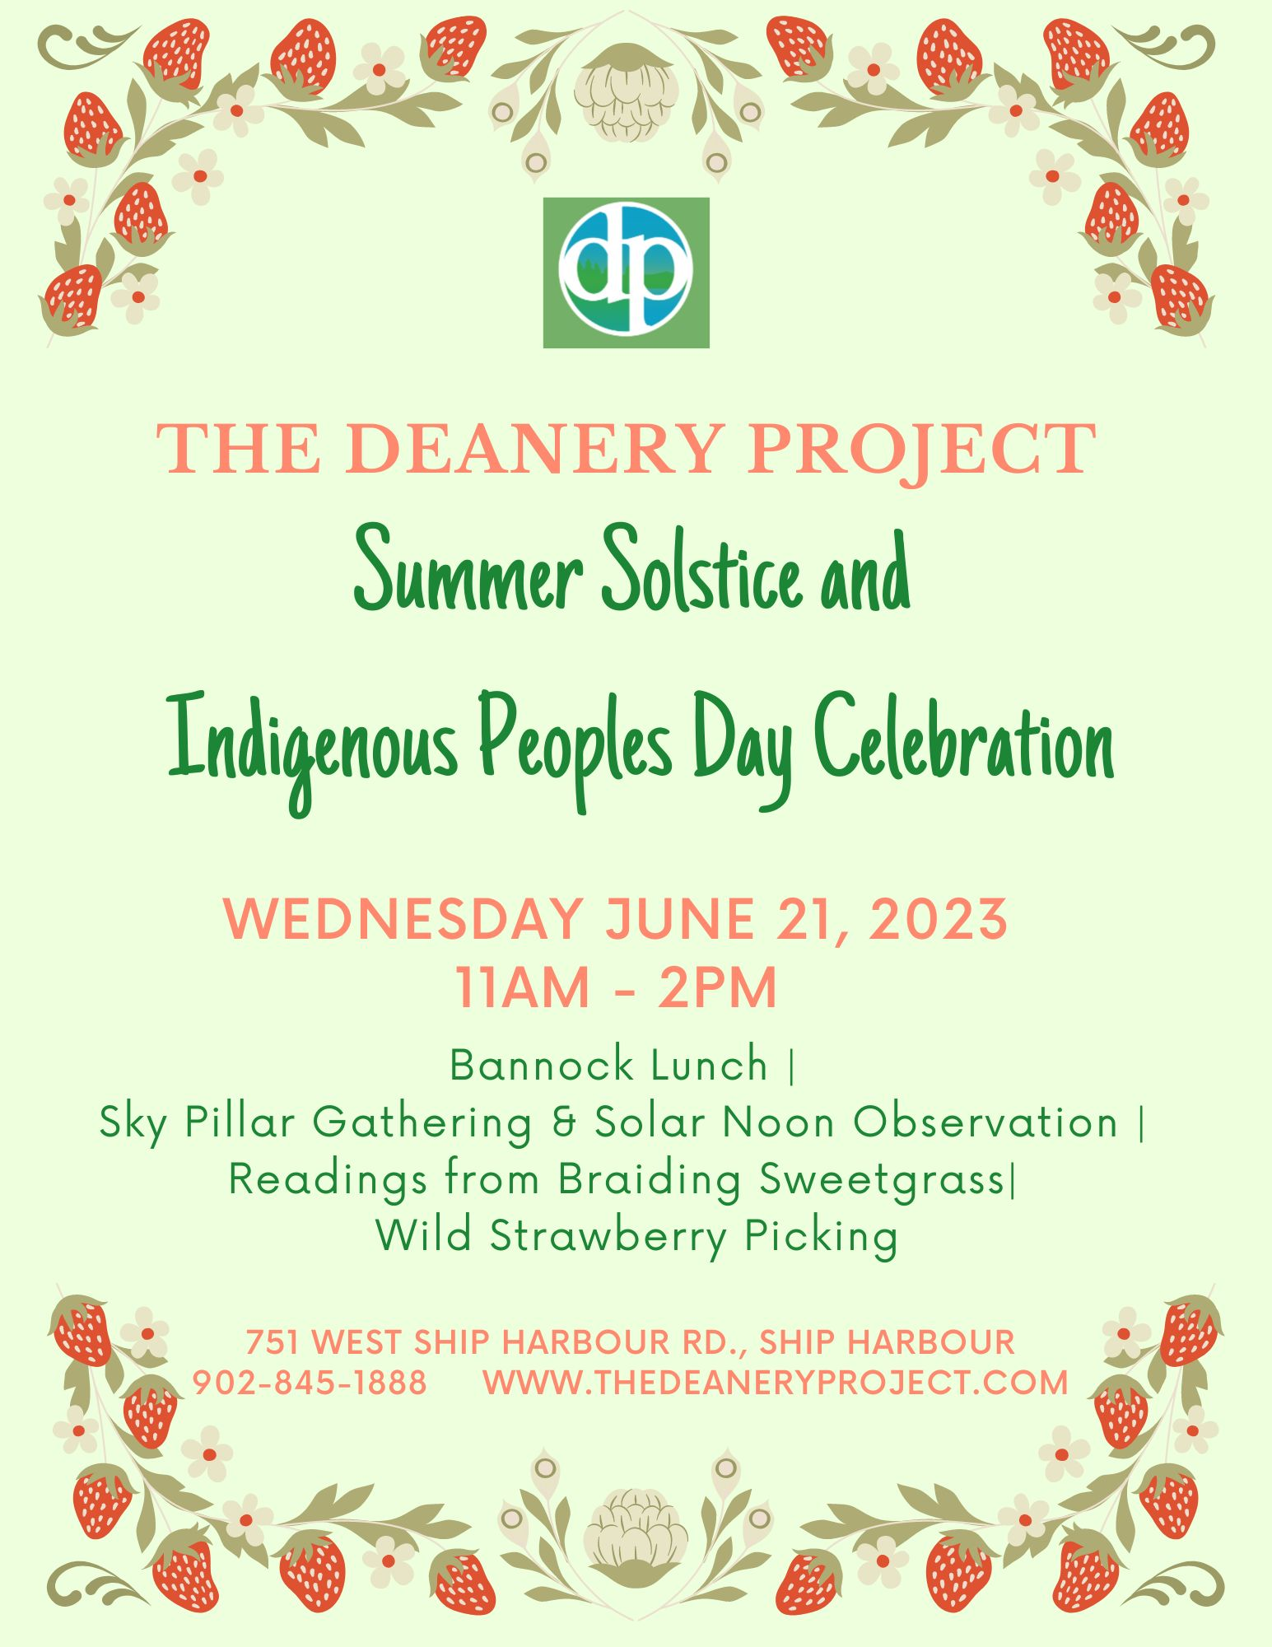

Celebrate Pollinators June 19 -26

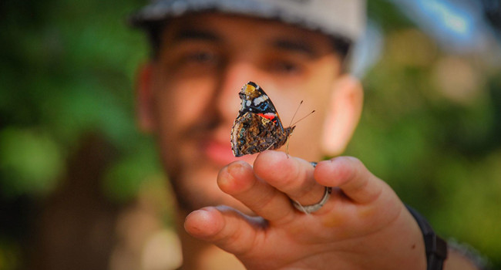
The David Suzuki Foundation invites you to celebrate pollinators and meet some of the Butterfly Rangers as they showcase the habitats they steward:
https://www.youtube.com/playlist?list=PLK1TK6eY3GAhMiTzV-F6B8C2zNkiGwDOi

It’s time to break up with Big Oil! | Leadnow.ca
This petition is a way to tell our government that it’s time to break up with Big Oil. If we want government policy to take on the climate crisis, we have to make them choose between their constituents’ support and Big Oil’s money. Ultimately, there is a question of people and the planet being worth more than profit. Big Oil has a stranglehold on politicians and lobby groups like the Canadian Association of Petroleum Producers (CAPP) have far more access to key ministries than environmentalist groups. The government could instate equitable lobbying for climate advocates and environmental NGOs. It’s time we break free of how things have been done. Add your name to join other Canadians in saying Big Oil has got to go.
Take Action, Sign a Petition | The Rainforest Site, a GreaterGood project
Spanish company Nueva Pescanova has invested 65 million to build the world's first commercial octopus farm in the Canary Islands. They have horrific plans to brutally slaughter around one million octopuses every year. An expert in the behavior of octopus and squid says, ‘There is absolutely no doubt that they feel pain’. Not only will this be forcing countless octopi into a life of captivity and suffering, but it puts more pressure on the ocean, disrupts marine ecosystems, and leads to the deaths of other marine life caught to feed the octopi. Take a stand now to protect these unique creatures and our oceans by telling the Spanish government to stop this octopus farm from operating!
Say No to Deep-Sea Mining (only.one)
Large corporations have poisoned rivers, devastated forests, and displaced communities. Now there is a rush to mine minerals from the last untouched piece of nature left on the planet – the deep sea. We know so little about it and new species are still being found there. Some scientists believe the deep sea and its water column may be the largest carbon sink on Earth. We don’t know the consequences, but we know they could be beyond devastating. If this dangerous experiment goes wrong, it could trigger a domino effect that could destabilize the ocean, trigger food insecurity, and affect all life on Earth. How can this type of risk be justified? More than 500 scientists from 44 countries have issued warnings to pause the process of enabling mining in the deep sea. There are 14 countries so far who have taken a stance against deep-sea mining (Canada is not one of them). Almost 300,000 people have signed their names to this petition going to the UN and International Seabed Authority leaders. Add your voice to say stop deep-sea mining!
Canada, break up with forest biomass (stand.earth)
The forest biomass industry has been exposed for logging and burning forests for fuel while calling it clean. The industry says it is renewable because trees grow back while fossil fuels do not. Scientists say that forests take decades, even centuries, to regenerate, and that burning wood produces more emissions than coal. The U.K.'s Drax Power Station gets pellets from forests around the world, including Canada’s. They have plans to almost double pellet production by 2030, from five million tonnes globally to eight million tonnes. Drax has a monopoly in B.C., while other forest biomass corporations are chopping up forests in Ontario and the East Coast. In the fine print of a March 2022 annual report, Drax acknowledged it is "operating in regions that include old growth forests" in B.C. Last December, Australia became the first major economy to reverse its renewable classification and stop this industry from destroying forests for fuel. We could do the same and save our forests. Send an email to our Ministers saying forest biomass as a renewable energy solution is not the way forward.
Tell Biden to Save the Arctic, Stop Willow (biologicaldiversity.org)
When the Willow oil-drilling project was approved, polar bears, caribou, seals, and other Arctic wildlife were sold out to Big Oil. This project will desecrate a precious landscape and cover it with hundreds of miles of roads and pipelines, puncturing it with nearly 200 new oil wells. It will cause the local Indigenous communities to deal with even more pollution and will push polar bears even closer to the brink. It will harm migratory birds, seals, and other species. The Willow Project will worsen the climate crisis by emitting more than 260 million metric tons of greenhouse gases over 30 years — as much as almost 2 million cars. Let’s help get the priorities straight and save the Arctic, protect wildlife, and stand in solidarity with Alaskan Indigenous communities. Add your name to tell the Biden administration to withdraw approval for the Willow project.

Online Courses
I wanted to take an online course on SEO (Search Engine Optimization) for over a year but things always got in the way. My first retirement activity was to sign up for a course.
Usually, online courses are 10-12 lessons or videos, write an exam where you need an 80% to pass and you get a certificate.
I, of course, had to choose the most comprehensive course with 47 lessons. I only needed a 75 to pass. Sure, no problem. So I did my usual study, made notes, retyped the notes, went over all the resource material, and got to the exam and (to my shame ) failed it by 1 point!
OK. I know the problem. I am told I am learning disabled (They told me that in high school and university but it never stopped me). I have problems with questions that start with “Which of the following is NOT an example of whatever” There were 12 out of 60 questions like that in the exam. (Sixty questions in 60 minutes)
Seems simple. You know which answer is an example of whatever, so one of the other three must not be the example. Sounds easy. Not really.
On the third attempt (yes I am that stubborn) I passed with five points to spare.
Online classes are free for the taking. They fall into a few categories but with an internet connection and some type of computer device, you can learn anything.
There are free courses with video lessons that give a certificate. Some are free to learn, but you pay if you want the certificate. Then there are online courses that you pay for.
Want to have a free Harvard certificate? Look at https://pll.harvard.edu/catalog?keywords=free+courses or
Yale directs you to their home on Courseca at https://www.yale.edu/search/google/free%20online%20courses?query=free%20online%20courses
Do a Google search on free environment courses. One of my favorite schools is Open Ed at https://www.open.edu/openlearn/nature-environment/free-courses Look at the green courses available
The United Nations offers so many free green courses at https://www.unep.org/explore-topics/education-environment/what-we-do/massive-open-online-courses
Go get yourself a binder and some sheet protectors. Once you take one of these you want to learn more. Those certificates add up.
My next course is Nature Based Solutions for Disaster and Climate Resilience The course video can be found at https://learning.edx.org/. It’s a UN course. Somehow liking gardening and nature-based solutions seemed to be a good match.
Any course you found interesting from an environmental point of view, let me know at claudiaazinck@gmail.com
Repurposing garden hoses.
My buckets are so old that the plastic (yes, plastic) guard that was around the top of the handle has broken making it harder to carry buckets of topsoil. This week I heard to cut a piece of old hose, split it, and press it on the bucket handle (where the broken plastic protector was). Makes it easier to carry weights.
You can cut and split garden hose to put over saw blades. Makes it safer in the shed.
Drill holes in an old hose and make your DIY soaker hose.
Lay a hose like a rope around a garden edge. Rabbits won’t enter as they think it is a snake.
Most parts for MOST hoses can be found at a hardware store and they can be repaired. Mine seem to always leak where I join two together. I will play more with washers this year.

Something to Eat.
Grandma can make good tasting dumplings or pancakes. My tea biscuits taste good, but they never rise well. That is until one of favorite cooks, Barry Parsons from Rock Recipes, taught me how to make scones. Scones are basically tea biscuits. They may have cream instead of milk, but very similar. I am adding these lemon scones. I subbed lemon extract for the lemon zest and vanilla. So good.
Lemon Scones
2 cups flour
¼ cup sugar
4 tsp. baking powder
¼ tsp. baking soda
¼ cup and 1 tbsp. cold butter
½ cup sour cream
½ cup milk
1 tsp. lemon flavoring
1 egg
1 tbsp. water
Pinch of salt
Put all your dry ingredients in a bowl and make a well in the middle. Put all the liquid in the well and then mix. It will be sticky
Shake flour on a baking cloth, tea towel or bare counter. Lay the dough on the flour and add a bit more to dry the surface so you can pat the dough into ¾ inch height. Cut out the biscuits and bake 12-15 minutes.
These are soft and delicious
O Almighty and Pre-eternal God: You hold all creation in the palm of your hands; You possess the heavens, the earth and all that is them; You compassionately grant unto all created things that which is beneficial for them. With compunction, we pray to You, O all-good One: As in ancient times You granted the Israelites a land flowing with milk and honey, and as you were well-pleased to nourish Your baptizer John in the wilderness with wild honey, so now by Your good pleasure and caring for our sustenance, bless the beehives in their apiary, greatly increase the number of bees in them, preserve them by Your grace, and fill us rich with honey. Let none of these beehives which You have fashioned be deprived of bees, but let them always be filled with honeycombs of honey. And according to Your great benefits and invincible might, let them be shown undefeated by evils and unshaken by curses. Rather, fenced round about by Your all-powerful might and defended by your armed host, let them always remain unharmed and in Your grasp, O Christ. For Yours it is to be merciful and to save us, O Christ our God, and unto You do we send up glory, honor and worship, together with Your Father and Holy Spirit. Amen
https://rivercottagefarm.net/the-blessing-of-the-bees/

