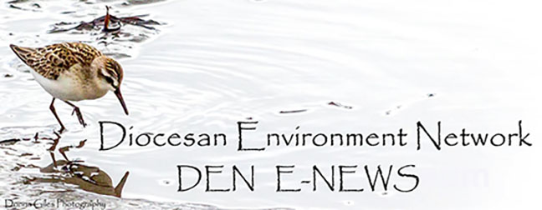
June 06. 2023
Facebook: https://www.facebook.com/groups/101542159983749
Website: https://www.nspeidiocese.ca/ministries/diocesan-environment-network

Email: endionspei@gmail.com
Our Mission: “To strive to safeguard the integrity of creation and sustain and renew the life of the earth”.
From Bishop Sandra’s Facebook and shared shamelessly without permission.
O God in whom our hope is secure, grant calm and courage to those who are working to extinguish forest and structure fires in Nova Scotia. Shelter those who have left their homes in search of safety. Sustain the weary. Encourage the faint-hearted. Enfold the fearful with your peace that passes all understanding. And all for your love’s sake. Amen.
The David Suzuki Foundation reports that Bill C-5 regarding the right to a healthy environment has passed. This means:
- A new duty for the government to protect the right to a healthy environment and uphold the principles of environmental justice.
- Requirement for the ministers of environment and health to develop a framework for implementation of the right to a healthy environment under CEPA.
- New requirements for consideration of cumulative effects on environmental and human health and on any vulnerable populations.
This is a major step forward in ensuring we all have cleaner air, water and communities. The foundation thanks everyone for supporting the foundation, contacting MPs, standing with them and being a part of this historical moment.
Canada's first deep water oil project (Bay du Nord) has been shelved for three years "in the face of challenging market conditions," according to Norwegian oil giant Equinor. The company sent a news release shortly after noon on Wednesday, in the midst of the Energy N.L. Conference and Exhibition in St. John's. I realize this does not seem to be good news for thousands in Newfoundland needing these jobs but our planet is on fire and bringing more oil up from the ocean to burn is not a good thing.
Sierra Club Canada, along with 118 environmental and citizens' groups across Canada, have long been against the Bay du Nord project for environmental and economic reasons. In March 2020, they banded together to call on Ottawa to reject the project completely. "Because we're aiming to meet our climate target, really in the long-term that means that a lot of that oil would not be needed. So developing long-term reserves of fossil fuels like the oil and gas from projects off of Newfoundland and Labrador, including Bay du Nord, really doesn't make much sense," Curtis said.(CBC, May 31)
Dogwood Press reports that Enbridge is hitting pause on its Westcoast Connector mega-pipeline, amid growing opposition to the project. Indigenous house groups and other residents on the pipeline route are deeply concerned about the impacts on Skeena salmon and local communities. With good reason: Coastal GasLink has cut a swathe of destruction through neighbouring Wet’suwet’en territory. Westcoast Connector is even bigger than Coastal GasLink. It would require thousands of new fracking wells. Exporting that gas as LNG would unlock gigatons of dangerous methane and CO2 emissions, amid unprecedented global heating. Enbridge’s project certificate expires next year. The company demanded an emergency extension from the B.C. government. On June 1st they withdrew the application although in their letter to the BC gov't they said “We still continue to work with stakeholders and Indigenous groups with respect to the development of the Project.”
Season of Creation 2023 was launched yesterday.
https://seasonofcreation.org/2023/03/03/we-are-launching-season-of-creation-2023-let-justice-and-peace-flow/
Celebration Guide https://drive.google.com/file/d/1SuaxcpQXN5rlDvZFPawoCbMCTyJ7gFmW/view
You are invited to participate in a research project titled “Opinions on Climate Change and Adaptation.”. Participation in this online study takes about 10 minutes to complete and seeks to examine opinions on climate change and adaptation within Atlantic Canadian communities.
https://mun.az1.qualtrics.com/jfe/form/SV_bKrrceyoHqiW3T8
Climate Action Week – Centering Indigenous Ways of Knowing
The first Climate Action Week of 2023 kicks off today! To read more, https://secure.kairoscanada.org/index.php?q=civicrm/mailing/view&reset=1&id=1554
More news can be found here:
https://secure.kairoscanada.org/index.php?q=civicrm/mailing/view&reset=1&id=1551

Kate Turner has asked us to share this campaign. She is one of the national coordinators of a solidarity campaign working with the Wet’suwet’en Nation. They are working to increase public resistance to RBC’s funding projects that do not have the consent of Indigenous communities. The following has been received from this group with the request to share their request for stories: Have you or your friends and neighbours been harmed by RBC?
Thousands of Royal Bank of Canada (RBC) customers have reported problems with their treatment by Canada's largest bank. As bank customers, we think we can #FixRBC if we raise our voices together.

Our organization began campaigning against RBC because of its history of violating Indigenous rights in Canada and other countries, by funding projects that do not have free, prior, and informed consent. We know that RBC harms many different communities in Canada in a variety of ways - from funding controversial pipelines running through unceded territory, to freezing the deposits or accounts of newcomers and causing serious financial and emotional stress, to gouging seniors on a fixed income with excessive fees.
We believe that if we come together, we can demand change from RBC. We want to make sure that RBC never harms another Indigenous person, new arrival, or senior. We want to hear your story! Would you share it with us using this form? You can also get in touch with us at fixrbc@protonmail.com.
From the South Shore Council of Canadians: We are urging the Government to not approve any new open-pen salmon farming leases, including no expansion of existing sites and to follow a plan to get all existing pens out of the water. Somethin’ Fishy’s Goin On, is being held Saturday, June 3, 1 to 5 pm, St Barnabas Hall, Blue Rocks. Stop by or stay for the afternoon for entertainment with local musicians, a satirical skit involving a “Salmon Farm CEO”, lots of information tables and an art space for the kids. Take a picture with Clawdia, our 8 foot lobster! It will be informative and fun for the whole family and admission is free.
There may also be a hall in your community where you can help organize a similar event? We would love to work with you. If you want more information please contact – southshore.coc@gmail.com or call Marilyn at 902-640-2043.

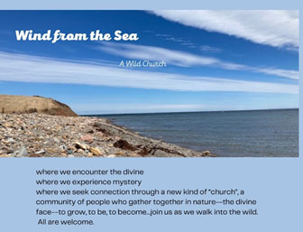
Join the Rev. Tasha Brubaker for Wild Church on Sunday June 18th. Natasha tells us this will be a time of “holy wander" and reflections, drawing on eco-mystics from all traditions, though with a special emphasis on our own Christian mystics and teachings.” The first gathering is Sunday June 18th @ 3 pm. Bethany Centennial Garden. Meet by the steeple. Marian Dr. Antigonish
For more info: Rector3harbours@gmail.com

https://www.facebook.com/profile.php?id=100092461746404

One-Click Letter to Elected Officials - Canadian Association of Physicians for the Environment (cape.ca)
Our country is on the verge of passing a landmark policy that could propel us towards our climate objectives. The Clean Electricity Regulations would advance a fully clean electricity grid in Canada by 2035. Coal is a major source of air pollution that impacts community health, from asthma to premature death. Land, water, and ecosystems are polluted through non-renewable energy, also leading back to public health concerns. This petition recognizes that a healthier planet means a healthier population, let’s ask our government to make that same connection. Sign your name to urge Canada to put a stringent clean electricity standard in place, to ensure no new fossil fuel electricity generation is built, to fully include the electricity sector for carbon pricing, and among other things, to terminate public financing for fossil fuels and redirect it toward renewable electricity.
Demand a Clean Energy Future for Canada! | Ecology Action Centre
With the federal government currently drafting new clean electricity regulations, here is another opportunity to secure 100% clean electricity across our country by 2035. Making this happen could secure good jobs, fair and stable energy prices for households, and a modernized electricity system that will position Canada as a leader in the global shift to clean energy. In order to help get us there, we need to demand it and to show our support. Add your name to send a message to our decision makers saying we support a clean, affordable, and reliable energy future!

Urge France to effectively protect its maritime spaces. (only.one)
The oceans are a crucial regulator of the climate and the largest living space on the planet. This is why 190 countries committed to protecting 30% of the ocean by 2030. France oversees the world’s second-largest maritime territory - nearly 11 million square kilometers! This means they have a critical responsibility to promote ocean health. Their government states 33% of its maritime spaces are covered by marine protected areas, however, industrial and extractive activities are still permitted in most of these “protected” areas. This petition is calling on France to define a marine protected area according to global conservation standards, and then apply this to their 33%. It also asks them to strictly protect 10% of each maritime coastline and outermost sea basin, and to use the EU’s definition of “strict protection”. France is currently developing a National Strategy for the Sea and the Coast that will be instrumental in reaching the 30% by 2030. This petition that can be signed by anyone may help define this major policy for the for’sea’able future.

Say NO to Trudeau's $3B for TMX | Leadnow.ca
Canada just announced another $3 billion in public subsidies for the Trans Mountain pipeline! A Finance Canada spokesperson said “This is common practice” and that the government will launch a divestment process “in due course.” We know that common practice is what got us here and that the time to alter our course is overdue. Construction of the expanded Trans Mountain pipeline is projected to be completed in late 2023. The result will be a tripling of its current capacity to 890,000 barrels per day. The latest estimate pegs this expansion project cost at C$30.9 billion. Sign your name to tell our Prime Minister no more public subsidies for the Trans Mountain Pipeline.
Take Action, Sign a Petition | The Animal Rescue Site, a GreaterGood project
The protection of endangered species is crucial for the health of our ecosystems. Canada Lynx are one of North America's most endangered species. In the U.S., they are protected by the federal Endangered Species Act. The State of Minnesota runs along the border of Northern Ontario and has a Lynx Management Zone covering most of northeastern Minnesota. There are believed to be only 50 to 200 lynxes at any given time in this state. Despite these low numbers, in the last 15 years at least 8 accidental lynx trappings have been recorded here. Snares can disrupt the delicate balance of ecosystems, damage the environment, and often hurt or kill unintended animals. Take action to help protect the Canada Lynx by signing this petition asking that snares be banned in the Lynx Management Zone and throughout the state where there is endangered species habitat.

Greenwashing
I heard a new term this week, Greenwashing. At first, I thought it was a good thing. For those that remember whitewashing, it was a cheap paint that freshened things up in the spring. It wasn’t a good paint or one that stayed long, but it did make things like fences look good for the summer.
Greenwashing is NOT the same.
Greenwashing is when someone says their product is environmentally good but maybe they get their materials in unethical ways or some other way not sustainable.
One example that was quoted was IKEA, which is known for sustainably making its furniture. That part is true. However, they were linked to illegal logging in Ukraine in June 2020. Ikea used a group called the Forest Stewardship Council to control which lumber they purchase. An NGO called Earthsight, called out the Forest Stewardship Council for not catching Ikea’s wood was sourced illegally.
It went from bad to worse for IKEA when they stated their new London store was the most sustainable store they had. It was built on the spot another sustainable store that had only been there for 17 years.
https://www.eco-business.com/news/8-brands-called-out-for-greenwashing-in-2020/#:~:text=IKEA's%20stellar%20sustainability%20credentials%20took,that%20greenwashes%20the%20timber%20industry.
Windex put out a new spray bottle saying it was made from plastics taken out of the ocean when the plastics were recycled on land (but called ocean-bound plastics). Still recycled but not quite as described.
Sometimes ads show children to make us think things “must be “safe for kids and good for the environment.
This certainly gave me food for thought.
If you see something in this or any category, send us a line at claudiaazinck@gmail.com

Garden Ideas
I just came in from pruning. The grapes have run away. They didn’t just grow off their trellis but decided to attach themselves to my fir trees and grow 10-20 feet up the branches. I now have several questionable grape vine circles, to dangle my bottle cap wind chines from. Now what else can I use grapevines for?
We all know to place coffee filters in the bottom of small planters to keep soil in and allow water out. This year I saw where it was suggested (over and over again) to place small sponges in the bottom of your pots before adding soil. Sponges trap water and allow it to be used slowly.
I liked the idea of putting a mailbox near or in your garden to store garden tools. A bucket with a good lid would do the same. My friend Mike kept all his garden tools, long or short in a golf bag on wheels, pulling it from garden to garden as he worked, rolling it back in the shed at night.
I just learned Epson salts can work like a fertilizer. Baking soda, sprinkled on the ground around tomato plants works to perk them up. Cinnamon sprinkled on the ground and plants prevent fungal growth. So much to learn.
I was told that eggshells deter slugs. I usually put rolled oats or cornmeal in an opened vitamin bottle to kill slugs. Eggshells go into my compost but for the past couple of weeks, I have saved the eggshells to put some in all my gardens. Compost only lasts to add to two boxes a year so a week’s worth of eggshells per garden box might work better.
I have started my half-moon garden, picture is below. The idea is to make a semi-circle garden going down a hill, so any runoff rainwater is caught inside the semi-circle. This is my new experiment for this summer. I read several articles and followed directions but still don’t understand the name half moon. To me, a half moon is filled in where these are more horseshoe shape. The picture doesn’t do it justice. After 40 buckets of topsoil, I emptied last year’s container gardens along the back. The top needs rounding. No horse I know uses square ended shoes.
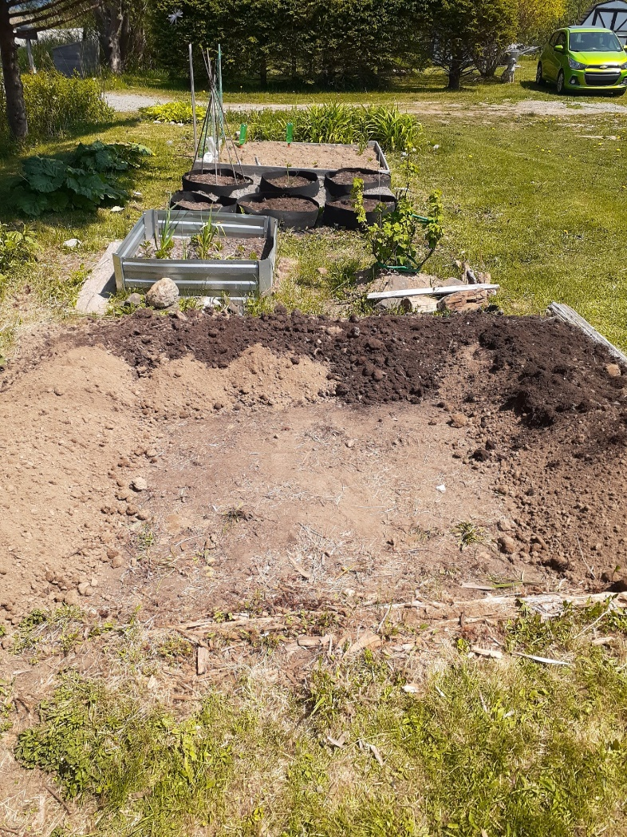
An Activity
Keep the little ones busy with an outdoor scavenger hunt. Here are a few items to get them to look for. Online there are printable hunts where you mark off or take a picture of the things on the list. This one is more of a “give them a bag to collect stuff” game. A paper bag, of course.
An Outdoor Scavenger Hunt
A Dandelion
Any other flower
A grey rock
Moss
5 different types of leaves
Seeds
A white rock
An acorn or walnut
Stick
A shell
Driftwood
Feather
Something to eat
Another one of my favorite cooks is Barry Parsons from Newfoundland. He puts out cookbooks called Rock Recipes. I had a couple extra ripe bananas, so I mixed this one up.
Oatmeal Apple Banana Muffins
1.5 rolled oats
1 cup flour
1.5 tsp. cinnamon
½ tsp nutmeg
2 eggs
4 tbsp vegetable oil
6 tbsp sugar2/3 cup milk
1 cup of ripe banana
1 cup peeled and grated apple ( I use applesauce0
Mix up and divide into 12 muffins. Bake 350 for 20-25 minutes.

