May 30. 2023
Facebook: https://www.facebook.com/groups/101542159983749
Website: https://www.nspeidiocese.ca/ministries/diocesan-environment-network

Email: endionspei@gmail.com
Our Mission: “To strive to safeguard the integrity of creation and sustain and renew the life of the earth”.
From Bishop Sandra’s Facebook and shared shamelessly without permission.
O God in whom our hope is secure, grant calm and courage to those who are working to extinguish forest and structure fires in Nova Scotia. Shelter those who have left their homes in search of safety. Sustain the weary. Encourage the faint-hearted. Enfold the fearful with your peace that passes all understanding. And all for your love’s sake. Amen.
From the South Shore Council of Canadians: Many people think the struggle to stop open-net pen salmon farming ended a few years ago, when communities resisted and sent Cermaq packing. Getting our ocean free from this polluting industry is far from over. The company wants to quadruple the number of pens and our Nova Scotia Government is allowing it to happen.
The South Shore Chapter of the Council of Canadians, supported by our allies in the Healthy Bays Network, is committed to holding community events to raise awareness and build resistance to this filthy industry that puts both human and environmental health at risk.
We are urging the Government to not approve any new leases, including no expansion of existing sites and to follow a plan to get all existing pens out of the water.
The first of these community events, Somethin’ Fishy’s Goin On, is being held Saturday, June 3, 1 to 5 pm, St Barnabas Hall, Blue Rocks. Stop by or stay for the afternoon for entertainment with local musicians, a satirical skit involving a “Salmon Farm CEO”, lots of information tables and an art space for the kids. Take a picture with Clawdia, our 8 foot lobster! It will be informative and fun for the whole family and admission is free.
There may also be a hall in your community where you can help organize a similar event? We would love to work with you. If you want more information please contact – southshore.coc@gmail.com or call Marilyn at 902-640-2043.

Parents Talk Climate: Halifax
Concerned about climate change and how it’s impacting our kids - now and in the future? Join For Our Kids and Ecology Action Centre for a supportive circle to connect and talk about what it’s like to love and care for kids while facing the climate crisis. We’ll also discuss unique actions parents and families could take to create the world we want for them.
Saturday, June 10
10am - 12:30pm
Where: Ecology Action Centre office
2705 Fern Ln, Halifax
Register here: forourkids.ca/parentstalk

It looks like a dry summer ahead and water is a precious resource. There are a number of groups selling rain barrels in Atlantic Canada. To find one nearest you: https://rainbarrel.ca/
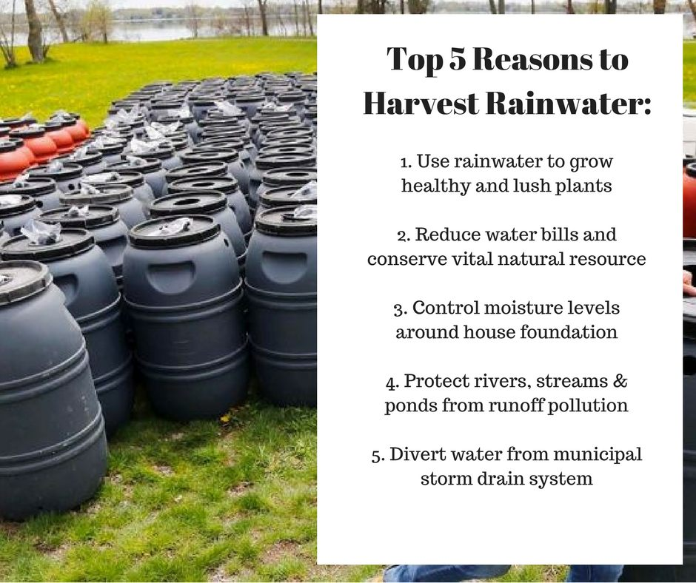 | Rain Barrel Sales in the Diocese of NS & PEI  Church of Saint Andrew, Cole Harbour  Women Addressing Violence on the Eastern Shore (WAVES) Head of Jeddore  Maple Ridge Stables - Mount Uniacke  Cape Breton Farmer’s Market – Sydney  Timberlea – you can join wait list  Living Earth Council – Truro  Windsor & District Food Bank - Windsor  PEI  Emergency Animal Response Team – Summerside  Bedeque Bay Environmental – Kinkora  Wheatley River Improvement Group – Rustico

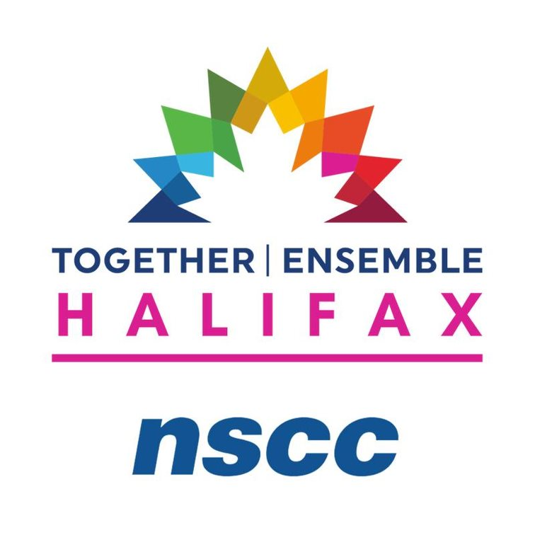
Nova Scotia Community College is pleased to share that we will be facilitating a regional conference in partnership with Together|Ensemble this year. On June 8th, we welcome you to join us at our Akerley Campus to participate in Together|Ensemble: Halifax.
The event will be packed with insightful speakers and panels that will support thinking and collaboration towards the advancement of the UN Sustainable Development Goals. This year’s event intends to reflect on the halfway point of the 2030 Agenda for Sustainable Development and map a pathway forward through partnership. Participants will be led through a facilitated discussion on regional progress towards the Goals by Engage Nova Scotia and will also have the opportunity to explore what the NSCC Akerley Campus has to offer.
We hope that you will be able to join us for this event. Registration details are available through Eventbrite and by following the link below.
https://www.eventbrite.ca/e/together-ensemble-conference-halifax-tickets-629151528157

Active Transportation Strategy – Do you want your voice heard?
WSP Canada Inc. in collaboration with the Province of Nova Scotia, is developing an Active Transportation Strategy.

To support this, the team from WSP will be holding a series of focus groups with partner organizations from across Nova Scotia. If you have any questions, please contact NSATStrategy@wsp.com or Christine Eisan, Senior Policy Advisor with the Nova Scotia Department of Public Works (Christine.Eisan@novascotia.ca
Topics we will discuss include: The roles that different organizations play in the Province; What resources and capacity already exist, and what could be strengthened, How the key themes of the AT Strategy could be enhanced; and Priorities, aspirations, and vision for Active Transportation in Nova Scotia.
Valley, Halifax, South Shore Locations:  - June 12: Kentville (2-4pm)  - June 13: Halifax (2 sessions available – 10am-12pm, or 1-3pm)  - June 14: Bridgewater (1-3pm)  - June 15: Shelburne (1-3pm) | Central, East, North (Cape Breton) Locations:  - June 12: Truro (2-4pm)  - June 13: Antigonish (9:30-11:30am), and Port Hawkesbury (2-4pm)  - June 14: Wagmatcook (10am -12pm)  - June 15: Membertou (10am -12pm)  - June 16: Cherry Brook (10am -12pm)
“The Campaign to Protect Offshore Nova Scotia (CPONS), working since 2016 to protect our coastal waters, is excited to present the “Celebrate World Oceans Day Expo, on Saturday, June 10th, 2023, from 12:30 to 3:30 PM at the Community Centre, 15 Green St., Lunenburg. This is a family friendly afternoon. Everyone is welcome, and admission is free.
The Expo will fortify our community's awareness of the interdependence of not only the North Atlantic, its watersheds, and coastal communities, but also environmental, economic, and climate solutions.
Be part of the lively afternoon of entertainment, learning and action. For more information, follow CPONS on FaceBook for updates or call 902 527 2928.”

--------------------------------------------------------------------------------------------------------------------------------------------------
Join the Rev. Tasha Brubaker for Wild Church on Sunday June 18th. Natasha tells us this will be a time of “holy wander" and reflections, drawing on eco-mystics from all traditions, though with a special emphasis on our own Christian mystics and teachings.”
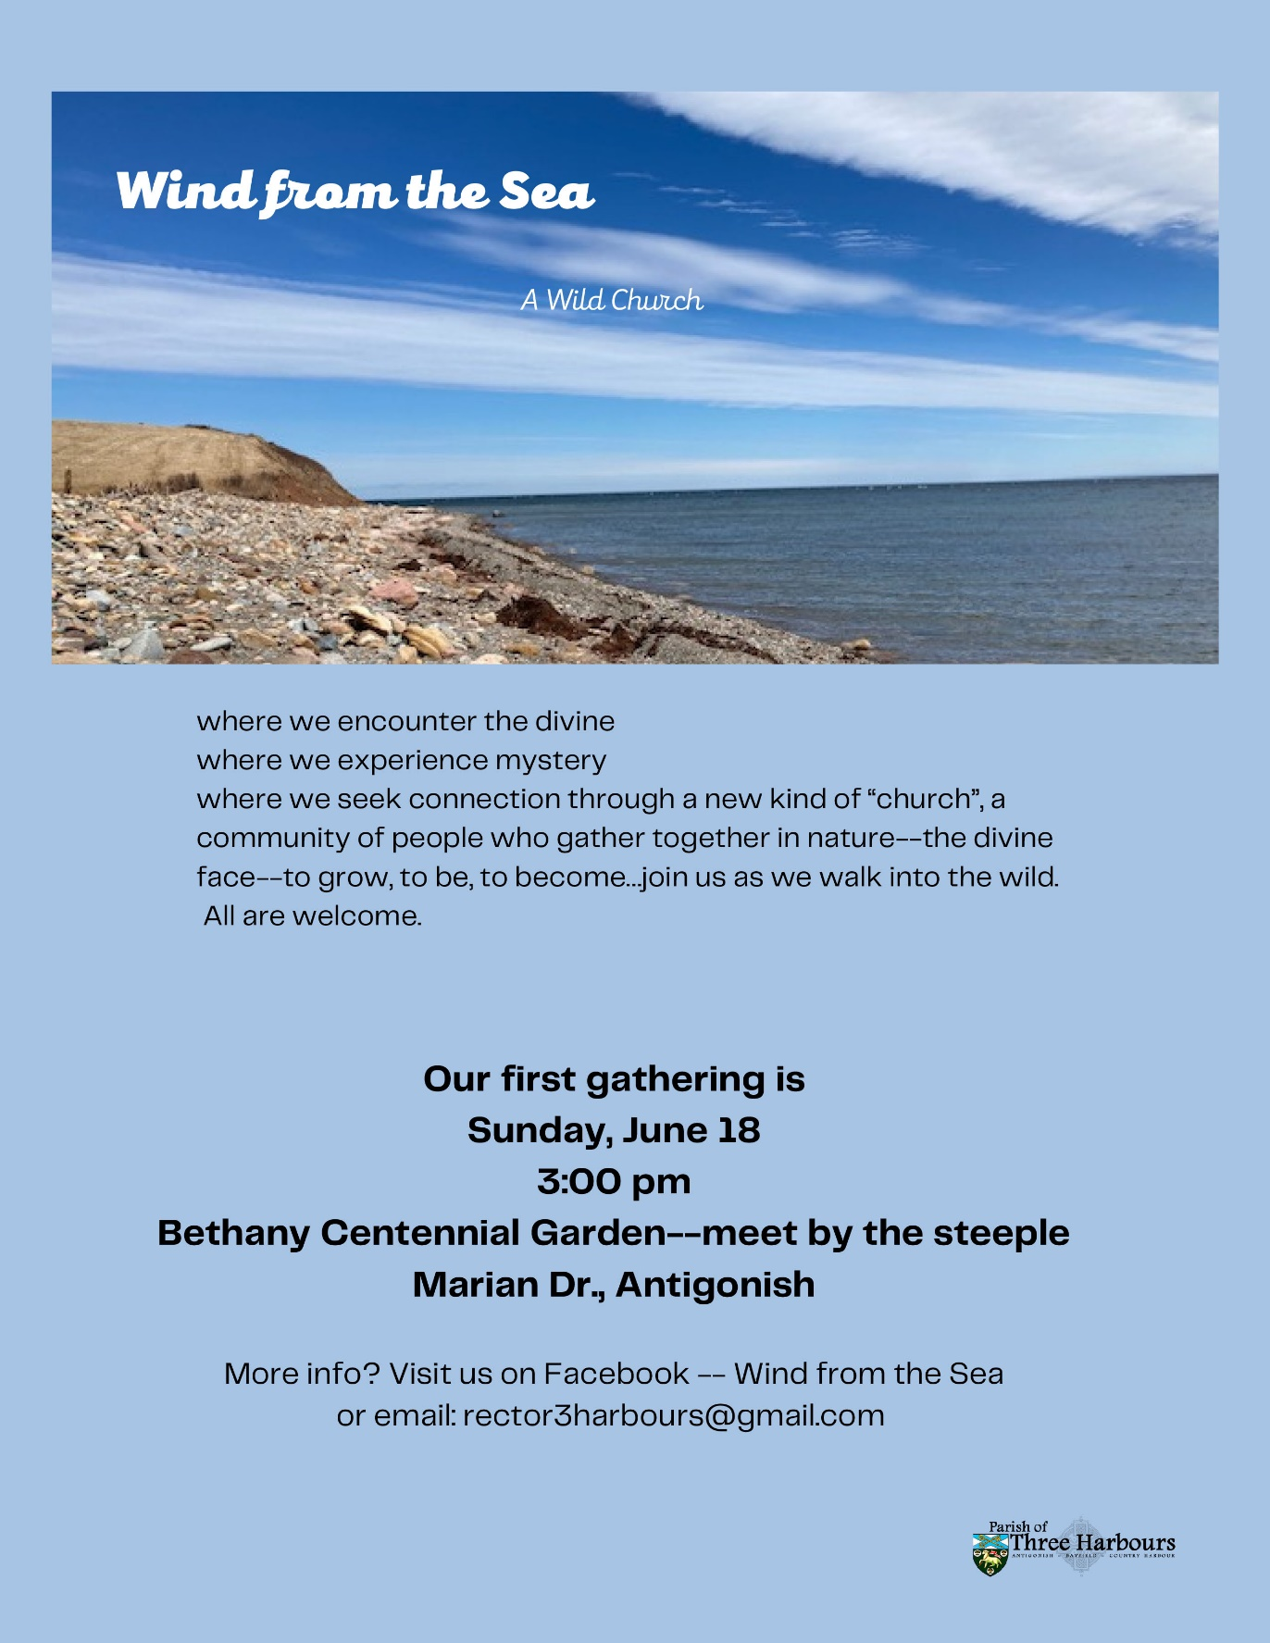

Help protect Indigenous Land and Precious Habitat in Borneo
Samling is a very large timber company which wants a court order to stop SAVE Rivers from reporting on the corporation's destructive logging. It is also demanding a payment of 1.1 million US dollars from this small not-for-profit (SAVE Rivers) all because it published reports from Indigenous communities in Borneo who found Samling logging their land without consent. Let's not let Samling get away with gagging and bankrupting Borneo’s forest defenders. Please sign to tell Samling’s CEO to drop the lawsuit.
Petition to Stop World's First Octopus farm
Octopuses are sentient beings who feel joy and excitement, but also pain and fear. They are extremely intelligent, they communicate with one another through complex colour changes and flashes that humans still don’t understand. Keeping them on farms will lead to unnatural aggression, cannibalism, injury, and death as they fight and struggle to escape. Farming octopuses is as unsustainable as it is inhumane. It would put yet more pressure on the ocean, as wild marine life would have to be caught to feed them, further depleting fish populations and disrupting the ecosystem. Please urge the minister for agriculture, livestock, and fisheries of the Canary Islands to stop these plans.
Please email the Peruvian authorities now! | Survival International
Violence towards Indigenous communities and political policy changes over Amazon resources have been making the news in Brazil and Peru. The ‘palm oil war’ in Brazil recently led to an Indigenous leader’s death on May 14th. A few days ago, draft legislation was approved to strip the Brazilian environment ministry and the ministry for Indigenous peoples of key tools needed to fight against illegal deforestation. In Peru, one of the gravest threats to uncontacted tribes anywhere is currently unfolding. A bill from the oil and gas industry ties in Peru’s Congress is set to open the territories of uncontacted tribes to oil and gas drilling, logging, and mining. It would make it possible to revoke established reserves, block the creation of desperately needed reserves for uncontacted tribes, and revoke official recognition of any uncontacted tribe’s existence. This bill would lead to the destruction of numerous people groups, as well as their environment. The consequences would be so serious that Indigenous organizations there are calling it the Genocide Bill. Please sign your name to urge Peru to stop this bill in its tracks.
petition: A Speed Limit on Boats Could Save Rice's Whales From Extinction (thepetitionsite.com)
Gulf of Mexico whales are also called Rice’s whales. Rice's whales are on the brink of extinction and alongside the vaquita as one of the most endangered cetaceans in the world. The best estimate puts the population at 33, with as little as 16 mature individuals. Scientists believe the industrialization of the Gulf of Mexico and the increase of anthropogenic activities within its habitat are primary contributors for the species' population decline. A unique trait of these whales is that they spend the majority of their time within 50 feet of the surface of the ocean. This means they have a high risk for vessel strikes. A simple policy change could have a huge impact for the Rice’s Whales, potentially saving them from extinction. A year-round, mandatory speed limit of 10-knots within the whale's core habitat could help protect the whales from vessel strikes and accidents. Sign your name to tell the U.S. National Oceanic and Atmospheric Administration to implement a vessel speed limit, and to protect these beautiful creatures before it’s too late.
Nestlé: cut rainforest-destroying collagen out of your supply chain (eko.org)
Did you know wellness products and the global frenzy for collagen-based beauty are massive problems for the Amazon rainforest? Bovine collagen is sourced from cattle, an industry responsible for 80% of all forest destruction in the Amazon. Vital Proteins is a Nestlé-owned brand that is also endorsed by Jennifer Aniston. Researchers traced the collagen found in it back to cattle and farms linked to chopping down the Amazon. The land grabs by cattle producers are fuelling political violence and displacing Indigenous and local communities. The Amazon is the habitat of hundreds of species not found anywhere else on Earth. We can’t let Nestlé risk it all in order to cash in on the latest wellness boom. They say they are investigating the allegations, but let’s make sure Nestlé knows we won’t stay quiet until its supply chain is cleaned up. This petition is to Nestlé, telling them to keep rainforest-destroying collagen out of their supply chain
Global Plastics Treaty petition (greenpeace.org.uk)
Plastic pollution is a global problem. It’s ruining the health of communities across the world, killing wildlife, fuelling the climate crisis, and being dumped into our oceans. A strong Global Plastics Treaty will keep oil and gas used to produce plastic in the ground and stop big polluters with their relentless plastic production. The negotiations for the Global Plastics Treaty have now started, with the goal of completing the process by the end of 2024. This petition is going to the UK Secretary of State for Environment, Food and Rural Affairs. Anyone can sign it and it doesn’t require your email address. The petition is demanding an ambitious and strong global plastics treaty that will limit plastic production and use.

Green Story
It’s spring in Nova Scotia and PEI, and the fifth season called “construction” is in full swing. We either pass by roads being built or buildings being put together and see busy spaces with lots of huge construction equipment.
So I wondered, what happens when something like a bulldozer gets to its end of life? Can it be recycled or repurposed? You don’t hear of construction equipment graveyards, so, what happens to them?
The most common action is to take them to a scrapyard. Even so, how do you get a completely immobile piece of equipment that weighs thousands of pounds off a work site? Well, some companies make their business doing just that.
https://www.aamachinery.com/4-options-for-disposing-machinery/
This site suggests three other ways to get rid of equipment. You can sell directly to a buyer but it is considered time-consuming for busy personnel. Going through a broker can build a network for the future even if it costs money now. Auctions can tell a large number of people about the item but placing the equipment in a spot where potential buyers can look at them takes little time.
Then I started searching for “problems” with heavy equipment disposals. Here is my problem; there doesn’t seem to be a problem. I searched and searched and except for maybe a lone bulldozer left in a gravel pit 20 years ago, the construction industry appears to clean up after itself.
Part of the answer might be in the fact that these heavy pieces of equipment, even when not working, contain large amounts of recyclable materials. Take a look at this website for a salvage yard in Bayer’s Lake. https://jrsons.ca/
As always, would love to hear from anyone with more information on any subject we discuss here. You can reach me at claudiaazinck@gmail.com.

Garden
One idea I saw this week was using repurposing plastic kiddie swimming pools. If you would find one at a yard sale or a neighbour is throwing one out they make a container garden. Even if properly recycled the next year you have a circular garden spot ready for the next year’s garden.
This is similar to my using heavy cardboard boxes to start gardens this year. The cardboard will decompose where plastic won’t.
I am sure everyone puts their coffee grounds in their compost but did you know they also deter slugs from finding your plants so sprinkle them anywhere in your gardens?
If you have seedling trays, brew up some chamomile tea. It strengthened baby plants. Any herbal teas help indoor plants. I have time to drink more herbal tea now and tend to pour cold tea on my houseplant containers. They probably needed the liquid but the turmeric and ginger tea seems to have perked up all the plants.
I save all my large (distilled) water bottles throughout the year. Cutting off the bottom they make the best frost deterrents. Recently I heard that the larger milk jugs will do the same.

Bubble Snakes
The sun has been out a lot and I haven’t been crafting. However, I remembered the Bubble Snakes my grandbabies made last year. I was going to make some but the garden called me, loudly.
You will need a plastic bottle (that will be re-purposed). Cut off the bottom of the plastic bottle. Wrap a facecloth or smaller cloth around the bottom of the bottle and keep secure with a rubber band (and eventually, a ponytail elastic when the rubber band breaks) You will need dish detergent and water to make bubbles and we reused the play pie plates to hold the bubble liquid.
Mix up dish soap and water. Dip the cloth end in the soap and blow air into the drinking end. It will make bubbles that form like a long snake. Just keep blowing and see how long you can make your snake. Save your bottle for another day or put it in your blue bag.
I found an article on Google similar to what we did. Have fun.
https://www.thirtyhandmadedays.com/diy_bubble_blower/

Something to eat
Dylan Hollis came out with a video about a recipe for pancakes that used stale bread. It reminded me of a bread pudding recipe. You can use stale hamburger and hotdog buns, croissants, biscuits, or whatever bread type of food that is getting old. My mother even used stale cake in her pudding. (It was a different era where cake couldn’t be more than 2 days old.) Having some crusts and odd older bread I made the pancakes this morning and they were delicious. Saving the leftover one for dessert tonight with strawberries and cream. Here is Dylan’s recipe
Bread Pancakes
7-8 slices of stale bread
1 cup of milk
2 tbsp sugar
1 tsp. baking powder
1 egg
Tear up the bread and add the other ingredients to it. I used the potato masher to turn the mixture into mush. Then I used my half-cup spoon to drop them into a hot pan splashed with a bit of oil. They were so good.

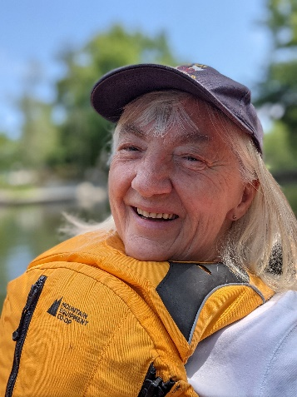
Wishing a very Happy Birthday to our intrepid Coordinator of DEN, Mo. Marian Lucas-Jefferies and best wishes on your third attempt at retiring.

