|  |
| --- |
| **May 02, 2023**  **Email:** **endionspei@gmail.com** **Website:** **nspeidiocese.ca/den**  **Facebook:** **Environment Network Diocese of NS & PEI**  **“To strive to safeguard the integrity of creation and sustain and renew the life of the earth”**. |
|  |

**The People’s Parade for Life on Earth was a huge success and the Anglican Communion Environment Network mentioned us again in their newsletter!**

|  |
| --- |
| *“Celebrating the planet: Earth Day marked with parade along Halifax Waterfront* *Dozens of local groups in Halifax, Nova Scotia, Canada gathered for the first* *People's Parade for Life* *on Earth on Saturday. The event, held on Earth Day, was intended to bring different communities together in a joyful celebration of the planet. Watch for the Anglicans with their delightful creation care banner and logo.”* https://mailchi.mp/418a7c43faa7/lambeth-conference-and-season-of-creation-5397078?e=0dd67e46dd&fbclid=IwAR2Xz9553yRKeqoHhPuFxahRVz0a6SIpIgZB4-2-7z0yLU2w5iFwPIEpy6E  **F:\0.DEN Enews\Banners\banners Good news.jpg** |

**West Mabou Beach Provincial Park will remain protected!**

Thanks goes out to the tireless advocates and supporters who sent the strong message that protected areas must remain protected. Now is the time to let the government know that the Provincial Parks Act must be strengthened to ensure their future for all Nova Scotians. Please find attached a sample letter offered to us from the Ecology Action Centre that you can use to send to Premier Tim Houston.



Congratulations to St. Luke’s Anglican Church in Dartmouth as they celebrate 75 years and for the successful tree planting held yesterday to commemorate the coronation of King Charles III. Present was the Lt. Gov., The Honourable Arthur J. LeBlanc and his wife, Mrs. Patsy LeBlanc, The Right Rev. Bishop Sandra Fyfe, various local clergy and parishioners from the Dartmouth region.

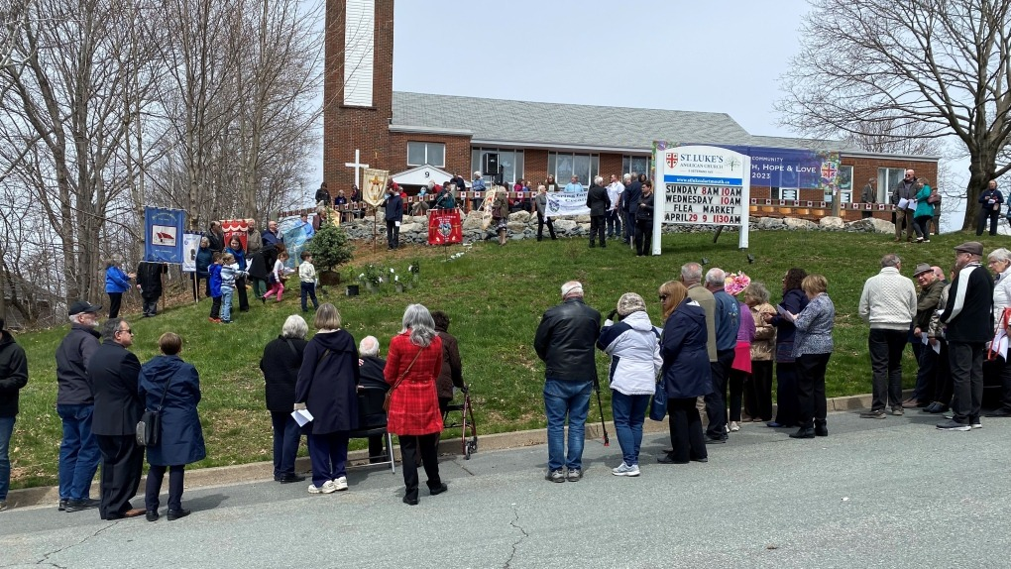



**Acting on Climate Change Together Today is the last day to register your concerns on this online survey: May 2** Halifax Public Libraries and HRM’s HalifACT team are partnering on climate change engagement to learn from you. This month’s topic is about preparing for climate change and HRM is seeking citizen feedback. Visit any library branch between April 25 – May 2 to share in person using interactive displays, or participate online on HRM’s shapeyourcity page here. Information gathered will be shared and used to help create climate resources, programs and support for effective climate action.For more information on HalifACT and to read about the plan’s second community updated, visit the HalifACT page here.

|  |  |
| --- | --- |
| **C:\Users\cayla\AppData\Local\Temp\image.png** | Join the Diocesan Environment Network (DEN) at Synod and test drive an electric vehicle! Register your spot and swing by Synod to see the benefits of switching to electric. Spots are limited so Email us to book your test drive today!   “Next Ride is the provincial electric vehicle education and engagement program for Nova Scotia. They are offering free test drives where you can experience the thrill of driving electric and receive answers to all of your questions about making the switch to an EV.”  Date: Thursday, May 26  Time: 10 am - 1230 pm  Location: Outside the Student Union Building on the Dal campus |



**New legislation for Canadian Companies to Act Responsibly Overseas**

A game-changing law has been tabled in Canada’s parliament. The law would oblige Canadian companies to respect human rights and the environment in all their business dealings around the world. Please sign the petition calling on the Minister of Labour, and the government of Canada, to enact robust due diligence legislation now! At present  people who protest these human rights abuses and environmental damages are often harassed, attacked, or killed.

**Avaaz Petition to Peru Government**

|  |
| --- |
| Powerful oil, logging, and mining corporations are pushing the Peruvian Congress to pass a new bill so they plunder the sacred lands of some of the last isolated Indigenous communities in the Amazon. They've even financed an all-out media campaign to deny the existence of these tribes! Now together we can launch a media counterattack alongside Indigenous leaders to expose the scandal and stop this insane law. Please stand up for Peru's uncontacted peoples. Early explorations by Shell resulted in almost one-half of the Nahua people dying from influenza and whooping cough, to which they were not immune. |

**StandEarth Petition to World's Largest Funder of Fossil Fuels**

The Royal Bank of Canada is the largest fossil fuel funder IN THE WORLD as of 2022. Since 2016, when the Paris climate agreement was signed, RBC has poured over $250 BILLION USD into dangerous fossil fuel projects that threaten the planet, and frontline communities. From financing new tar sand pipeline projects that infringe on the rights of Indigenous peoples, to funding the fracked gas Coastal GasLink pipeline, to financing gas projects on the Gulf Coast that pollute the air of predominantly communities of color, RBC continues to bury its proverbial head in the sand when it comes to the need for real climate action.In 2022, RBC financed US$42.1 BILLION in fossil fuel projects that drag us backwards on climate.

**Sign this Petition - Petitions (ourcommons.ca)**

This petition is asking Canada to oppose octopus farming. Octopus are complex, highly intelligent, and inquisitive creatures. They feel and respond to pain in a similar way to mammals. They are solitary and would suffer in captivity. Companies around the world have been developing industrial-scale commercial cephalopod farms. This means octopus and squid will be bred, raised, and then slaughtered for human consumption. Significant environmental concerns include new effluents being produced and discharged into ecosystems. The need for fishmeal and fish oil products will increase to feed carnivorous farmed octopus and this will contribute to the unsustainable pressure on wild fish populations. There are numerous public health risks, as well as risks to other animals and habitats. There is also no legislation protecting the welfare of the creatures who are soon to be farmed. This e-petition will close on May 16th. It asks Canada to ban the import of farmed cephalopod products and to prohibit this farming on Canadian territory.

**Take action for Africa and the climate now (greenpeaceafrica.org)**

Around the world, we are seeing the need to push for change in order to protect our planet. Africa is no different in this need. They are on the frontline of the climate crisis and the frontline of a new scramble for oil and gas extraction and exploitation. This Greenpeace petition is going to the African Heads of State asking that African countries phase out coal and commit to Net Zero by 2050. That long-term renewable energy solutions be chosen over short term reckless investments in fossil fuels. That foreign governments work with them to curtail illegal fishing and logging. That restoration of forests happens instead of new industrial logging and agriculture in rainforests. The issues we face are on a global scale, as are the changes needed. It is our unity that can be a formidable tool in the face of our obstacles. This petition is a way to add our voices together.

**petition: Charmin Toilet Paper Is Destroying Canadian Forests (thepetitionsite.com)**

Forests around the world are being logged and destroyed at dangerous rates. The increasing demand for toilet paper is one of the culprits. In our own country, companies are deforesting the boreal forest to create toilet paper. A recent report shows about six NHL-sized hockey rinks' worth of forest are destroyed every minute - just to meet our growing TP demand. Procter & Gamble are a major toilet paper producer and own the popular brand Charmin. They made over $80 billion in revenue last year. This company could commit to using sustainable materials and our collective future could be invested in instead of sacrificed for the profit of a few in the present. Recycled content or bamboo products are viable options being used by other companies. There is no excuse to continue contributing to deforestation and it's time for a company with this much wealth to take responsibility for its environmental footprint. This petition is going to the CEO of Procter & Gamble, saying they need to reduce Charmin's impact on the environment and commit to sustainable practices.

|  |
| --- |
| F:\0.DEN Enews\Banners\banners Grandmas Going Green.jpg  **Earth Day** Earth Day, an event that started in the 1970’s when people began to realize the human impact on our planet.  I hope all of you had a great Earth Day! It isn’t the amount of “stuff” we do on this one day but rather that a whole bunch of us think about the environment and maybe come up with one new thing we can do to help.  I think we accomplished that. Schools had projects. Events were planned. Even a parade took place. In my corner of the world a Bee and Butterfly Garden was made ready. I did a first planting knowing it is too cold but what harm did it cause and what surprises await us.  On the internet you can learn about forestry at https://pltcanada.org/en/earthday/  I enjoy the original Earth Day site, https://www.earthday.org/  Canada has it’s own site at https://www.earthday.ca  Now that Earth Day is over, let’s think of enviro activities we can do this summer. It isn’t all about beach clean ups and litter chases. You can help the environment by having fun.  Plan a beach day, even if in winter coats and eating your sandwich in the car. Get out and be there and do little else but enjoy the wonder of nature.  Take a walk along one of the Rails to Trails spots. If you can’t do from Point A to Point B, go halfway and walk back to the car.  Go to a Farmer’s Market if only to look. Maybe buy a bagel, a bunch of carrots some fresh from the earth peas. You can plant peas outdoors in April so someone may have a lee spot and have peas soon.  Do a low waste DIY. One of my favorites right now is my reminder ribbon. I’ll show a picture in craft  Go camping.  Start a composter.  And so much more. Try to find one new thing to give a try  **Garden**  Grandma retired on a Friday. On Saturday her dump truck load of topsoil arrived. All the garden boxes need topping which equals exercise in the fresh air.  Having a battery-operated grass trimmer, each morning I cut a few more feet of scruff grass. Long before we can use a lawnmower, the grass will be mid-calf high around the house, the well box, the box gardens etc. Getting an early start this year.  If you have an aloe vera plant that could be cut back, you have the best base to root cuttings. Pretend you have a favorite bush in your or a friend’s yard. Cut off a few twigs. Insert twigs in a piece of aloe vera and put the whole thing in a pot. The aloe vera gives the twigs more moisture to start rooting. |
|  |

Eternal God,  
whose Spirit moved over the face of the deep bringing forth light and life;  
by that same Spirit, renew your creation, and restore your image in your people.  
Turn us from careless tenants to faithful stewards,  
that your threefold blessing of clean air, pure water and rich earth  
may be the inheritance of everything that has the breath of life  
and one generation may proclaim to another the wonder of your works;  
through Jesus Christ, your living Word,  
in whom the fullness of your glory is revealed.  
Amen.

**Rt Revd Libby Lane  
Bishop of Derby**

https://www.churchofengland.org/prayer-and-worship/topical-prayers/prayers-world-environment-day