|  |
| --- |
| **April 18, 2023**  **Email:** **endionspei@gmail.com** **Website:** **nspeidiocese.ca/den**  **Facebook:** **Environment Network Diocese of NS & PEI**  **“To strive to safeguard the integrity of creation and sustain and renew the life of the earth”**. |
|  |



|  |  |
| --- | --- |
| F:\0.DEN Enews\Earth day parade.jpg | ***The People's Parade for Life on Earth!***  Earth Day, Saturday, April 22nd (Rain Date: Sunday, April 23rd, 2023)  Organized by the Grassroots Grandmothers, Ecology Action Centre, School Strike 4 Climate Halifax, iMOVe, DEN and others.  A celebration of Mother Earth, connecting and reconnecting us with all of creation and all that is in, on and about it, all our relations. We encourage to use imagination, creativity and expressions of Earth Day joy. (But NO motorized vehicles.) Everyone is welcome!  We gather at 1 pm at the wave on the waterfront. The parade begins 2 pm and ends at the Peace & Friendship Park with a community gathering and celebration.  If you have any questions contact Joanna Bull at joanna@ecologyaction.ca  We hope to see you there! |

**Really hope as many as possible from DEN can join us. Please share with your parishes.**

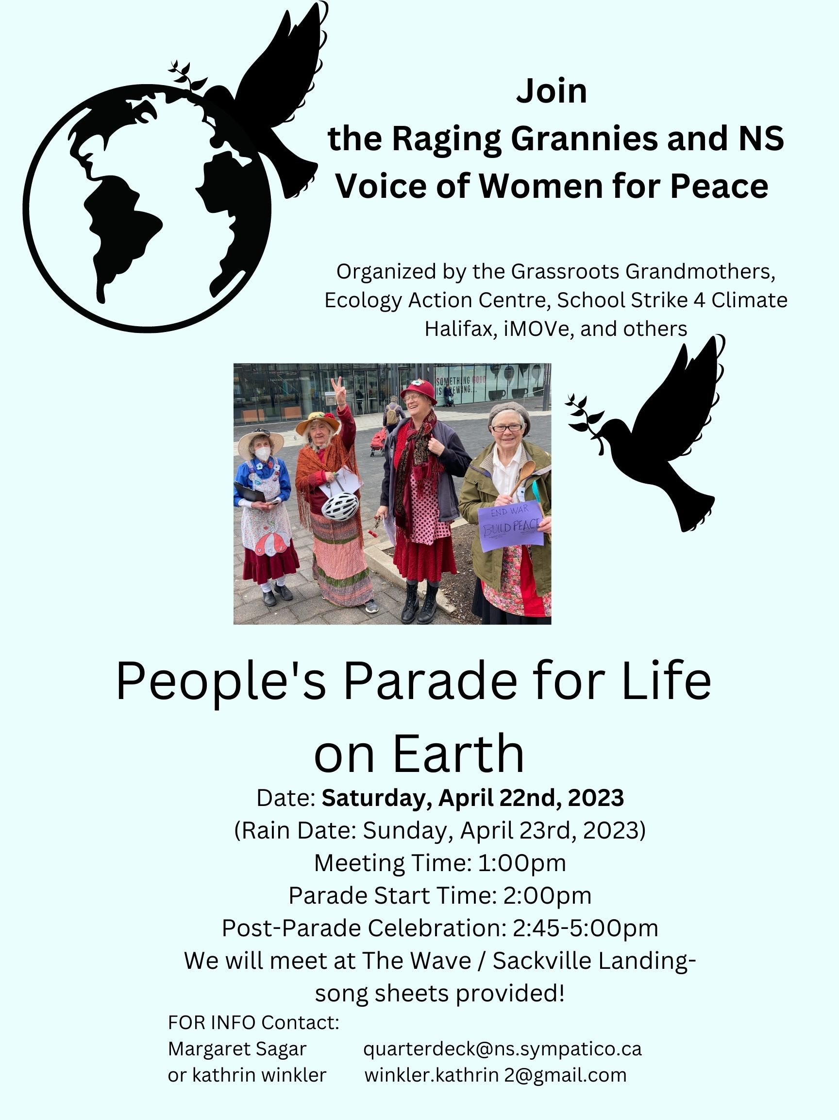

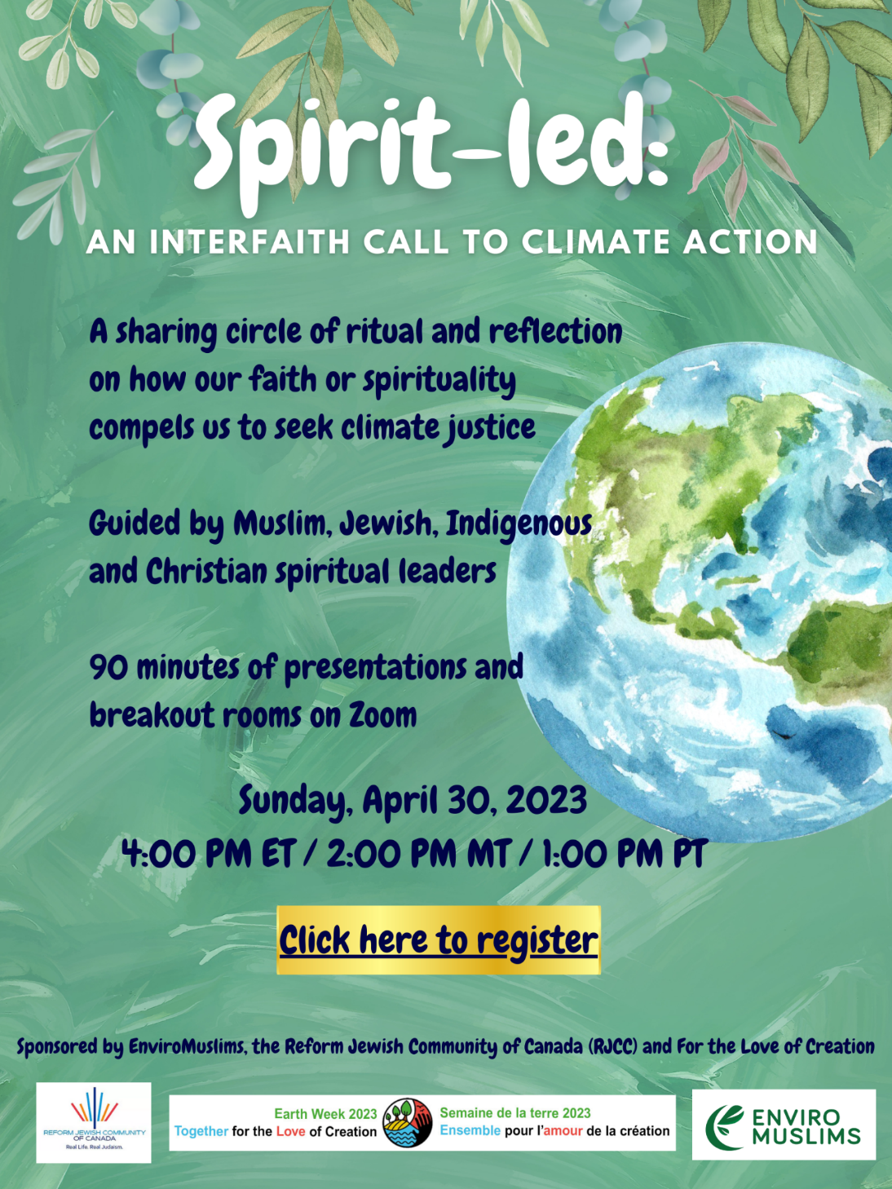

|  |
| --- |
| **Camino Nova Scotia**  Since 2014, Camino Nova Scotia has "made pilgrimage local." Pilgrimage is spiritual travel for transformation. Camino NS offers walking pilgrimages in—you guessed it—Nova Scotia! Our walks are set in our gorgeous Maritime province where anywhere you go you're never far from the sea. Discover more about yourself in community as you also discover the Gaelic, Mi’kmaq, and Acadian histories of the Land under your feet.  https://www.caminonovascotia.ca/  F:\0.DEN Enews\Banners\banners Advocacy.jpg  **Petition to Protect NS coasts**  Despite Nova Scotia facing the worst sea-level rise predictions in the country, Nova Scotia Minister of the Environment and Climate Change Tim Halman has announced an indefinite delay on implementing the Coastal Protection Act (CPA) regulations.   The implementation of the CPA regulations is already long overdue. As Hurricane Fiona showed us, Nova Scotians are already feeling the effects of the climate emergency and paying for the results of irresponsible development through disaster relief funds and clean-up efforts.  **Read about EAC's response to Federal Budget**  The Ecology Action Centre welcomed significant investments that will play a crucial role in creating a clean, affordable and reliable energy grid, as well as supports to help Canada’s fisheries and coastal communities adapt to a rapidly changing ocean. However, large gaps remain on efficiency and supports for workers and low-income individuals.  **Minister Guilbeault: Expand the Ban on Single-Use Plastics (greenpeace.ca)**  Canada’s single-use plastic ban tackles only about 3% of the plastic waste generated nationwide. This obviously falls short and does not match the urgency nor the scale of the worsening plastic waste and pollution crisis. Recycling will never be the solution to our growing plastic problem. Curbing plastic pollution simply requires curbing plastic production. If we are planning on fulfilling our goal of beating plastic pollution and achieving zero plastic waste by 2030, then we need more action; we need an expanded ban on plastic. Sign your name saying to expand the ban! This letter will go to our Health Minister and the Environment and Climate Change Minister.  **Protect Ontario’s precious wetlands | Ontario Greens (gpo.ca)**  Wetlands are incredibly important! They play a key role in protecting us from floods by soaking up stormwater runoff. They provide habitat for threatened species. They improve water quality and protect us from soil erosion. They’re one of our best defences against the effects of climate change and severe weather. We can’t replace wetlands; we need to protect them. Approximately 85% of wetlands in southern Ontario have already been lost. Doug Ford is planning on paving over 7,400 acres of the Greenbelt, which among many disastrous impacts would also destroy some of Ontario’s most significant wetlands. This government is also planning to gut the province’s wetland evaluation system. Sign your name to tell Ford to stop paving over our wetlands and to instead permanently protect the few we have left.  **Uganda: keep the oil in the ground – save Murchison Falls! - Rainforest Rescue (rainforest-rescue.org)**  The Murchison Falls landscape in Uganda is one of Africa's jewels. It is home to iconic species such as lions, elephants, hippos, and at least 500 other animal species! Every year, thousands of tourists visit and generate a substantial income for local people and the country. There are vast oil resources in Uganda, and this means companies are circling to drill – regardless of this being in national parks and protected areas. A Chinese construction company is already expanding a road that cuts through this protected area. The Tilenga oil exploitation project and related infrastructure measures would endanger the unique ecosystems of the region. This petition is asking for your voice. It’s saying to stop the Tilenga project, stop all projects connected to oil exploitation such as road works, and to keep the oil in the ground.  **Support Kwakiutl: No old-growth logging without community consent | Wilderness Committee**  On Kwakiutl territory, on Vancouver Island, rich old-growth stands are being clearcut against the wishes of the community. The leaders and matriarchs have called on the BC government to intervene. They are asking that all old-growth logging in Suquash Creek and the rest of Kwakiutl Territory be immediately halted. They are also asking for help to amplify this call. This is an open letter where you can copy and paste different provided points, such as “No consultation: no consent. Hands off the old-growth”. At risk old-growth forests deserve protection. On-going logging in these threatened ecosystems is unacceptable. This letter will be going to various parties in the BC government.  **Show your support for clean, reliable and affordable energy!**  Right now, we have the opportunity to secure 100 per cent zero-emissions electricity across the country by 2035. With the federal government currently drafting new clean electricity regulations, we could improve affordability, create thousands of good jobs and help modernize Canada’s electricity grid as we join the global shift to renewable electricity. Clean, reliable and affordable energy solutions are in our power! Click below to use our simple tool to tell your local representatives that you support strong regulations to get us to 100 % clean electricity by 2035.  https://ecologyaction.ca/CleanEnergy2035?utm_source=civicrm&utm_medium=email&utm_campaign=clean_electricity_2035  F:\0.DEN Enews\Banners\banners Grandmas Going Green.jpg  **Green Story - Planting Kit Story**  It’s time to tell the planting kit story.  I know, every spring I brag and brag about the kits. Bear with me a few minutes. April 1st both Parish of Blandford and Hubbards Area Lions Club got together to make up the 200 kits. While waiting for everyone to get there we made our plant markers by cutting up the plastic margarine or yogurt lids and labeling them.  The Lions club didn’t want to use plastic bags for the soil and had these great little paper bags I worried about the soil dampening the bags, which it did, but since we were using a 4 inch fiber pot, the bag fit inside the pot snugly. If the bag broke it would already be in a pot  The lettuce seed envelopes and the tags were already made up.  We started a line to put the kits together in a box bottomed bag and tied the tag saying who the kit was from.  Two hundred kits in under three hours.  There will be 125 kits given away at the Shatford Memorial Elementary School where every kid goes home with a planting kit on April 21st. Forty kits were given away at our Blandford Bunny Day. The remaining 20-30 went to the community breakfast April 15thwhere they quickly disappeared.  Great story you think. They had a lot of workers to do this, right? Nope!  THREE, count them, 3 from the Parish came to make the kits along with 6 Lions. That’s all it took. There may be lettuce seeds in the kits, but what we planted was knowledge of growing your own food. We planted in 200 young minds. That’s the real prize of the project.  Thanks to the Church of St. Andrew for following us and supplying another school with kits  Don’t worry about numbers. If you have 6 kids in your church, make a kit for them for Rogation. If you are a Grandma with one grandbaby, make them a kit. We may be getting older. Good. It is time for us oldsters to be teachers. Thanks be!  **Garden**  Those big green composters on wheels are filling up.  I want to get out in the garden but I know it is too early. Luckily for my “need to be outdoors doing something”, I have walnut trees. They don’t just drop leaves in the fall but also these sticks or twigs the leaves were on. Too heavy to just mow over and scatter them, they need raking and I needed to be outdoors.  Are your windowsills filling up with seed trays? My daughter, granddaughter and I went through my seed box. There is always something new they want to try.  Nana and I each planted the lettuce planting kit. I heard from my cousin Carly that her Mack and Mollie were pumped as the lettuce was up in four days. I ran to our kits and sure enough 4 days later the lettuce was above ground.  Amazing how a few lettuce leaves can lift your spirits.  Maybe that is why we garden. That incredible joy of seeing a few seeds grow.  **Rocking Robins**  You will need to cut a larger circle and a small circle. I used a plastic cup and traced around the top for the larger circle and the bottom of the cup for a smaller circle. Make them different colours.  Cut them out neatly and fold them in half. Make sure the two sides are even so your robins will rock back and forth.  Glue the smaller circle over the larger circle  Fold a rectangle and a triangle out of coloured paper. I used goldenrod. Turn the side with two circles over and glue the beck and tail in place on the back.  Use a pen or marker to make and eye and maybe draw in feathers. I have even seen the smaller circle only half glued and the bottom of the small circle brought up like flaps or wings.  Play and see what you can create. They add nicely to church windowsills to make spring decorations.  Image preview  **Something to Eat (close to) One Pan Minced Chicken Meal**  Cook and mash a pot of potatoes or cheat like I do and made instant mashed potatoes from a box.  Using a cast iron or oven safe pan cook  1 pack of minced chicken or turkey  An onion  Garlic fresh or powdered garlic  When brown add 2 cups chicken broth (OXO in water works)  A can or fresh pack of mushrooms  A small can of peas and carrots or frozen  2 tsp. of Worchester sauce  ½ tsp of Italian seasoning  Let that bubble awhile and mix some corn starch and water and add to pan  Turn off the heat when broth starts to thicken.  Add your potatoes on top and put in the over 30-45 minutes.  I did not use the cheese they suggested on top. This smells and tastes so good. |
|  |



**Earth Quotes to Inspire**“Earth rejoices our words, breathing, and peaceful steps. Let every breath, every word, and every step make the mother earth proud of us.” – Amit Ray

“One of the first conditions of happiness is that the link between man and nature shall not be broken.” – Leo Tolstoy

“Like music and art, love of nature is a common language that can transcend political or social boundaries.” – Jimmy Carter

“The Earth will not continue to offer its harvest, except with faithful stewardship. We cannot say we love the land and then take steps to destroy it for use by future generations.” – John Paul II

“Plant seeds of happiness, hope, success, and love; it will all come back to you in abundance. This is the law of nature.” – Steve Maraboli

“You cannot get through a single day without having an impact on the world around you. What you do makes a difference and you have to decide what kind of a difference you want to make.” – Jane Goodall

To make this world a better living place it is a must to plant hope, indoor greenery, and outdoor pride to flaunt the beautiful mother nature around you. Here read more quotes about the earth and get inspired:

“To me, a lush carpet of pine needles or spongy grass is more welcome than the most luxurious Persian rug.” – Helen Keller

“The proper use of science is not to conquer nature but to live in it.” – Barry Commoner

“Keep close to Nature’s heart… and break clear away, once in a while, and climb a mountain or spend a week in the woods. Wash your spirit clean.” – John Muir

“The more clearly we can focus our attention on the wonders and realities of the universe about us, the less taste we shall have for destruction.” – Rachel Carson

“I’m not an environmentalist. I’m an Earth warrior.” – Darryl Cherney

“Earth Day should encourage us to reflect on what we are doing to make our planet a more sustainable and livable place.” – Scott Peters

“Humankind has not woven the web of life. We are but one thread within it. Whatever we do to the web, we do to ourselves. All things are bound together … all things connect.” – Chief Seattle

“Environmentally friendly cars will soon cease to be an option…they will become a necessity.” – Fujio Cho

“There is a pleasure in the pathless woods. There is a rapture on the lonely shore. There is society, where none intrudes by the deep sea, and music in its roar. I love not to man the less, but nature more.” – Lord Byron

“The earth is what we all have in common.” – Wendell Berry

“It’s Earth day. I wonder if we can plant more trees than people for a change?” – Stanley Victor Paskavich

“To leave the world better than you found it, sometimes you have to pick up other people’s trash.” – Bill Nye

“Look deep into nature and you will understand everything better.” – Einstein

“There is no single day that you’ve never been radiant and beautiful. Thank you, mother nature.” – Vanshika Varshney

“Nature always wears the colors of the spirit.” -Ralph Waldo Emerson

“Nature is painting for us, day after day, pictures of infinite beauty.” – John Ruskin

“Nothing is more beautiful than the loveliness of the woods before sunrise.” – George Washington Carver

“Going to the mountains is like going home.” – John Muir

“The earth does not belong to us, we belong to the earth.” – Chief Seattle

“If you can’t be in awe of Mother Nature, there’s something wrong with you.”- Alex Trebek

“The wide world is all about you: you can fence yourselves in, but you cannot forever fence it out.”- J.R.R. Tolkien

“We do not inherit the earth from our ancestors. We borrow it from our children.” – Unknown

“Love the earth as you would love yourself.” – John Denver

“Aim at heaven and you will get earth thrown in. Aim at earth and you get neither.”- C.S. Lewis

“And forget not that the earth delights to feel your bare feet and the winds long to play with your hair.” — Kahlil Gibran

“There is hope if people will begin to awaken that spiritual part of themselves, that heartfelt knowledge that we are caretakers of this planet.” – Brooke Medicine Eagle

“If we are ever to halt climate change and conserve land, water, and other resources, not to mention reduce animal suffering, we must celebrate Earth Day every day – at every meal.” – Ingrid Newkirk

“The environment is where we all meet; where all have a mutual interest; it is the one thing all of us share.” – Lady Bird Johnson

“We often forget that we are nature. Nature is not something separate from us. So, when we say that we have lost our connection to nature, we’ve lost our connection to ourselves.” — Andy Goldsworthy

“He that plants trees love others besides himself.” – Thomas Fuller

“The materials of wealth are in the earth, in the seas, and in their natural and unaided productions.” — Daniel Webster

“The goal of life is to make your heartbeat match the beat of the universe, to match your nature with Nature.” – Joseph Campbell

“If you truly love nature, you will find beauty everywhere.” – Laura Ingalls Wilder

“Every day is Earth Day, and I vote we start investing in a secure climate future right now.” – Jackie Speier

“Now I see the secret of making the best person: it is to grow in the open air and to eat and sleep with the earth.” – Walt Whitman

“Earth provides enough to satisfy every man’s need, but not every man’s greed.” – Gandhi

“The three great elemental sounds in nature are the sound of rain, the sound of wind in a primeval wood, and the sound of outer ocean on a beach.” — Henry Beston

“My soul can find no staircase to heaven unless it is through Earth’s loveliness.” – Michaelangelo

“On earth, there is no heaven, but there are pieces of it.” – Jules Renard

“Dear old world…You are very lovely, And I am glad to be alive in you.”-Lucy Maud Montgomery

“Today I have grown taller from walking with the trees.”- Karle Wilson Baker

“The highest art is the art of putting peaceful steps on the earth, so that entire cosmos get rejuvenated by each step.” – Amit Ray

“Nature is painting for us, day after day, pictures of infinite beauty.” – John Ruskin

“There is only one way to keep ourselves alive, and that is to keep the earth alive!” – Mehmet Murat Ildan

We have forgotten how to be good guests, how to walk lightly on the earth as its other creatures do.” – Barbara Ward

“A nation that destroys its soils destroys itself. Forests are the lungs of our land, purifying the air and giving fresh strength to our people.” – Franklin D. Roosevelt

“What is the use of a house if you haven’t got a tolerable planet to put it on?” – Henry David Thoreau

https://blog.inspireuplift.com/earth-day-quotes/