|  |
| --- |
| **March 21, 2023**  **Email:** **endionspei@gmail.com** **Website:** **nspeidiocese.ca/den**  **Facebook:** **Environment Network Diocese of NS & PEI**  **“To strive to safeguard the integrity of creation and sustain and renew the life of the earth”**. |
|  |





St. Mary’s River receives $1.56 Million from federal Aquatic Ecosystems Restoration Fund! For more info:

https://www.facebook.com/StMarysRiverAssociation



**Save West Mabou Beach Provincial Park** https://www.facebook.com/savewestmaboubeach

**Annapolis Waterkeepers** https://www.facebook.com/AnnapolisWaterkeepers/

**Protect Ingram River Wilderness Area** https://www.facebook.com/IngramRiverWildernessArea

**Protect Hartlen Point** https://www.gofundme.com/f/protecthartlenpoint?fbclid=IwAR3Ox3Yhd8nw0n7TAdjit5sxNp_2h7XC_3fakHz2AyMWmV7lEW5lBWf5kcY

**Arlington Forest Protection Society** https://www.facebook.com/ArlingtonForestProtectionSociety/

**Save our old Forests** https://www.facebook.com/events/877709060181142/?ref=newsfeed

**Cochrane Gold Mine Conversation** https://www.thegoldmineconversation.com/

https://www.thegoldmineconversation.com/take-action-1

**Archibald Lake** https://www.thegoldmineconversation.com/archilbaldlakewildernessarea

## **UN Landmark Climate-Change Report released today.**



## **Our world needs climate action on all fronts — everything, everywhere, all at once.**

## https://www.thestar.com/news/canada/2023/03/20/the-un-just-released-a-landmark-climate-change-report-heres-the-timeline-it-gives-us.html?source=newsletter&utm_source=ts_nl&utm_medium=email&utm_email=75A48BE86A1558409CC31E163C4946A3&utm_campaign=bn_172348&fbclid=IwAR0q04djba7xjD1w5zInpclD_JFBrmAcdnKLmfe7F2BaLROP8ZOKKmitwhY



“Let Justice and Peace Flow” is the theme chosen for Season of Creation 2023, the ecumenical celebration held each year from September 1, World Day of Prayer for the Care of Creation, to October 4th, the feast of St. Francis of Assisi. For more information: https://seasonofcreation.org/ or contact the Diocesan Environment Network at endionspei@gmail.com

F:\0.DEN Enews\Banners\banners World Water Day.jpg



What are you doing for World Water Day, Wed. March 22 and beyond? The UN 2023 campaign is now live with the theme *Be the Change*. It encourages people to take action to change the way they use, consume and manage water. Go to: https://www.worldwaterday.org/



***The People's Parade for Life on Earth!***

A group of folks including the Mi'kmaw Grassroots Grandmothers, the Ecology Action Centre, School Strike 4 Climate Halifax, and others are working together to organize a beautiful event for Earth Day, April 22nd:

The vision is a grassroots community parade, which would be a joyful celebration of Mother Earth, of Water which is Life, of our beautiful communities and our beautiful resistance for love, justice and all our relations. A celebration to help us reconnect with the Earth, and uplift people's spirits, bringing out the joy and creativity in people. Something everyone can see a place for themselves in, from the Water Walkers to the Girl Guides to drummers and choirs and drag queens and beyond. The parade will end with a community gathering and celebration.

**Stay tuned for more details!**

|  |
| --- |
| https://secure.kairoscanada.org/sites/secure.kairoscanada.org/files/civicrm/persist/contribute/images/uploads/static/EarthWeekLogoEn_fd394478602ed7a85b2927070a616557.jpg |
| |  | | --- | | **Let’s make hope visible across the country** | |  | | We invite all faith communities to be part of the movement and join with faith communities across the country in:  **Earth Week 2023 - Together for the Love of Creation**  **During the week of April 16 - 23, engage in a climate justice activity…praying, learning, acting.**  **Please add your activities to the For the Love of Creation Earth Week 2023 map, as soon as possible:**  **https://fortheloveofcreation.ca/earth-week/** | |  | |
|  |



**Webinar: Community Energy & Energy Democracy**

**Find out more and register for this March 23rd webinar:**

https://beyondclimatepromises.ca/community-energy-democracy/



**David Suzuki petition for Endangered Salmon**

Canada’s Department of Fisheries and Oceans has decided to open five new fisheries in April located within the critical habitat of endangered southern resident killer whales and will negatively affect endangered Fraser River Chinook salmon and the whales that depend on them. There are growing concerns that members of the charter sport fishing industry pushed the DFO to open these fisheries on an expedited timeline without proper assessment, process, consultation and monitoring.

**Tell Canada to BAN Wildlife Poisons | Animal Justice**

Animal Justice and Wolf Awareness are calling on Health Canada to outlaw poisons used to kill wildlife in Canada. Strychnine and Compound 1080 are used in Alberta to kill animals such as wolves, coyotes, skunks, and black bears. These poisons cause extreme and prolonged suffering before death. Other animals, including endangered species, can scavenge on the poisoned victims. This leads to more pain and death throughout the ecosystem. The majority of Canadians agree that the risks are unacceptable. This petition is for Health Minister Jean-Yves Duclos, asking to end the cruel poisoning of wildlife in Canada.

**Petition · Save Mexico's Vaquita Porpoise from Imminent Extinction! · Change.org**

The vaquita is a small porpoise found only in the Sea of Cortez by Mexico. It is listed as critically endangered and faces imminent extinction. In the last 25 years, the species has dropped to being fewer than 20 left. This alarming decline continues and the vaquita may only have a matter of months left. They become entangled in gillnets set for a large species of fish, the totoaba. The totoaba fish are being hunted for their swim bladders, which are so valuable on the Chinese black market that they reach prices of $46,000 per kg! The nets designed to catch these fish have a mesh size that is also perfect to catch vaquita. Once caught, the vaquita drown within minutes. Gillnets kill about 300,000 whales, porpoises, and dolphins each year, but because of the vaquita's small range and low numbers, it is particularly vulnerable. This petition is for the Mexican government, saying poachers need to be prosecuted, active and abandoned gillnets need to be removed, and that we can’t wait. Let’s be the vaquita's voice and help save this unique and beautiful species from extinction.

**Ask Ontario for more transit funding!  - David Suzuki Foundation**

Improved public transportation is needed everywhere. Investing in buses, light rail, or subways is one of the tools we have to help cut and reduce air pollution, congestion, and greenhouse gas emissions. Covid-19 has changed our transit use and options. There is ridership loss, higher fuel costs, and municipal transit agencies face severe budgetary shortfalls. Without an infusion of cash, the result will be slashing services. An area like Southern Ontario has a high population density, removing transit options here will have large environmental consequences for our country. This petition is for Ontario’s Minister of Finance. It’s asking for new revenue tools, emergency transit operations funding in 2023, and in all future years so that transit agencies can plan and expand their service.

**Demand climate justice for Madagascar - Amnesty International**

Madagascar is a unique island country filled with incredible nature that exists only here. For example, out of the 250 different species of birds found here, 44% are found nowhere else in the world. From the more than 50 species of lemurs, to the strange tomato frogs, aye-ayes, or chameleons; this isolated environment is a global natural treasure. Madagascar is also one of the most climate-vulnerable countries in the world. They have been experiencing their worst drought in history. Millions are facing famine, malnutrition, food insecurity, displacement, and reduced access to water, sanitation, and hygiene. With climate change projected to worsen the severity and occurrence of droughts in southern Madagascar, it is urgent that the international community respond to the crisis. The situation is a reminder that climate change is already causing great suffering and death, and is rooted in injustice. The Malagasy People of this island are calling on world leaders, particularly those of countries most responsible for the climate crisis, to protect the people and this island from the disastrous effects of drought and climate change.



**Oceans to Rivers**

Rivers carry garbage to our Oceans. Ocean currents move the trash to the Garbage Patches.

There are people trying to collect the trash before it gets to the Big Ocean Patches. Since the patches are constantly moving with currents there will always be parts breaking off the main Patch. The plan is to first catch the trash before it gets to the Patches, then catch the loose debris and prevent the Patches from growing. If we can chip away at what is in the Patches, they will get smaller till next to nothing is left.

An ocean clean-up device has been created and is working to prevent the Patches from growing. Picture a power source that pulls a long line of trash catching floating barrier.

Here is a picture from https://www.globalcitizen.org/en/content/ocean-cleanup-great-pacific-garbage-patch-2/?gclid=Cj0KCQjwk7ugBhDIARIsAGuvgPYyBUKMLW-_8d-AOVtPsNHJ5A8SJWehGul_Su0VabLPpUfc20OXe70aAo9SEALw_wcB

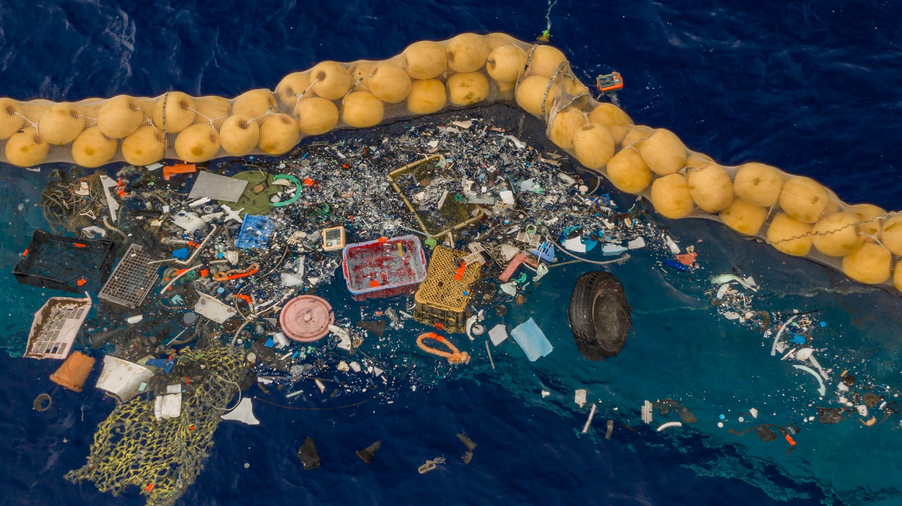

What is happening in the Atlantic has already happened in the Pacific. A good general reference for the Ocean Cleanup group can be found here

https://theoceancleanup.com/great-pacific-garbage-patch/

So that is the mess. How did it get there? From Rivers.

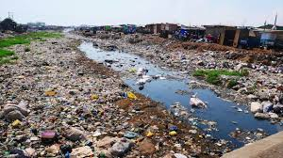

(Stock Photos from Google) Very Polluted Rivers.

Eighty per cent of Ocean Trash comes from Rivers. Enter the Ocean Clean Up Foundation’s Interceptor.

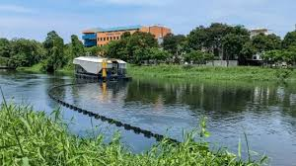

Ocean Cleanup’s River Interceptor is a brilliant machine. The Interceptor is anchored and a boom is let out and anchored to corral debris coming down a river. The river current takes the debris to conveyer belts that move the debris to large bins inside the Interceptor. As a bin gets full the conveyer is moved to the next bin. When the bins are almost filled a message is sent to a collection team that brings out new bins and takes away the full one.

Did I mention this is all automated and SOLAR POWERED?

We don’t have the large rivers or Interceptors here, so, we need to do out part to not litter first and then clean up after those that don’t understand the importance of clean water.

Here is the video of how the Interceptor works.

https://www.google.ca/search?q=river+clean+up+Interceptor&source=lmns&tbm=vid&bih=625&biw=1366&hl=en&sa=X&ved=2ahUKEwjb__CW1tj9AhWnD1kFHQFJAy0Q0pQJKAR6BAgBEAo#fpstate=ive&vld=cid:23e5ba48,vid:bm1rH70wfJo

**Gardening Ideas**

I have heard the best gardening idea this week from a teammate at my call center.

You may have seen it on Facebook, where they break open blueberries and pot them.

My buddy Dawn did that and she figures she has 100 blueberry plants growing in her basement. One step more …. Drumroll please …. Dawn admits she has a lot to learn about gardening and because of that she thought nothing of using FROZEN blueberries for her experiment. AND IT WORKED!

Like my first time gardener friend AMY who grew these beautiful yard long Armenian cucumbers. Meanwhile I still can’t get those cukes to grow longer than a straight eight variety.

Dawn wants to reduce her lawn and turn it into gardens bit by bit. She feels in the future she will need a strip of grass out by the sidewalk just to give a street break for her plants. She has planned that she can keep that strip of grass tidy with an electric grass trimmer and the grass put in her compost to continue the cycle.

More people are thinking sustainable. Thanks be.

**Make a River**

I asked around about what would be a good craft when talking abut rivers. Someone came up with “Make a River with sand.

Making a river really interested me. Apparently it was a fun thing one Grandma used when visiting Grandbabies were much smaller. She used a tarp and a bag of traction sand with a variety of spoons and shovels and buckets.

She kept the sand in the middle of the tarp and repurposed an old belt to tie it shut when not in use.

The tarp would be laid out flat on the lawn and the hose turned on to fill water buckets. Besides that, the kids made mountains and valleys and a river. Kept them busy for hours. So simple. So easy to store in a shed.

**Peanut Butter Cereal Cookies**

One cup white sugar

One cup corn syrup

One tsp vanilla

One ½ cups peanut butter.

Five cups of crushed cereal

Two cups mini marshmallows

Use a large saucepan, like a stew pot.

Add sugar, corn syrup and vanilla and bring to a boil stirring continuously

Add peanut butter until it is all mixed well together.

Mix in the cereal.

Add marshmallows last so they don’t melt too much.

Drop by spoonful or use a cookie or ice cream scoop.

Let cool. I keep them in an air tight container, not that they last long wen the grandbabies are here.



**A Prayer for Children and the Environment**

Loving Lord, your word reminds us how much you value and love children. We pray for the climate crisis and the devastating impact on children’s lives and future generations.

We thank you for young people and their passion and conviction to care for and protect your world for the common good. We pray that their actions and words will be taken seriously.

We ask that as adults, we’ll strive to protect the world that they will grow up in. We thank you for Compassion’s local church partners and for the amazing work that they are doing to protect your precious ecosystems, children, and their communities. Amen

https://www.compassionuk.org/blogs/5-powerful-prayers-for-climate-change/