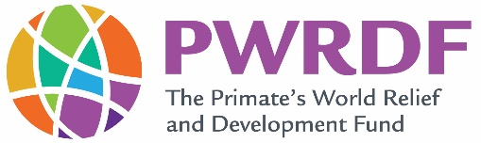
Working towards a truly just, health and peaceful world.

Application Form
Hurricane Fiona Resilience Response Project
Community/parish name and address:
Contact person, phone # and email:
Project name:
Amount requested:
Project start date:
Project end date:

Please review the Contents and Expectations noted in the Request for Proposal

- What is the concern / challenge that your community is facing that has been brought to the fore by Hurricane Fiona?

- What specific damage was done in your community from Hurricane Fiona?

- What supports have been offered to date, by whom and for what purposes?

- Are there continued conversations in your community with regards to what more can be done (or differently done) to be ready for a next emergency need, such as a hurricane?

- What are one or two sentences that can describe what you would to see happen as a result of your project?

- Are there opportunities by which your project can leverage or complement other funding from government or other sources, thus making possible an even larger benefit?

- Please provide a budget with specifics on inputs of goods and cost of any services or training. With the budget, provide any explanation that will be helpful in understanding your project.

- Should you have support from government officials or from others in your community, please feel free to share their names. Is this project eligible for funding from another source and have you applied?

- Please share any relevant reports, media stories about your community, etc. that may help to provide context to your application.

- What are plans for longer term sustainability, etc. (recurrent costs, etc.) and follow up.

Please note that the maximum amount of funding per initiative is $8,000.

Please send your completed application to:

Chris Pharo, PWRDF Diocesan Representative
cpharo@eastlink.ca

