February 07, 2023
Email: HYPERLINK "about:blank" endionspei@gmail.com Website: HYPERLINK "about:blank" nspeidiocese.ca/den
Facebook: HYPERLINK "about:blank" Environment Network Diocese of NS & PEI

“To strive to safeguard the integrity of creation and sustain and renew the life of the earth”.

The Enews welcomes contributors on issues that ignite your passion for the earth. Feel free to email us: endionspei@gmail.com




The next Christchurch Climate Cafe will be February 16 at 7:00 PM in the Christ Church Hall, Ochterloney St in Dartmouth. We meet the third Thursday of each month. For information, please contact Nancy Blair, nancyblaircounselling@gmail.com All are welcome.


Please note that this demonstration and the related hearing is on hold and will be rescheduled as Equinor has asked for an adjournment of the hearing. We will write with a new time when we have more information on the hearing rescheduling. In the meantime, we are asking if you can make a call to the Prime Minister and Minister of Natural Resources to tell them they must reject further development of offshore oil. Here's our recent mailer with their numbers and points you can make: https://www.sierraclub.ca/en/civicrm/mailing/view?id=2865&reset=1



Unearthing Solidarity: Global Voices on Mining
Everyone is invited to join us on Thursday, February 16, 7:00 – 8:30 PM Eastern time for an online event with Indigenous and global partners who are advocating for mining justice.
Seeking justice in resource extraction has long been a goal for Development and Peace (Caritas Canada) and KAIROS, and more recently for the Student Christian Movement (SCM). These three groups have organized a learning and action series for students and young adults that includes an in-person study of Joan Kuyek’s book, Unearthing Justice: How to Protect Your Community from the Mining Industry. At the February 16 webinar, Joan will moderate a panel of three global or Indigenous partners to deepen and expand this learning circle.
Follow up to the webinar will include planning an action at the Prospectors and Developers Association of Canada conference in Toronto in March.
To Register: https://secure.kairoscanada.org/civicrm/event/register?reset=1&id=321




“There is plenty of private coastline that Cabot can buy to make their golf course. This is a democratic issue. West Mabou Beach Park is public land, it belongs to the people, and is protected through legislation to save crucial ecosystems and ensure access for everyone living in Nova Scotia. Cabot can pay locals market value for the land and still make contributions to the local economy, as any developer should. If they want to build a golf course, then they can do it on private land and leave our ecologically crucial provincial parks alone!”
https://www.change.org/p/protect-west-mabou-beach?recruiter=1175151957&utm_source=share_petition&utm_medium=facebook&utm_campaign=psf_combo_share_initial&recruited_by_id=d5e3ed60-59b1-11eb-8dda-b526dfce9633&share_bandit_exp=initial-34856699-en-CA&utm_content=fht-34856699-en-ca%3A0

Kairos Canada is asking us to Take Action – Keep up the Pressure on Bill C-226 to end Environmental Racism.
For more information: https://www.kairoscanada.org/take-action-keep-up-the-pressure-on-bill-c-226-to-end-environmental-racism
Editor’s Note: Thank you so much to Jesse Hamilton for moving beyond assistant editor with Eva Evans to filling in completely while Eva takes a much needed family vacation.
Mondelēz: Be a Rainforest Hero (sumofus.org)
This petition is asking for a big public push towards 100% sustainable palm oil. Mondelēz is the company that makes Oreos. They have cut ties with many of the large palm oil producers and they claim to be using only sustainable palm oil. However, the supply chains for major companies include too many small palm oil companies that still burn and bulldoze rainforests illegally. The good news is that Mondelēz is keen to become truly sustainable, and if this snack food company goes full-disclosure on palm oil then many of its peers will follow. Add your voice to say palm oil needs to be 100% sustainably sourced!
Take Action, Sign a Petition | The Animal Rescue Site, a GreaterGood project
The woodland caribou populations in North America are in trouble and they have been on the decline for years. Predators and habitat destruction from encroaching human activities continue to threaten them, but they have one last great refuge - Canada's Boreal Forest. This forest is being destroyed by logging, roads, and pipelines. Despite the fact that the endangered woodland caribou are a protected species under Canada's Species at Risk Act, deforestation continues to decimate the caribous' habitat and food. Sign your name to tell our government we need to protect the woodland caribou and their habitat in the Boreal Forest!

Petition · Save Ngong Road Forest from more destruction, reroute the sewage line · Change.org
This petition is brand new and it comes from a 10-year-old Kenyan eco-activist named Jada Neema. She asks, “Do children not have the right to clean air? To water? To a liveable future city and planet?”. Jada is trying to stop the biggest remaining forest in Nairobi city from being destroyed, all in order to put a sewage line through it. Thousands of trees will be cut down and the animals will lose their habitat. This petition will go to the Kenyan Cabinet secretary for Environment and Sanitation. Sign your name to support Jada and to show there are people everywhere who care about forests and our shared environment and future.
Canada: Stop Bankrolling Fossil Fuels | Amnesty International Canada
Burning fossil fuels accounts for more than 70% of global greenhouse gas emissions. It is the primary cause of climate change, and the ripple effects endanger the right to life, to water, food, housing, health – the list goes on and on. A rapid phaseout of fossil fuels is necessary, and the industrialized countries who continue to fund the expansion of fossil fuels are sadly condemning countless people to the worsening impacts of climate change. Export Development Canada is one of the biggest public financial backers of fossil fuels in the world. They direct billions to fossil fuel activity in Canada and other countries. This petition is urging Canada to STOP financing fossil fuels!
Stop Plastic Laundry Pods and Sheets from Contaminating Our Water - Action Network
Plastic is everywhere, right down to the way we wash our clothes. Laundry detergent pods are made from a petroleum-based plastic called Polyvinyl Alcohol (PVA). The conditions needed to degrade this plastic are very specific and do not exist in most wastewater treatment facilities. There is research showing that over 75% of intact plastic particles from these laundry and dishwasher pods and sheets are released into our oceans, rivers and soil. PVA has recently been found in drinking water. It may not be visible to the human eye, but it’s still contributing to our current plastic crisis at a massive scale. This petition is going to the EPA, demanding the regulation of PVA in consumer-packaged goods and to keep this plastic film out of our water!
Air wells, fences, and catchers.
Failure can be a blessing. Let me explain.
Two years ago, I told you about fog fences. It is two upright poles with a net strung across it. Fog gathers on the net and gravity feeds it down to a trough which drains the water into a bucket.
What I constructed was a good start. It gave water, just not enough. It kept one box garden watered where I have seen photos of green fields. We all want BIG so I thought my (present) fog fence was a bit of a failure.
It was and I thank the universe for that lesson.
This year my fog fence will have four sides. Whichever way the wind blows, water will collect. I want to use AC condenser filters for at least one side. This story will continue as I grow. I promise pictures.
Research a bit more and you will find “dew collectors” and “air wells” in the same category.
One of the best stories I had seen is about a simple roof structure or a sloped wall.
At one point I saw where in a semi-desert type area the roof collected rainwater (when it occasionally rained) and kept it in a cistern for use in months without rain.
This week that same-shaped structure was set up so each morning someone would use an oversized squeegee to wipe down water from the roof.
The “roof” can be a tarp. It has a frame under it but even Grandma can see making a frame. There are a few tarps sitting around here that could be put to use. I wonder where I use the roof of a shed as part of a makeshift greenhouse in the springtime, could I run a trough off that and wipe down the roof with something like my roof rake for snow? Let’s see what Grandma can do.
Tarp Air Wells
https://www.permaculturenews.org/2016/05/09/airwells/
Hydro Panels, Sky water, Condensers.
https://www.youtube.com/watch?v=k7Vfp4aAuKE

https://www.youtube.com/watch?v=0F7CQMd6mQ4
Grandma’s first Fog Fence
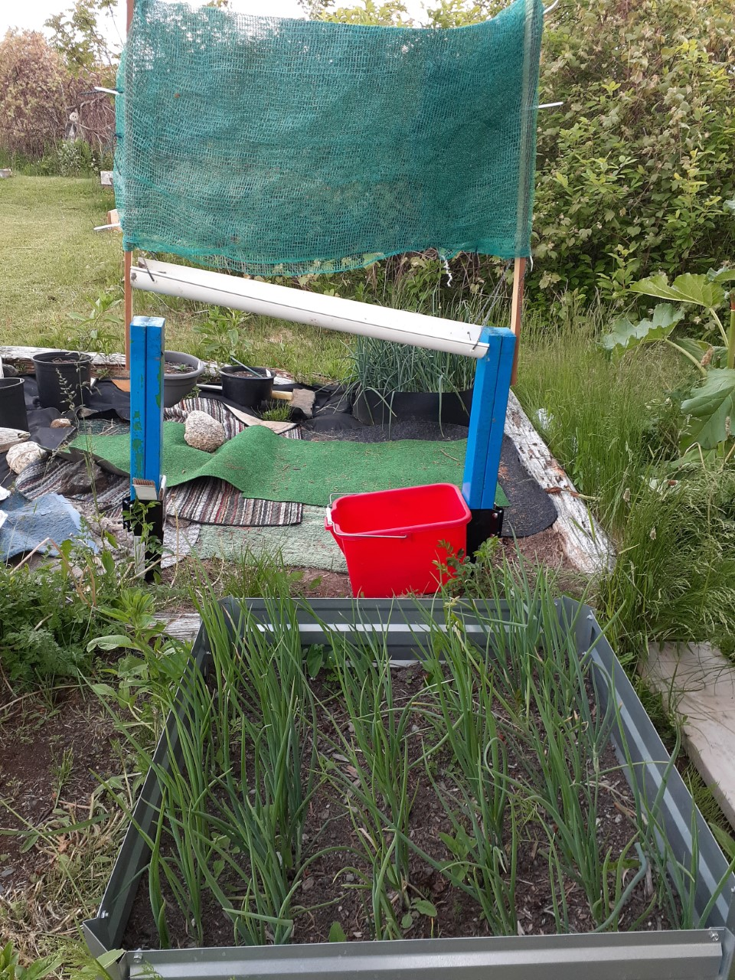
CRAFT
Craft this week is an idea for Earth Day. I know it is early but if your church is planning something for the community for their “Bunny Day”, you need ideas now.
Make your planting pots
You will need
A can of skinny soup (10 oz I think)
Newspaper
Tape
If you have a double page of newsprint, fold and make 4 pieces of long paper. I use a letter opener to make fast work.
Take 2 pieces of paper thick. Lay your can on the paper with a bit of the can sticking out. Roll the can, wrapping the paper around the can. Tape the paper together. Fold in the end and tape shut. Pull out the can.
There are fancy wooden tools that do the same thing. I have found regular soup cans work just as well
Now NEXT STEPS could be
Have the Sunday School plant after making their kits and take something home on Earth Day
Add a pack of seeds (make your packets) and a bag of soil as an Earth Day giveaway
Start your own sets in these containers to give away at Rogation. Have fun.
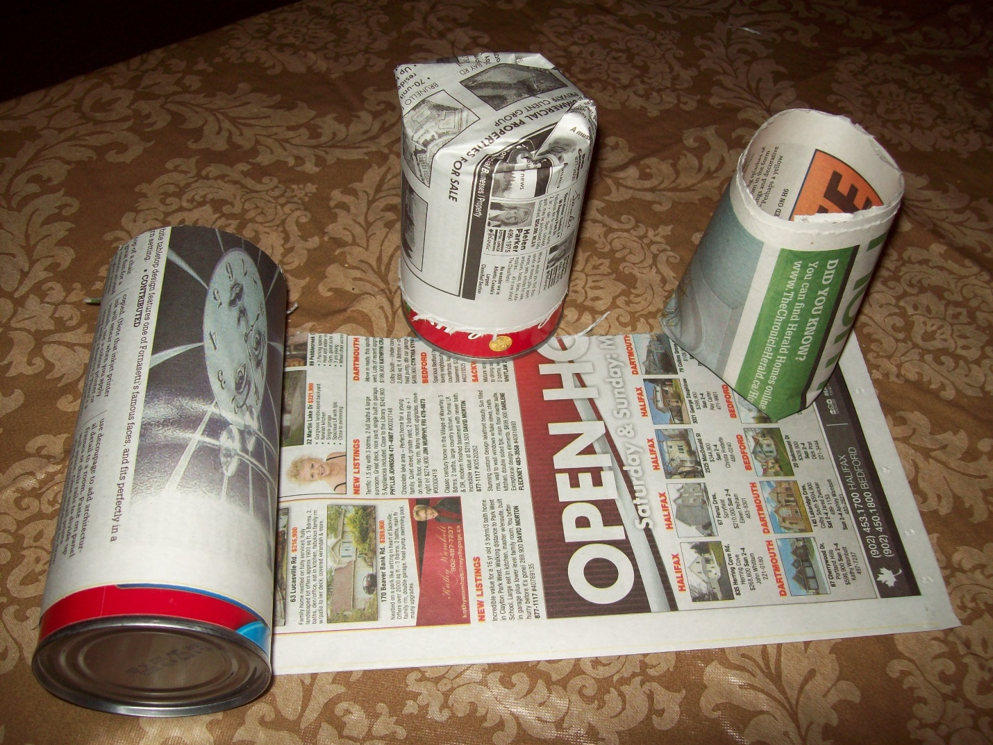

Something to Eat
During the cold spurt, Grandma spent the morning cooking and baking. Many sweets went into the freezer but supper made a new dish. I didn’t quite have all the fancy things asked for so this is how I made it
Taco Pie
Tortillas
Oil
Onion
Peppers
2 garlic cloves
Can of Refried beans
Can of chili
Can of drained kernel corn
Salt and pepper, ½ tsp ground cumin if you like it.
1-2 cups shredded cheese
Heat the oil in a pan and add everything. I had one can of refried beans. The can of chili added more volume.
If you have the big tortillas, use 4, smaller use more. The idea is to lay a tortilla, add sauce, add cheese, and repeat for 4 lays adding extra cheese on top. Into the oven at 350 for 20 minutes.
It was so good with a salad.

Environmental Racism
As a prayer practice this week, we recommend prayerfully reading this blog from Ecojustice.
https://ecojustice.ca/environmental-racism-in-canada/

Let us also pray for Turkey and Syria as they deal with the effects of the recent earthquake.
St. Peter, first Pope, who preached in Antioch, pray for us.
Sts. Andrew and Philip, Apostles, who preached the Word of hope to this region, pray for us.
St. Paul, who journeyed through the region, preaching the Gospel, pray for us.
Great doctors of the Church, friends and brothers, John Chrysostom, Basil the Great, Gregory of Nazianzen, John Chrysostom, pray for us.
St. Cyril of Jerusalem, pray for us.
St. John of Damascus, pray for us.
St. Ephrem the Syrian, pray for us.
Our Lady of Sorrows, Consoler of Syrians, pray for us.
Sacred Heart of Jesus, have mercy on your suffering people. Amen.
https://aleteia.org/2023/02/06/litany-for-earthquake-victims-in-turkey-and-region/

