January 31, 2023
Email: HYPERLINK "about:blank" endionspei@gmail.com Website: HYPERLINK "about:blank" nspeidiocese.ca/den
Facebook: HYPERLINK "about:blank" Environment Network Diocese of NS & PEI

“To strive to safeguard the integrity of creation and sustain and renew the life of the earth”.

The Enews welcomes contributors on issues that ignite your passion for the earth. Feel free to email us: endionspei@gmail.com

Proud Mom, Dorothy Mosher, wrote to tell us that her daughter, Linda Mosher, former HRM councillor for 16 years, was awarded the Queen Elizabeth Platinum Jubilee Medal in recognition of her work for the environment. Congratulations Linda!




We’re taking Big Oil and Gas to court and we want you to join us!
When: Wednesday, February 1, 9-10 AM
Where: Nova Scotia Supreme Court, 1815 Upper Water Street, Kjipuktuk/Halifax
For more information:
https://www.facebook.com/events/571500767910112?ref=newsfeed



IISD is excited to host a webinar TOMORROW February 1st, 12:00pm EST about ensuring Canada’s energy transition aligns with 1.5 degree scenarios. We’ve got an exciting line-up of speakers – see below for the full list – and hope you will join us!
Register here: https://us06web.zoom.us/webinar/register/WN_VNCmNJgPT5WZBIt-Dc85-g
Vanessa Corkal (she/her) Senior Policy Advisor, Canada Energy Transitions International Institute for Sustainable Development (IISD) www.iisd.org

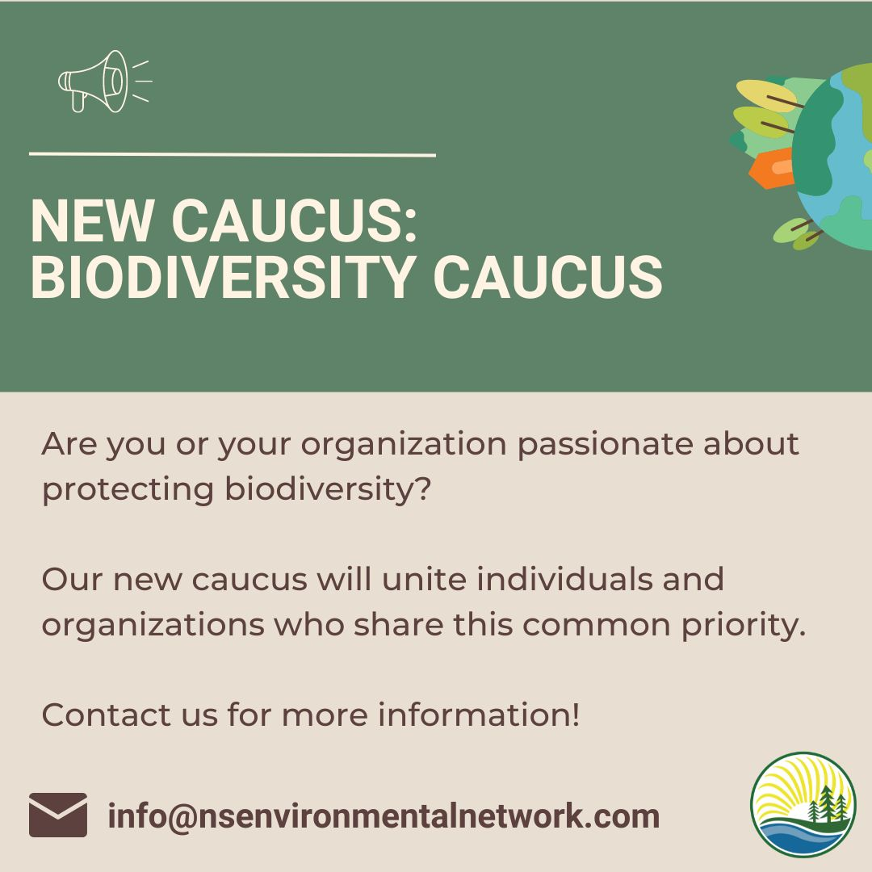 | The Nova Scotia Environmental Network will be hosting an information session TOMORROW Wed. Feb. 1st at 7 pm. To provide an opportunity to find out more about this initiative. To Register:  https://nsenvironmentalnetwork.app.neoncrm.com/np/clients/nsenvironmentalnetwork/event.jsp?event=69&&secureIdCustomer=1&  Are you passionate about protecting biodiversity? Our new caucus will unite individuals and organizations who share this common priority. We ask those who are interested to please complete the form below to express your level of interest in joining the biodiversity caucus.  https://docs.google.com/forms/d/e/1FAIpQLSc9WGIpze45-jfhNwNTJvAFy3kujcIQ76xn3ewGABv2bq2YAQ/viewform


Following a resolution at the recent January 16th meeting of the National Council, we are pleased to share the news with you that the February 4th AGA will be open to non-voting observers to attend.
If you are not already a delegate for your diocese, you are warmly invited as an observer to register for the AGA using this same registration link.
To register as an observer to the February 4th AGA (1:30pm ET) Please Click on this Registration Link: https://us02web.zoom.us/meeting/register/tZAkfuysrzwvH9TIOK_MYudKl4JsBlkXHPhI
We have also conveniently created an online folder where all the relevant AGA documents, including those already received by delegates via email, can be located: Info - AGA 2023


We’re excited to host two wonderful speakers:
- Ann Eriksson is the author of Urgent Message from a Hot Planet: Navigating the Climate Crisis, an illustrated book about the climate crisis and how to take action.
- Eric Doherty is a transportation planning consultant whose research informed Amnesty International’s 2021 report Stop burning our rights! and Amnesty Canada’s latest comic book, Stop Paving Over Our Rights.

To Register:
https://amnesty.ca/what-you-can-do/events/#event=75551104;instance=20230205163000?popup=1&utm_medium=email&utm_source=engagingnetworks&utm_campaign=utm_campaign&utm_content=Workshop-Jan25-2023-Climate+Justice



Unearthing Solidarity: Global Voices on Mining
Everyone is invited to join us on Thursday, February 16, 7:00 – 8:30 PM Eastern time for an online event with Indigenous and global partners who are advocating for mining justice.
Seeking justice in resource extraction has long been a goal for Development and Peace (Caritas Canada) and KAIROS, and more recently for the Student Christian Movement (SCM). These three groups have organized a learning and action series for students and young adults that includes an in-person study of Joan Kuyek’s book, Unearthing Justice: How to Protect Your Community from the Mining Industry. At the February 16 webinar, Joan will moderate a panel of three global or Indigenous partners to deepen and expand this learning circle.
Follow up to the webinar will include planning an action at the Prospectors and Developers Association of Canada conference in Toronto in March.
To Register: https://secure.kairoscanada.org/civicrm/event/register?reset=1&id=321

Information session TONIGHT - Tuesday Jan 31 from 6:30 to 8:30 pm at Hartlen Point Golf Club.
You need to register here: rsvp@prospectus.ca
If you attend, these are the questions we will be asking in support of the Save Hartlen’s Point Group:
- What consultation was done with local residents and businesses?
- What is your response to the COP 15 focus on protecting nature and halting biodiversity loss around the world?
- How do you justify building on a biodiverse headland, and on a migratory bird staging area which cannot be mitigated?
- Why can’t a different spot be chosen for the build? One with an already degraded environment. (i.e. the oil refinery land is for sale in Eastern Passage) or the Shearwater base where there is already safe management of radio frequencies?
- Why should this build happen in the fastest-growing community in HRM, where you can actually see downtown Halifax?
- Why aren’t we protecting this entire site for future generations?
- At the March 22 meeting, you said the location was chosen for security reasons, to keep it away from populations, to utilize radio frequencies without harming the environment, and to be able to maintain operations on a permanent basis. How do you justify the above, in a rapidly growing urban community?
- How is Irving involved with this decision?
- Is there adequate infrastructure to service this area? Ie. Police, fire.?

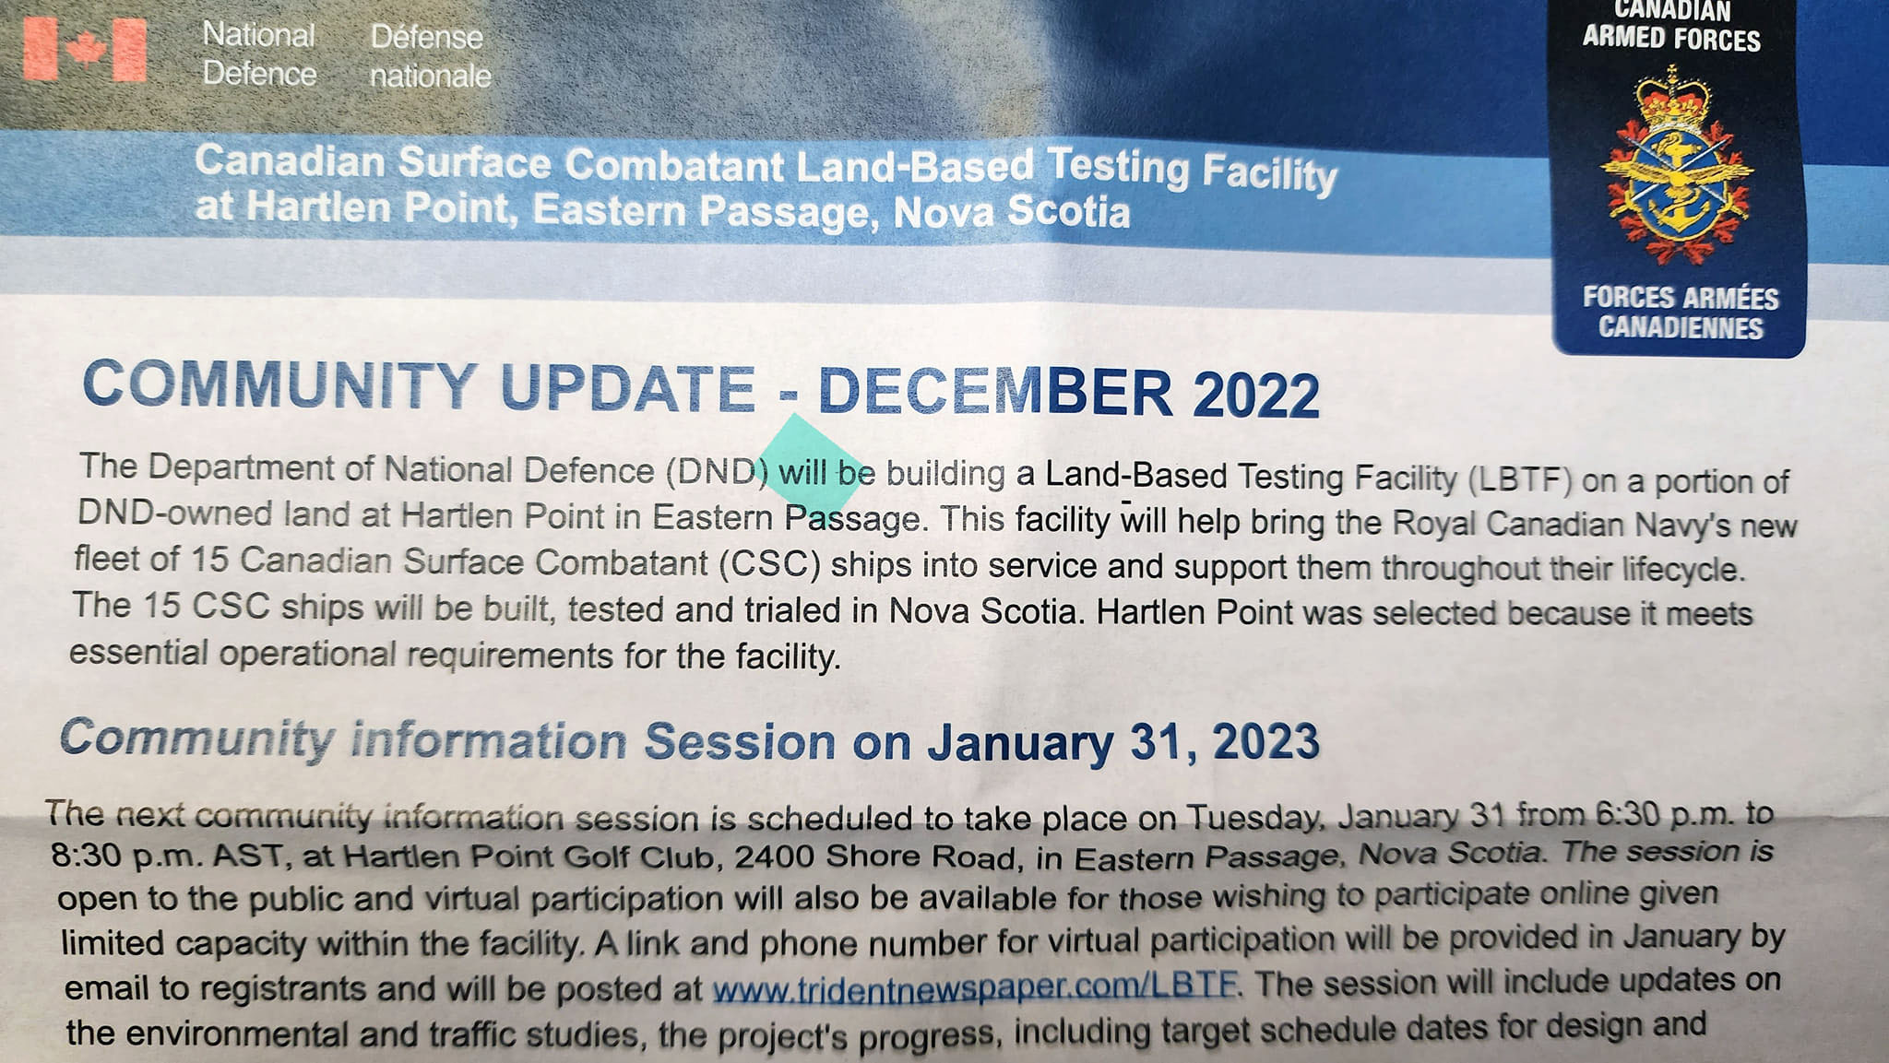



“There is plenty of private coastline that Cabot can buy to make their golf course. This is a democratic issue. West Mabou Beach Park is public land, it belongs to the people, and is protected through legislation to save crucial ecosystems and ensure access for everyone living in Nova Scotia. Cabot can pay locals market value for the land and still make contributions to the local economy, as any developer should. If they want to build a golf course, then they can do it on private land and leave our ecologically crucial provincial parks alone!”
https://www.change.org/p/protect-west-mabou-beach?recruiter=1175151957&utm_source=share_petition&utm_medium=facebook&utm_campaign=psf_combo_share_initial&recruited_by_id=d5e3ed60-59b1-11eb-8dda-b526dfce9633&share_bandit_exp=initial-34856699-en-CA&utm_content=fht-34856699-en-ca%3A0

.

Mining Company Belo Sun Out of the Amazon! | Amazon Watch
Industrial mining in the Brazilian Amazon has caused a sharp increase in deforestation. Despite this, requests for permits to mine on Indigenous lands are steadily increasing and the biodiversity loss is a growing threat. Canada’s Belo Sun Mining Corporation is planning projects that threaten the already fragile Xingu River Basin, one of the most biodiverse places on our planet! This petition is asking us to join the campaign to stop Belo Sun from destroying the Amazon and its traditional communities.

Final fish farms decision pending - David Suzuki Foundation
Many salmon runs are in decline and threatened by climate change. This makes it paramount to protect wild salmon from risks within our control. Decades of research has shown that fish farms increase the risk of disease and parasites that adversely affect salmon. Our federal government made a commitment to transition away from open-net pen salmon farms by 2025. More than 100 First Nations and 75 per cent of British Columbians have said they want to remove open-net pens from B.C coastal waters. If you agree, then sign this letter going to your MP and to the Minister of Fisheries, Oceans and the Canadian Coast Guard.

Ask your MP to support just transition legislation – The Council of Canadians
This year, the federal government is planning to introduce just transition legislation to address the climate emergency. This legislation needs to prioritize workers, communities, and Indigenous rights, instead of lining the pockets of fossil fuel CEOs and billionaires. The Council of Canadians’ petition can make needed change by demanding we reduce emissions, wind down the fossil fuel industry, and create good green jobs. More than 40 MPs across party lines have committed to tabling this petition so far. Check to see if your MP is one of them and if not then send a letter asking them to support just transition legislation!

petition: The U.S. Needs to Finally Ban Single-Use Plastics (thepetitionsite.com)
The need to ditch single-use plastics is a global one and the health of our environment affects us all. There has been a recent victory for our planet, with the British Government recently joining the other countries who have announced official bans on many single-use plastics. Currently, corporations produce over 300 million tons of plastic every year around the world. A ban in the U.S. would help significantly reduce that number. This petition is a way to tell the EPA to step up and finally enact a single-use plastic ban!

Petition · Stop trophy hunting of grizzly bears in the Yukon, Canada · Change.org
Grizzly bears were once wide-spread throughout North America. With human development, these bears have had to accommodate farmers, ranchers, mining, and big oil. They face even more threats by being persecuted for entertainment and trophy hunting. In June 2018, grizzly bears in western Canada were listed under the federal species at risk act as a species of special concern. Regardless of this listing, trophy hunting is legal in the Yukon and more than two thousand hunting tags are sold each year. Grizzly bears are the slowest land mammal in North America to reproduce and they are highly vulnerable to habitat changes. This petition is from an organization called Grizzly Bear Protection Yukon and is asking us to take action to ban trophy hunting.
DEN Challenges parishes to make planting kits for your local community. Let us know!
Planting Kits
It is the end of January and I am in the middle of planning Planting Kits.
Since 2012, the Parish of Blandford has been involved in teaching the children to grow their own food. In the beginning, we had “planting night” where we got together as a community and invited youth groups from other communities to join us to plant.
We used as many different types of recycled containers as we could find and spent a couple of hours putting seeds in the ground.
The year before the pandemic we started the planting kits. On Planting night, we put together I think a whole 20 kits that night to give to the Senior group (who held their meeting next door the same night). After planting the kids took the kits to the seniors and talked about what they did.
The pandemic made us “think” we had to stop planting night.
About two minutes later I wondered if I couldn’t make some kits and put them out by the road to be picked up. I made up 30 kits and made up a sign “Free Planting Kits”. I took a picture and put it on our Blandford page and the kits disappeared.
The next year, still in the grips of Covid I made 60 kits and they disappeared.
Last year we were back at our convenience store and 80 kits disappeared. We had taken another 50 kits to the Hubbards Area Lions Club which works with a school and sent them home in the backpacks of 50 kids.
The rest of the kids in the school wanted a planting kit
SO
This year we are making 100 kits for the school and 80 to give away in Blandford.
Better yet, the Lion’s Club wants to join with the Parish to make this happen.
The kits are different this year. We are changing from three veggies to one
This year we are going to use the news stories of how hard it is to get lettuce to teach you can grow your own.
I will still be making seed packets to repackage lettuce seeds from bigger packets. Just ordered the seed.
This year I am asking the person that labeled the 390 seed packs by hand last year to write on the master sheet that I will photocopy.
I have saved the tops of yogurt and margarine containers to cut into plant markers and labeled” lettuce”
The Lions Club is providing soil. They are finding bowls to grow the lettuce in and small paper bags to put the soil in.
The tag is an important thing for me. This year it is “A Planting Kit from the Parish of Blandford AND The Hubbards Area Lion’s Club.
Consider yourself invited to a work party at the Fox Point Lions Club in the afternoon on Saturday, April 1st. Their Bunny breakfast is that morning between 9-12. Get a great breakfast for a donation at the door. Take a drive around the peninsula and come back in the afternoon to work.
Why is Grandma excited over a work party? Two reasons.
First, we get to not only brag but send out a challenge. What other Parish can do a “planting” challenge? It doesn’t have to be big. Ours grew from a night with a dozen kids.
Secondly, it is our job as Anglican Christian folks to shine our light and show by example, what can help those around us. It may be a kid’s planting kit but our little place is shining and growing with our community to show what our Lord is teaching.
These were the original kits
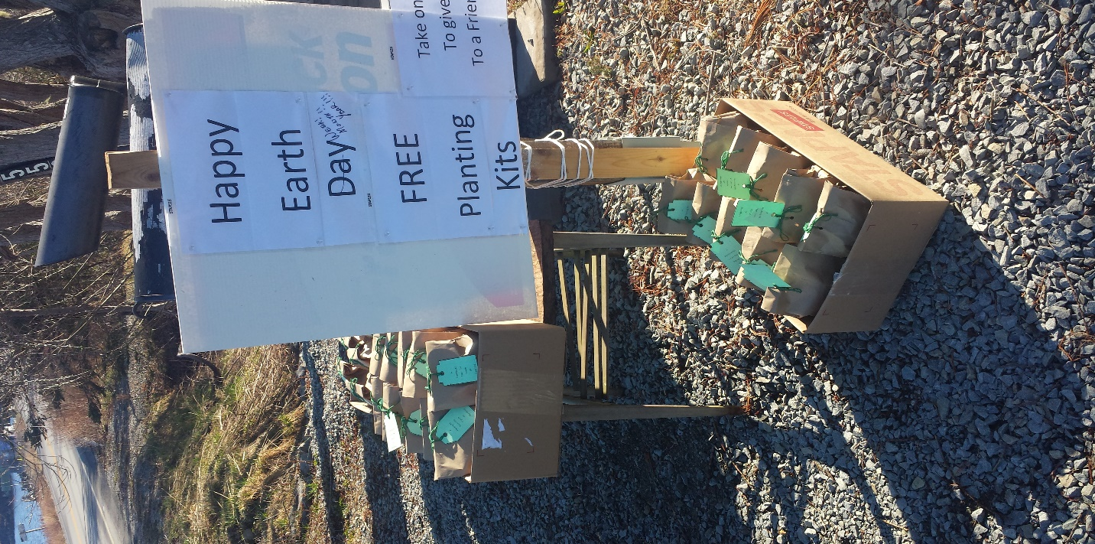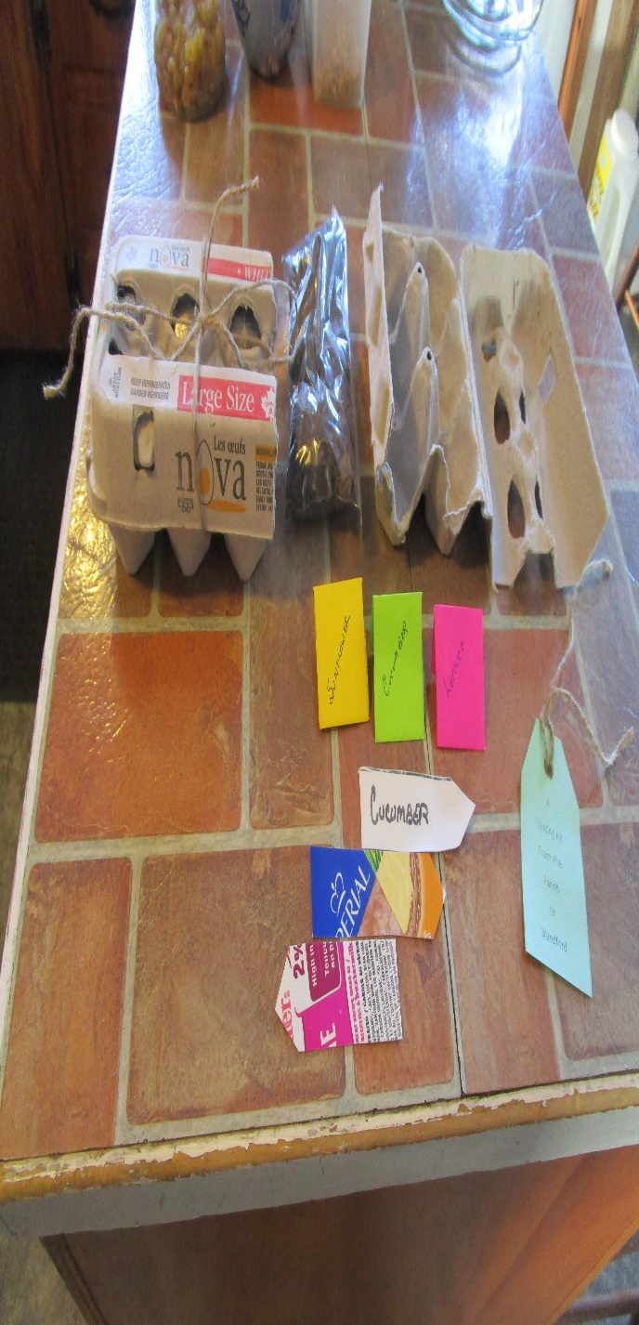
Wait for a picture of the 2023 Planting kits

Filing paper
One thing that I have way too much of is paper.
I have discovered paper isn’t the problem but the MESS of a pile of paper is.
Why not have a sorting place where paper can be thrown, and organized, until you have a minute for the next step?
Find a cereal box or some sort of tall skinny box. Mark about two inches or more, up from the bottom of one side of the box. Draw a line from that mark to the top of the opposite side of the box. Make a matching line on the opposite side and cut that piece out.
Next, you decorate the box. Scraps of wallpaper work well as a cover. Glue on coloured paper. Paint the box.
When finished, label what it contains. Mine read Bills, Green, Crafts, Food, and Whatever. There always is something that doesn’t fit in anything.
You may see the trend here this month. Making things that reduce mess.
I wait till Lent to do my Deep Clean. I usually give up clutter for Lent and TRY, try being the important word, try to get rid of a former grocery store bag size of something daily. That could be going through the closet and dresser drawers and giving away or just plain throwing away, what has been sitting for a year or more. One area alone may give me 3 or 4 days’ worth of clutter. A book cleanse is so hard but so is a fabric cleanse in your craft room.
I don’t have to look far for a mess here. Luckily, I still find ways to reduce the messes
I do apologize. Grandma could not get pictures taken of the different stages of this craft. So I found a good tutorial on the internet. It has lots of pictures.
The best instructions so far are
https://www.instructables.com/Cereal-box-magazine-holder/
https://christines-crafts.com/diy-magazine-holder-from-a-cereal-box/
Something to Eat
Grandma was gifted a large new fry pan with a cover for Christmas. She had worn out her last one.
As days get busier as spring comes forward or those winter days when the wind blows cold, Grandma loves to make a one pan skillet meal. There are so many to choose from but this one is rather basic. Enjoy!
Cheeseburger Macaroni Skillet
1 good sized package of hamburger
4 cups macaroni
3 cups beef broth (2 beef powder envelopes in water)
¾ cup milk (or whatever dairy you have too much of)
3-4 tbsp. ketchup
2 tsp. Montreal steak seasoning (or Italian seasoning)
1 tsp dry mustard or a squirt of regular mustard.
1 tsp onion powder or cut up an onion.
Cook the hamburger (and onion) and drain off the excess fat.
Add everything else. Bring to a boil and then reduce and simmer 15-20 minutes until the macaroni is cooked and little to no liquid in the pan
Makes enough for 2-3 meals for Nana and I. A salad is added if time allows.



