January 24, 2023
Email: HYPERLINK "about:blank" endionspei@gmail.com Website: HYPERLINK "about:blank" nspeidiocese.ca/den
Facebook: HYPERLINK "about:blank" Environment Network Diocese of NS & PEI

“To strive to safeguard the integrity of creation and sustain and renew the life of the earth”.

The Enews welcomes contributors on issues that ignite your passion for the earth. Feel free to email us: endionspei@gmail.com



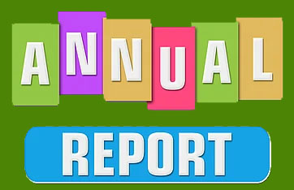

Every parish leader and council is in the midst of writing reports for their annual meeting. Does your parish have a report on how you are caring for God’s Creation? How you are responding to the 5th Mark of Mission?

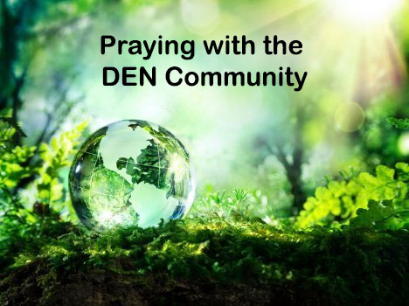 | Praying with the DEN Community continues each Friday 9:00 am on Zoom. To obtain the link, please email endionspei@gmail.com The prayers are led by DEN members who are deeply committed to praying for God's creation and for sharing interests and initiatives and information. Individual members take turns leading the prayers which are followed by a time of discussion, conversation and sharing. All are welcome to participate. Thanks to The Church of St Andrew for hosting.

If you read the Anglican Journal in September, you already know a national group has been created to erase Anglican churches’ ‘huge’ carbon emissions from coast to coast. The Net Zero Churches Project group was formed in January 2022 and their aim is to reduce the greenhouse gas emissions from church buildings to zero. In October our Diocesan Environmental Network (DEN) committed to participating and a volunteer coordinator for our diocese was appointed. Hopefully, many parishes in our diocese will embrace the initiative as a way to honour the 5th Mark of Mission, “To strive to safeguard the integrity of creation and sustain and renew the life of the earth.”
The Net Zero Churches Project has sought technical guidance from educational institutions nationally and aims to share information gleaned to advise parishes how to reduce carbon emissions. Understanding how to reduce emission of greenhouse gases by addressing type of mechanical systems in facilities and reducing energy consumption are the initial challenges being addressed.

How can we find out more about the Net Zero Churches Project?
You can learn more by:
• Reading the article in the September issue of the Anglican Journal,
https://anglicanjournal.com/new-group-aims-to-erase-anglican-churches-huge-carbon-
emissions/
• Viewing the Net Zero churches video at https://www.netzerochurches.ca/
• Contacting:Margaret Bateman Ellison, Volunteer Coordinator for Diocese of Nova Scotia and Prince Edward Island briarwoodbob@aol.com
* Mark Gibson. National Coordinator coordinator@netzero.churches.ca

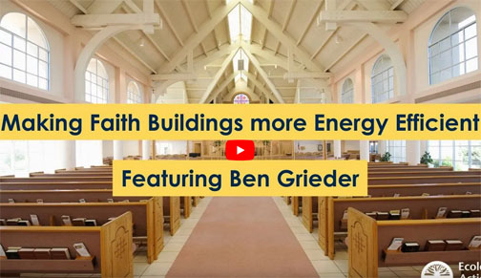

With thanks to Lorraine Lewis for sending us this link to the video prepared for the Ecology Action Center by Ben Greider. https://www.youtube.com/watch?v=o3gxTiqN6D0


Call for Participants! Free Online Course
System Change and the Climate Emergency

The Centre for Local Prosperity and The Deanery Project have teamed up to co-facilitate an exciting and timely MOOC (Massive Open Online Course) titled Transition in a Perilous Century. The course focuses on climate adaptation education and action in Nova Scotia. We are looking for individuals, or pairs from organizations to join us. We would like at least 2 people from an organization to attend but it can be more.. A certificate of completion, or a graduate level university credit are available on completion.

The course is composed of 7 modules spread over 21 weeks. Each module runs for 3 weeks and takes about 2 hours/week to complete. Our team will be facilitating NS specific learning circles.

The course is free and begins January 29th. It aims to build a network of informed local participants focused on building community resiliency and action around climate change adaptation.

For information on the modules, and to register, visit Synergia.
Curious to know more? Email Olivia at thedeaneryproject@gmail.com or call 902-845-1888

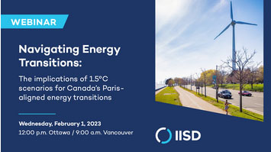
IISD is excited to host a webinar on February 1st, 12:00pm EST about ensuring Canada’s energy transition aligns with 1.5 degree scenarios. We’ve got an exciting line-up of speakers – see below for the full list – and hope you will join us!

Register here: https://us06web.zoom.us/webinar/register/WN_VNCmNJgPT5WZBIt-Dc85-g
Vanessa Corkal (she/her) Senior Policy Advisor, Canada Energy Transitions International Institute for Sustainable Development (IISD) www.iisd.org
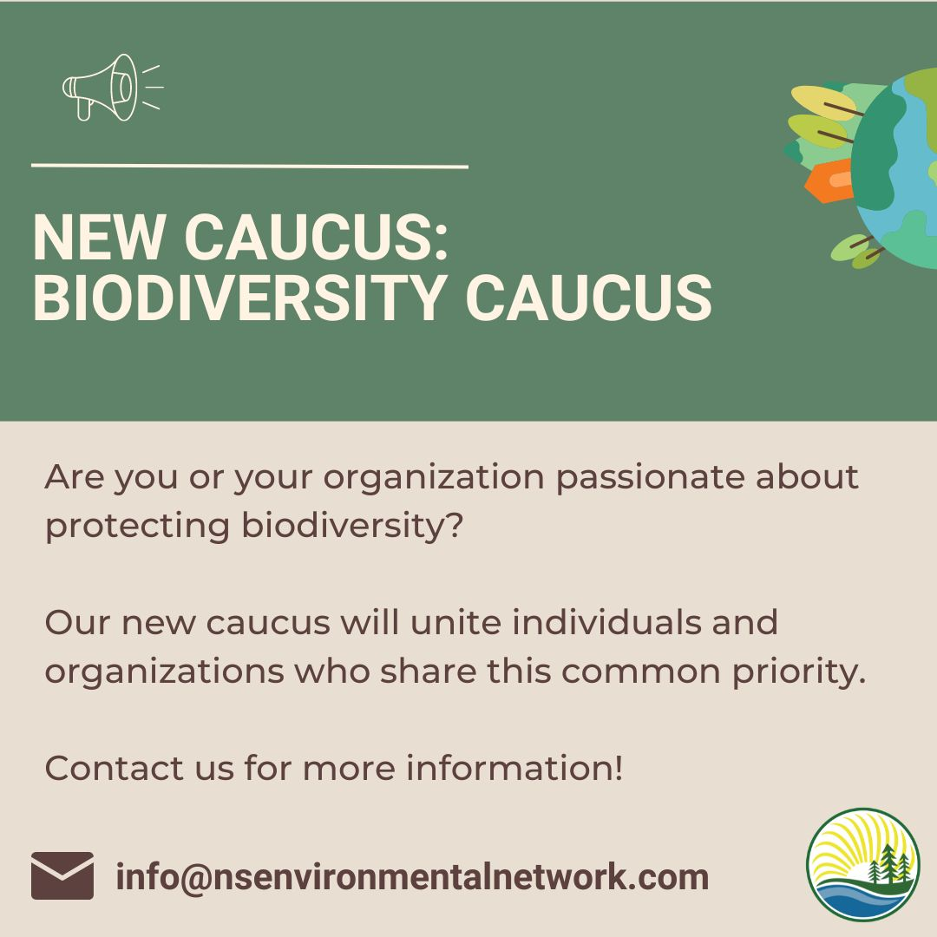 | The Nova Scotia Environmental Network will be hosting an information session on Wed. Feb. 1st at 7 pm. To provide an opportunity to find out more about this initiative.  To Register:  https://nsenvironmentalnetwork.app.neoncrm.com/np/clients/nsenvironmentalnetwork/event.jsp?event=69&&secureIdCustomer=1&  Are you passionate about protecting biodiversity? Our new caucus will unite individuals and organizations who share this common priority. We ask those who are interested to please complete the form below to express your level of interest in joining the biodiversity caucus.  https://docs.google.com/forms/d/e/1FAIpQLSc9WGIpze45-jfhNwNTJvAFy3kujcIQ76xn3ewGABv2bq2YAQ/viewform

-----------------------------------------------------------------------------------------------------------------------------------------------------------
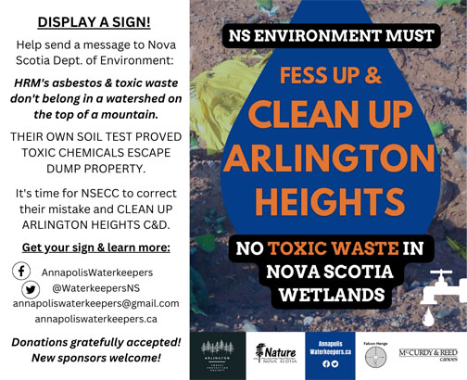

CAN YOU HELP WITH OUR SIGN CAMPAIGN?

A toxic, unlawful landfill has been degrading the land, water, air and property values on the North Mountain for too long!

Arlington Heights C&D was built at the apex of three watersheds that have provided pristine drinking water and supported livestock and gardening installations for communities immediately downslope for centuries. Four brooks from the wetland lead directly into the Bay of Fundy.

Nova Scotia Environment and Climate Change (NSECC) admits an Environmental Assessment was "overlooked" when the site was originally approved. The truth is, a lot more than that has been overlooked or outright ignored. NSECC has not followed its own rules and has failed to protect this vitally important environment. Because due diligence was not done at the outset, multiple expansion and other approvals have been allowed that never should have been.

Instead, the wetland has been all but destroyed - clearcut, bulldozed, and stuffed full of tens of thousands of tons of HRM's asbestos and toxic auto shredder residue (ASR) - all without the proper environmental protection in place (it's a generation one, primitive unlined landfill). ASR is a known carcinogen and is highly susceptible to spontaneous combustion.

We know the repeated mantra of "impermeable soil" that both the dump and the department tried to sell us is false. THEIR OWN SOIL TESTS PROVED THE PRESENCE OF CONTAMINATED LEACHATE BEYOND DUMP PROPERTY.

The answer is clear: It's time to stop this insanity once and for all and CLEAN UP ARLINGTON HEIGHTS!

GET IN TOUCH FOR YOUR SIGN! They are free, but we are gratefully accepting donations toward their cost.

Reach us on Facebook, Twitter or Email
www.annapoliswaterkeepers.ca

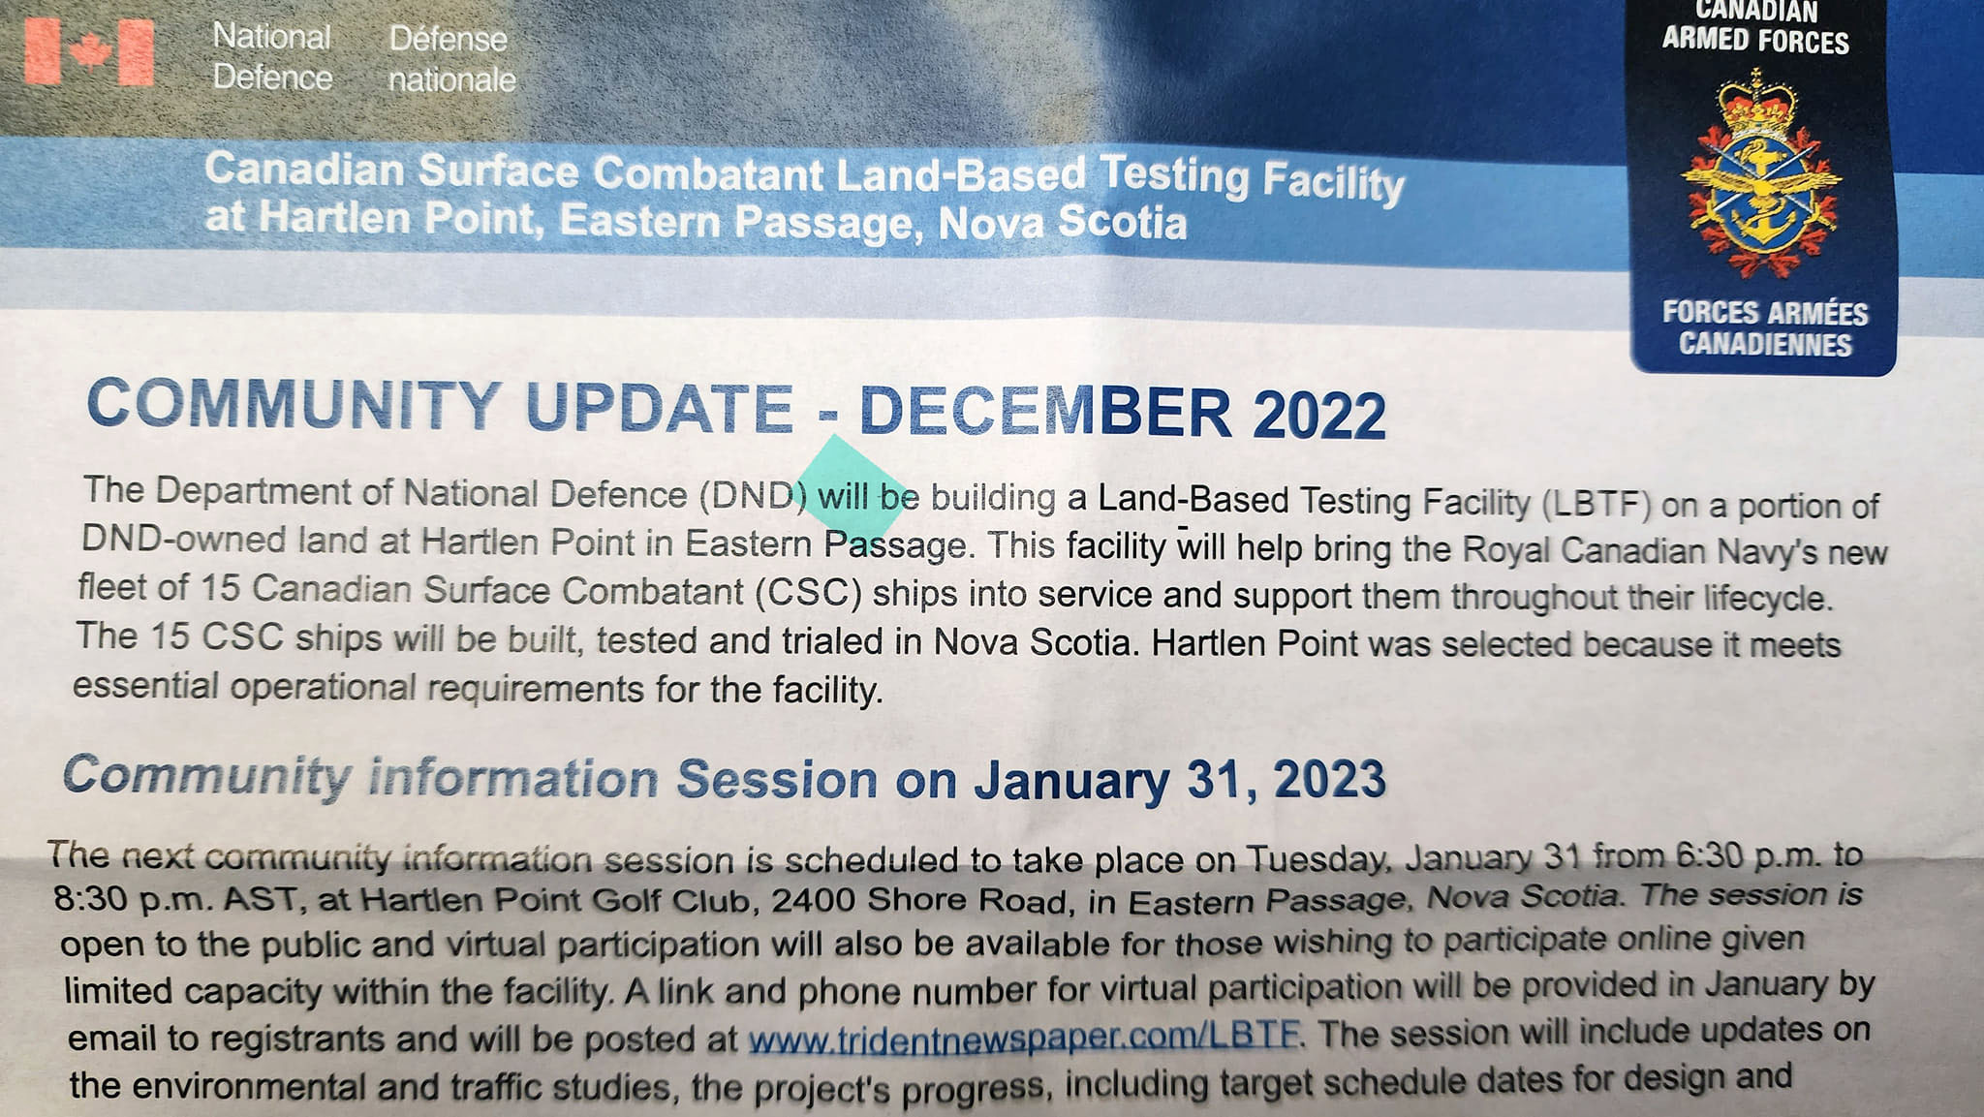
Highlight from above: Information session Tuesday Jan 31 from 6:30 to 8:30 pm at Hartlen Point Golf Club.
The Climate Emergency Unit has 2 petitions for us this week:
Youth Climate Corps
The Youth Climate Corps is an invitation to the country’s youth to mobilize to confront today’s gravest threat: the climate emergency. We are past overdue on a real plan that acts fast to transform the country away from its current trajectory to growing emissions and climate disaster. A Youth Climate Corps would put thousands of young people to work in rapidly curbing emissions, preparing our infrastructure for its coming impacts, and responding to the emergencies we're locking in. Send a message now to key cabinet ministers and MPs demanding clear action for a Youth Climate Corps that will kick off a decade of real climate action.
Climate Emergency Federal Just Transition Transfer
We desperately need to transition away from an economy dependent on fossil fuels. If we don’t invest now in safe and well-paying jobs for workers, hundreds of thousands of Canadians will be left behind. We need to get politicians acting on real climate solutions now, before more people, animals, and ecosystems are lost.
Stop plastic pollution! - Greenpeace International
This petition is asking world leaders to support a global plastics treaty. This treaty would limit plastic production, change the way corporations deliver products to people, and hold corporate polluters accountable. It would also demand full transparency on plastic production, require wealthy countries to lead the zero-waste transition and help others, and to ensure that Indigenous Peoples and affected workers have a voice in the transition to a reuse economy. Add your name to tell world leaders that we want a strong Global Plastics Treaty!
petition: The Somali Elephant Shrew Has Defied Extinction. Now Scientists Must Commit to Protecting It in the Future! (thepetitionsite.com)
The Somali elephant shrew was once declared extinct to due data deficiency, but against all odds it has been spotted in Djibouti! Researchers were able to spot 12 of them living happily together. That means there is still hope to protect the species from extinction. This petition is asking the International Union for the Conservation of Nature to invest more time and resources into research and developing conservation plans, in order to protect the Somali elephant shrew in the future.

Brazil: Stop land grabbing and violence for “fair and sustainable” palm oil! - Rainforest Rescue (rainforest-rescue.org)
Agropalma is the largest palm oil producer in Brazil. The group is certified with ten international seals for organic, fair and sustainable oil palm cultivation; however, it seems that much of their land comes from illegal appropriation of state-owned land, from local communities and from resident smallholders. Local people have complained that the company resorts to violence and roadblocks, and that it denies them access to public places such as rivers and cemeteries. Human rights organizations have also recorded serious human rights violations. This petition is asking certifiers and food manufacturers to ensure that certified palm oil is free of human rights violations.
Plasma Gems
Grandma is always looking for new ways where someone is changing waste into useable materials.
Grandma understands the science but needs to translate anything science into something of the arts. People like me are hybrids between the two worlds and like to study things like Anthropology or Environment Studies.
Plasma gems are one of those things.
You take a whole bunch of trash and heat it to thousands of degrees hot using a device called a plasma arch until everything vaporizes or becomes a gas.
As it cools you get two products. One is a useable gas that can be used to fuel the plasma arch that heats everything or sold for energy use elsewhere. The remainder is a glass-like solid they call aggregate often used in roadmaking or construction sites.
Aggregate is just a fancy word for a collection of many things that are mixed together. In this case it is the combination of everything in that trash heap pressed into these chunks of solids that look like glass.
That same aggregate is used by craftspeople to be turned into beautiful stones in jewelry making, often referred to as plasma gems.
The part that interested me was way back at the beginning. This all starts with “you take a whole bunch of trash.”
Landfills do not work. Teaching a planet to sort their trash helps greatly but doesn’t solve the problem. Making something from the trash, using our resources, even a resource like trash, will save the planet.
Plasma Arcs that are changing trash into usable material is one way. What are others? Does a small business in your area use something to make a new product. Let us know.
See some pictures of plasma gems at
https://www.google.ca/imgres?imgurl=http%3A%2F%2Fgem5.com%2Fimages%2Fgem%2Fplasma-chalcedony.png&imgrefurl=https%3A%2F%2Fgem5.com%2Fstone%2F89%2Fplasma-chalcedony%2F&tbnid=bJUPlrDn1xsF_M&vet=12ahUKEwix36bkmtz8AhWKrnIEHVYfBc0QMygBegUIARDMAQ..i&docid=zIi2C95Px9tiFM&w=360&h=135&q=picture%20of%20a%20plasma%20gem&ved=2ahUKEwix36bkmtz8AhWKrnIEHVYfBc0QMygBegUIARDMAQ

Craft
Promise, these will be easy to do.
Herbal Tea Bags Holder - Oh yes, the orange pekoe is in a good size can at hand’s reach any time of day but what about all those herbal teas? I have used cans, plastic airtight bins where everything is a jumble to plastic trays that don’t have a cover. Then I saw a use for a rectangle cookie tin with compartments made with box board.
This picture isn’t mine but I have one very much like it now. Look at this and other organizational crafts at https://www.pinterest.ca/pin/512777107627877672/

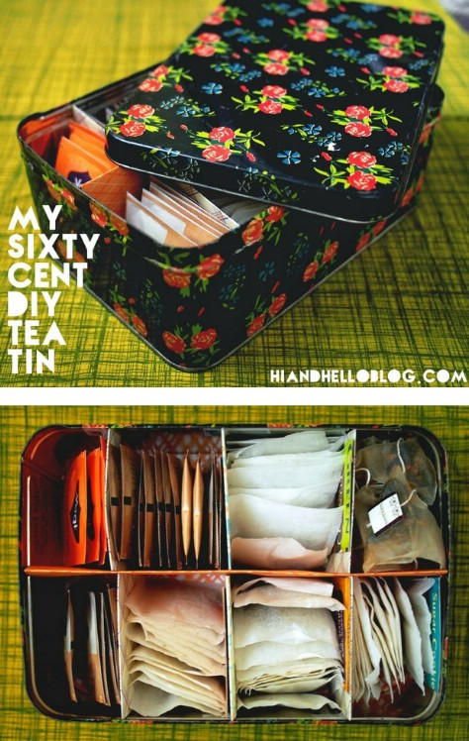

Something to eat.
It seems in January or February there are so many meetings. Meetings usually mean a food or snack. Lunch boxes need snacks. Breaks from doing anything usually involve a snack to keep our strength up.
This is a no-bake, easy-to-make, snack that used up a cereal that isn’t popular.
Peanut Butter Snack Bars
2/3 cup of peanut butter
1 bag of baking chips (peanut butter, caramel, chocolate)
2 cups of cereal.
In a microwave bowl melt peanut butter and baking chips by cooking in small increments. Add to cereal. Spread in an 8 x 8 pan lined with wax or parchment paper. Set in a fridge for half an hour to cool. Cut in squares and enjoy.

We pray for the Earth:
- in acknowledgement of God’s love for all creation
- because we pray for what we care about, and care about what we pray for
- because humanity is the ‘priesthood’ of creation, giving voice to the ceaseless praise that the whole creation offers to its creator
- because we need to learn a less self-centered language, in order to re-discover our place within and dependence on the whole of creation
- in response to an acute environmental crisis affecting all life
https://thevalueofsparrows.wordpress.com/2016/09/01/prayer-remembering-the-environment-in-our-public-and-private-prayers-of-intercession/

