January 17, 2023
Email: HYPERLINK "about:blank" endionspei@gmail.com Website: HYPERLINK "about:blank" nspeidiocese.ca/den
Facebook: HYPERLINK "about:blank" Environment Network Diocese of NS & PEI

The Enews welcomes contributors on issues that ignite your passion for the earth. Feel free to email us: endionspei@gmail.com



The Christchurch Climate Cafe starts up this
Thursday, January 19th, 7:00 PM in the Christ Church Hall. We meet the third Thursday of each month. For information, please contact Nancy Blair, nancyblaircounselling@gmail.com All welcome. The following is a quote from Sally Gillespie, a member of the Australian group Psychology for a Safe Climate and the Climate Psychology Alliance. She speaks about why talking about our feelings about the climate crisis is important.

"Compassionate and tolerant dialogues are crucial in helping people to identify a sense of something being not right in themselves and in their world, and then to reflect on what is needed in response. Hearing other struggle with similar feelings and experiences lays the way for negotiating the conflicted feelings and thoughts that we all carry, and which become more highlighted in times of change. A basic premise of depth psychology is that identifying suppressed thoughts and feelings begins the work of healing. Acknowledge feelings of sadness about dying fish, or an anxiety about a heatwave deepens understandings and mobilizes energy for action, when done is the company of supportive others.”

Gillespie, S. (2020). Climate Crisis and Consciousness: Re-imaging Our World and Ourselves. New York, Routledge, p.89.

 | Praying with the DEN Community continues each Friday 9:00 am on Zoom. To obtain the link, please email endionspei@gmail.com The prayers are led by DEN members who are deeply committed to praying for God's creation and for sharing interests and initiatives and information. Individual members take turns leading the prayers which are followed by a time of discussion, conversation and sharing. All are welcome to participate. Thanks to The Church of St Andrew for hosting.

If you read the Anglican Journal in September you already know a national group has been created to erase Anglican churches’ ‘huge’ carbon emissions from coast to coast. The Net Zero Churches Project group was formed in January 2022 and their aim is to reduce the greenhouse gas emissions from church buildings to zero. In October our Diocesan Environmental Network (DEN) committed to participating and a volunteer coordinator for our diocese was appointed. Hopefully, many parishes in our diocese will embrace the initiative as a way to honour the 5th Mark of Mission, “To strive to safeguard the integrity of creation and sustain and renew the life of the earth.”
The Net Zero Churches Project has sought technical guidance from educational institutions nationally and aims to share information gleaned to advise parishes how to reduce carbon emissions. Understanding how to reduce emission of greenhouse gases by addressing type of mechanical systems in facilities and reducing energy consumption are the initial challenges being addressed.

How can we find out more about the Net Zero Churches Project?
You can learn more by:
• Reading the article in the September issue of the Anglican Journal,
https://anglicanjournal.com/new-group-aims-to-erase-anglican-churches-huge-carbon-
emissions/
• Viewing the Net Zero churches video at https://www.netzerochurches.ca/
• Contacting:Margaret Bateman Ellison, Volunteer Coordinator for Diocese of Nova Scotia and Prince Edward Island briarwoodbob@aol.com
* Mark Gibson. National Coordinator coordinator@netzero.churches.ca

Sackville River Wilderness Area designated for perpetual protection. “The Nova Scotia government announced today that it has completed the legal designation process for public lands in the Upper Sackville and Beaver Bank area. The 800-hectare Sackville River Wilderness Area will be protected in perpetuity after the provincial Environment Department officially designated it Monday as a protected wilderness area….the Sackville Rivers Association is a voluntary association that has been trying to preserve, protect and save the Sackville River and its watershed since 1988.” Quote from Francis Campbell – Multimedia journalist
https://www.saltwire.com/cape-breton/news/sackville-river-wilderness-area-designated-for-perpetual-protection-100805162/
Huge shoutout from DEN to all the tireless volunteers over 34 years who finally achieved their goal.

Province Protects 9300 hectares of public land with $20.M in funding to NS Crown Share Land Legacy Trust. “The Ecology Action Centre is delighted by the announcement, what it sees as the Houston government's first concrete move toward fulfilling its commitment to protect 20 per cent of N.S. lands and water by 2030…“Today’s announcement is very welcome news,” says Raymond Plourde, senior wilderness coordinator with the EAC….Plourde says that although this is a big win for nature in Nova Scotia, the work to achieve 20 per cent is far from done. “https://ecologyaction.ca/resources-media/press-releases/eac-applauds-new-provincial-protected-areas-20-million-ns-crown

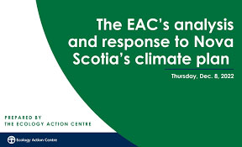  From our Advocacy Editor, Eva Evans:  Good and Disappointing news:  Nova Scotia’s long-awaited climate plan, Our Climate, Our Future: Nova Scotia’s Climate Change Plan for Clean Growth, was released on Dec. 7, 2022. The Ecology Action Centre did a close analysis of the plan to look for: | *Clear, actionable measures to address the climate crisis  *An appropriate level of funding commitments  *Accountability mechanisms  *Commitments to stop undermining climate action with further investment in outdated industries  To see the detailed report:  https://ecologyaction.ca/sites/default/files/2022-12/EAC_ClimatePlanResponse_2022.pdf  If you don't have time or inclination to read the whole 28 pages, please read the last two pages. This is what we need to press the gov't for. (This is my recommendation, not EAC's)

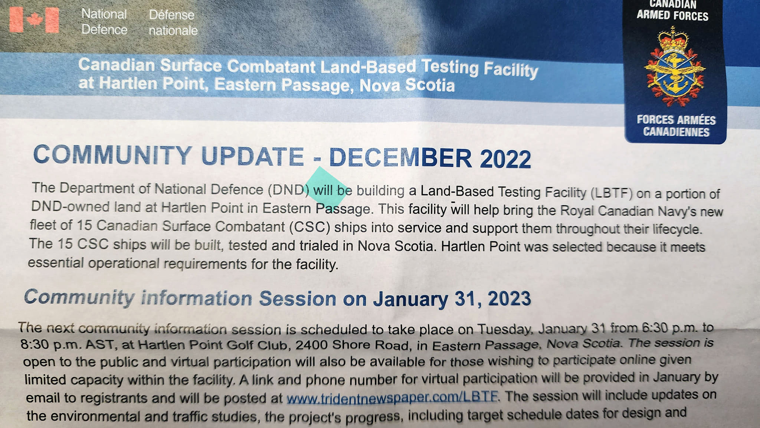
Highlight from above: Information session Tuesday Jan 31 from 6:30 to 8:30 pm at Hartlen Point Golf Club.

Take Action, Sign a Petition | The Rainforest Site, a GreaterGood project
The population of loggerhead turtles is dropping fast. In the past decade, there has been an 80% decrease in the North Pacific and a 40% decline in the Northwest Atlantic. Thousands of sea turtles are injured or killed each year as a result of commercial fishing activity. Illegal fishing practices lead to sea turtles being harpooned or caught in nets, and many turtle habitats and nesting areas have been polluted with discarded plastic, nets, ropes, and chemicals. This petition is asking that the loggerhead turtle be listed as endangered under the Endangered Species Act.
Don’t let oil interests derail Canada’s clean fuel standard (davidsuzuki.org)
This petition is a letter to our government, asking it to stand firm and to move forward with actions to reduce Canada’s carbon emissions - including a robust clean fuel standard. The clean fuel standard will require fossil fuel companies to reduce the carbon-intensity of their fuels. It would position Canada as a clean fuel leader, increase low-carbon fuels in the Canadian market, create innovation in the biofuel sector, and it could make the biggest contribution to carbon emission reductions in Canada between now and 2030. Sign your name to support a strong clean fuel standard for Canada!
Leadnow letter to sign to Canada's big banks
There's been a huge win for climate action! HSBC - Europe's largest historical financier of fossil fuel expansion, and the UK's biggest lender - will no longer fund the development of any new oil and gas fields, including the infrastructure used for transport. HSBC's announcement is directly attributed to climate advocates like us, calling out their greenwashing lies. But there's a catch. HSBC's Canadian operations are explicitly exempted from this new commitment. The reason? Because HSBC's entire operation in this country is being sold off — to RBC. This is the only unit of HSBC to be exempted. Just months ago, RBC's CEO published an op-ed on the need for banks to do much more on climate. Yet they're refusing to put their money where their mouth is. And other major Canadian banks aren't doing much better. Please sign this letter written by LeadNow to the top executives of RBC and Canada's big five banks a requesting they join HSBC in pulling the plug on new funding for oil and gas.
CAPE's letter to government to stop fossil fuel advertisng
Did you know that fossil fuel air pollution causes up to 34,000 premature deaths in Canada each year? Just like the tobacco industry, fossil fuel companies are still lying to us about the known dangers of their products. Join a campaign by Canadian Association of the Physicians for the Environment asking federal and provincial governments for further restrictions on the advertising of fossil fuel products and industries to address the public health crises of climate change and air pollution. Fossil fuel pollution and climate impacts have killed and will kill many more people than smoking.

The Myth of climate change
When Grandma was a girl, New Year's Eve meant being allowed to stay up late, as long as I behaved. Supper that night may not have been fancy but there were extra treats as we sat around the kitchen fire. We all made resolutions that probably never made it past February.
New Year’s Eve was bitter cold. Pipes usually froze that night. Some years there were snow drifts but it usually was a time for ice.
Even twenty years ago, going out to a New Year’s Eve party meant extra sweaters, boots, parkas, hats, mitts, and scarves. Cars were warmed 20 minutes before the ladies left the hall.
Fast forward to 2023. I scrambled to cut that second crop of parsley before the cold, but only rain came. The grass is green. My garlic planted in November for next spring is all sprouted 6 inches.
Can people not see climate change is happening?
Not all is doom and gloom. So many of the general public recognize environmental issues now. More and more are doing small things which add up to help in big ways. Did you hear the ozone area around the poles is shrinking?
This is all part of DEN’s job. We need to get enough ideas out there that the public thinks “I can do that” and simply tries. You will probably succeed but what if you don’t? You learned what not to do next time because you try again.
Just keep trying folks.
When something does work, please tell DEN so we can spread the word. You can reach Grandma at claudiaazinck@gmail.com

Pretty Ribbons
When I went to an elementary school, every morning my Mom braided my hair and tied my ribbons in place. The ribbons had been washed the night before and wrapped around a milk bottle to “press” overnight.
Ribbons and lace were just part of a girl’s wardrobe no matter how much you wanted your plaid and pants that were only allowed to be worn at home.
Being a ribbon collector I have tried various ways of storing ribbons through the years. This week I found what is the best way for me.
The article suggested pop bottles and even used the bottom of a second pop bottle to use upside down for a cap
Since we don’t usually have an empty pop bottle (the last one became my portable umbrella holder if I am at a meeting) I used a tall water bottle.
Cutting off the top I simply placed spools of ribbon in the tube. They fit snugly but they did fit. A couple of elastics kept everything in place.
Either standing upright or laying down, they fit in the cupboard much better than the box I had been using. Pull a tube out and see what colours you have to work with, without emptying a box. Here is a picture of mine.
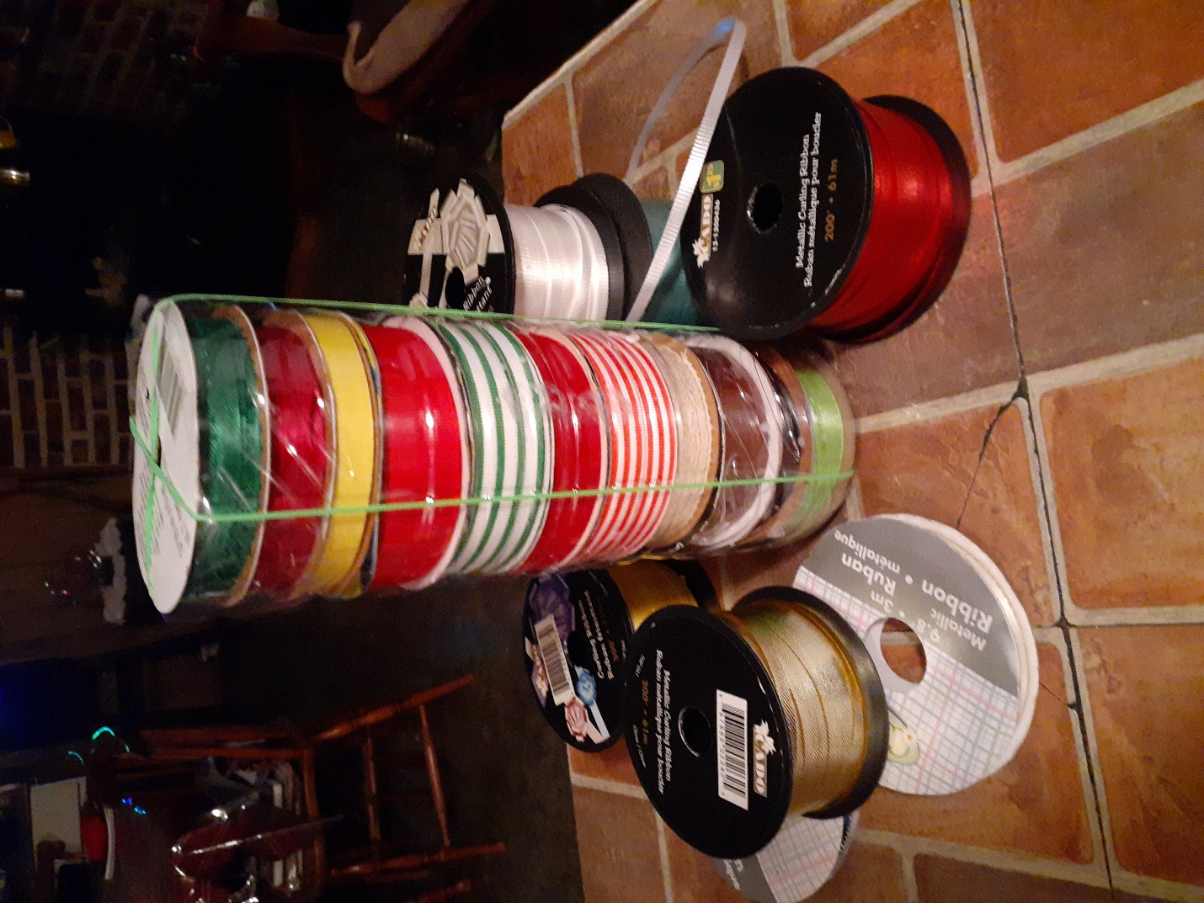

I might have to go back into Christmas wrap. Besides ribbons, these bottles or tubs would hold the leftover bows without crushing them. Ideas are boundless now.
Something to eat
Ham Pinwheels
A pack of wraps
1 can of tin ham, flaked variety, or cut-up solid ham
1 or 2 dill pickles
1 or 2 tsp. of mayonnaise OR a pack of cream cheese
Cut the pickle into tiny bits, add ham and mayonnaise or cream cheese, and mix. Spread on the wraps. Roll them up and slice like pinwheels.
HINT; When Grandma buys wraps, she opens the bag and puts a piece of waxed paper between each of the wraps before she freezes them. Then she can pull out 2 or 3 wraps and keep the rest frozen.
With grateful hearts for all who work tirelessly to care for creation, we offer this Thanksgiving address from passthefeather.ca


passthefeather.ca

