January 10, 2023
Email: HYPERLINK "about:blank" endionspei@gmail.com Website: HYPERLINK "about:blank" nspeidiocese.ca/den
Facebook: HYPERLINK "about:blank" Environment Network Diocese of NS & PEI

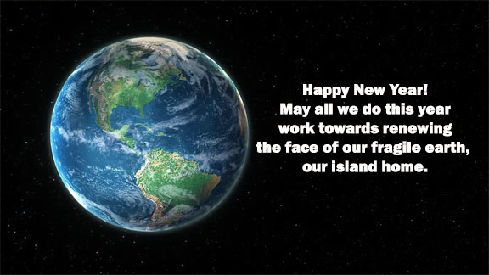
The Enews welcomes contributors on issues that ignite your passion for the earth. Feel free to email us: endionspei@gmail.com



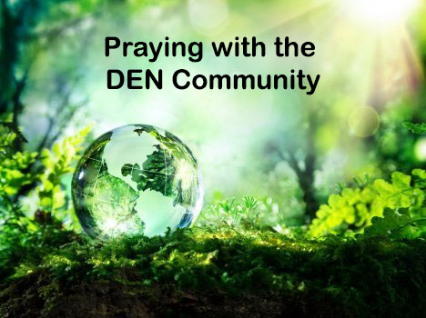 | Praying with the DEN Community continues each Friday 9:00 am on Zoom. To obtain the link, please email endionspei@gmail.com The prayers are led by DEN members who are deeply committed to praying for God's creation and for sharing interests and initiatives and information. Individual members take turns leading the prayers which are followed by a time of discussion, conversation and sharing. All are welcome to participate. Thanks to The Church of St Andrew for hosting.

Hartlen Point is the #1 location for birds in Nova Scotia, #10 in Canada. It is the ONLY birding area in Canada’s top 40 that is NOT PROTECTED. There are many more reasons a Warship Testing Facility should not be built on Hartlen Point. The Coast has an excellent article with lots of info worth reading: https://www.thecoast.ca/halifax/how-dnd-chose-hartlen-point-for-planned-warship-testing-site/Content?oid=29895820
To follow this issue: https://www.facebook.com/ProtectHartlenPoint/
To sign the petition: https://www.change.org/p/protect-hartlen-point-in-eastern-passage-nova-scotia-from-weapons-systems-testing-facility-demand-the-government-complete-a-proper-unbiased-environmental-impact-assessment-which-takes-into-account-wildlife-community-traffic-ns-s-1-spot-for-birds

From Into the Weeds team: Only Three Days Left to Sign our Petition and Get Glyphosate Banned in Canada! We are reaching out on behalf of documentary director Jennifer Baichwal regarding the issue of toxic pesticides in our communities. Jennifer’s recent award-winning film Into the Weeds has inspired an impact campaign to reduce pesticide use, specifically the cancer-linked and biodiversity-threatening chemical glyphosate, used in pesticides like RoundUp and Ranger Pro. You can watch the trailer and learn more about the film and impact campaign here.
To sign the petition: https://petitions.ourcommons.ca/en/Petition/Sign/e-4127

-------------------------------------------------------------------------------------------------------------------------------
North America Summit This week, Prime Minister Justin Trudeau, U.S. President Joe Biden, and Mexico’s President Andrés Manuel López Obrador are all coming together at the North America Summit to discuss a range of topics from supply chains to immigration and energy.
This is the first time the three leaders have met since 2021, and we need to make sure climate justice is on top of the agenda.
https://act.350.org/sign/na-summit-petiton/?source=ca-em20230110&utm_medium=email&utm_source=actionkit&referring_akid=233124.4738626.oSg_oD

New Beginnings
There is always a great feeling of hope and expectation that comes with a new day, a new week, a month, and especially a New Year

Back in 2012 when DEN first started, I remember the hope was that we would find “a few more people” that believed that climate change even existed.

On New Year’s Eve, I am scrambling for enough time to cut another crop of parsley because surely tomorrow everything will freeze. New Year’s Day was always the time we worried about frozen pipes instead of how tall the green grass outside has grown.

My little stories these past two years have barely scratched the surface of the issues “out there” that affect us. My belief still is, that we need to work right where we presently stand.

Tiny villages or big cities are the perfect places to start learning because it is the learning that we need.

When I teach at Environment Day at our church camps, I am amazed at how much the schools have taught environmental issues even in the smallest grades. Kids accept recycling, reducing, repurposing, and any other R they hear about.

There are so many adults that may not join an environmental movement but would go to a workshop to learn how to make, say, a rocket stove. How about a class on making tea biscuits?

I know what you are thinking. Yes, it appears no one is interested in that. Think of the expense of renting a hall and putting on a class. How many would show up?

If you keep things small, then there are small bills. Our Parish made planting kits, last year, 130 of them. Six to 8 people did one part of the kit in their homes. Grandma and Nana just put them together. Fifty kids in one school and 80 people in our community took a planting kit home.

Think of tea biscuits. Pretend two people wanted to learn to make them. Pretend Aunt Sally is willing to teach. You can fit two extra people inside most kitchens. Most kitchens could afford a couple of cups of flour, a bit of fat, baking powder, and milk. Make it easier and open it to older children. Open only to what you can fit in easily. Maybe one recipe every second month or twice a year.

Church buildings are underused. We have these big, usually empty spaces sitting in all our parishes. Churches were originally places of learning. We taught Sunday School in them for centuries. You didn’t always sit in pews but used them as desks and worktables. Why not take that back?

It is one thing to have all these fancy ideas and another to make them work. If people were retired or could even work at such things for a living, there would be more opportunities to grow. We rely on volunteers and those volunteers are getting scarce.

Grandma had an idea for years. Rocket stoves! I want to teach even two people how to make a rocket stove after I have made one. I have a buddy up the hill that is mechanically inclined. I have the big ketchup or coffee tin cans. If I can get my friend to muddle through making the first stove with me, I can see a class. Have the class at the church. Once made we can try them out on the church steps or parking area.

Why rocket stoves? It’s a cooking device that allows you to cook a meal by burning twigs. No smoke. Easy to carry in a backpack. It could be a survival device.

That is my goal for 2023. One class people, just one for now, on any topic.
When you get your class going, let me know. If I can, I will visit if not participate. claudiaazinck@gmail.com I would love to hear your ideas.

Craft
Christmas is a time when craft ideas just take over. January is a bit slow before the red hearts come out in February.

Grandma likes bare walls. Something is soothing in the plain after all the glitter and sparkle.

So this week let’s start organizing. I find I need a pen and marker in several places in the house. Here is an easy “holder “for them

An empty toilet tissue roll. A bit of colored copy or construction paper and an elastic band.

Eyes, either store-bought or made as white oblong circles with a smaller dark circle colored in.

Leave the tube a plain brown or color the tube.

Draw a circle an inch bigger than a toilet tissue tube. Make the edges scalloped or plain. This becomes a collar. Putting the paper over the bottom of the tube, attach it with the elastic band. Fold it down or tie a ribbon. Draw a nose and a mouth and attach the eyes.

Put a pen and marker in the tube and place it where you stop and run for that marker.

I have one in the tin cupboard, so I use the oldest tins first. I have one on top of the fridge that I keep adding to the grocery list. Because they stand out wherever they sit, a pen or marker is easily found.
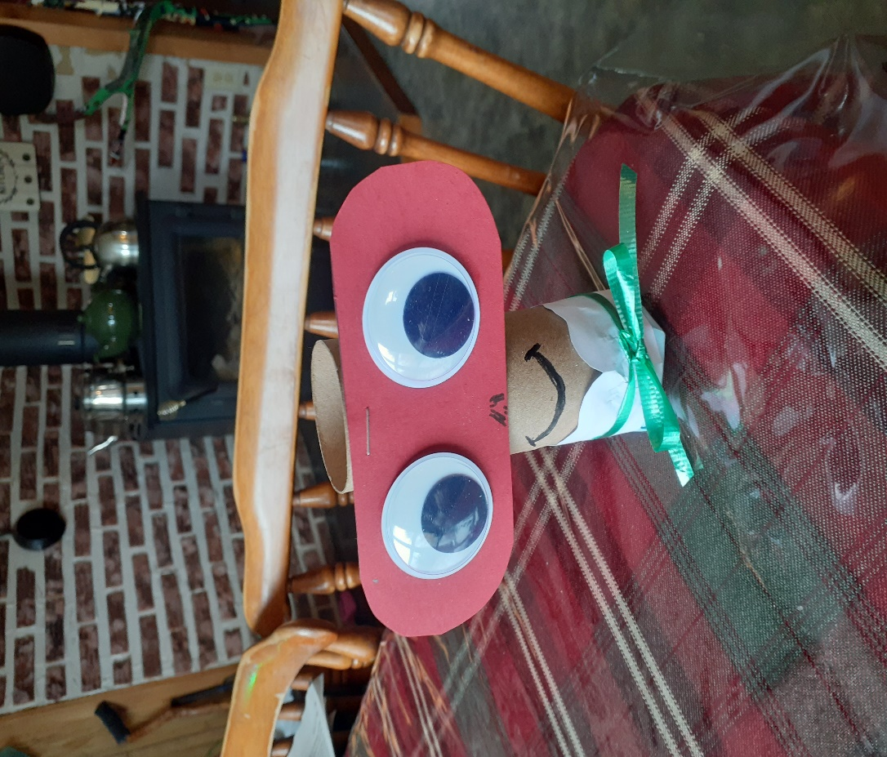
.
Something to eat - Crab Snack.
These are so easy. Grandma has been squirreling away tin crab when she can buy it reasonably. I walked into a store before Christmas and a display had tins of crab for half the price. Let’s just say this easy snack will be made more often.

Crab Toast
In a bowl mix a tin of crabmeat with a piece of cucumber or celery chopped very fine, a pickle or two chopped up, a spoonful of mayonnaise, and a squirt of Worcestershire sauce.

It is suggested to make toast, butter it, and cut circles out of the middle. Toast cut in fours tastes just as good. I have seen this on corn rounds, rice cakes, baguette bread, or any bread-type bottom.

On the toast put a quarter of a cheese slice, followed by a teaspoon of crab mixture. Put in oven or microwave to melt the cheese. So good.
Till next week, Grandma is sending hugs.

May yours be the gift of reverence for all created things. May you face bravely and enthusiastically the responsibility to preserve and care for the beauty of Earth. (Sir 42:15-43:33).

