November 29, 2022
Email: HYPERLINK "about:blank" endionspei@gmail.com Website: HYPERLINK "about:blank" nspeidiocese.ca/den
Facebook: HYPERLINK "about:blank" Environment Network Diocese of NS & PEI



This will be our last issue until the New Year. May all you do bring Hope, Peace, Joy and Love to our beautiful world.

A Christmas Gift for DEN
We are down to our last week before the DEN e-news goes quiet for a month
I am asking everyone to do a green action as a Christmas gift for DEN
Just do one new or used green action this Christmas season. Not a hundred. You don’t need to build the next great solar-powered carbon gobbler. Just do one thing to help the environment.
Sort trash. Use a reusable coffee mug. Hang one thing out to dry instead of using the dryer. Have one container on your balcony and grow one plant. Then tell someone about it.
I have preached the power of one long enough but in case someone didn’t hear it.
One person does one green action and then brags, in this case, that they made Grandma or DEN happy. Their buddy laughs but later that day they do something green (that makes 2 people who did something green). They both tell a buddy that they made Grandma happy by doing this one action and they have a chuckle. After all, Grandma just asked for one action. Doesn’t take much effort.
Later on, those 2 people each tell 2 more people to do something green and laugh with their buddies. Soon 4, 8, and 16, people chuckle over making Grandma happy with a single green action. Suddenly there were 32, 64, 128, or more green actions done. Then double those numbers again and again. All of this because ONE person did something green for Grandma.
Tell the story this year and see what happens.
Christmas is coming and there will be so many ideas that you could do to be green. Choose one thing and do it. Maybe you can do a dozen. Great! All Grandma is asking is that you consider one thing on any one day.
Then let’s be happy that we are growing, no matter how slowly, towards a greener life.

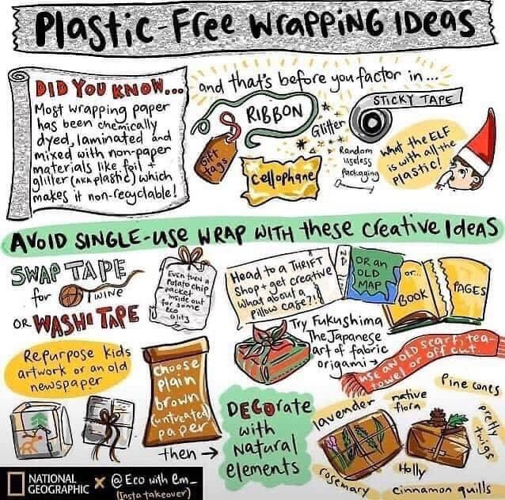

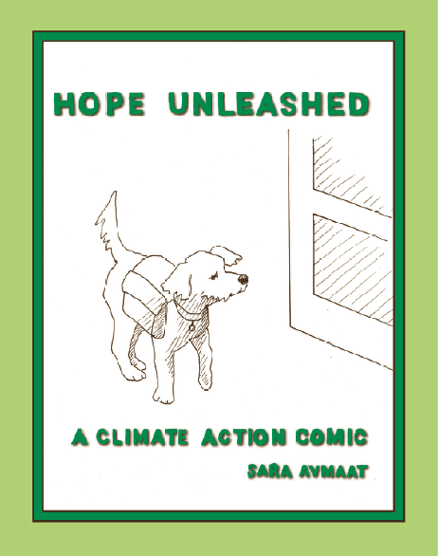 | Hope Unleashed is a comic book about moving from climate anxiety to climate action. The story begins with Maude the dog and her concern for her person, Patrick, who is paralyzed by climate anxiety. We follow Maude and Patrick as they learn about some of the people and organizations in Nova Scotia working to make a difference. We empathize with Patrick when he reaches the point where "it still feels like all too much" but he knows he's ready to make a start. The story is appropriate for upper elementary to adult readers. Younger (or older) readers may also enjoy colouring the pictures.  Hope Unleashed is available in Halifax at Ecology Action Centre, Atlantic News, Strange Adventures, and Venus Envy. Elsewhere from savmaat@yahoo.ca for $7 plus $5 shipping.

 | An interesting reflection on what Advent has to do with sustainability and how renewal runs through the story of Christmas. https://plantwithpurpose.org/christmasrenewal/

 | Religions and Environmental Protection  “Spiritual leaders at all levels are critical to the success of the global solidarity for an ethical, moral and spiritual commitment to protect the environment and God’s creation.”  This article is a reflection on religions across the world and their commitment to the environment.  https://www.unep.org/about-un-environment-programme/faith-earth-initiative/religions-and-environmental-protection




Kairos is gearing up for diversity COP15 in Montreal; https://www.biodiversity.faith/
and their Ecological Justice Circle as well.
Here is the link to a doodle poll to help choose a convenient time for everyone:
https://doodle.com/meeting/participate/id/dL7RoP4b

The topics to discuss include:
*Reporting back over this year
*Direction-setting for the next year.
*Any discussion of KAIROS changes, in terms of the new organizational structure (see https://www.kairoscanada.org/kairos-is-restructuring).
*A review of KAIROS Guiding Principles for Human Rights & Peace Framework
*Review of the terms of reference for the Circles of Ecumenical Collaboration, providing feedback or recommendations as it has not been updated in a full five years.



Please click on the link below for their latest newsletter
https://mailchi.mp/5dfa91ce792f/lambeth-conference-and-season-of-creation-5266550?e=0dd67e46dd

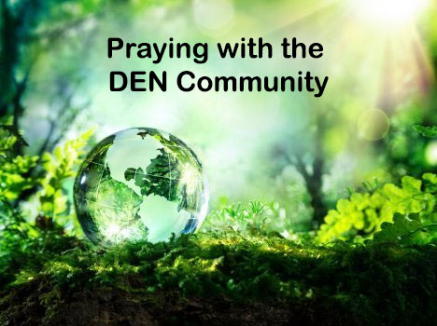 | Praying with the DEN Community continues each Friday 9:00 am on Zoom. To obtain the link, please email endionspei@gmail.com The prayers are led by DEN members who are deeply committed to praying for God's creation and for sharing interests and initiatives and information. Individual members take turns leading the prayers which are followed by a time of discussion, conversation and sharing. All are welcome to participate. Thanks to The Church of St Andrew for hosting.

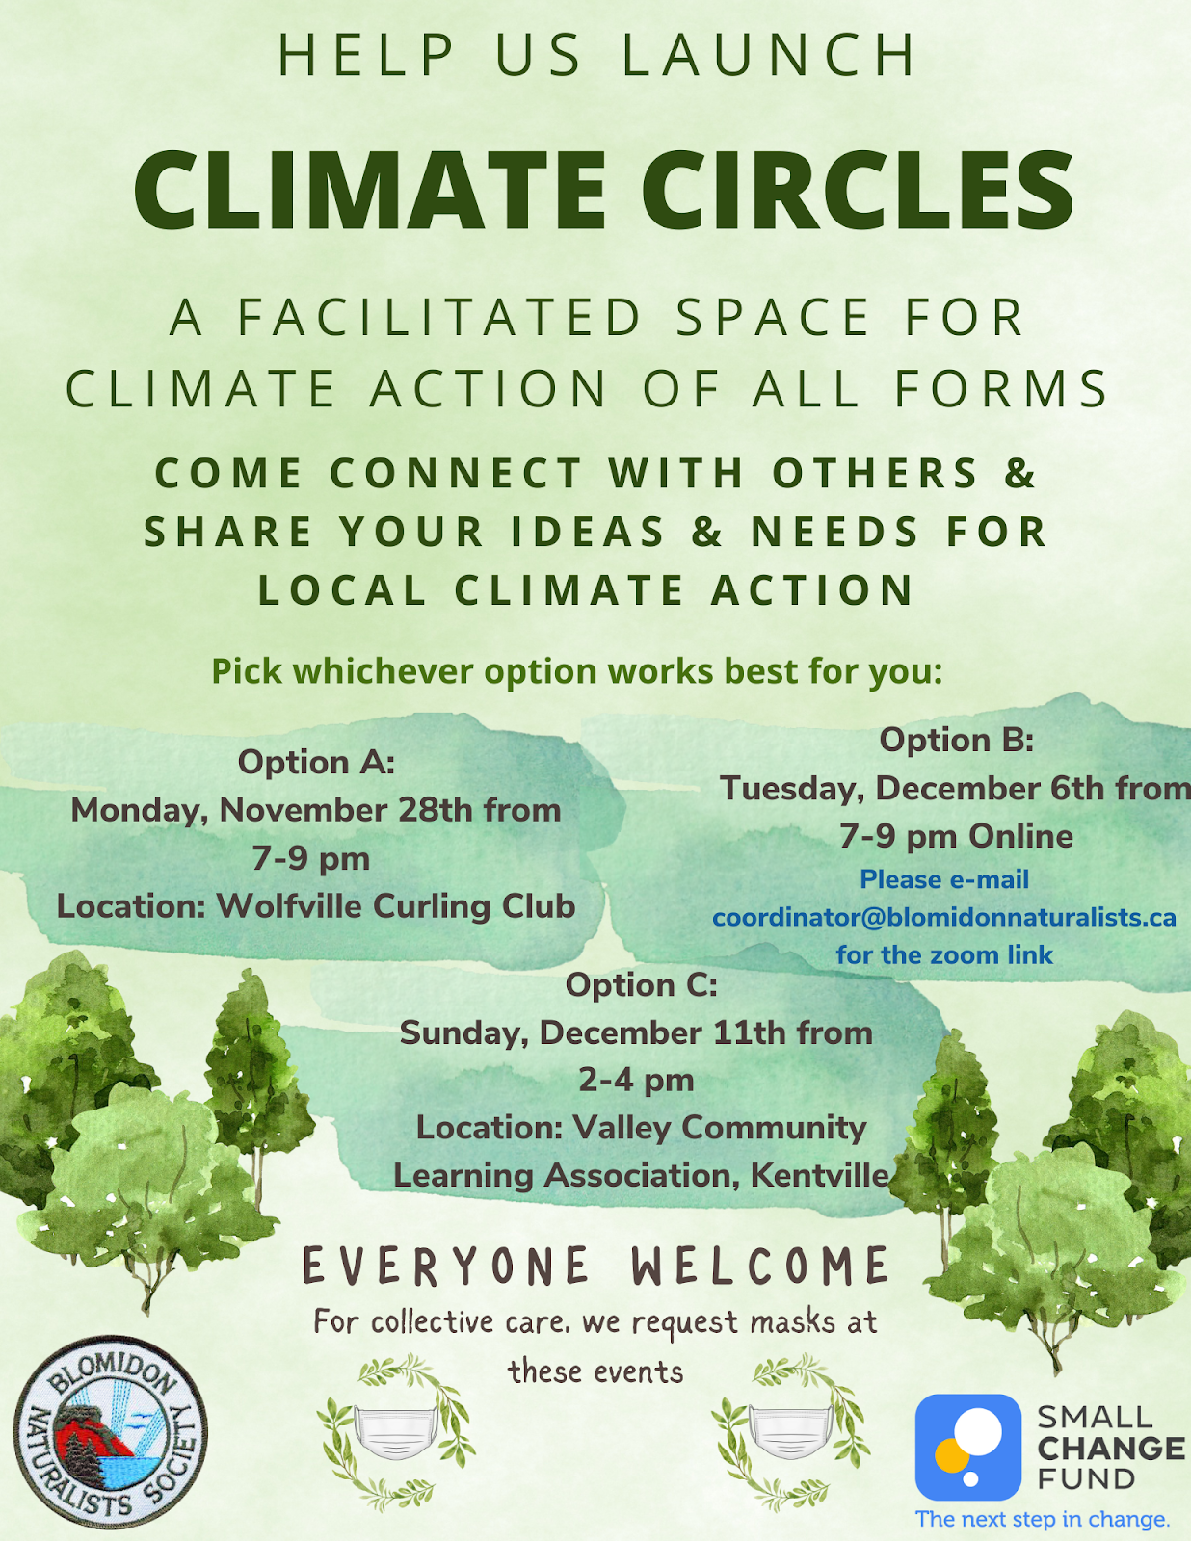



Christ Church Climate Cafe - continuing and growing Join us Thursday Dec 15th- 7 pm.

The first Christ Church Climate Cafe was held in April of this year. In that Cafe, and in the following Cafes, participants have come from Christ Church and also the community at large. Participants are from a range of backgrounds, experiences and ages. What we all have in common is our need for a safe and supportive place to talk about our feelings about climate change. It is natural to think that talking about these feelings is depressing; what we find is exactly the opposite. Talking about our feelings, and listening to others in this setting, is heartening.

Nancy Blair is a Climate Psychotherapist in Dartmouth and a parishioner at Christ Church. She started the Climate Cafe as a project of the Diocesan Environment Network (DEN). She was trained through the Climate Psychology Alliance (CPA). We now have a second trained leader, David Paterson, who is the early stages of his teaching career. The Climate Cafe meets at 7:00 PM the third Thursday of the month in the Christ Church Hall. Everyone is welcome. For information, contact Nancy Blair. nancyblaircounselling@gmail.com 902-223-3151

Protect Biodiversity in Canada. Montreal is the host city for the Convention on Biological Diversity We must set an example by creating a Nature & Biodiversity Act.
https://act.greenpeace.ca/en-ca/protect-biodiversity?utm_term=en-20221124-sign-link&utm_campaign=en-biodiversity_20220202&utm_content=229364540&utm_medium=social&utm_source=facebook&hss_channel=fbp-19750184960&fbclid=IwAR0bpM5x10vBhQG51ts2iL4qfbH3NCRo_OC92PYAkIfCGSZ64lwtP8ixulc

Save West Mabou Provincial Park
The Ecology Action Center has made it easy for us to write to the NS Premier and 2 other ministers urging them to say NO to an American billionaire golf course developer who wants to develop a private 18-hole golf course in this legally protected and ecologically sensitive area. West Mabou Beach Provincial Park is part of the mere 5% of Nova Scotian coastline that is protected public land. We cannot afford to lose it to private development.

Petition from EAC to Save Sandy Lake and Sackville River
We cannot try to solve the housing crisis by making the climate and biodiversity crises worse! Sandy Lake and Sackville River form a popular nature space on the edge of Halifax's urban centre. It contains some of Nova Scotia’s last remaining old-growth forests. But on March 24 2022, the Provincial government’s Task Force on Housing picked the Sandy Lake – Sackville River area as one of its locations to fast-track for development. The very same area has been proposed for protection as part of Sandy Lake Regional Park. It shows up in multiple studies as a key area for wildlife corridors and is invaluable as intact, interconnected wild areas that help with the twin crises of climate change and biodiversity loss.

350.org petition to federal leaders
Canada's oil and gas sector will more than triple its profits in 2022. Meanwhile, the rest of us struggle with surging prices and more extreme weather. It’s time to make polluters pay their fair share. We know we can’t trust these companies to direct their record profits into climate solutions. Our government needs to take the decision out of their hands with a Windfall Profits Tax. Join thousands of people across Canada calling on Justin Trudeau and Steven Guilbeault to tax the excess profits of fossil fuel companies to pay for loss and damage, and fund a just transition to 100% clean energy that puts workers and communities first.
For Children's Sake - Cap Fossil Fuel Emissions
The United Nations Committee on the Rights of the Child has expressed serious concerns about Canada’s climate policies, calling out the “disproportionately high carbon footprint of [Canada], in particular through investments made in fossil fuels.” The committee addressed climate as a serious children’s human rights concern and called on Canada to “systematically” include children in climate policy decisions, to collect data on the impacts of climate on children and to ensure children’s access to climate justice. The committee also called on Canada to meet its international commitments to reduce greenhouse gas emissions. The federal government can start by immediately enacting regulations that put a hard cap on GHG emissions from the oil and gas sector, end subsidies and public funding for fossil fuels, and require Canada’s electricity grid to achieve zero emissions by 2035.The David Suzuki Foundation has made it easy for us to ask Prime Minster Trudeau and Environment Minister Guilbeault to act NOW.

CRAFT - REINDEER FOOD
It’s time to make Reindeer Food!
I know we often leave a carrot for Rudolf but what about the rest of the Reindeer?
They need directions to your house. One way is to make reindeer food. They see it from the sky and come graze on your lawn while Santa is busy with the presents.
According to how much food you are making, there might be enough to give the squirrels and birds a snack
Reindeer Food
Start with 2 cups of rolled oats
2 tsp. of sprinkles
1 tsp glitter (approximately)
From here add what you think might be best and what is in the cupboard.
Bird seed is a favorite
Nuts, shelled, or left in the shell
Some people add dried cranberries, flax seeds, pumpkin seeds, etc.
The first three ingredients are the important part. They magically mix so they can be seen from the sky.
My grandbabies have boots and coats over their PJs as soon as they hear Santa’s sleigh was seen around Big Ben in England. They aren’t trusting anything to fate. Santa needs to know how to come to their house.
USING UP - Reusing cards
I think we have gone through all things Christmas now and used all we could. You could save your Christmas card fronts to use for card baskets another year. Just google making baskets from cards and you will find something like
https://www.youtube.com/watch?v=BJL63pJrB7A
Or make boxes from cards
https://www.youtube.com/watch?v=YQtee_BoQH0

SOMETHING TO EAT - Grandkids Baking
Now is the time for those last-minute baking with the children. A friend of mine was heartbroken last year when she couldn’t get Rice Krispies. She always made the Krispie squares with the grandkids on Christmas Eve and there were no Krispies to be had. I told her of Corn Flake Clusters and will put both here in case you want to try them.
Rice Krispie Squares
3 tbsp butter
1 package of regular marshmallows or 5-6 cups of the miniature ones
6 cups of Rice Krispies
In a good size pot, melt the butter and the marshmallows. When melted, add the rice Krispies and quickly spoon into a pan smoothing the top. Wait 10 minutes and cut into squares.

Corn Flake Clusters
3 tbsp butter
1 big spoonful of honey
3-4 cups of Corn Flakes
A few shakes of sprinkles
Melt butter and honey together in a pot and add the cornflakes. Drop by spoonful on waxed paper and cool.

It doesn’t matter what you do, traditions live on in your memories for a lifetime.
I remember being allowed to decorate the house and the tree, excused from other chores. Setting up the manger scene and even sending a few prayers for something I wanted under the tree. Filling the baking (storage) tins with so many good things that came out when “company” visited all of Christmas week.
The 4 PM service on Christmas Eve always started the holiday. I may even remember carrying one of the animals to the front of the church while carols were sung.
My kids went to that same 4 PM service. Then we always went up to my Mom’s for the “Eve” meal. My brother came out from the city with his kids and the house was full, busy, and noisy. The kitchen was packed with good things to eat, most people having a plate on their lap as the tables were saved for the older ones. Babies were passed around, pictures were taken, and children showed off their concert songs with Mom and Dad in their corner enjoying it all.
Whatever you do at Christmas time, let’s send a prayer for our environment and send as much love as we can to our world. Until the New Year, Grandma is sending hugs
MERRY CHRISTMAS!!!!!!!!!!!!!!!!!!!!!!!!
PS
Much more could be shared here like my Newfoundland raisin cake cooked in tin cans. I will try to get that printed for the first of the year. Tell us at DEN what you do at Christmas that makes this Birthday party so great
cludiaazinck@gmail.com
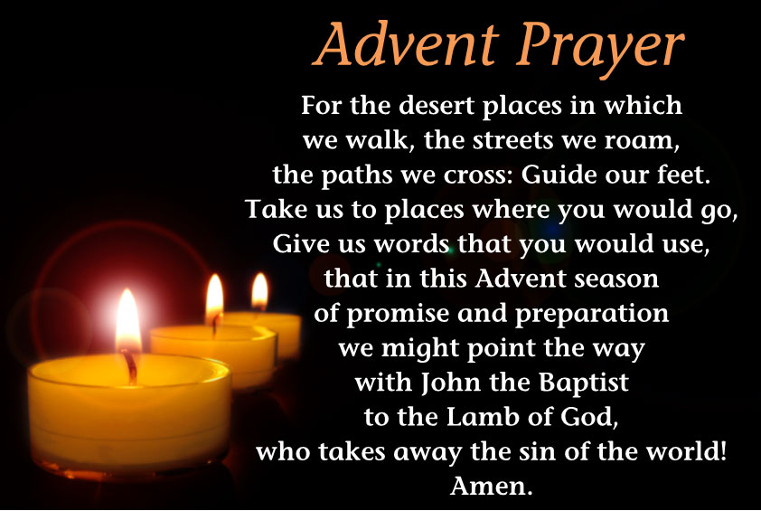
https://www.scross.co.za/2016/12/advent-prayer-3rd-sunday-advent/

