November 22, 2022
Email: HYPERLINK "about:blank" endionspei@gmail.com Website: HYPERLINK "about:blank" nspeidiocese.ca/den
Facebook: HYPERLINK "about:blank" Environment Network Diocese of NS & PEI



A Buyer’s Guide to Heat Pumps: How you can save money by making the switch.
TODAY 7:30 – 8:30 (note time correction from last enews)
ONLINE. FREE.

To reserve a spot, https://www.eventbrite.com/e/a-buyers-guide-to-heat-pumps-how-you-can-save-money-by-making-the-switch-tickets-450872811717

 | Praying with the DEN Community continues each Friday 9:00 am on Zoom. To obtain the link, please email endionspei@gmail.com The prayers are led by DEN members who are deeply committed to praying for God's creation and for sharing interests and initiatives and information. Individual members take turns leading the prayers which are followed by a time of discussion, conversation and sharing. All are welcome to participate. Thanks to The Church of St Andrew for hosting.
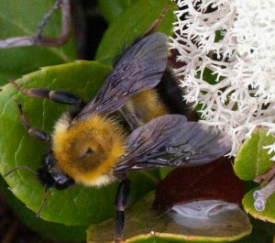
Nova Scotia Wild Flora Society
http://nswildflora.ca/2022/11/04/nov-28-online-members-meeting-the-diverse-bees-of-nova-scotia/
The next presentation of the Nova Scotia Wild Flora Society will be by Alana Pindar on The Diverse Bees of Nova Scotia. The meeting will via Zoom at 7:00 pm on Mon Nov 28, 2022. Invitations will be emailed to current members closer to the date. For more information on memberships: nswildflora@yahoo.ca





Christ Church Climate Cafe - continuing and growing Join us Thursday Dec 15th- 7 pm.

The first Christ Church Climate Cafe was held in April of this year. In that Cafe, and in the following Cafes, participants have come from Christ Church and also the community at large. Participants are from a range of backgrounds, experiences and ages. What we all have in common is our need for a safe and supportive place to talk about our feelings about climate change. It is natural to think that talking about these feelings is depressing; what we find is exactly the opposite. Talking about our feelings, and listening to others in this setting, is heartening.

Nancy Blair is a Climate Psychotherapist in Dartmouth and a parishioner at Christ Church. She started the Climate Cafe as a project of the Diocesan Environment Network (DEN). She was trained through the Climate Psychology Alliance (CPA). We now have a second trained leader, David Paterson, who is the early stages of his teaching career. The Climate Cafe meets at 7:00 PM the third Thursday of the month in the Christ Church Hall. Everyone is welcome.

For information, contact Nancy Blair. nancyblaircounselling@gmail.com 902-223-3151

Hartlen Point is the #1 location for birds in Nova Scotia, #10 in Canada. It is the ONLY birding area in Canada’s top 40 that is NOT PROTECTED. There are many more reasons a Warship Testing Facility should not be built on Hartlen Point. To read more of them and to sign the petition:
https://www.change.org/p/protect-hartlen-point-in-eastern-passage-nova-scotia-from-weapons-systems-testing-facility-demand-the-government-complete-a-proper-unbiased-environmental-impact-assessment-which-takes-into-account-wildlife-community-traffic-ns-s-1-spot-for-birds/u/31092124?cs_tk=Avvl9CN1FVuARUyGfmMAAXicyyvNyQEABF8BvGXQVn5EzyTLKIggpfGQXfg%3D&utm_campaign=adb3ce8c239a4229a2e88e5e005ef76f&utm_content=initial_v0_6_0&utm_medium=email&utm_source=petition_update&utm_term=cs
Join the effort to protect this untouched wilderness and encourage DND to move it somewhere less dangerous and destructive.
WHAT: Peaceful rally to Protect Hartlen Point
WHERE: 82 Tacoma Drive, Dartmouth - MP Darren Fisher’s Office
WHEN: November 26, 12PM - 2PM
WHO: Anyone wishing to protect Hartlen Point
Thank you for all of your support, we hope to see you there!!

Please keep our Advocacy Editor, Eva Evans, in your prayers as she mourns the loss of a much beloved brother. May he rest in peace and rise in glory.

GREEN STORY
Many say the best Christmas tree is a real tree. Although it is environment-friendly, having needles dropping off a half-dried-out tree isn’t fun.
Artificial trees are made with a lot of plastic. They can be put up early and enjoyed longer. Grandma likes to argue that it is more enviro-friendly to reuse the same tree for 20 years than to cut down a tree every year
Unless you live in Blandford.
Down the road is a buddy with goats and a pony that loves eating trees.
After Christmas, there is a large pile of donated trees in his yard.
When the trees are eaten bare, they are cut up for summer campfire wood.
The Green debate on Christmas trees ends there in our village. Choose your side. I choose both.
CRAFT
Just a few easy ideas
Bunting: All you need is something to cut out triangles, a string, and some glue
Cut triangles the size you want
Fold over the top of the triangle making a hem to feed the string through. Some like to glue the string to the paper to position the triangle permanently. Play and see what works best for you.
You need a wall or if lucky a wide doorway to hang the bunting. Bunting says celebration. It makes a great icon at the Birthday Party for our Lord on Christmas day
Here is mine. Can you tell it is made from flyers at a first glance?
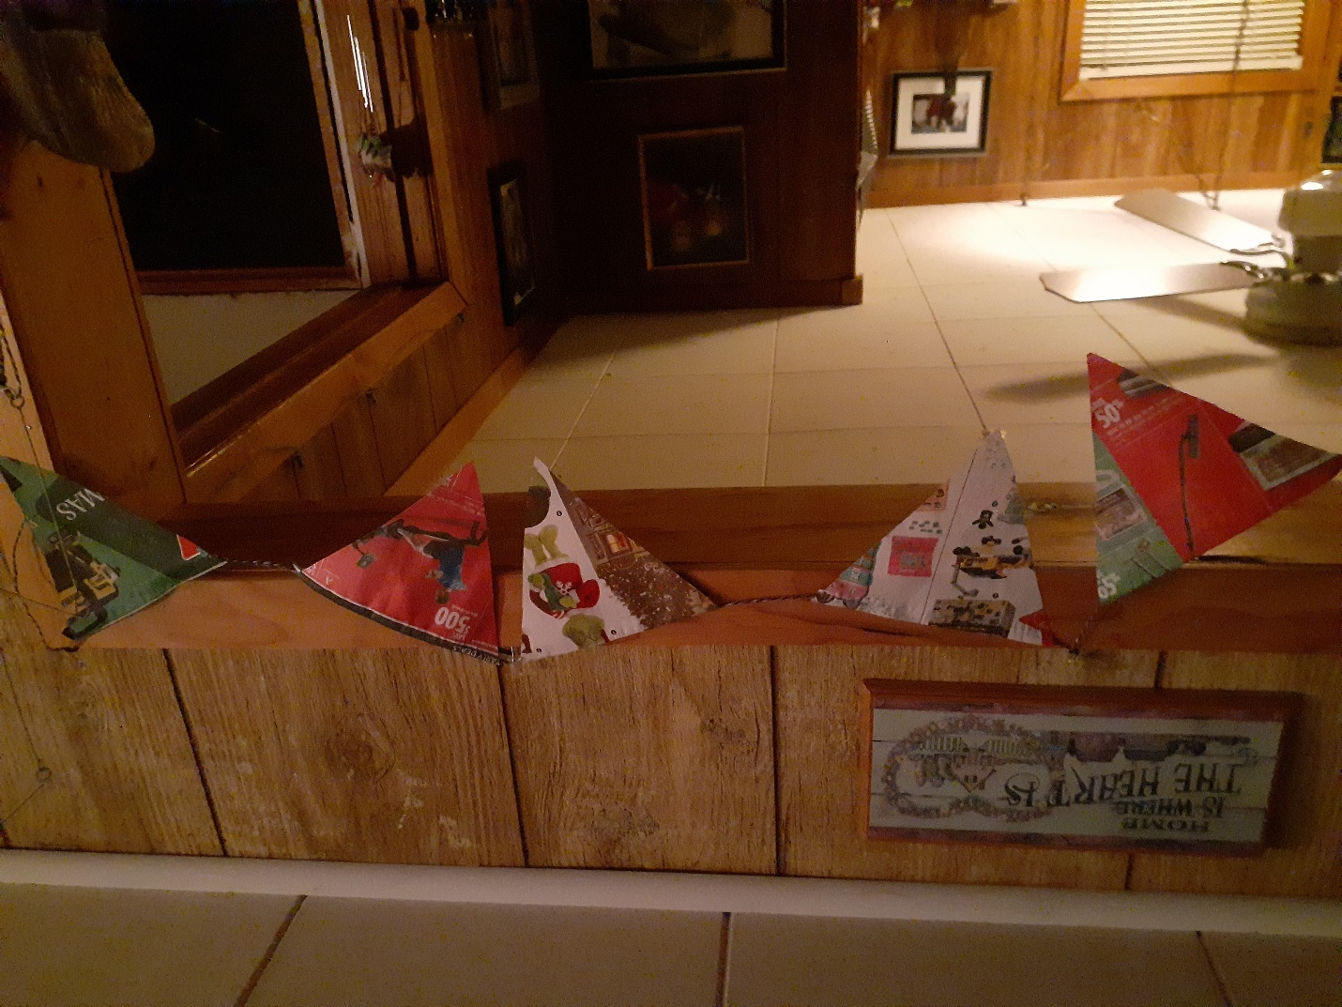
Popcorn strung for the tree and around the house works well and keeps young ones busy. Making bracelet popcorn rings and hanging them on the branches outside for the birds is a great nature Christmas gift.

SOMETHING TO EAT
I put off the baking until the last, just so I can enjoy it. The problem is that time gets short. This week I want to give some ideas for easy or quick food.
The food does matter but the people around the table and the time to be with them matter more.
When I have people drop in for a visit and I want to keep them longer, I suggest they stay for a “supper” Remember supper isn’t “dinner”. Supper means some little things and a gathering around a table. Here is my super easy meal
Shrimp Pasta
1 bag Shrimp
1 can mushroom soup
1 pack of pasta, about 2 cups
A dab of oil or butter.
Boil the pasta and drain, set aside.
In a big fry pan add oil and shrimp (minus their tails) on medium heat. Stir a bit till the shrimp turn pink. Add the mushroom soup and stir till soft and gooey. Add the cooked pasta and let them blend for 7-10 minutes. Maybe shake a little pepper, parsley, or savory for looks more than taste.
If lucky to have ingredients, add a salad. Sometimes I put drop biscuits in the oven. Yummy!
……………………………………………………
Some people make fruit cakes in October and dose them with brandy or other alcohol-based liquid for 2 months. Some year I may have the time for that. Instead, my family looks for chocolate fruit cake mixed up, baked, and eaten the same day, although it stores well.
Chocolate Fruit Cake
In one bowl
1/2 Cup margarine
1 Cup brown sugar
2 eggs
In the second bowl
2 cups flour
2 cups fruit (whatever you have cherries, apricots, raisins, or those citrus mixes)
1 tsp baking powder
½ cup cocoa
Mix the fruit in dry ingredients and then add to the butter and sugar bowl. If needed add a bit of milk. Put it in a square 8 x 8 pan and bake at 350 for 25-30 minutes.
……………………………………………………………………………
It’s 10 PM and you realize that it is tomorrow you need to be somewhere and bring dessert. The urge to stop at the bakery section is great but why not look like an organized person, even if you aren’t? Whip this up before bed and keep it in a fridge till you go to dinner. My kids call this,
The Cracker Dessert
1 sleeve of crackers
1 can of pie filling
1 tub of whipped cream
Layer crackers, pie filling, and then whipped cream in an 8 x 8 pan. Make several layers and put them in the fridge overnight so the crackers get soft and make a wonderful dessert.
Cinnamon & Sugar Biscuit bites
I love to buy those rolls of biscuits in the dairy section, but I seldom use them for biscuits. This time I am turning them into the dessert.
Open the package and cut each biscuit into quarters.
Put on a baking sheet and cook slightly undercooked for 7-8 minutes. Have a dish of melted butter and one of a cinnamon sugar mix ready. Roll the biscuit bites in butter and then the sugar mixture and put them back on the baking tray and cook just a minute or two more to stick the sugar well.
Makes a fast sweet when guests are coming.
Pantry Snacks
I keep a few things on hand for snacks for emergency entertaining. Have 3 to 6 types of crackers in different shapes for variety.
Pate in the little tins makes a great spread
Dill pickles cut small, big olives, pickled herring, and even pickled eggs cut in wedges.
Nuts, dried fruits, pretzels, goldfish
Make a pot of tea, put together a tray, and let people nosh.

Do you have special food for the holidays? Send it along to us and we will print them after the holidays. Good food is great any time of year. Till next week Grandma is sending hugs. claudiaazinck@gmail.com
As we contemplate the damage that we,
over so many years, have inflicted upon
this beautiful garden created for us,
give us the wisdom to know where we,
as individuals, can make a difference,
by the things we do, and by speaking out.
We give thanks for those whose courage
has awoken the world, in part, into action,
and ask that the eyes of all be opened
to the task before us, to make good again
that which has been badly spoiled,
and live as stewards of this fragile world.

https://www.faithandworship.com/prayers_care_for_Gods_world.htm#gsc.tab=0

