November 08, 2022
Email: HYPERLINK "about:blank" endionspei@gmail.com Website: HYPERLINK "about:blank" nspeidiocese.ca/den
Facebook: HYPERLINK "about:blank" Environment Network Diocese of NS & PEI


Five transformational aspirations have emerged from the work of the Strategic Planning Working Group to direct and inform the future mission of the church. This working group was really excited about DEN and interviewed Mo. Marian Lucas-Jefferies and the Enews editor.
DEN is the first video of 5 videos which will be presented at General Synod in 2023.

Here is the link to the video:

https://changingchurch.anglican.ca/



DEN will be holding a virtual vigil, led and hosted by the DEN Morning Prayer group at 1 pm on Nov 12. Please attend with a candle or light or a symbol that works for you.

From November 6th-18th of this year, world leaders will gather at the COP27 conference in Egypt to discuss their plans to address global heating. This will be a time to reflect and share our love for our planet, our concern for ourselves and our fellow human beings at risk from climate change, and our hopes for truly transformative action to happen at COP and through each other. This invitation coincides with and complements the call for a Global Day of Action on November 12.
Join Zoom Meeting
https://us06web.zoom.us/j/81697631364?pwd=czBVdGJibVlJQm43Q2g0TTQwTkhVQT09

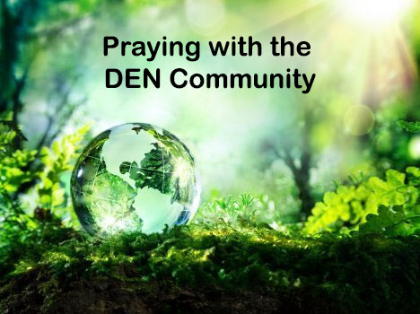 | Praying with the DEN Community continues each Friday 9:00 am on Zoom. To obtain the link, please email endionspei@gmail.com The prayers are led by DEN members who are deeply committed to praying for God's creation and for sharing interests and initiatives and information. Individual members take turns leading the prayers which are followed by a time of discussion, conversation and sharing. All are welcome to participate. Thanks to The Church of St Andrew for hosting.


Voices to COP27 / Des voix à COP27 / Voces a la COP27

Thursday, November 3 - 8:30 - 10:30 a.m. EDT

Register for either or both here.
Join us on Thursday, November 3 for Voices to COP27, an online conversation with the KAIROS/For the Love of Creation Delegation to the 2022 United Nations Climate Change Conference (COP27) in Sharm al-Sheikh, Egypt. This event will be presented in English, French, and Spanish with full simultaneous interpretation available through Zoom. The timing is early morning to accommodate the delegates in the Global South: 8:30 to 10:30 a.m. EDT

KAIROS / For the Love of Creation COP27 Delegation
Follow 10 delegates during the United Nations conference on climate change (known as COP27 for the 27th “conference of parties” – that is, signatories – to the United Nations Framework Convention on Climate Change) in Sharm al-Sheikh, Egypt. Part of the KAIROS and For the Love of Creation (FLC) Delegation, they will be reporting from Egypt, November 8-18, and advocating for a seat at decision-making tables to tackle the climate crisis. Read their blogs and videos throughout COP27, and the KAIROS and FLC social media feeds. KAIROS Facebook, FLC Facebook, KAIROS Instagram, FLC Instagram, KAIROS Twitter. The 10 delegates include Indigenous partners and youth from Turtle Island, and KAIROS Women, Peace and Security and global solidarity partners. To read about these 10 delegates go to https://www.kairoscanada.org/indigenous-youth-and-women-delegates-from-canada-and-global-south-head-to-cop27

A Buyer’s Guide to Heat Pumps: How you can save money by making the switch. Nov. 22,2022. 6:30 – 7:30 ONLINE. FREE. To reserve a spot, https://www.eventbrite.com/e/a-buyers-guide-to-heat-pumps-how-you-can-save-money-by-making-the-switch-tickets-450872811717



You, energy, and fossil fuels – a footnote to the end of the current era
Join us on Sunday!
Sunday, November 13, 2:00-4:00 | Tantallon Public Library
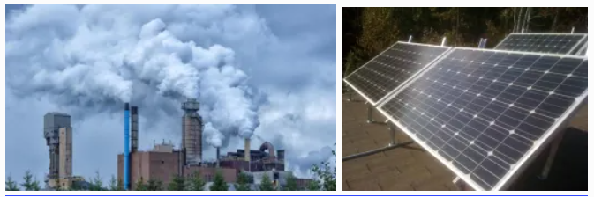
This presentation is about energy. Why it is important, why it is going to change your life, and some things you might want to think about. Join us for this timely and critical workshop about energy, with host Cam Farnell. This is sure to be an informative talk and lively discussion, and will be our first in-person program in over two years.
This event is free (donations appreciated!), and takes place at the Tantallon Public Library.



Christ Church Climate Cafe - continuing and growing Join us Thursday Nov. 17th- 7 pm.

The first Christ Church Climate Cafe was held in April of this year. In that Cafe, and in the following Cafes, participants have come from Christ Church and also the community at large. Participants are from a range of backgrounds, experiences and ages. What we all have in common is our need for a safe and supportive place to talk about our feelings about climate change. It is natural to think that talking about these feelings is depressing; what we find is exactly the opposite. Talking about our feelings, and listening to others in this setting, is heartening.

Nancy Blair is a Climate Psychotherapist in Dartmouth and a parishioner at Christ Church. She started the Climate Cafe as a project of the Diocesan Environment Network (DEN). She was trained through the Climate Psychology Alliance (CPA). We now have a second trained leader, David Paterson, who is the early stages of his teaching career. The Climate Cafe meets at 7:00 PM the third Thursday of the month in the Christ Church Hall. Everyone is welcome.

For information, contact Nancy Blair. nancyblaircounselling@gmail.com 902-223-3151

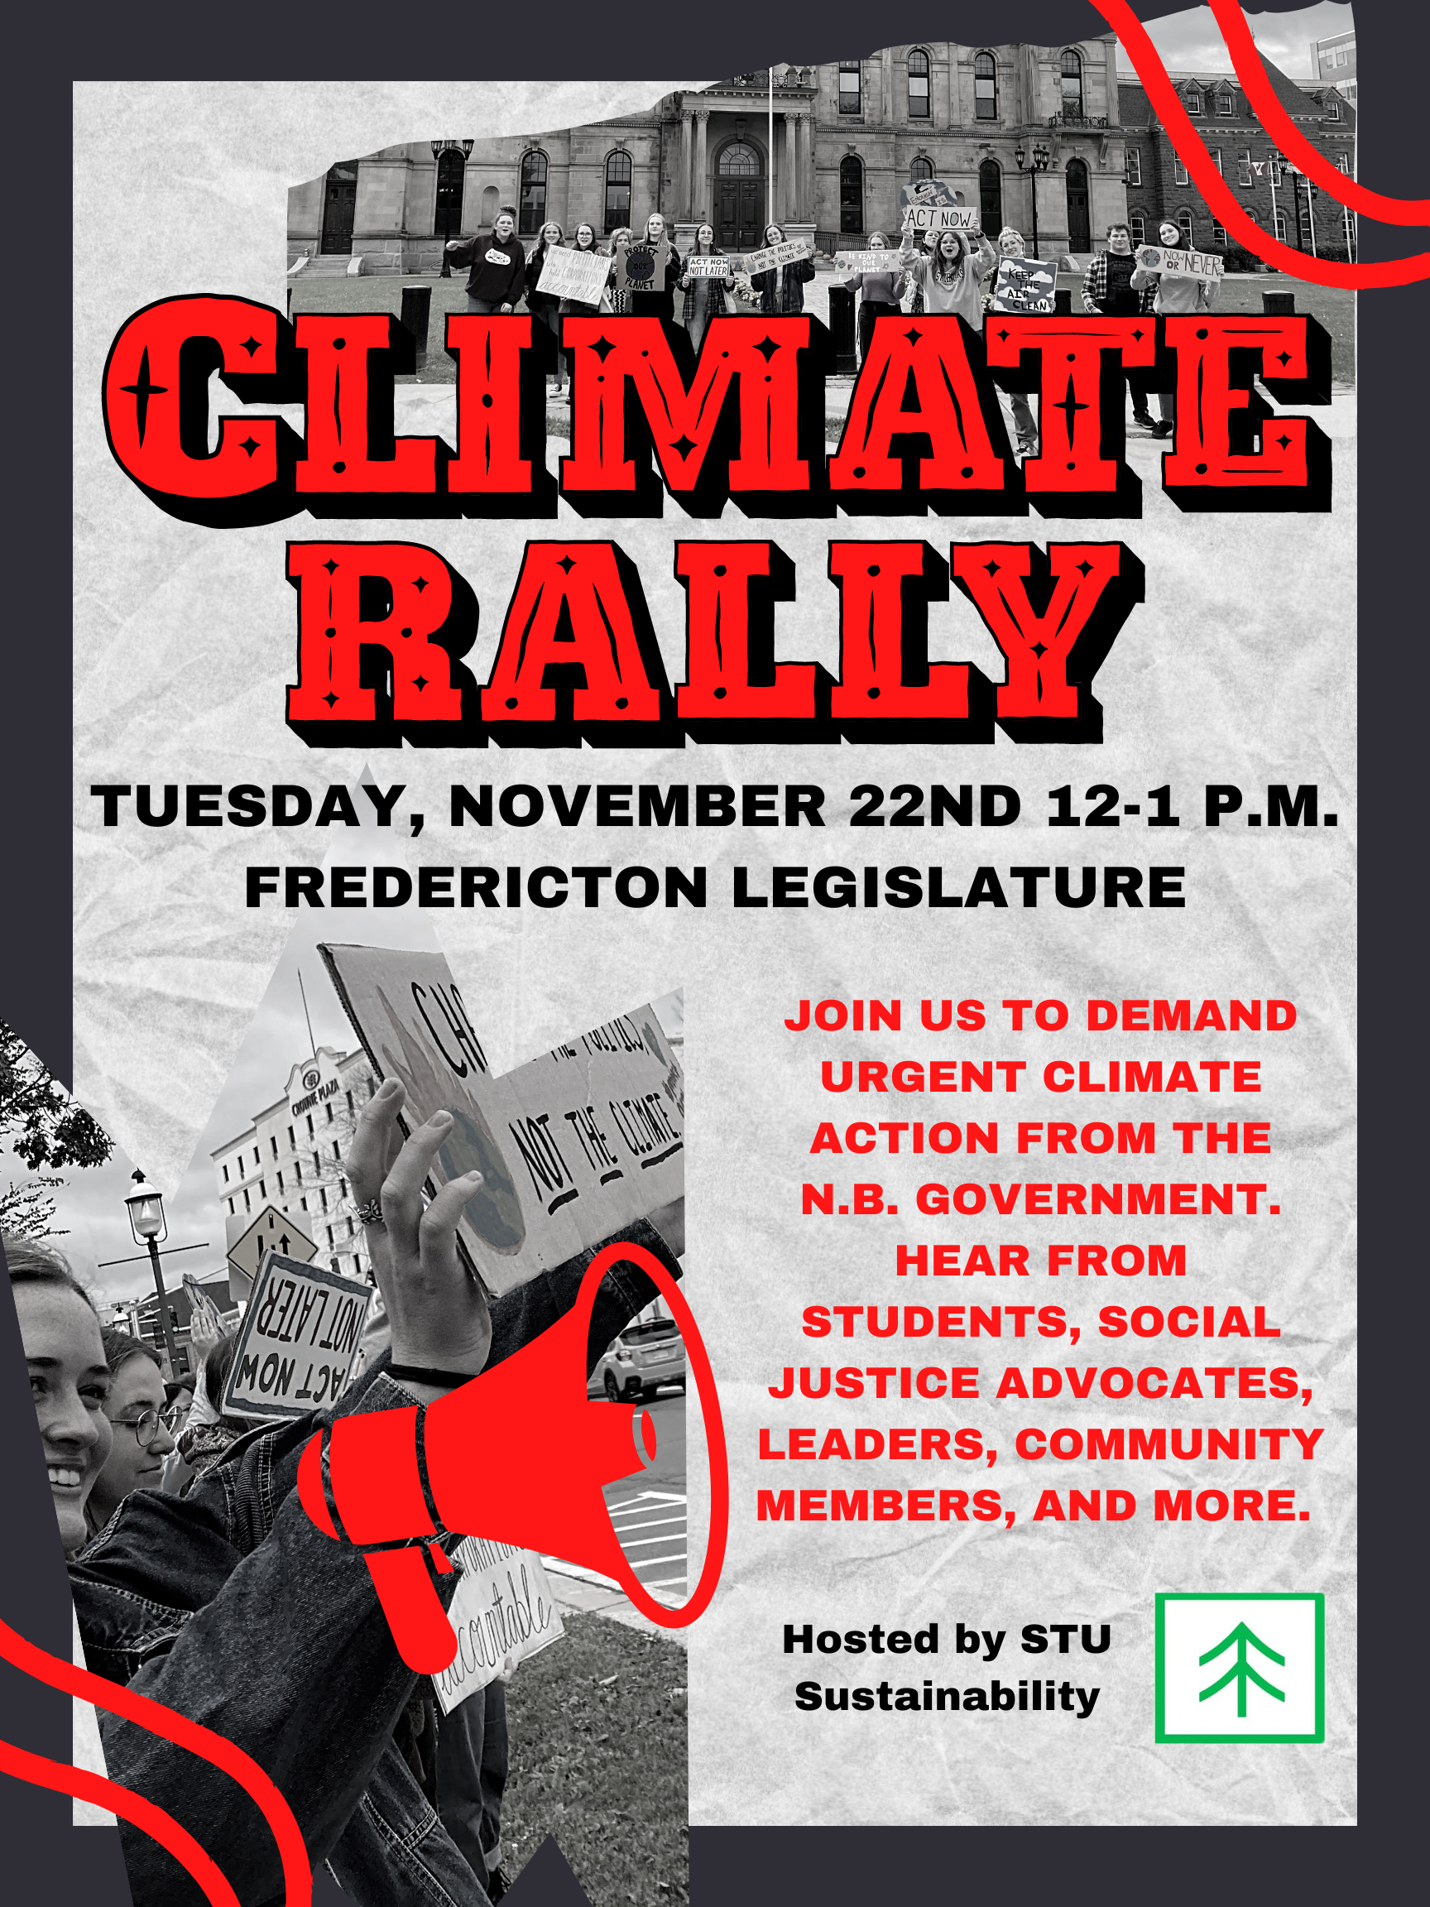

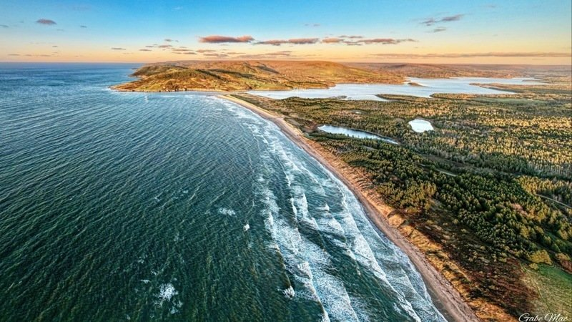
Protect West Mabou Beach - https://www.change.org/p/protect-west-mabou-beach
Grandmother Birch has sent us the following:
Dear Friends,
I am forwarding this petition to you in the hopes you will consider adding your name to the growing list of concerned earth-loving citizens who oppose the development of yet another private golf course in Inverness County. While this petition is not about opposing 'golf', it is about opposing the destruction of a very fragile coastal ecosystem near the community of Mabou - on Cape Breton Island - where I live. The beach ecosystem is home to many rare coastal plants, and provides nesting and migratory launching for many shore birds. The beach and park trails are also one of the few remaining access points for Nova Scotians to enjoy the ocean. It is a place visited by thousands of people --both local and visitors -- each year.
This is a sacred place. You can feel it the moment you step foot on the beach or walk the trails or view the dunes and marsh ponds. It would be a travesty to destroy it, when that is not remotely necessary. While there are a few people who are pushing for this golf course to be built in the local community, with the hopes that it will generate 'jobs', many more people are opposing the destruction of this gem of a common space for all. Please add your name to those who have already expressed opposition.
On behalf of all the more-than-human communities who call West Mabou Beach Provincial Park Ecosystem their home, I want to thank you for your concern.
Kind regards,
Ruth

Supporting 3 bills to lessen environmental racism and hold corporations accountable
For decades, polluting industries and landfill sites have ended up in Indigenous, Black, Brown and other racialized communities in Canada, burdening these communities with higher-than-normal rates of cancer, respiratory illnesses, and other chronic health problems. These sacrifice zones extend to communities in the Global South – usually poor and often Indigenous – where Canadian mining companies operate, contaminating fresh water sources, and contributing to well-documented human rights violations (see on the Kairos site under Resources). Please write to your MP asking support of Bills C-226, C-262 and C-263

A Letter to sign to help save our Forests and Reduce Logging Emissions
A recent Nature Canada report finds that Canada’s net logging emissions were higher than emissions from oil sands production in every year from 2005 to 2018. Carbon emissions from Canada’s logging sector are not clearly reported to the public. The government of Canada has no plan for reducing them. Sustainable forestry in Canada is a corporate myth. The federal government needs to transparently report the greenhouse gas emissions of the logging sector and put in place policies to reduce logging emissions to align with climate goals and protect old-growth forests. Tell the Government to protect old-growth forests and stop obscuring climate emissions from logging.

Why we need to make our voices heard
Environmental Defense have been tracking lobbying in Ottawa. Fossil fuel lobbyists met with government officials a minimum of 102 times in September: over four times per working day. This only counts the federal government, not provincial or territorial governments. That’s an incredible amount of access granted to companies that have been fighting against effective climate regulations, advocating to be allowed to continue extracting oil & gas indefinitely, and for more subsidies to help them do it.

Hustle and Bustle
Christmas is coming! As much as I like the hustle and bustle, I also do not want to be overwhelmed by it all. Christmas shopping alone can do that to a person. I have come up with a strategy. Yes, I start in January when I see something, but the real work starts around Halloween.
When thinking of gifts, get a sheet of paper and write the name of your closest people. When thinking of gift shopping remember
Something they want
Something they need
Something to wear
And something to read
One year Emily wanted a magenta marker, not purple or pink or red but a MAGENTA marker. Such a thing cost me a whole $1.98 and gave her more joy than I could imagine.
A need doesn’t mean something like food or shelter. One need one year was giving someone a certain “night course” so they could learn something computer that helped with something else. It wasn’t that expensive, but they wouldn’t spend the money on themselves. Another need was a movie ticket so someone went and laughed for 2 hours in a dark time.
Something to wear can be easy. Last year I made girls and Moms giggle all day with knee-high socks in Christmas stripes and animal colors. They thought they were hilarious
Reading gifts can be challenging with the guys. Hunting magazines if older, boat or building, cars or wrestling magazines for others.
Now if you only give one gift to someone, then consider getting 4 things to pack in a box, sort of a mini stocking idea.
What candy do they like? Get those hollow Santa Clause in bright foil if you don't know. Who can not smile when finding one of those?
What craft do they do or would like to do.? Maybe a little kit to try something new
What is just plain silly but would make them laugh. I found wind-up toys one year but gave them to all the adults.
Maybe green things like steel straws, paper straws, water bottles, (maybe foldable water bottles), sporks, bamboo spoons for their lunch boxes, crank phone chargers, crank radios, flash drives, power packs, and so much more.
Christmas gifts do not have to be obligatory “nice” under the tree. Make it fun. Do you want them to think “Thanks Grandma for the great (toy, game, candy, sparkly thing)? or do you want to be “Thank you for the beige socks”? Gifts should be wild. Then add a $5 or $10 card to someplace they never go. Get a fancy coffee or pick up a burger.
Get the shopping out of the way so we can have fun with all the rest of Christmas. Then if you need to wait 3 weeks for that set of a certain type of graphite shading pencils to go with the sketchbook, you have the time. It is going to be a great year. I am already trying to find some kids to make bunting that would run around the church. And I will keep saying, no, I will be yelling, MERRY CHRISTMAS.
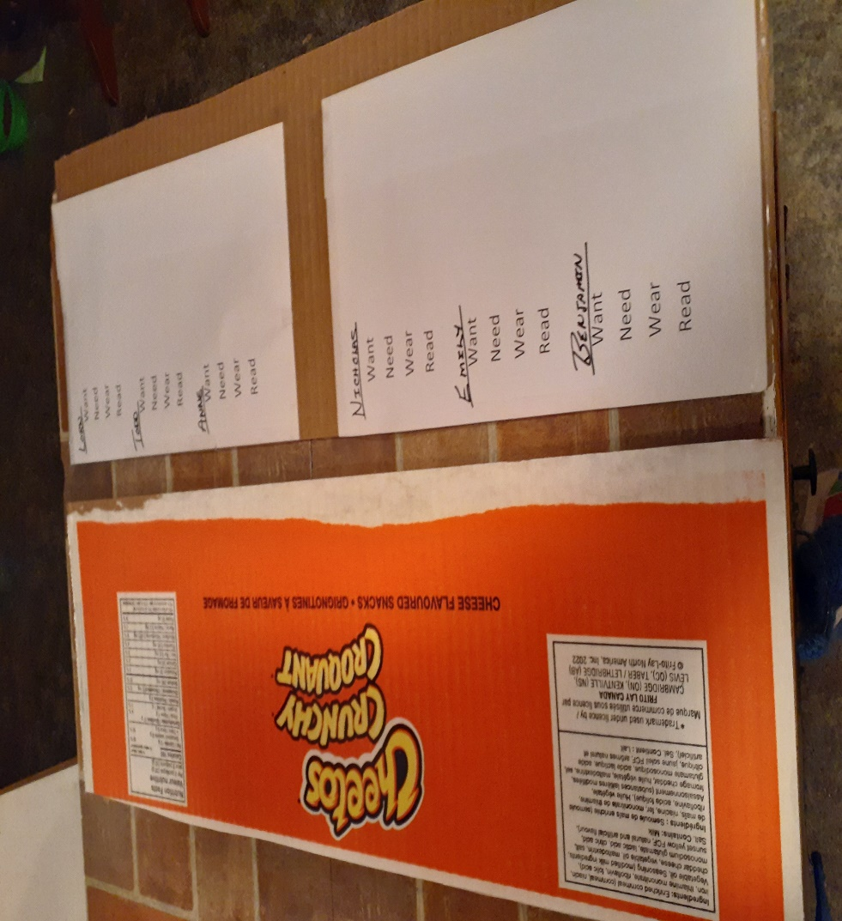
Christmas Craft
One of the neatest things I saw last year was so simple. They had cut-out stars on the boxboard that were painted on both sides in a solid green, red, blue, or gold. It may have been colored Bristol board. Spray glue and add a bit of glitter to make it simple with a sparkle. One-hole punches on the end of one of the star points and hung with a narrow ribbon with a plain wall backdrop. Beautiful!
Go to google.ca, type in star templates, and click images at the top. Plenty to print off to use for templates.
Now Look for the Nativity scene cut out. This makes a stormy day activity to prepare for Christmas.
https://madebyjoel.com/2013/12/paper-city-nativity-scene-joyfully-expanded.html
This is a bigger project for parents or grandparents. You make a green Christmas tree that is mounted on a wall. You make felt ornaments that will naturally stick to the tree. The little ones can decorate and undecorate all they want.
https://projectnursery.com/2015/12/diy-felt-christmas-tree/

USING UP
This year, as I have said for many years, I am using up ribbon, stickers, fancy tape, and whatever else is in the wrapping boxes. Sometimes, I tend to “save” something to use on that special box. No more. Before it is completely dried up or looks worn and old everyone is having the fancy whatnots on the parcels.
Now if you have a few extra small to medium boxes that carried something to your door take a bit of time and paint them solid colors with the little bottles of paint from the dollar store. You just need to line them with tissue, plop them in your gift and tie it with a ribbon when the time comes. You are saving the environment and using what is around you.
Make up the newspaper gift bags now. Just look back at a few issues for that craft. Turn that potato chip bag inside out, wash, fold the top and insert ribbon handles for silver bags under the tree.
Give yourself time just to get the wrapping ready. Get a list of what you need. early (tape, ribbon, bows) and have it ready.
Caught without enough tags? Just type in free Christmas present tags templates and see what you can print out. Grandma has a template for a tag and soon I will sit down and start tracing and cutting out all the bits of patterned cardboard I saved through the year for tags. I know I can buy them cheaply, but I enjoy making them. A one-hole punch and a bit of ribbon and I have plenty.
Have your gift list ready to fill in and then boxes and bags ready to pack. If you are super organized, you have bins (or physical areas) for each household and each gift goes to its appointed place till given out. Yeah, I never get that organized but there is hope.

SOMETHING TO EAT
Just tuck this recipe somewhere. It is my grandmother’s sugar cookies. If you just underbake them a bit, to that point the bottoms have started to tinge brown, then people will praise your “shortbreads”. They aren’t that fancy, just plain sugar cookies, but you will be surprised how many people like them.
Sugar Cookies
In one bowl
4 cups flour
2 tsp baking powder
¼ tsp baking soda
I a second bowl
1 cup butter
2 cups sugar
2 eggs2 tsp vanilla
¼ cup milk
Mix, roll, cut out and bake Sprinkle sugar on cookies before baking. Colored sugar turns them into Christmas cookies. The recipe is well over a hundred years old.
It’s beginning to get exciting! Grandma is sending hugs!

Prayer for the COP 27 Climate Summit
God of blessings,
the universe sings of your glory.
Deepen our gratitude for all you have made
and awaken in us a renewed commitment
to care for the earth and each other.
Inspire world leaders at COP27,
with openness to listen to those most affected by climate change
and with courage to act urgently and wisely,
so that our common home may be healed and restored
and all people, and generations to come, may delight in it.
Amen.
https://cafod.org.uk/Pray/Prayer-resources/COP27-prayer

e

