November 01, 2022
Email: HYPERLINK "about:blank" endionspei@gmail.com Website: HYPERLINK "about:blank" nspeidiocese.ca/den
Facebook: HYPERLINK "about:blank" Environment Network Diocese of NS & PEI

Join the Communion Forests movement. Start planning now for the spring.

What is it? A legacy of the 2022 Lambeth Conference with the aim to increase Anglican tree growing and landscape protection around the world and deepen care for creation within the life of the church. This is a global act of hope with a wide range of creation care activities depending on local needs and expressions. Churches might choose to take up a project that involves:
A message from Bishop Sandra and her reflections on the Lambeth Conference and Communion Forests
Care for the environment is a spiritual practice

One of my special memories of the Lambeth Conference was visiting the gardens at Lambeth Palace in London. Our day there was focused on care for the environment and sustainable development, and it began with a self-directed prayer walk. At each of five prayer stations we were invited to stop, to pray and to reflect on the environment through some action such as pouring water into a bowl or adding petals to create a flower mandala. The prayers were written by bishops from all over the world, some of whom are experiencing firsthand the devastating impacts of the climate crisis. My husband, Jim, and I shared our prayer walk with the Episcopal Bishop of Pittsburgh, the Right Reverend Ketlen Solak, and her husband, Scott Solak, and each of us took turns leading the prayers at each station. As we prayed for the care of creation and expressed contrition for how our actions have contributed to the current situation, we couldn’t help but notice the dry, brown grass all around us. We were told it was one of the hottest summers on record in England. The land was in desperate need of rain.

As we continued our conversations over lunch, we heard from Elizabeth Wathuti, a young environmental activist from Kenya; Archbishop Julio Murry, Primate of Iglesia Anglicana de la Region Central de America (IARCA), who leads the Anglican Communion delegation to the COP meetings on climate change; and Antonio Guterres, the Secretary General of the United Nations (via video message). All highlighted the urgency for action and strategies to slow down the effects of climate change and create a more sustainable future for the planet and its inhabitants. Before lunch concluded we were urged to write a prayer for the earth, which was later placed on a ceremonial tree on the grounds of Lambeth Palace.

Our visit concluded with worship as the Archbishop of Canterbury launched the Communion Forest initiative by planting a tree with Archbishop Julio, Elizabeth Wathuti, and the Archbishop of Cape Town Thabo Makgoba. The Communion Forest is a worldwide environmental initiative encouraging a wide range of creation care activities, including tree planting, the creation of wetlands, and coastal restoration projects. Each area of the Anglican Communion is asked to determine locally how we would like to create and enhance landscape protection, to ensure that our actions are geographically, culturally and environmentally appropriate. You’ll hear more about this in the coming months as we engage this conversation with our Diocesan Environment Network. You’ll also hear more about the Lambeth Calls to action, some of which deal directly with environmental protection and sustainable development.

There is no question that there is some urgency. We don’t have to look far to see the devastating impacts of climate change. However, our time on that prayer walk in the gardens at Lambeth Palace offered hope and encouragement. It was a reality check, for sure. And yet, the frankness and honesty of those prayers reminded us to confess where we have gone astray, to take ownership of our actions which continue to negatively impact the environment, and to pray for the courage and resolve to change.

As we near the end of the Season of Creation, may care for the environment become for us a spiritual practice flowing out of our prayer and worship as we seek to bring healing, help and hope to those most severely impacted by climate change and slow down its effects. There is a saying that the best time to plant a tree was 20 years ago; the second best time is now. Our actions now do matter. May we commit ourselves to walking this path of caring for creation. Trusting in God’s guidance and strength, and the willingness to listen to the advice of climate scientists and other experts, may we continue to take steps that will lead to a healthier planet.

For more information and to register for newsletters https://www.communionforest.org/

Five transformational aspirations have emerged from the work of the Strategic Planning Working Group to direct and inform the future mission of the church. This working group was really excited about DEN and interviewed Mo. Marian Lucas-Jefferies and the Enews editor.
DEN is the first video of 5 videos which will be presented at General Synod in 2023.

Stewards and renews God’s creation: protects and sustains the earth; pursues justice for all

Here is the link to the video:

https://changingchurch.anglican.ca/



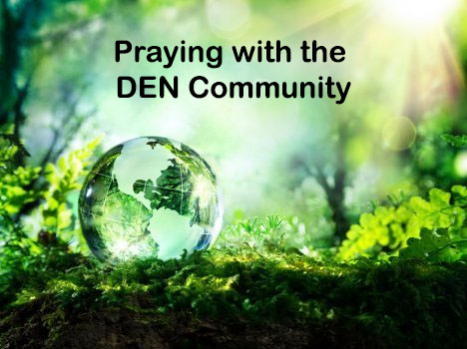 | Praying with the DEN Community continues each Friday 9:00 am on Zoom. To obtain the link, please email endionspei@gmail.com The prayers are led by DEN members who are deeply committed to praying for God's creation and for sharing interests and initiatives and information. Individual members take turns leading the prayers which are followed by a time of discussion, conversation and sharing. All are welcome to participate. Thanks to The Church of St Andrew for hosting.


Voices to COP27 / Des voix à COP27 / Voces a la COP27

Thursday, November 3 - 8:30 - 10:30 a.m. EDT

Register for either or both here.
Join us on Thursday, November 3 for Voices to COP27, an online conversation with the KAIROS/For the Love of Creation Delegation to the 2022 United Nations Climate Change Conference (COP27) in Sharm al-Sheikh, Egypt. This event will be presented in English, French, and Spanish with full simultaneous interpretation available through Zoom. The timing is early morning to accommodate the delegates in the Global South: 8:30 to 10:30 a.m. EDT

Also from Kairos – Upcoming Webinar” Palestine is a Climate Justice Emergency Nov. 9th.
To register: https://us02web.zoom.us/meeting/register/tZUldOisqjMoGtx2aBb0cwhTAqT8owe6UsQm?eType=EmailBlastContent&eId=508a78b6-9a58-4ee8-932b-214f7fb3f3af
 | Applications are still open for the fifth edition of the World Council of Churches Eco School on Water, Food and Climate Justice to be held Dec. 5-11, 2022.  Deadline for applications is Nov. 10, 2022.  https://www.oikoumene.org/news/applications-extended-for-wcc-eco-school-2022-with-focus-on-north-america


What is it? https://united-church.ca/events/candles-cop27-vigils-climate-justice
November 11 - 13th, 2022
DEN will be holding a virtual vigil, led and hosted by the DEN Morning Prayer group at 1 pm on Nov 12. Please attend with a candle or light or a symbol that works for you.

From November 6th-18th of this year, world leaders will gather at the COP27 conference in Egypt to discuss their plans to address global heating. This will be a time to reflect and share our love for our planet, our concern for ourselves and our fellow human beings at risk from climate change, and our hopes for truly transformative action to happen at COP and through each other. This invitation coincides with and complements the call for a Global Day of Action on November 12.
Join Zoom Meeting
https://us06web.zoom.us/j/81697631364?pwd=czBVdGJibVlJQm43Q2g0TTQwTkhVQT09
Meeting ID: 816 9763 1364
Passcode: 861700
One tap mobile
+14388097799,,81697631364#,,,,*861700# Canada
+15873281099,,81697631364#,,,,*861700# Canada
Dial by your location
+1 647 374 4685 Canada
+1 647 558 0588 Canada
+1 778 907 2071 Canada
Meeting ID: 816 9763 1364
Passcode: 861700
Find your local number: https://us06web.zoom.us/u/kgEi1386


A Buyer’s Guide to Heat Pumps: How you can save money by making the switch. Nov. 22,2022. 6:30 – 7:30 ONLINE. FREE. To reserve a spot, https://www.eventbrite.com/e/a-buyers-guide-to-heat-pumps-how-you-can-save-money-by-making-the-switch-tickets-450872811717


Please see their latest newsletter online: https://api.neonemails.com/emails/content/agmtXE-oWp_sPu_hGsuQw8wxqO0DTUz-qf35qwyktXo=

EAC petition re Provincial Park- golf course?
Premier Tim Houston says he will listen to Nova Scotians. Use the form from Ecology Action Centre to send a message to the Premier, Minister of Natural Resources and Renewables Tory Rushton and Minister of Environment and Climate Change Tim Halman urging them to do the right thing: say no to the development of a golf course in the West Mabou Beach Provincial Park and make it clear to all that our parks and protected areas are not for sale – period.
Message to prov. and HRM officials to save Sandy Lake and Sackville River
On March 24 2022, the Provincial government’s Task Force on Housing picked the Sandy Lake – Sackville River area as one of its locations to fast-track for development. The very same area has been proposed for protection as part of Sandy Lake Regional Park. It shows up in multiple studies as a key area for wildlife corridors and is invaluable as intact, interconnected wild areas that help with the twin crises of climate change and biodiversity loss. We still have time to come together and save Sandy Lake and Sackville River! HRM councillors have recently shown an interest in keeping this important wild area safe, but their views were over-ridden by the provincial Task Force’s decision.
350.org letter to the editor re an oil and gas windfalls tax
With the COP 27 climate summit right around the corner, Canada’s lack of climate progress is in the spotlight and Trudeau is looking to prove he’s serious about cutting emissions. This gives us a real chance to make him deliver an oil and gas Windfall Profits Tax and invest in a bold and ambitious Just Transition. Spreading the word through local newspapers is an important way to build public pressure and counter Big Oil’s greenwashing tactics.

New Petition to Save Eisner Cove Wetland This is an easy one to fill out. We can't give up!

Green Story - After the Hurricane
Not having internet for a week after Hurricane Fiona gave me a new perspective. My computer was charged even when we didn’t have power, but you will never guess how many times I went to check some facts and there is no internet!!!!!!
Without the internet, you can’t send pictures from your phone to the computer. Instead, I download them, found them, put them in folders, and then copy and paste them into articles. It worked but oh the frustration!
Complain! Complain! Complain! If this was the worse, that I suffered, I was lucky. So many may have been missing internet services like me, but did they have a computer to work on or a warm house to sit in? I missed getting my article in on time. Boo Hoo!
It all made me feel so lucky. Sure there may have been a dozen things to make an inconvenient day but I was warm, had food, and could sleep in a warm bed.
Yes, I worried about my work-at-home job, but would anyone fire a person when the whole province is down?
Somehow in all of this, the healthcare system we love to complain about even gave Grandma the operation she needed. There could have been no better care provided.
As always, Grandma and Nana look for anything new that may help when the power is out
We learned about a product that will allow us to start the generator in its little shed and then plug it into the outside of our house. That connects to a panel of plugs indoors that can run cords to freezers, heaters, and our one-burner stove.
I may have enjoyed cooking one meal on my backpack burner, but not for many days. The only difference with this device is that we won’t need the door open in a blizzard losing more heat than we can generate.
We had purchased power packs to charge the phones and tried those out this time. They gave a great charge. I also had a solar one we tried, it was slower but worked.
Our next thing will be a bigger indoor power pack that will keep the C-pap machine going. Without it, I snore, and Nana can tell you just how loud I can be.
With each storm, we learn more ways to help ourselves be more comfortable. Each storm hopefully teaches the world that climate change is real. Hoping you all came through this fine
Garlic
Do you have your garlic planted?
You can plant them in the spring but if you want a head start we plant in October or early November. Put a couple of inches of soil over them, plant pointy end up, and forget them till April when they start shooting up before anything else is ready.
There are mainly 2 types of garlic. The soft neck variety will not grow skypes but their bulbs grow bigger and can be stored for a whole 12 months. Hard neck garlic grows the skypes and can be stored for six months.
Our lay minister gave me 2 garlic last year and I managed to harvest quite a few this year. (Update, planted a week ago, and with the extra mild weather my garlic came up. I am told not to worry as the little bulbs are establishing roots that will help them get through the winter. See what you can do if you just plant the big cloves in one garlic bulb.
Gift Card holders  We have four more issues after today, before the DEN e-news closes down for the Christmas holiday. One thing we could make ahead of time is the gift card holders.  I know I will be putting a gift card in the boxes for my 5 Ontario grandchildren, so I usually make up 10 card envelopes. It’s nice to give a coffee to the mailman, the flyer delivers, or just plain slip a $5 coffee card in a senior’s mailbox.  Get your box board out and some Christmas wrap or just your aluminum foil from the kitchen.  Draw a rectangle about 4 x 7 inches or 10 x 17 cm. on your box board and cut it out. Before covering it, fold it in threes, making one of the ends just a bit shorter for the cover. I clip the cover corners to be a bit fancier.  Cover and decorate the card. Fold in threes and tape the sides of the envelope together. | 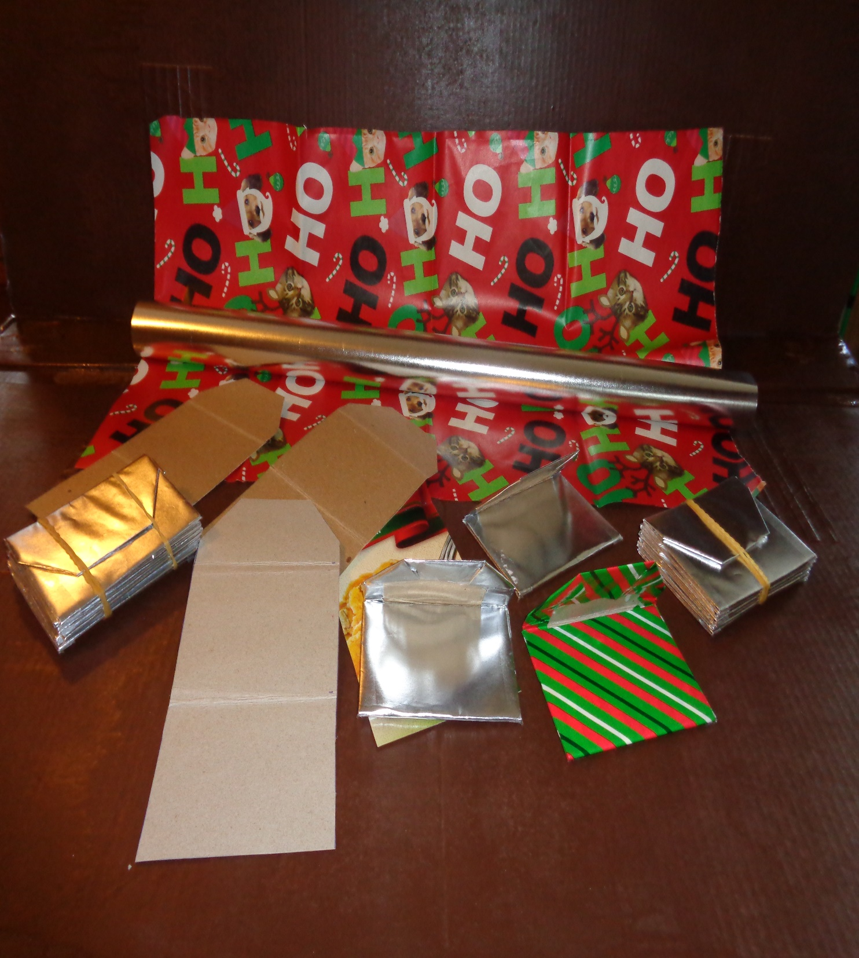  You could punch a one-hole punch in the front and tie in a ribbon to use as a closure. Some people use stickers to close them  You may be surprised how quickly gift card holders disappear as you start wrapping. Remember you just reduced your carbon footprint, had fun making a craft, and have one thing ready for the holidays.

Using up or stocking up
Grandma has a squirrel problem. When that squirrel got in the house and chewed my good plastic container full of oatmeal, she declared war on squirrels.
One way to keep them away is to mix up ¼ cup castor oil and 2 big spoons full of dish detergent in a gallon of water and spray it everywhere. My basement floor could use an extra splash of soapy water.
How is that stocking up? I needed the castor oil and went to order it from a pharmacy, which got me checking just regular supplies. Do you have enough cold medicine, rubbing alcohol, or peroxide in the house? Was the first aid kit refilled after that last fall?
Go through the medicine spot. Throw out what may be too old and fill in what you need. If you catch that cold, you don’t want to drag yourself to a store for medicine. Get it now when you are well
Something to Eat
My family came out from Dartmouth to help Grandma with a few things. Todd and the teenage Nicholas were putting in that generator plug. My daughter Anne had planned on piling wood. She always loved that chore as a kid and she and my granddaughter Emily stacked the best part of a cord of wood. Little Benjamin was so excited to run to the end of the yard and back, thinking it was so big to go by himself (with many eyes on him). Just a regular family day.
Workers need to keep up their strength so Grandma made her son-in-law’s favorite cookie, a 3 chip, chocolate chip cookie. (Tastes just as good if you only have one type of chocolate chip but the kids love this version.) We know them as Stephen’s cookies although I am not sure who Stephen was.

Stephen’s Cookies
In one bowl mix
1 cup butter
1 cup brown sugar
1 cup white sugar (Grandma never uses that much)
2 eggs
1 tsp. vanilla extract
In a second bowl mix
2.5 cups of flour
1 tsp baking soda
1 tsp. baking powder
Dash of salt if you use it
2 cups of chips using
Milk chocolate
White
Semi-sweet
1 cup of nuts, be they walnuts, pecans, almonds, or another nut
Mix the dry into the wet bowl till mixed and drop by the spoonful. I use a fork and crisscross the top of the cookies before baking at 350 for 8-10 minutes.
Makes over 2 dozen. There were very few left when the container went out to the truck to starve off hunger on the way back to the city.

Prayer for the COP 27 Climate Summit
God of blessings,
the universe sings of your glory.
Deepen our gratitude for all you have made
and awaken in us a renewed commitment
to care for the earth and each other.
Inspire world leaders at COP27,
with openness to listen to those most affected by climate change
and with courage to act urgently and wisely,
so that our common home may be healed and restored
and all people, and generations to come, may delight in it.
Amen.
https://cafod.org.uk/Pray/Prayer-resources/COP27-prayer

e

