October 11, 2022
Email: HYPERLINK "about:blank" endionspei@gmail.com Website: HYPERLINK "about:blank" nspeidiocese.ca/den
Facebook: HYPERLINK "about:blank" Environment Network Diocese of NS & PEI


What is it? A legacy of the 2022 Lambeth Conference with the aim to increase Anglican tree growing and landscape protection around the world and deepen care for creation within the life of the church.
This is a global act of hope with a wide range of creation care activities depending on local needs and expressions. Churches might choose to take up a project that involves:
- Protection – advocating and taking action to stop deforestation or prevent the destruction of other habitats.
- Restoration – restoring a piece of waste land or other degraded environment.
- Creation – starting a forest initiative on church land or support a project in the wider community.
- Growing – protection and restoration should be considered ahead of establishing something new. Where something new is set up, the emphasis should be on growing, not just planting. It is about growing the right kind of tree in the right place.
- Multiplying – helping others get involved. Churches or diocese can be a ‘multiplier’ by setting up a tree or plant nursery to enable wider participation in afforestation.
For more information and to register for newsletters https://www.communionforest.org/

Webinar to learn more is tomorrow

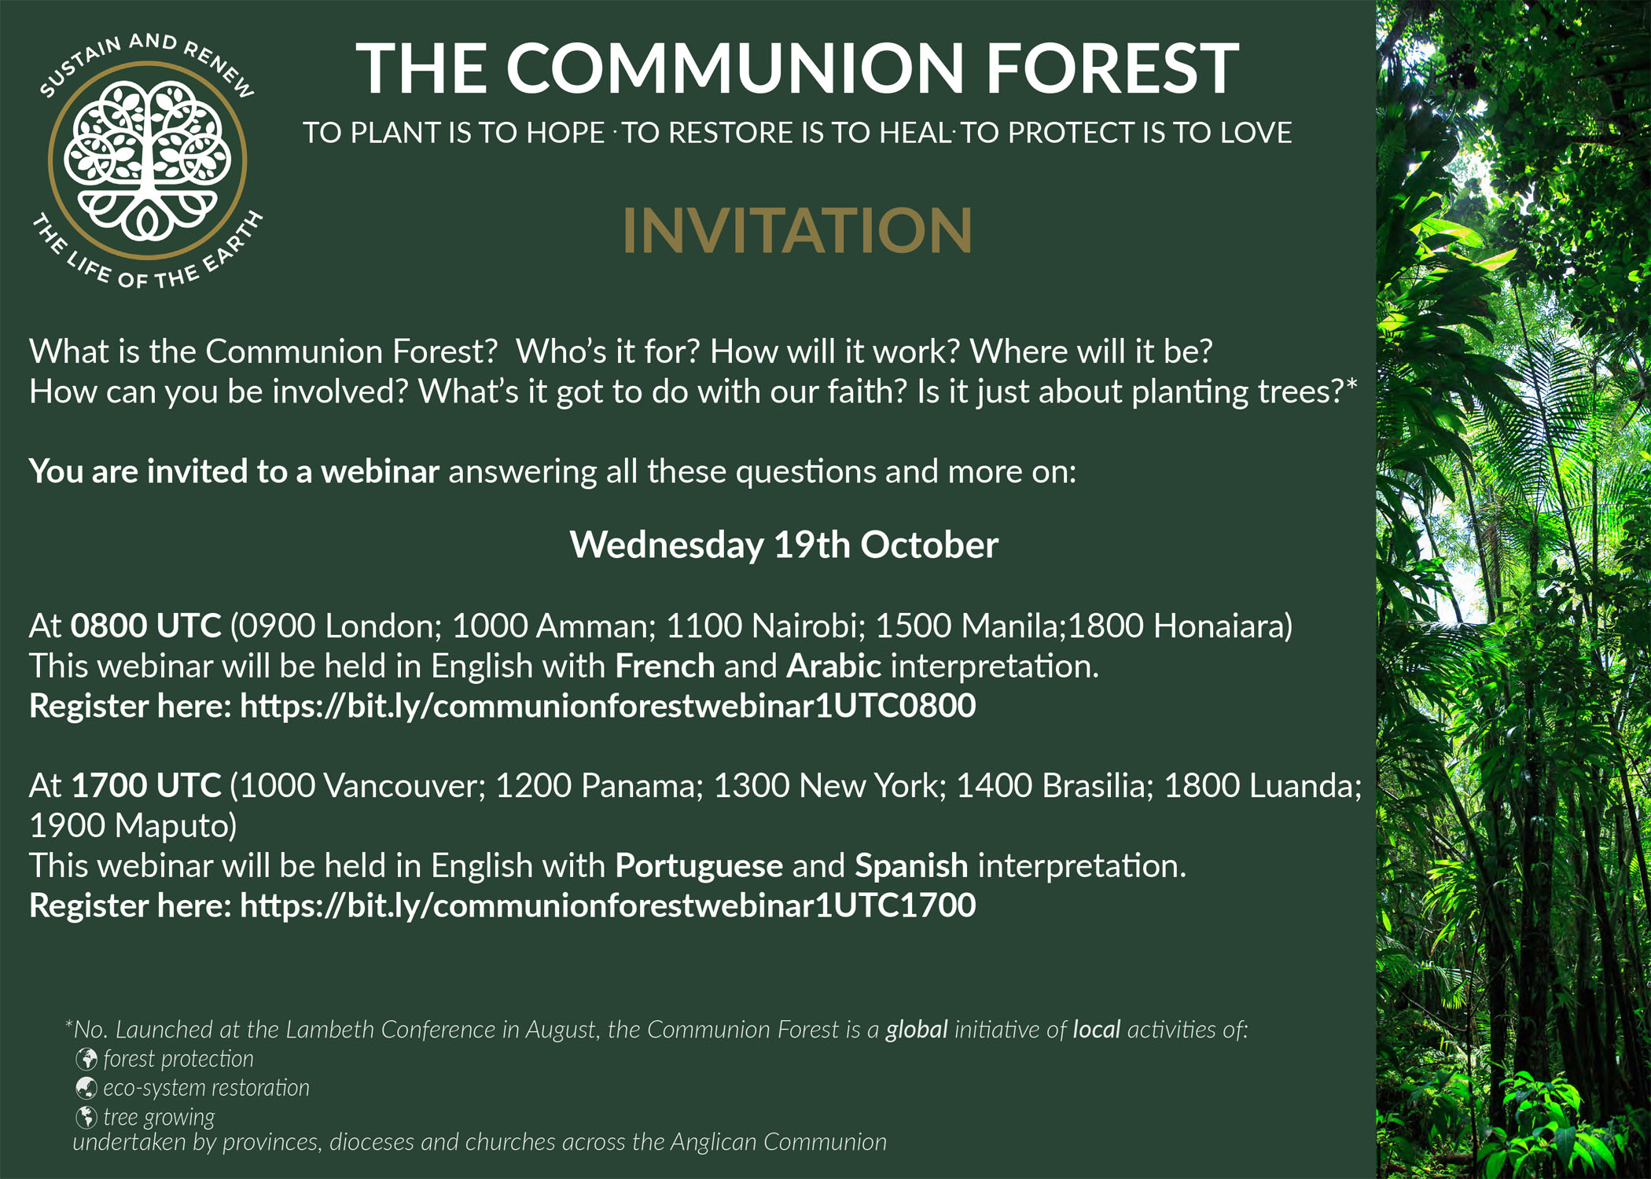

Join the Communion Forests movement and send us your photos.
A message from the Communion Forest Global Facilitator, Nicholas Pande:
Dear Rev. Marian,
We are so happy to hear of how the Communion Forest has been embraced in the Diocese of Nova Scotia and Prince Edward Island. We appreciate your efforts and very much looking forward to having you share the stories of your initiatives to inspire the rest of the Communion. I would also like to invite you to join our webinar coming up this Wednesday 19, October.


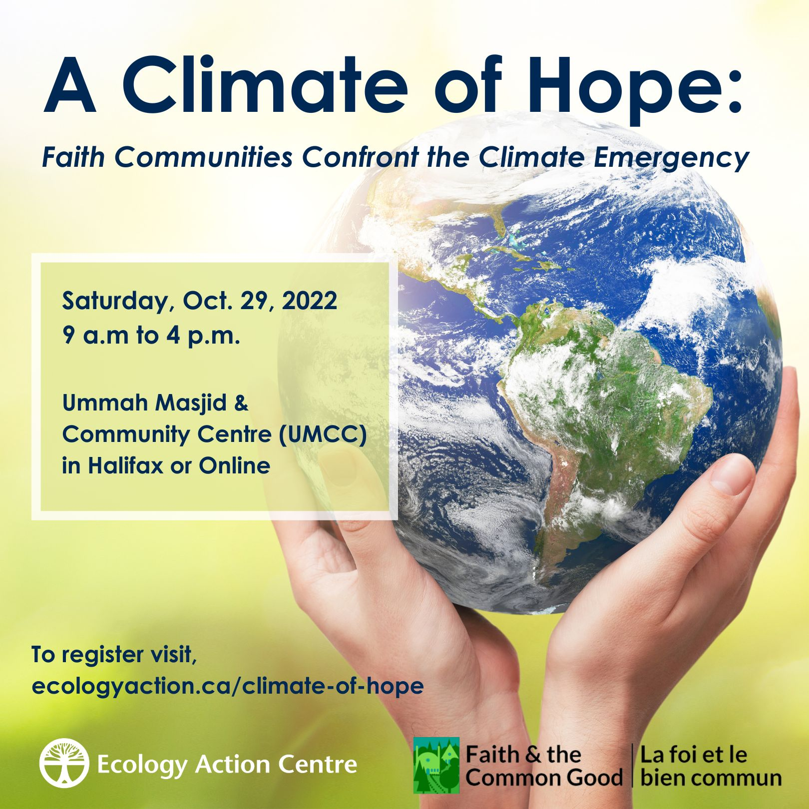
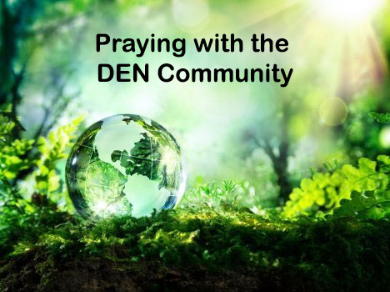 | Praying with the DEN Community led by the Rev.Tory Byrnes continues each Friday 9:00 am on Zoom. To obtain the link, please email endionspei@gmail.com Prayers will take shape from different traditions and focus on various aspects of our relationship with the Creation. For more information or questions or to share how you/your parish or group are praying for creation, please e-mail victoriabyrne02@gmail.com  Thanks to The Church of St Andrew for hosting.

The Climate Cafe is a safe and respectful place for people to talk about how they feel about Climate Change. This month’s date is Oct.20th 7:00-8:30 PM in the Christ Church Hall (Lower Level), Dartmouth, Nova Scotia. During the Cafe, we listen to each other and those who want to talk, do so.Individuals interested in attending, or who simply want to learn about what happens in the Climate Cafe, are invited to contact Nancy Blair, nancyblaircounselling@gmail.com
The Climate Cafe is open to all - masks are required.

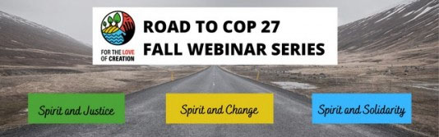
Join the Road to COP27: Fall Webinar Series, Oct 4, 11, 18 – 8 pm EST Learn More and Register One last session Tomorrow October 18 – Road to COP 27: Spirit and Solidarity,delves into climate mitigation and adaptation as it relates to the Global South. The main speaker is Naomi Johnson of Canadian Foodgrains Bank.
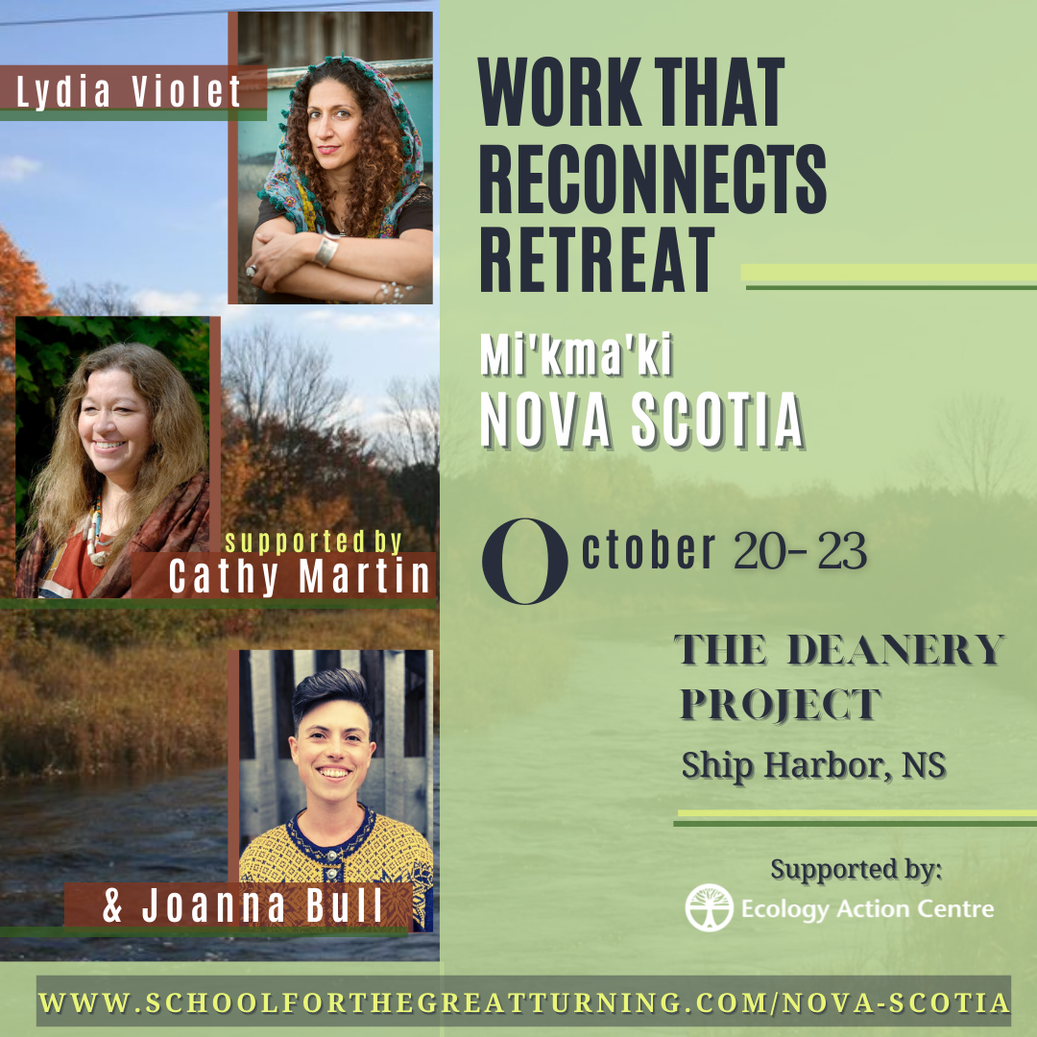 | There are still a few registration spots available for the Work That Reconnects retreat at the Deanery Project from October 20-23.  Catherine Martin will joining this retreat as a Mi'kmaw knowledge keeper, to weave in Mi'kmaw teachings and practices with the Work That Reconnects and to explore with us what it is like to do the work here with this land, in Mi'kma'ki.
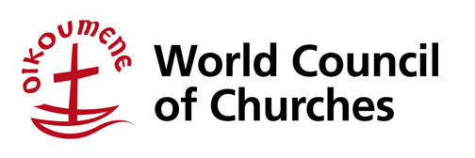 | Applications are still open for the fifth edition of the World Council of Churches Eco School on Water, Food and Climate Justice to be held Dec. 5-11, 2022.  Deadline for applications is Nov. 10, 2022.  https://www.oikoumene.org/news/applications-extended-for-wcc-eco-school-2022-with-focus-on-north-america



R
Candles for COP27: Vigils for Climate Justice
November 11 - 13th, 2022
Dear Volunteers and Faith Communities,
From November 6th-18th of this year, world leaders will gather at the COP27 conference in Egypt to discuss their plans to address global heating.
Despite increasingly clear evidence of the climate emergency, leaders across the world and particularly in Canada are failing to take the decisive action needed to protect our world, and particularly the most vulnerable members of the global community. Canada has yet to reduce our national emissions, our government continues to approve and subsidize new fossil fuel infrastructure, and we are falling behind in our commitments to fund energy transitions in less developed countries. This cannot continue.
In recognition of the need for change, members of ClimateFast and For the Love of Creation invite groups across Canada to host candlelight vigils in their own communities on the weekend of November 11-13. This will be a time to reflect and share our love for our planet, our concern for ourselves and our fellow human beings at risk from climate change, and our hopes for truly transformative action to happen at COP and through each other. This invitation coincides with and complements the call for a Global Day of Action on November 12. Candlelight vigils are already being planned in several places.
We encourage people to use their local events to highlight local climate-related issues that are important to them, as well as international issues such as the demand for a Fossil Fuel Non-Proliferation Treaty. Information on key pan-Canadian asks will be provided in advance of the date. We will amplify each other’s voices by acting on the same weekend. Let’s light up the whole Canadian map!
If you or your group is interested in hosting a vigil, please contact climatefast@climatefast.ca to add your event details to the national list. Check here for the list.

350.org petition to fed. gov't on clean energy transition
While communities across Canada reel from devastating climate disasters and buckle under the increased cost of living, fossil fuel executives are laughing all the way to the bank. The oil and gas sector will earn a record $4 trillion in 2022. Meanwhile, even as the cost of oil drops, these companies keep gouging consumers with high gas prices. It’s time to make polluters pay their fair share. We can’t trust these companies to direct their record profits into climate solutions. We need our government to act. Please sign a new petition from 350.org calling on Prime Minister Trudeau and Environment Minister Guilbeault to tax the fossil fuel industry’s excess profits and fund a rapid, just transition to clean energy.
David Suzuki Petition for more Electric Vehicles
Transportation accounts for a quarter of Canada’s carbon emissions.Canada’s climate plan includes a mandate so that all new passenger vehicles will be zero-emission by 2035. Automakers will have to ramp up sales of EVs and phase out gas guzzlers. This will make more electric vehicles available on car lots at lower prices. Canada’s environment minister said he would bring in the new regulation this year, but auto industry lobbyists are trying to scuttle it. At present only 1 in 20 new passenger vehicles sold is electric.
Petition re Toxins in Dollar Store Products
1 in 4 products tested at Canadian dollar stores are toxic – that’s the latest findings from a report released by Environmental Defence. The levels of toxicity are alarming – dollar store headphones tested had 3,000 times the amount of lead allowed according to Canadian law. Lead poisoning can cause significant cognitive and developmental delays in young children with high exposures and can create risks of high blood pressure and kidney damage in adults. Canadian law leaves huge loopholes for stores such as Dollarama and Dollar Tree.
Council of Canadians Petition to RBC to save the Wedzin Kwa river
Despite years of organized, principled resistance by the Wet’suwet’en people and their allies, the Coastal GasLink pipeline could begin drilling under the internationally significant Wedzin Kwa river any day now. The Wet’suwet’en people depend on the Wedzin Kwa: it is a source of food, water, and a site for ceremony. It’s one of the most pristine rivers in the world. But that could change if the Coastal GasLink pipeline is allowed to proceed. RBC is under immense pressure and it’s working. In recent months the Wet'suwet'en have faced increased surveillance and harassment from RCMP's C-IRG unit (a police unit created to facilitate pipeline construction) and a series of private security contractors. Wet’suwet’en village sites remain under 24 hour surveillance, while police have made several arbitrary violent arrests, including with pepper spray.
Letters to the Editor - from Kairos
Help amplify action on the climate crisis! Letters to the editor (LTE) are a great way to do just that. A newspaper’s letters section is one of its most popular pages, and elected officials and staff tend to read them to sense the priority interests of local citizens. KAIROS will monitor newspapers in the lead up and during COP27 for LTE opportunities. If you or your communications person would like to receive LTE notifications (and in turn notify your own networks), please let Cheryl McNamara know at cmcnamara@kairoscanada.org.

Green Story - Coffee Pods
This is one our editor Carole mentioned on our Facebook page and I started researching.
There are 2.8 MILLION coffee pods used each day in Canada. You can’t recycle them. They are too tiny but with 2.8 million of them being thrown in the trash daily, that adds to landfills substantially in a month, in a year.
Enter coffee balls. The coffee is inside a dissolvable, biodegradable outer covering. When put through a single serve machine there is nothing left to throw away. There is just a cup of coffee to drink.

Coffee Balls – Carol posted on our webpage
https://abcnews.go.com/International/wireStory/swiss-retailer-rolls-coffee-balls-replace-capsules-89389600?cid=social_fb_abcn&fbclid=IwAR2BKuQ8Rrt8NsjnYqvnB7CoySmxrrZQebl69C1SbOzrk0XxBexNA8APJGE
From CBC - 2.8 million pods a day, ONE DAY
https://ww.cbc.ca/news/canada/toronto/too-many-single-serve-coffee-pods-ending-up-in-landfills-coun-jaye-robinson-says-1.3802265#:~:text=In%20Canada%2C%20two%20thirds%20of,study%20on%20coffee%2Ddrinking%20habits.

Craft
If we are cleaning a cupboard, consider making your own storage boxes. Yes, I tend to save little boxes. I buy the border wallpaper, maybe 8-12 inches wide, when I see it on sale. As little boxes come in, I cover them in wallpaper, making the box stronger and pretty. Sometimes I just paint them with little bottles of paint from the dollar store. I always find something in the junk cupboard to organize in a cute box.

e mak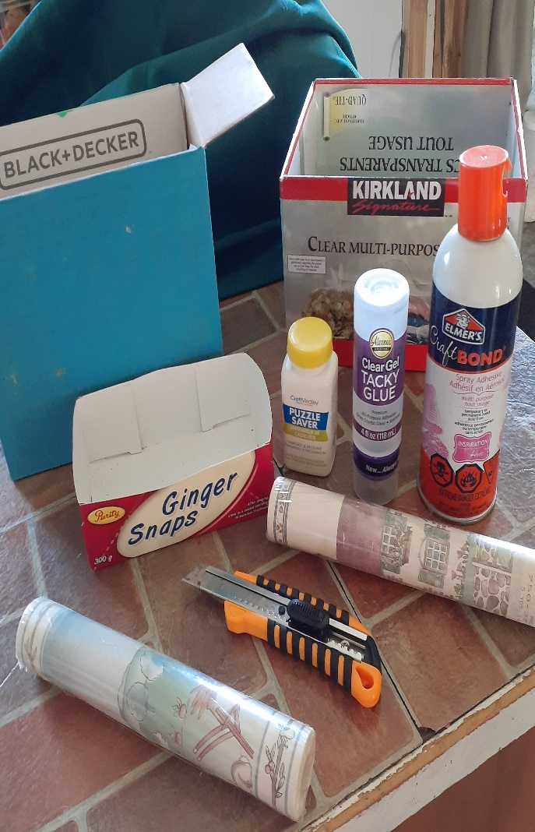ing li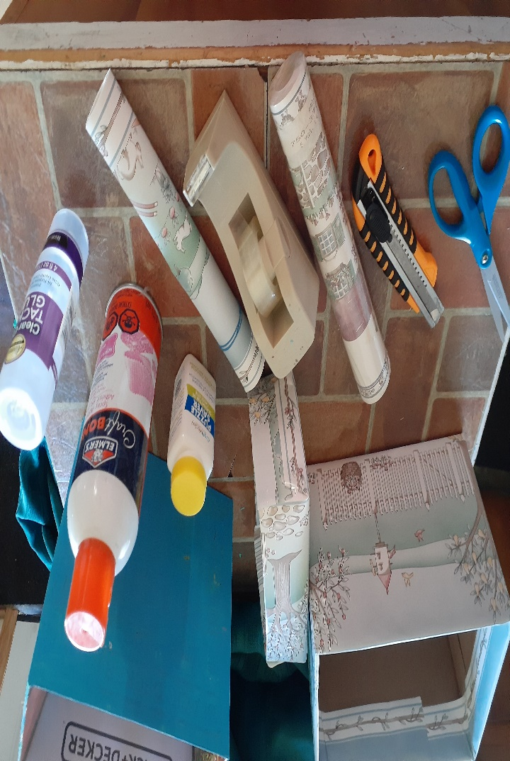fe harder in B.C. Last year 600 people died, thousands lost their homes or jobs, and billions in infr Using up
During the hurricane I had a three shelf cupboard pulled out to grab a freezer plug that eventually led to a generator. When the power came on, I replaced the plug and pushed the cupboard back. Like one of those cartoons, the whole left side of the cupboard came apart and everything on the shelves slid sideways.
It was about time to clean it anyway.
Finding SIX, yes 6, of those screw connectors that wrap around bolts or screws on the new “assemble yourself” furniture, I knew I could repair the cupboard. Not that I needed extra work, but a wiggly cupboard became sturdy.
Here was my everything (junk) drawer that explodes to a cupboard. Batteries that were put in several locations were gathered. Flashlights waiting for a new battery or bulb were repaired or thrown out.
String, jute, nylon cord, a heavy ribbon or anything else that can tie up things were put in a spot.
There was a container for regular tape, masking tape, filament tape, two-sided tape, magnetic tape, duct tape and Waso tape but more rolls had just landed somewhere in that cupboard. astructure damage hammered our economy. The science is crystal clear: unless govern
Dry ones were thrown. The glue collection needed some added and some thrown out.
There also lay the dozen craft projects, Some I had finished and some I didn’t. All of them disappeared.
Books were culled to be given away. They are the hardest, but I do try to talk myself into” someone else would love to have this one.”
What had been busting at its seams turned into orderly shelves of supplies.
What is in your junk drawer? What can be thrown? Perhaps you have an office supply cupboard that hasn’t been organized in a while. Pick something, reduce it, organize and add to the shopping list those things you need. You have room for them now that the clutter is gone.
ing new oil and gas projects now, deadly climate disasters like these will get much worse, fast. In Something to eat
It’s time for another large casserole and this time it has a taste of Mexico. When I found this recipe it was called “Cattle Drive Casserole”. Supper with family often is a couple casseroles and a big salad. Our teenager loves hot spicy food but he calls this one, tame. If you want it really hot then add some hot sauce. This turns out like mild to medium chilli.

Cattle Drive Casserole
1 pack of hamburg, your family’s size or a pound.
1 diced medium onion
1 bell pepper and green chillies if using them
1 Taco seasoning mix
½ cup sour cream
½ cup mayonnaise
1 cup shredded cheese
1 can green chilies (optional)
1 10 oz can diced tomatoes or ¾ of a 14 oz can)
2 cups Bisquick and water for that mix
Brown the beef, add onion, pepper, and taco seasoning cooking till veggies soften.
In a bowl mix sour cream, mayonnaise, some shredded cheese
For tomatoes I use a big 14 oz can of diced tomatoes and put some aside. Leave some juice with the tomatoes to make the biscuits cook better.
We said Bisquick and if using it, mix and put in the bottom of the pan. Homemade biscuit dough is just as good but I did mine with the Pillsbury bisuicts from the frozen section.
Which ever you use, make a base of biscuit. Add the meat mixture, sour cream mixture, add tomatoes and cover in cheese. Cook about 30 minutes at 350F
It is a little spicy but not flame thrower hot..C.’s biggest climate problem is fracked gas. Tell the government

Your World
God, you created the world with your dream of what it could be.
You dreamed of people and plants, animals and air,
all living in right relationship to you and to each other.
Today we offer to you our dream for a world
which is not threatened by a changing climate
which hurts our atmosphere,
which wounds the poorest and most vulnerable,
which leaves this wonderful planet in poor shape
for future generations.
Help us to listen to your voice,
your Word, and your creation.
Adapted from Dream for the World,
Center for Ministry Development and Catholic Coalition for Climate Change

