October 04, 2022
Email: HYPERLINK "about:blank" endionspei@gmail.com Website: HYPERLINK "about:blank" nspeidiocese.ca/den
Facebook: HYPERLINK "about:blank" Environment Network Diocese of NS & PEI

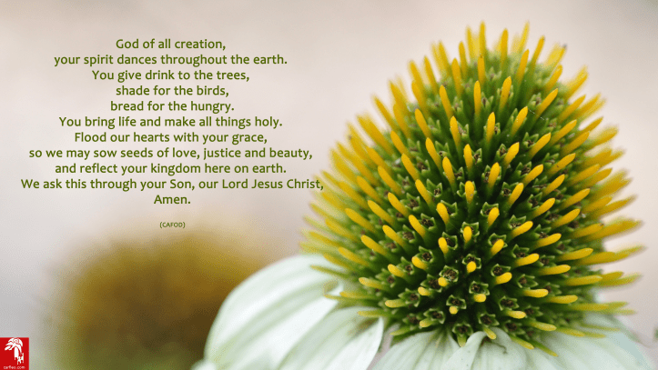
Image from https://carfleo.com/2018/08/31/world-day-of-prayer-for-the-care-of-creation-2/

News from the Rev. David Greenwood and the Parish of the Holy Spirit, Dartmouth : “The Parish of the Holy Spirit, Dartmouth was fully committed to the Season of Creation again this year. Four Sundays were dedicated to highlighting eco-justice concerns and the climate crisis. We started our services on Sunday 2 September with a bare sapling at the front of the church. For the second week, it was decorated with red "burning bush" leaves. The third Sunday the leaves had turned green, yellow, and brown. And for the fourth Sunday, the tree was covered with flowers and had birds nesting in its branches. Each of the Sundays also had the themes of (1) Water Justice, (2) Land conservation, (3) plants and agriculture, and (4) Animals and how pollution is contributing to mass extinction.

Just as the Season was ending, we had the honour of hosting the funeral for Mrs Joan Strang, one of our congregational pewmates. During the funeral planning meeting, we assured Joan's daughters that the tree would be removed from the chancel, but they so enjoyed the tree that they asked if it could remain up for the funeral. And so, our Burning Bush became the Tree of Life for Joan's funeral. Joan had been a member of our Altar Guild and so having trees, Advent wreaths, Christmas poinsettia, Easter lilies, and wedding bowers, were no stranger to her. Following the funeral, Joan's grandchildren were invited to take a paper bird from the Tree of Life to remember her. So, it was a case of recycle, re-use, and remember.”

Blessings of the Animals at Sullivan’s Pond with Holy Trinity Emmanuel, St. Alban’s, Christ Church, Grace United and Victoria Road United Baptist Church:
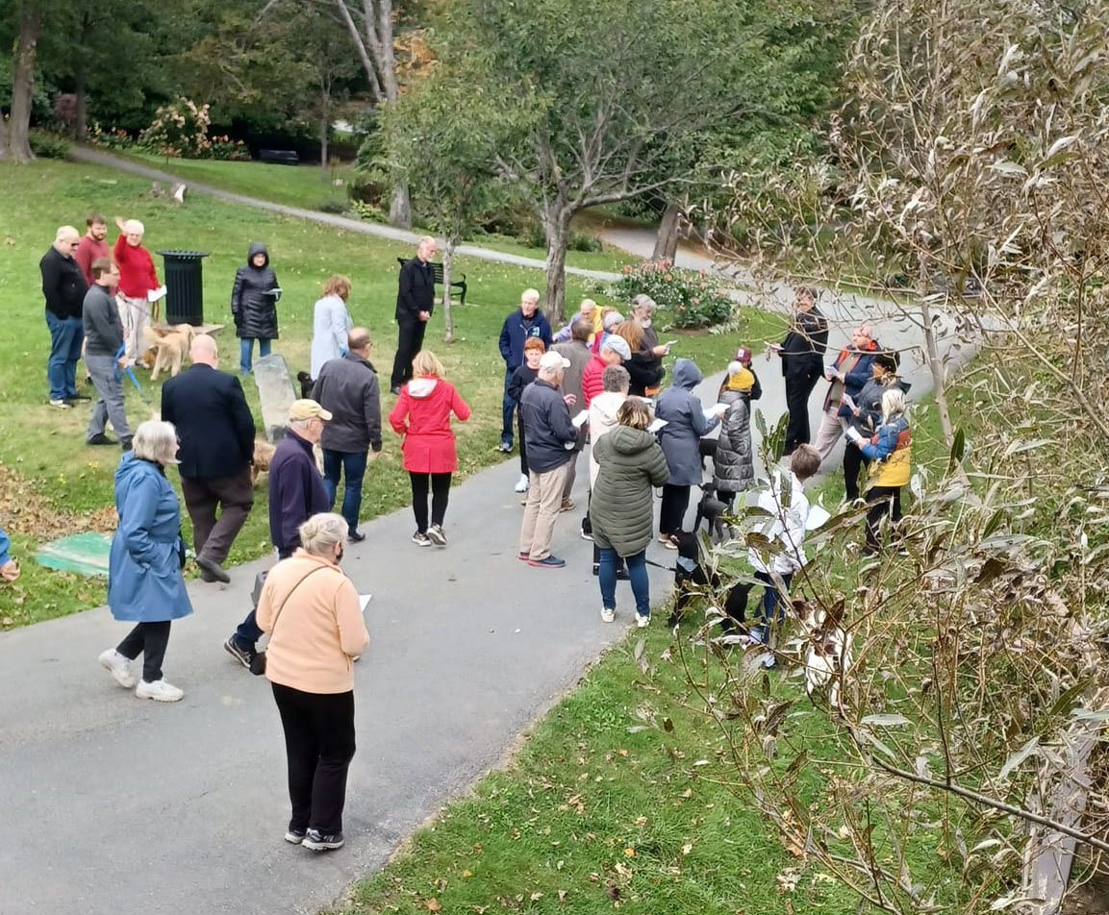



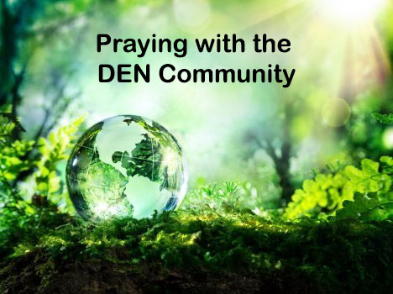 | Praying with the DEN Community led by the Rev.Tory Byrnes continues each Friday 9:00 am on Zoom. To obtain the link, please email endionspei@gmail.com Prayers will take shape from different traditions and focus on various aspects of our relationship with the Creation. For more information or questions or to share how you/your parish or group are praying for creation, please e-mail victoriabyrne02@gmail.com  Thanks to The Church of St Andrew for hosting.


Help Relaunch Climate Circles, A Weekly Community Climate Action Meeting

Two and a half years after Climate Circles first served the Annapolis Valley region in facilitating local climate action, the Blomidon Naturalists Society plans to bring it back bigger and better than before! But the BNS needs your help. We want to be able to fund staff to serve those who want to take patient, kind, sustained and effective climate action and create local, custom-fit solutions together. With paid staff, we will be able to support climate-caring community members with the complexities and challenges that come up when we decide to take climate action together. We will be able to offer trainings, one-on-one and group action coaching, facilitation and meeting skills, and information-sharing options and platforms, as well as the core experience of Climate Circles, a regular, welcoming and well-structured meeting space to find like-minded people, generate ideas and commit to a diverse array of action projects. We also need money to rent space for large meetings every week, and space for working groups to meet between meetings. Please consider donating so we can serve our climate-caring community! https://smallchangefund.ca/project/climate-circles-weekly-action-meetings-to-sustain-grassroots-climate-work/

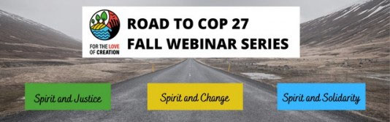
Join the Road to COP27: Fall Webinar Series, Oct 4, 11, 18 – 8 pm EST Learn More and Register
October 4 - Road to COP 27: Spirit and Justice, on Sisters in Spirit Day, examines Indigenous knowledge in connection with decolonizing climate action.
October 11 – Road to COP 27: Spirit and Change, focuses on just transitions and other societal change. The primary speaker is researcher Angele Alook. Learn about different understandings of the term “just transition.”
October 18 – Road to COP 27: Spirit and Solidarity, delves into climate mitigation and adaptation as it relates to the Global South. The main speaker is Naomi Johnson of Canadian Foodgrains Bank, the author of a soon to be published paper on climate finance.
From N.S. Gylphosate aerial spraying in some of NS has been stopped thanks to their MLA and to people camping out. MLA Carman Kerr tried to get the government to follow its own regulations. None of the 13 sites from Baxter’s Harbour in Kings to Concession in Clare was sprayed, thanks to all the communities who stood up and said no, you don’t. Sadly in all the counties where communities did not take direct action, the aerial spraying did take place.

From Germany Buses can move far more people using much less energy than private automobiles. In Germany, inexpensive bus passes got people out of their cars and kept 1.8 million tonnes of emissions from the atmosphere. Under a three-month pilot program, 52 million unlimited monthly transit passes were sold for €9 (US$9) each. That cut car travel by about 10 per cent and “led one-fifth of Germans to begin regularly taking public transit for the first time.”

From Quebec A Quebec company has developed a new way to get salt out of seawater, using only the ocean’s power. Oneka’s Snowflake system sits on the water’s surface like an oversized buoy. “As the waves move the device, it uses the hydropower to drive the onboard desalination mechanism.” No carbon emissions!

David Suzuki Petition to Cap Oil & Gas Emissions
The federal government is finally consulting Canadians on a cap on oil and gas emissions. It’s no surprise that industry is lobbying hard against it. we can all help by writing a letter to counter industry pressure and land a strong cap.

Support Bill C-226 on Environmental Racism
The status of Bill C-226, An Act respecting the development of a national strategy to assess, prevent and address environmental racism, is fragile! Please ask your MP to fast track it. The Bill has passed its second reading earlier this year and has been referred to the Standing Committee on Environment and Sustainable Development, where it may get bogged down this fall.

Petition against Expansion of Mine in Nunavut
In just a few weeks, Northern Affairs Minister Dan Vandal will make a decision on an iron ore mine expansion in Nunavut , one that’s being strongly opposed by Inuit land defenders. Mining company Baffinland is behind the expansion, pushing forward with this dangerous proposal for its iron mine. This mine expansion is a grave threat to local Inuit and the wildlife they depend upon for their food, livelihoods, and culture. The Nunavut government’s own environmental assessment agency has recommendedthe expansion not proceed because of the potential for significant adverse effects on wildlife and Inuit. Inuit have been speaking out forcefully against the project.

Letter to Your MP to support the Just Transition Act It’s time for ambitious just transition legislation that tackles the climate crisis and spiraling inequality head on. That means investing directly in workers and communities, taking bold action to build a clean energy economy, and creating millions of good, green jobs. Tell your MP to commit to passing a bold and ambitious Just Transition Act before the end of 2022.

The Climate Cafe is a safe and respectful place for people to talk about how they feel about Climate Change. This month’s date is Oct.20th 7:00-8:30 PM in the Christ Church Hall (Lower Level), Dartmouth, Nova Scotia. During the Cafe, we listen to each other and those who want to talk, do so.Individuals interested in attending, or who simply want to learn about what happens in the Climate Cafe, are invited to contact Nancy Blair, nancyblaircounselling@gmail.com
The Climate Cafe is open to all - masks are required.

