September 27, 2022
Email: HYPERLINK "about:blank" endionspei@gmail.com Website: HYPERLINK "about:blank" nspeidiocese.ca/den
Facebook: HYPERLINK "about:blank" Environment Network Diocese of NS & PEI

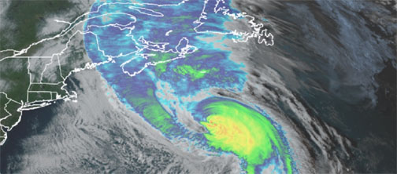

Creator God, you created the heavens and the earth and all the glory and majesty within. Today we mourn the losses, not only of your creation but the loss of homes and communities. We pray for those still without power. We pray for those needing shelter and much needed supplies. Open our hearts to the needs of others and inspire us to find ways to help where needed. With grateful hearts for all who have worked tirelessly to restore power and continue to do so, bless them and keep them safe. Bless our First Responders and all those who continue to set aside their own needs for the sake of us all. Amen
Please send us photos of your parish/group activities. We would love to feature what you are doing for Creation.


On October 2nd, 2022 we are holding a special Blessing of the Animals service at Sullivan’s Pond. The informal service will be held between 2:00-3:00 pm. In the case of rain, we will move to the Upper Hall at Christ Church (61 Dundas Street). You are invited to attend and if you choose, bring along your furry, scaly, prickly, and feathered friends for a special blessing.
Donations for the food bank (for people and pets) will be collected but are not required to attend.
For further information, please contact us at stalbans@bellaliant.com or call St. Albans at 902-463-2493. https://www.facebook.com/events/352030950391762?ref=newsfeed



 | Praying with the DEN Community led by the Rev.Tory Byrnes continues each Friday 9:00 am on Zoom. To obtain the link, please email endionspei@gmail.com Prayers will take shape from different traditions and focus on various aspects of our relationship with the Creation. For more information or questions or to share how you/your parish or group are praying for creation, please e-mail victoriabyrne02@gmail.com  Thanks to The Church of St Andrew for hosting.


October 2 at 4 pm - To register and for full information: https://www.eventbrite.ca/e/the-missa-gaiaearth-mass-tickets-419607957697


Join the conversation Engaging the Climate either live or via livestream with 4 writers who are thinking and writing about the environment, our place in it and how we can best move forward together. For more information: https://www.afterwordsliteraryfestival.com/

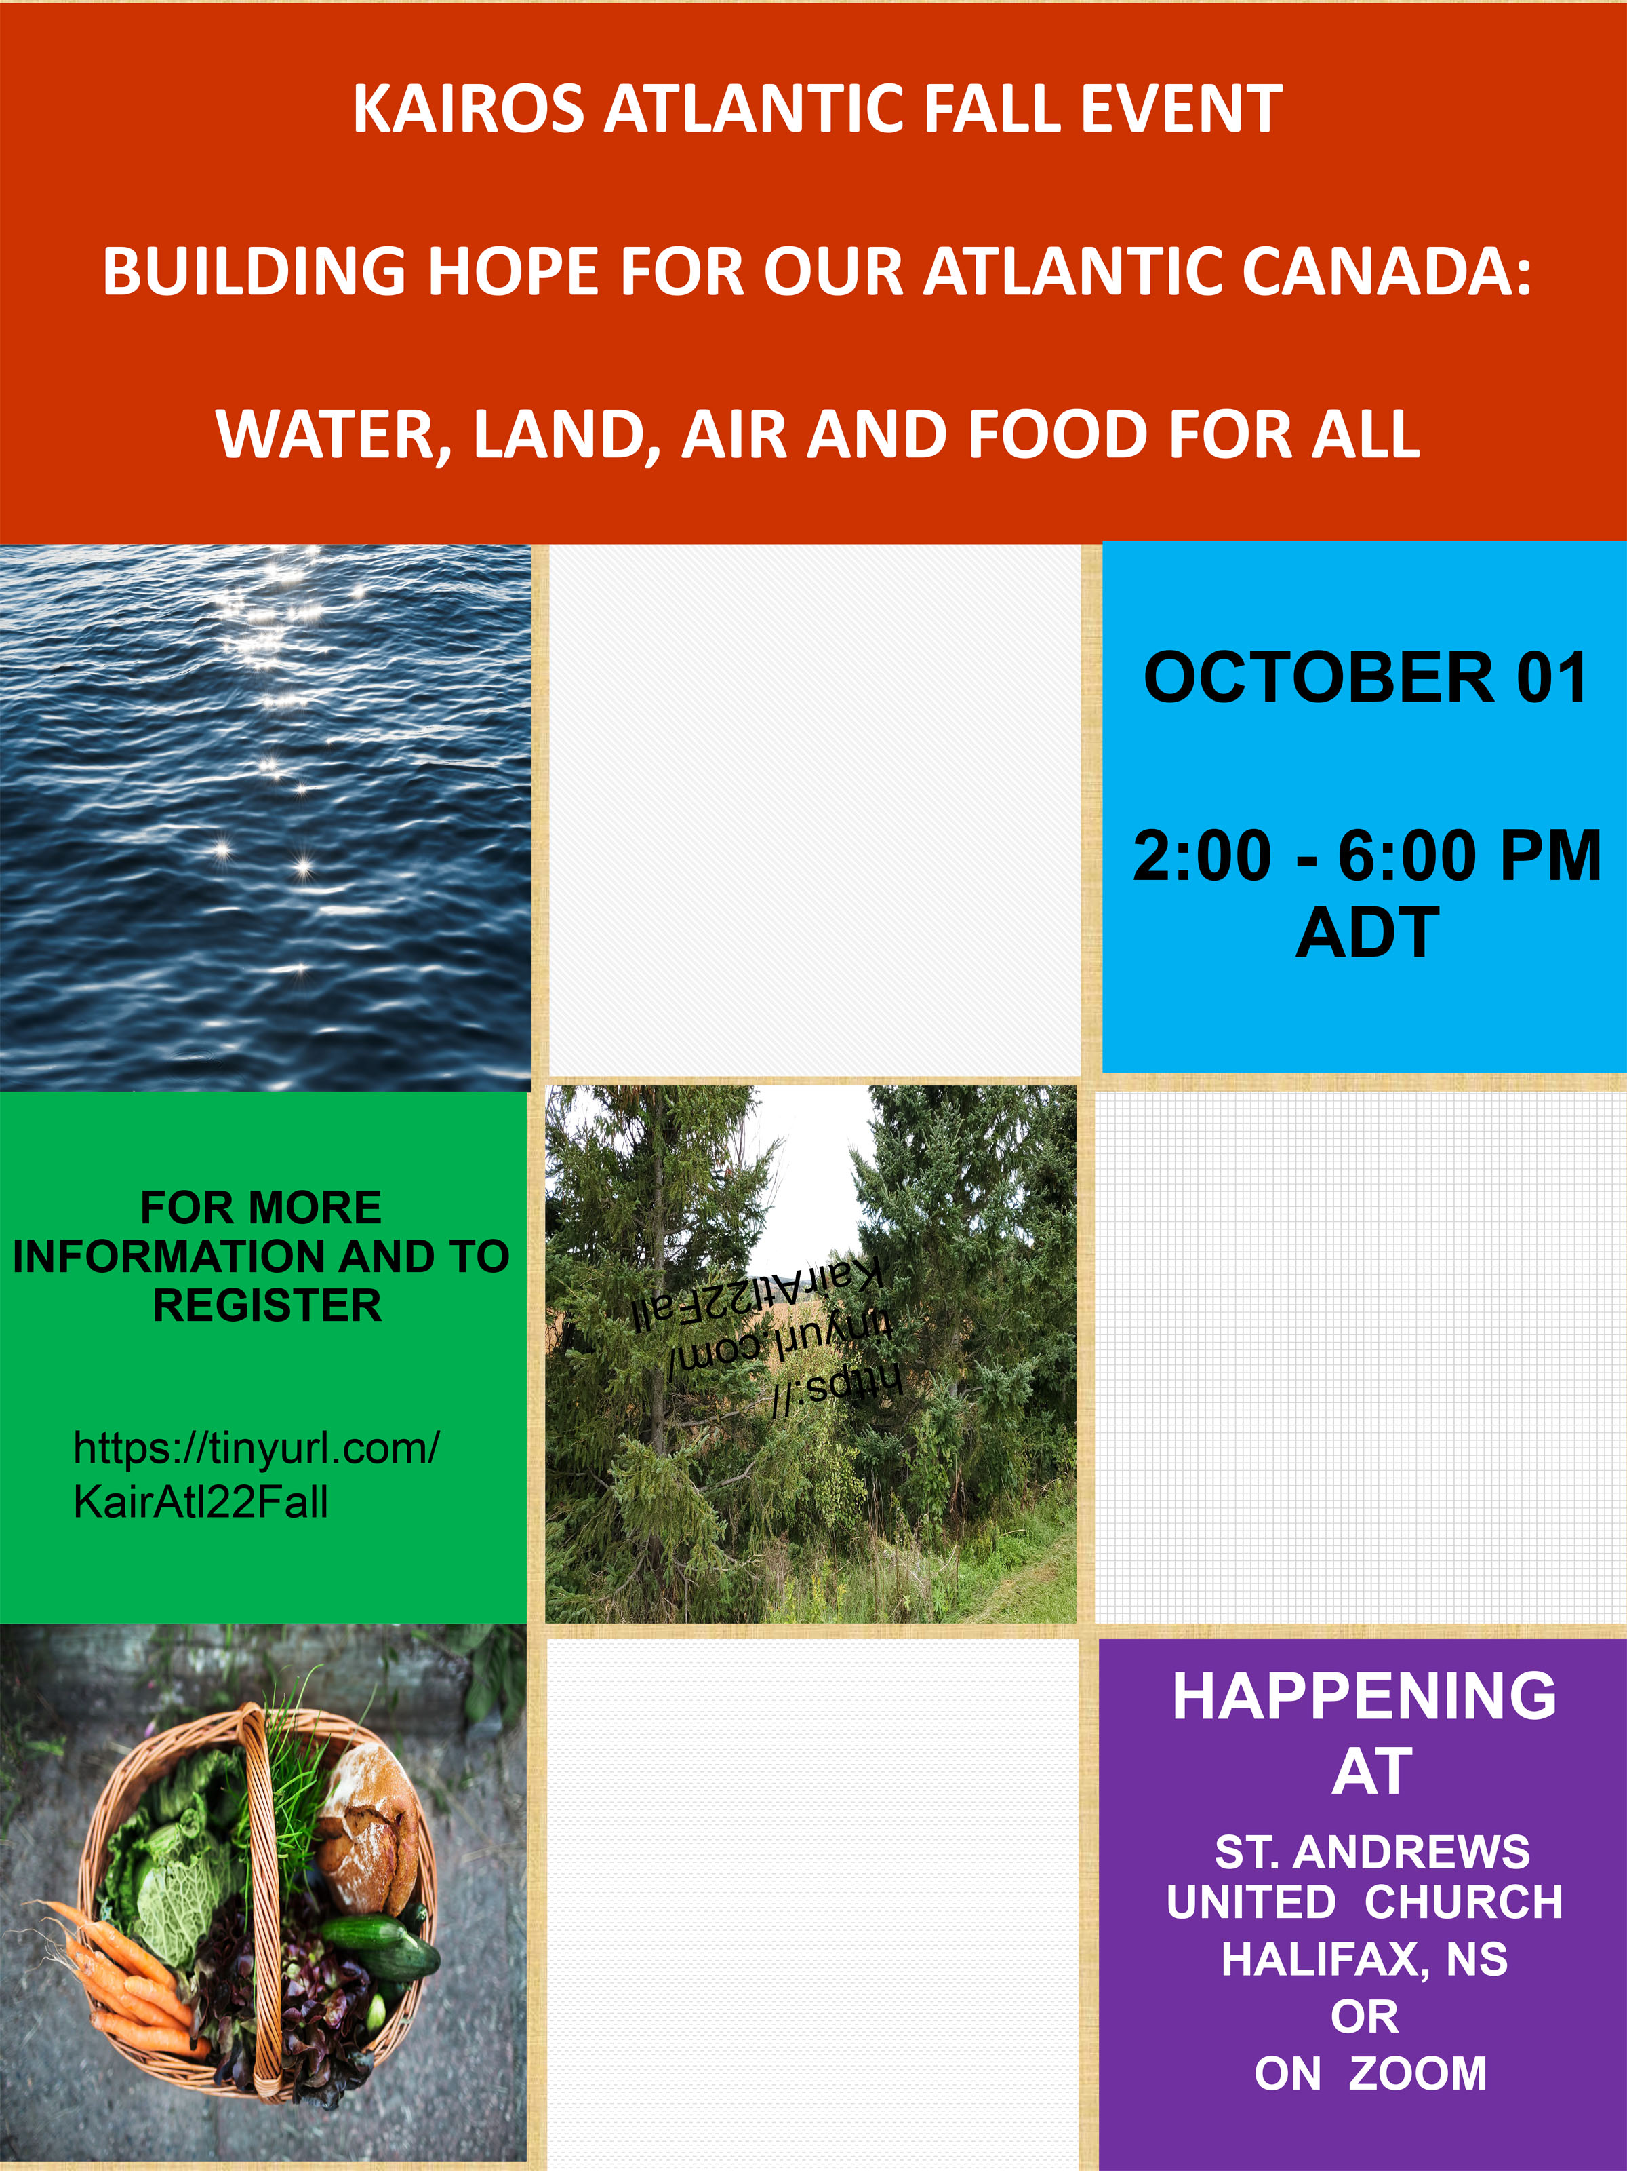
Come --- Listen and Learn from Change Makers sharing about the Last Hope for Forests, Water Not Gold, Beyond Coal and Food Securit
Engage with others in circle groups – share thoughts and inspire each other on ways to do justice and make a difference
Snacks, drumming, display tables and time for networking will be part of the afternoon’s activities.
A Registration/ RSVP link will be sent out soon along with details of all speakers and more…
Hope changes Everything!! Hope is the only thing stronger than Fear!
To Register: https://secure.kairoscanada.org/civicrm/event/info?reset=1&id=311


Stay up to date on how you can help by visiting this website:
https://www.protecteisnerwetland.ca/
https://www.facebook.com/groups/599766713496876

Fed. Gov't and Premiers for Renewable Energy
New energy modelling details how we can have 100 per cent clean, renewable, reliable electricity where and when we need it by 2035. 1) It’s reliable: Wind, solar, energy efficiency, energy storage, existing hydroelectricity and grid connections between provinces work together so we can meet our demands for electricity where and when we need it, even with increased demand as we switch to electric cars. 2) It’s affordable: Wind and solar are the cheapest sources of electricity in history, and Canada has a lot of potential for both. Adding only clean, renewable energy to the grid, the average energy cost is lower than the business-as-usual alternatives. 3) It creates new jobs in clean energy: Construction, operation and maintenance employment alone will grow to more than 75,000 jobs a year, resulting in more than 1.5 million job-years between 2025 and 2050. 4) It avoids expensive and toxic energy: The path to clean electricity does not need new nuclear reactors or any fossil fuels — with or without immature technologies like carbon capture and storage. 5) It is good for community well-being: Indigenous nations and communities will be safer, healthier and have opportunities to benefit from renewable energy projects they can own and operate. 6) It meets climate goals: By switching out fossil fuels for cleaner, renewable electricity, Canada can reduce emissions by more than 27 per cent, which is needed to meet its 2050 net-zero goal. https://davidsuzuki.org/action/call-for-clean-renewable-electricity/
Find out more about 100 per cent clean electricity https://davidsuzuki.org/project/clean-electricity/
and the report on our clean power pathway. https://davidsuzuki.org/science-learning-centre-article/Shifting-Power-Zero-Emissions-Electricity-Across-Canada-by-2035/
Environmental Defence Canada
Canada has committed to ending plastic waste by 2030, and has made federal regulations to ban six harmful single-use plastics that will come into effect at the end of this year. This is a good start, but it’s not good enough to actually tackle the plastic waste problem across Canada. We need to phase out plastics that aren’t being reused and recycled. Our government needs to expand the bans to include more harmful single-use plastics, to require reusable packaging, to stop plastic additives, and to reject solutions that include burning plastic waste and the continuation of our toxic plastic cycle. Add your name to tell our country that we need step up our commitment in achieving zero plastic waste and pollution by 2030! https://act.environmentaldefence.ca/page/113165/action/1?ea.tracking.id=eblast&ea.url.id=6072574&forwarded=true

World Animal Protection
The Jane Goodall Act will ban the use of wild animals like elephants, great apes, and tigers for entertainment and commercial trade in Canada. It will also create stronger animal welfare regulations to protect more than 800 wild animal species! Sadly, thousands of wild animals are trapped in cages for profit. They are bred and subjected to suffering simply to entertain tourists by performing tricks, being used as props for photos, or other inhumane practices. Canada continues to import hundreds of thousands of wild animals every year. This petition is asking that we end wildlife entertainment in our country and for good. https://www.worldanimalprotection.ca/take-action/petition-jane-goodall-bill?utm_campaign=22-lg-wildlife&utm_source=facebook_paid&utm_medium=social_paid&utm_content=wildlife-1&ea.tracking.id=facebook_paid&en_og_source=leadgen_paid&fbclid=IwAR2fY4QxMWBCW9617pUtXUeUY4GAkr37B6rvkCcxa-SUUB4ij9pr_s21meM#action

CEPA needs a makeover now (ecojustice.ca)
It’s been more than 20 years since the Canadian Environmental Protection Act (CEPA) was last updated! Things have obviously changed in 20 years. Today the climate emergency, plastic crisis, and the unequal distribution of pollution all make strengthening CEPA an urgent priority. Bill S-5 is a starting point for this and will work towards improved health for Canadians and a better protected environment in our country. Send a letter to your local MP, the Minister of Environment and Climate Change, and the Minister of Health, urging them to strengthen Bill S-5. https://www.support.ecojustice.ca/page/111326/action/1?ea.tracking.id=leadgen_Facebook&en_og_source=FB_paid

Stop banks from fueling the Climate Crisis
Email Canada's bank regulator asking them to stop banks from fueling/funding the climate crisis. Since the Paris Agreement 7 years ago, Canada’s big banks have poured over $900 billion into fossil fuels.

Canada’s bank regulator OSFI recently proposed new climate guidelines for banks, and is asking for input on them from the public until Sept. 30th. Right now the rules are weak, and do nothing to actually stop the banks from financing fossil fuels.But with significant public pressure they could become much stronger and actually force the banks to clean up their acts. https://www.greenpeace.org/canada/en/story/54005/banking-regulators-must-stop-letting-big-banks-finance-the-climate-crisis/?_hsmi=226960183&_hsenc=p2ANqtz-8ejGom_V_DdxWAne4Wi7Cj-7Vol6-BZtwrE7OEARHA1VEMSAPmy3RWTo56LVLuMRNfC4qsD6pJTRPNHas_Zlhpmw9XIw

