July 05, 2022
Email: HYPERLINK "about:blank" endionspei@gmail.com Website: HYPERLINK "about:blank" nspeidiocese.ca/den
Facebook: HYPERLINK "about:blank" Environment Network Diocese of NS & PEI



The Climate Cafe is a safe and respectful place for people to talk about how they feel about Climate Change. It is held the Third Thursday of the Month from 7:00-8:30 PM in the Christ Church Hall (Lower Level), Dartmouth, Nova Scotia. Nancy Blair, a Climate Psychotherapist and a member of the Climate Psychology Alliance (CPA), is the group leader and has received Climate Cafe training from the CPA. During the Cafe, we listen to each other and those who want to talk, do so.

Individuals interested in attending, or who simply want to learn about what happens in the Climate Cafe, are invited to contact Nancy Blair, nancyblaircounselling@gmail.com Some individuals come regularly, some once, some occasionally.

The Climate Cafe is open to all - masks are required


Season of Creation 2022
September 1 – October 4th
The 2022 Season of Creation Toolkit is now available for download here:
Season of Creation – Green Churches
‘LISTEN TO THE VOICE OF CREATION’ is the international theme, and the Green Churches Network put a Canadian perspective to produce 4 subthemes:

We have a POSTER for your bulletin board, a PRAYER GUIDE for your Sunday services, a calendar of KEY DATES throughout the month. and new this year is the FAMILY AND COMMUNITY GUIDE. All available here: https://greenchurches.ca/season-of-creation/ Plus new videos on our YouTube channel to accompany the Season of Creation 2022! Check it out here: YouTube Channel
The Eisner Cove Wetlands, also known as the Southdale Wetlands is almost pristine wetland and forest approx.2 km from the Woodside Ferry in Dartmouth. Once public land, it was quietly sold in 2018. It is slated to be fast-tracked for affordable housing. The concerns include wetlands as necessary carbon sinks and biodiverse systems that contain many species-at-risk. For more complete information, please check out these links:
https://www.protecteisnerwetland.ca/
https://www.facebook.com/groups/599766713496876/

https://www.protecteisnerwetland.ca/_files/ugd/3cc864_e1484a6002ed47edbc65b8511eb566d5.pdf?fbclid=IwAR3k38bEcwh1dtSP0X08_hFlMLRKbqT1cHu08h-vmon_GIrwDB7d8p2mATQ

Link for email addresses and phone numbers

Change.org petition to save Eisner Cove Wetlands in Dartmouth
A housing development is planned for a rich ecological area in Dartmouth which would change the area from a carbon sink to a carbon emitter, increase local flooding, destroy habitat of flora and fauna as well as the loss of a treasured community space. Further, the destruction of the last untouched (non-park land) open space in the Regional Centre will inhibit the municipality from achieving its goals related to open space preservation set out in the Halifax Green Network Plan and climate change mitigation and adaptation targets in the HalifACT 2050plan.

The Bridgewater Watershed Protection Alliance is seeking support for their submission to the Minister of Environment and Climate Change to have crown lands in the Petite Riviere Watershed (Lunenburg County) designated as a Wilderness Area. This group formed in March to oppose a proposed harvest of three parcels of crown land on Minamkeak Lake and also began to work on a Wilderness area designation submission. For more information: https://eco-action.ca/include/protect-bridgewater-watershed.htm

Petition started by Democracy Watch re Lobbying Laws in Canada
Think about any bad government decision that has upset you, and likely secret, unethical lobbying played a part in the decision. Because of huge loopholes in lobbying laws, it is legal to lobby governments and politicians across Canada in secret. Huge loopholes in ethics rules also allow lobbyists to fundraise for politicians, and give gifts and do other favours for politicians and government officials, in secret. Big money donations from lobbyists to politicians are also legal across Canada. As well, lobby groups are not required to disclose how much they spend on lobbying on any issue, nor who funds them, which allows big businesses and other wealthy interests (including foreign governments, corporations and billionaires) to spend huge amounts of money secretly pushing their agenda, including by secretly funding front groups that are not actually supported by any or many Canadians. Lobbying laws also need to be strengthened across Canada to make it illegal for lobbyists to mislead voters with false claims, misinformation or disinformation. All of these loopholes need to be closed to stop politicians and governments from doing secret, behind-closed-door deals with lobbyists that waste taxpayers’ money and hurt voters and communities across the country. Incredibly, the federal Commissioner of Lobbying is proposing right now to weaken the ethics rules for lobbyists to allow them to do even more fundraising and other favours for federal Cabinet ministers, MPs and federal government officials, and then lobby them soon afterwards.
Say YES to clean, renewable electricity by 2035 - David Suzuki Foundation
The most recent Intergovernmental Panel on Climate Change report found that energy security is best advanced by an electrified global energy system, powered by clean renewable power and energy storage. We can have 100% clean, renewable, reliable electricity by 2030. This will create new jobs in clean energy, offer affordable and reliable energy, it’s good for community well-being, it avoids expensive, unethical, or toxic energy, and it meets our climate goals. Add your name and send this petition to our prime minister and environmental ministers
Chrystia Freeland, Mary Ng and Justin Trudeau: Reverse the $10 billion loan to TMX and invest in a Just Transition instead | Leadnow.ca
Our government just approved another huge loan for the Trans Mountain Expansion Project, 10 billion dollars! We need to uphold our promise to end fossil fuel subsidies and to respect Indigenous rights, and we need to invest in what is sustainable. This petition hopes to rally public outcry with a massive petition, in order to convince those in power to reverse the loan guarantee, and ultimately abandon the project altogether.
Tell UNESCO to recognize great apes as Living World Heritage - Rainforest Rescue (rainforest-rescue.org)
The Great Ape Project calls for UNESCO to recognize our closest relatives as a Living World Heritage before it’s too late. Bonobos, orangutans, chimpanzees, and gorillas are all facing extinction. One of the main drivers of extinction is the clearing of tropical forests and we could wipe the great apes out in as little as ten years. UNESCO does not currently recognize living beings as World Heritage, but the hope and this petition is asking them to do so as there is no greater or more beautiful heritage than nature itself and its inhabitants. Sign your name to this petition if you agree.
Environmental Defence Canada
There is an election promise to label hazardous ingredients in cosmetics, upholstered furniture, and cleaning products by Spring 2022. Unfortunately, our government recently announced that they plan to drop most of their plans to require hazardous ingredient disclosure for consumer products. The consumer products industry wants to keep their hazardous ingredients hidden and if they get their way, we won’t see any action to disclose toxic ingredients. Please sign your name to remind our leaders that we want to see action now.
Greenpeace petition for global plastic reduction
The global plastic industry is pushing hard to double production within the next 10-15 years, with Canada's industry working hard to keep plastic in our lives for good. And this is happening while millions of seabirds and sea creatures perish from ingesting plastic; while vulnerable communities face contamination and disease from production and recycling and while the extraction of oil to create plastic fuels global heating. Tiny bits of plastic are even in the human body.

Seed packets
Luckily, I had just changed my work code to “break” when Jazz started barking. There at my front door stood my neighbour, Mary, carrying a LARGE cardboard box filled with sunflower seeds. I expect over 500 packs of sunflower seeds. “I knew you were the one that could do something with this,” she said.
I smiled and nodded and thanked her ever so kindly for thinking of me and walked back into the house with a “What am I going to do with these?” attitude.
I have discovered it is very easy to get rid of FREE seeds. 100 went to the Farmer’s Market in Chester to be given away to patrons. Another 100 went to the community breakfast that week. Rogation Sunday took 80 plus 20 to a neighbour wanting to plant a bunch. Another 100 were put away for the Lion’s Club, 400 hundred down and 100 to go
It was time for my Earth Warriors. There are young people in the parish who jump at the chance to help out. Putting 10 packs of seeds and a note with each bundle I dropped them off to my Earth Warriors. The note said to take a shovel and push it into the ground anywhere. Push the shovel forward and drop some seeds. Pull out the shovel, stomp on the ground and move on and repeat.
My dream is to see sunflowers all around my community come August. There is a good chance I will see my wish come true
Craft
This one is the easiest rainy-day craft to keep people busy for a good long time.
Bring out the box board that you saved from that frozen pizza or cereal box.
Draw out a letter for one of your initials. Bring out the yarn bag, that ball of jute string or ribbon, and wrap it around the cardboard letter. Hang them up perhaps on your bedroom door.
My daughter discovered early that bedroom doors were a great place for an art gallery. We have those hooks that you hang a wreath from at Christmas. A flat thumb tack on the back of the covered letter allows a string to loop over the wreath hook
This is one of those crafts that you can pull out of your hat in minutes.
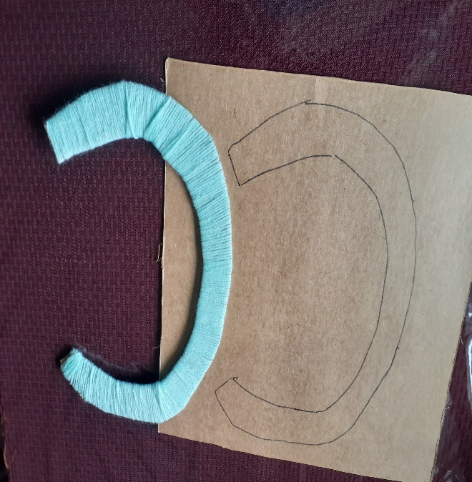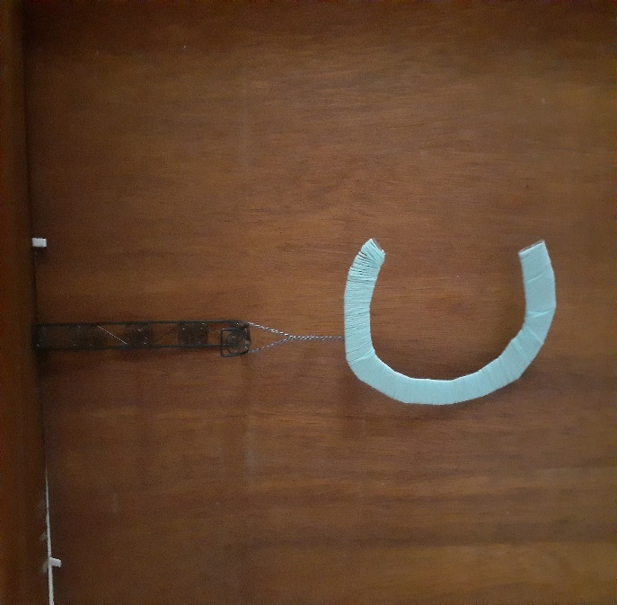

Garden – Cucumber Trellis Ideas
We love our cucumbers, eat fresh, make our dill pickles, Bread and Butter pickles, relishes, plus salads. Cucumbers grow well just being left to spread out on the ground. When you only have so many gardens, you need to find the space for them. Vertical planting seems to be my theme this year.
There are so many ways to make a trellis. Rather than bore you with my long-winded description, let me point you to a site that has 12 ways to do the same thing.
https://www.ruralsprout.com/cucumber-trellis-ideas/
My favorite was using my old crib rails again. This time there was an upright stand in back made from bamboo sticks. They covered their crib rails with fencing wire and then leaned it against the bamboo uprights. Lettuce was then grown underneath. The picture on this site is close. https://www.pinterest.ca/pin/246431410836230293/
Does anyone have a picture to show how you did this in your garden?
Something to eat
I can’t recall if I put this one in before. If I did, my apologies. This is the recipe I go to when supper doesn’t quite seem like enough but adding a salad doesn’t work. It is called Green Bean Casserole, but green beans are but one thing in it. My kids and grandkids clean the dish when here, but it does freeze well to put half the recipe away for another day,
Green Bean Casserole
1 Stuffing mix (or make your own)
1 tin mushrooms
1 tin mushroom soup (or cream of anything)
2 tins of green beans or cook fresh beans to about that amount.
Cheese (probably recipes would say 1 cup but see what you have in your cheese box and add a handful or two of Mozza shredded cheese).
In a bowl empty stuffing mix, add the water the box suggests, and stir. Add beans, mushrooms, soup, and cheese. Stir and put in a casserole dish and bake for half an hour.
This picture also includes the cod cakes I fried this morning (to go with beans) the rhubarb I cooked yesterday and canned this morning and a small carrot cake for (somewhat) sweets for a few days.

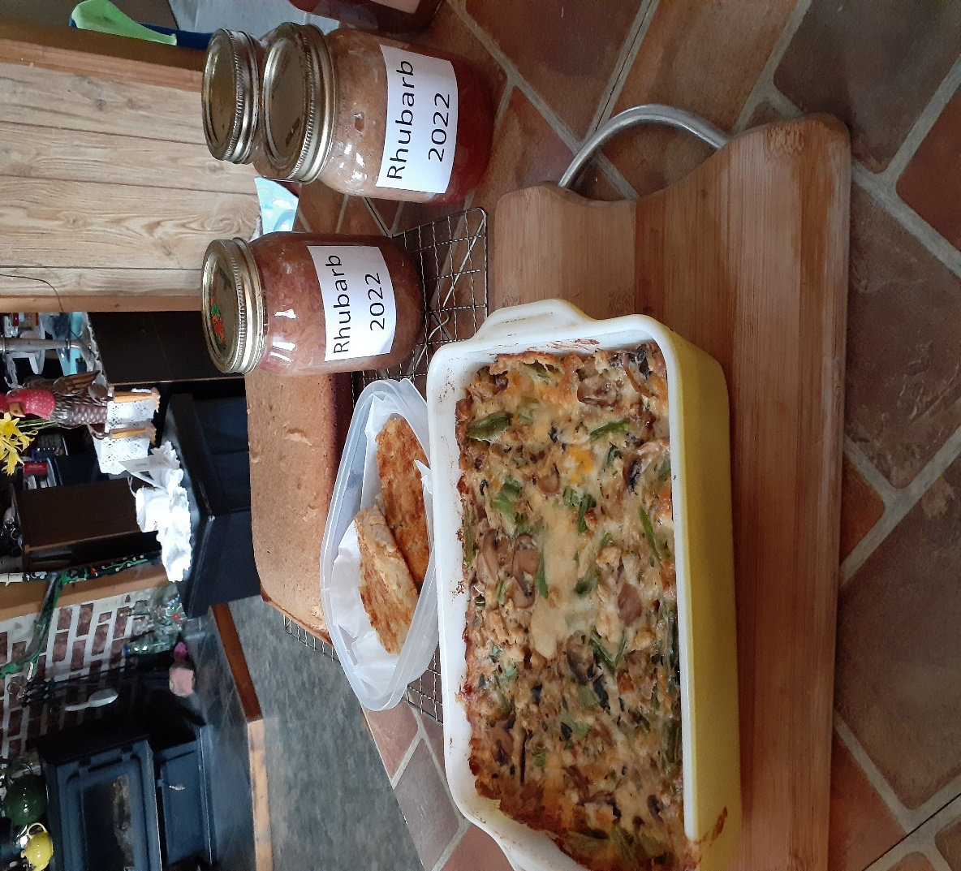
Till next week, Grandma is sending hugs.

Do you have a resolution that could or should be brought to Synod? The deadline to submit resolutions is July 14, 2022. Foe more info on writing a resolution: https://www.nspeidiocese.ca/synod-oct-2022/pages/resolutions

A prayer from the Iona Community
Come God
Come walk with your people
for you alone are our strength and glory
AND WE PUT OUR TRUST IN YOU

Come God
Come walk behind us, beside us, before us
for you alone are our shelter and direction
AND WE PUT OUR TRUST IN YOU

Come God
Come seek and find and put us right
for you alone are the light in our darkness
AND WE PUT OUR TRUST IN YOU

Come God
We know you are near
the sound of your footsteps sets us dancing
HELP US TO PRAISE AND WORSHIP YOU

