St. Francis By The Lakes Church

192 First Lake Drive, Lower Sackville, N.S

www.stfrancisbythelakes.ca

Tired of cooking? Want a healthy, complete, home-cooked meal without the prep and dishes? Let the skilled & fabulous talents of the St Francis by the Lakes Church chefs cook it for you!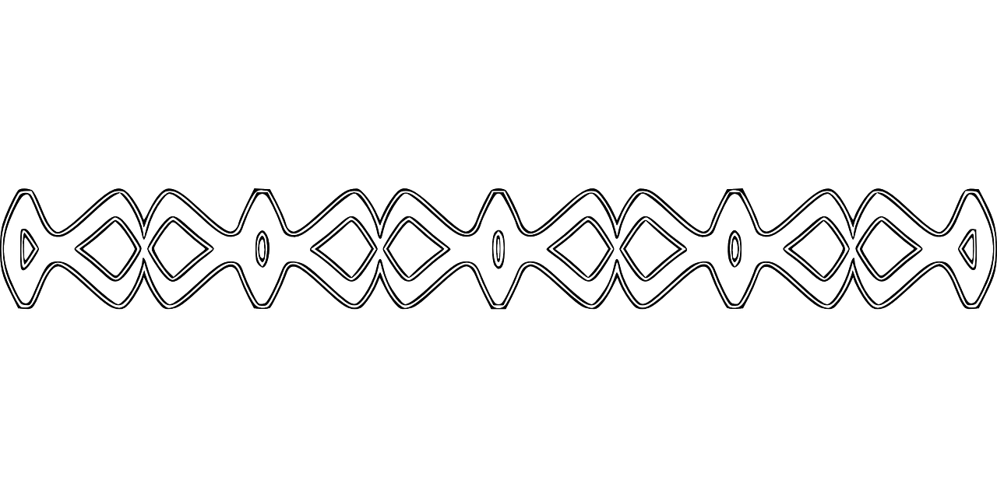Cold Plate Supper (Take Out Only)
Meals must be pre-ordered.
Call Ellen at 902-817-8457 by Mon. July 11th to order & get a time for drive-thru pickup on Sat. July 16th, 2022 between 4:30 pm to 6:00 pm
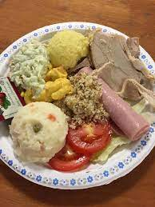
Supper includes delicious, succulent roast beef & ham, potato salad, coleslaw, tomato, cucumber, fresh dinner roll, and a yummy strawberry dessert!
Adult - $15.00 Child (5-12) - $7.00
You can add a Dozen Chewy Brownie Bites for just $4.00

