May 24, 2022
Email: HYPERLINK "about:blank" endionspei@gmail.com Website: HYPERLINK "about:blank" nspeidiocese.ca/den
Facebook: HYPERLINK "about:blank" Environment Network Diocese of NS & PEI



This week DEN Thursday gathering, May 26th, 7 pm – Preserving the Forests we call home An Investment opportunity.
Growing Forests is a new investment opportunity designed to preserve regional woodlots through acquisition and sustainable management. Growing Forests is launching a start-up investment round as a qualified Community Economic Development Investment Fund (CEDIF)
Please email dale@growingforests.ca
for more information and for the Offering Document
You can also download the information and learn more about the project at https://www.growingforests.ca
The Offering has been extended to June 28th.

Climate Cafes provide an opportunity for individuals to share feelings about climate change and climate emergency. The process, developed by the Climate Psychology Alliance - UK, is facilitated by Nancy Blair who is active in the Diocesan Environment Network and Climate Ministry at Christ Church, Dartmouth. It is not always easy to find someone to talk to about climate change. The Climate Cafe provides a calm and supportive space to listen and to be listened to. The next café is Thursday June 9th, 7-830 pm in Christ Church Hall on Ochterloney in Dartmouth. Bring a mask; we follow diocesan covid regulations. https://www.christchurchdartmouth.com/climate-cafe.html
For information: Nancy Blair, nancyblaircounselling@gmail.com
$65. Rain Barrels are another way to strive for water security and save money. There are a number of local groups fund raising selling water barrels. Click on https://rainbarrel.ca/
The sale in Dartmouth closes on May 25th.

Scroll down the page to find a sale in your community of New Brunswick, Newfoundland and Nova Scotia. Save water WITH the bonus of using recycled/ repurposed food grade barrels. Please share this with all your friends. Each group fundraiser is for a worthy cause.

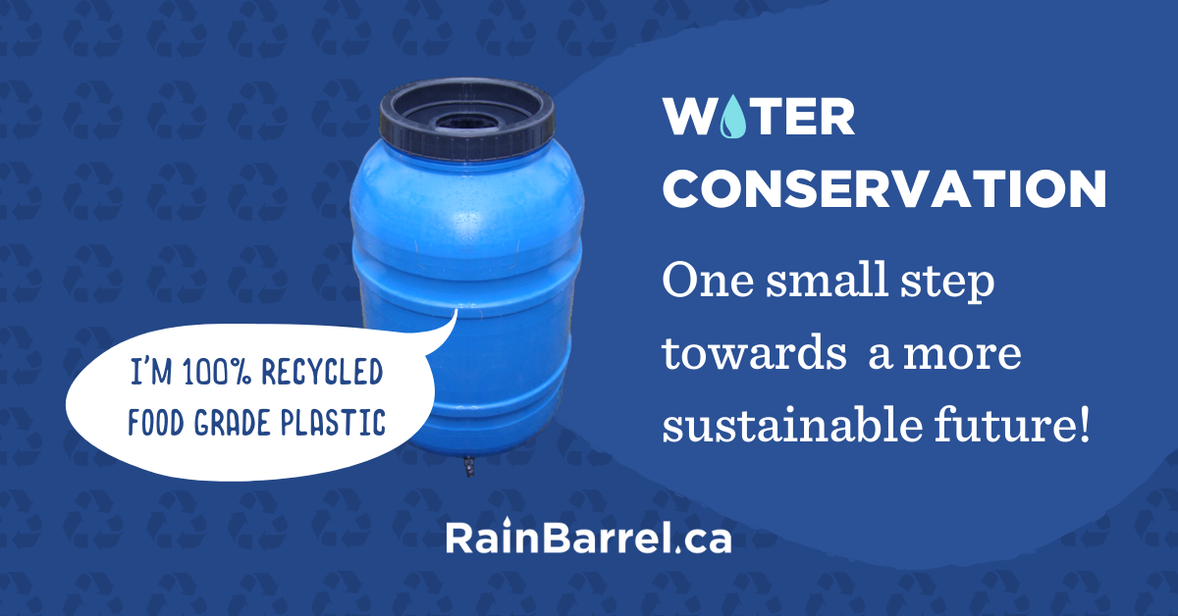

Petition to all federal leaders for bold climate action
Top climate scientists issued a “code red for humanity” warning that this is our last chance to implement the transformational changes necessary to keep warming below 1.5 C and avoid the most dangerous impacts of climate chaos. Canada’s climate targets are still critically insufficient. We are the only G7 country whose emissions have increased since the Paris Agreement was signed.
Stand earth petition calling on banks to divest from fossil fuel projects around the world
Banks are the backbones in fossil fuel industry, funneling trillions into the expansion of harmful and environmentally damaging oil and gas projects - but they don’t have to be. We need to transition to a more sustainable economy and the financial sector plays a large role in this. This petition is adding its voice to the growing movement of frontline communities, Indigenous leaders, environmental organizations, and customers who are calling on banks around the globe to divest from the fossil fuel industry!
Petition to Put the Brakes on Logging Industry
Nature Canada stop the destruction of Canada’s forests!
Canada’s Boreal Forest stores twice as much carbon as the world’s recoverable oil reserves. It also provides critical habitat for billions of species, including many at risk. Yet hundreds of thousands of hectares of the Boreal Forest are clear-cut each year. Massive greenhouse gas emissions are released by destroying this carbon-rich ecosystem and Canada won’t meet its 2030 climate target of a 40-45% reduction in emissions unless all sectors take action. This petition is to the Environment Minister and the Natural Resources Minister asking that Canada stop giving the logging industry a free pass on emissions.

URGENT: Please help us save Kinipan forest! - Rainforest Rescue (rainforest-rescue.org)
Kinipan is a small village in Borneo with a population of just under 1,000 and the people make their livelihoods in rice, rubber, rattan and the fruits of the forest. The palm oil company PT Sawit Mandiri Lestari (SML) has a land concession of almost 30,000 hectares and a logging concession of almost 20,000 hectares. Three quarters of the area is forest and habitat for orangutans and clouded leopards, along with many other endangered wildlife species and rare tropical trees. The company has already clear-cut more than 10,000 hectares. Further deforestation must be prevented without delay and the residents applied for traditional land rights to the forest and have been peacefully protesting for years. This petition is to stand with them and say this forest must be protected under national and international law.
petition: There Are No Other Species On Earth Quite Like The Axolotl. We Must Save Them From Extinction! (thepetitionsite.com)
Axolotls are related to the tiger salamander and they are unusual among amphibians in that they reach adulthood without undergoing metamorphosis. Instead of taking to the land, adults remain aquatic and gilled. Another unique feature is that they do not heal by scarring but are capable of regeneration of entire lost appendages in a period of months! This species shows how rich our world is with individual creatures who share the planet with us. The axolotls are only found in 2 lakes in Mexico City, one of those lakes was drained and the other has dramatically changed with reduced water and increased pollution. Habitat loss, climate change, and other human-induced impacts are all threats and now there are more of these creatures in labs rather than their nature environment. This petition is to the Mexican government to say more is needed to protect the unique axolotls.

Green Story
If anyone else uses Dempster’s bread, take a look at the tag. They are made of cardboard now. Biodegradable. In our house, bread tags somehow always end up in Jazz’s bed. Being made of cardboard is one less worry for this fur Momma.
Environment work can be as easy as when the Hubbards Guiding group (they are so small that Sparks, Brownies, and Guides all meet together) made planting pots from newspapers and planted flower seeds for the bees.
The Parish of Blandford in conjunction with the Blandford Board of Directors (for our Community Centre) and with Our Health Centre in Chester has received a grant for 2 tall gardens. They are enormous. I expected a small box on stilts. These are 4 x 8 feet at least, made of heavy board. There may be a chance we may get a truckload of compost.
Meanwhile, the call went out to fill half the height of the boxes with cardboard and styrofoam. The boxes are more than full. Will send updates.
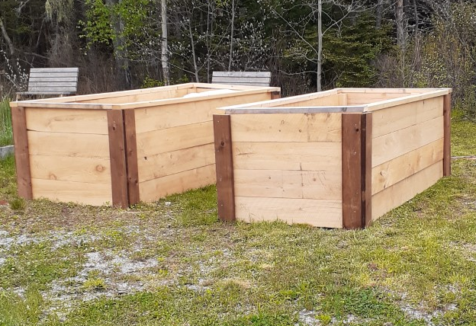
Covid was and is a terrible disease; the pandemic caused all sorts of problems BUT it got a whole new generation interested in gardening.
What green things are happening around you? They can be little things. I saw the Lutheran church in Chester had the most beautiful daffodils bordering their church steps. What a beautiful sight this time of year.
Let us know and if possible just send a pic to either the DEN email or to claudiaazinck@gmail.com
Gardening
This week has been prepping all the gardens. I have a week off work soon and almost all the plants go in the garden. I need to wait for Rogation to get my last tomato plants from Rev. Louie’s greenhouse. We are having a plant giveaway on May 29th after service which will be a 3 PM afternoon evensong service at Ocean Swells Community Hall (old schoolhouse) next to St. Cuthbert church in Northwest Cove (15 minutes from Hubbards.) As always, all welcome.

Ball and Cup Toy
We are in a milk jug craft theme. The Parish of Blandford is getting ready for another Community Roots camp the first week of August. They are allowing Grandma to go play with the kids that Friday.
There was a perfectly good top with a handle left over when making wind socks, so why not make a ball and cup toy. I took this one to my grandbabies one Sunday and they played half the afternoon with such a simple thing.
If you have the leftover part from the windsock great. If not, cut a 1-liter milk jug about an inch below the handle.
Punch a hole in the bottle cap and draw a string through, knotting it.
Make a pompom or tie a small ball to the other end of the string.
Holding the handle, toss the pompom through the air and catch it in the milk jug. Makes for lots of fun.

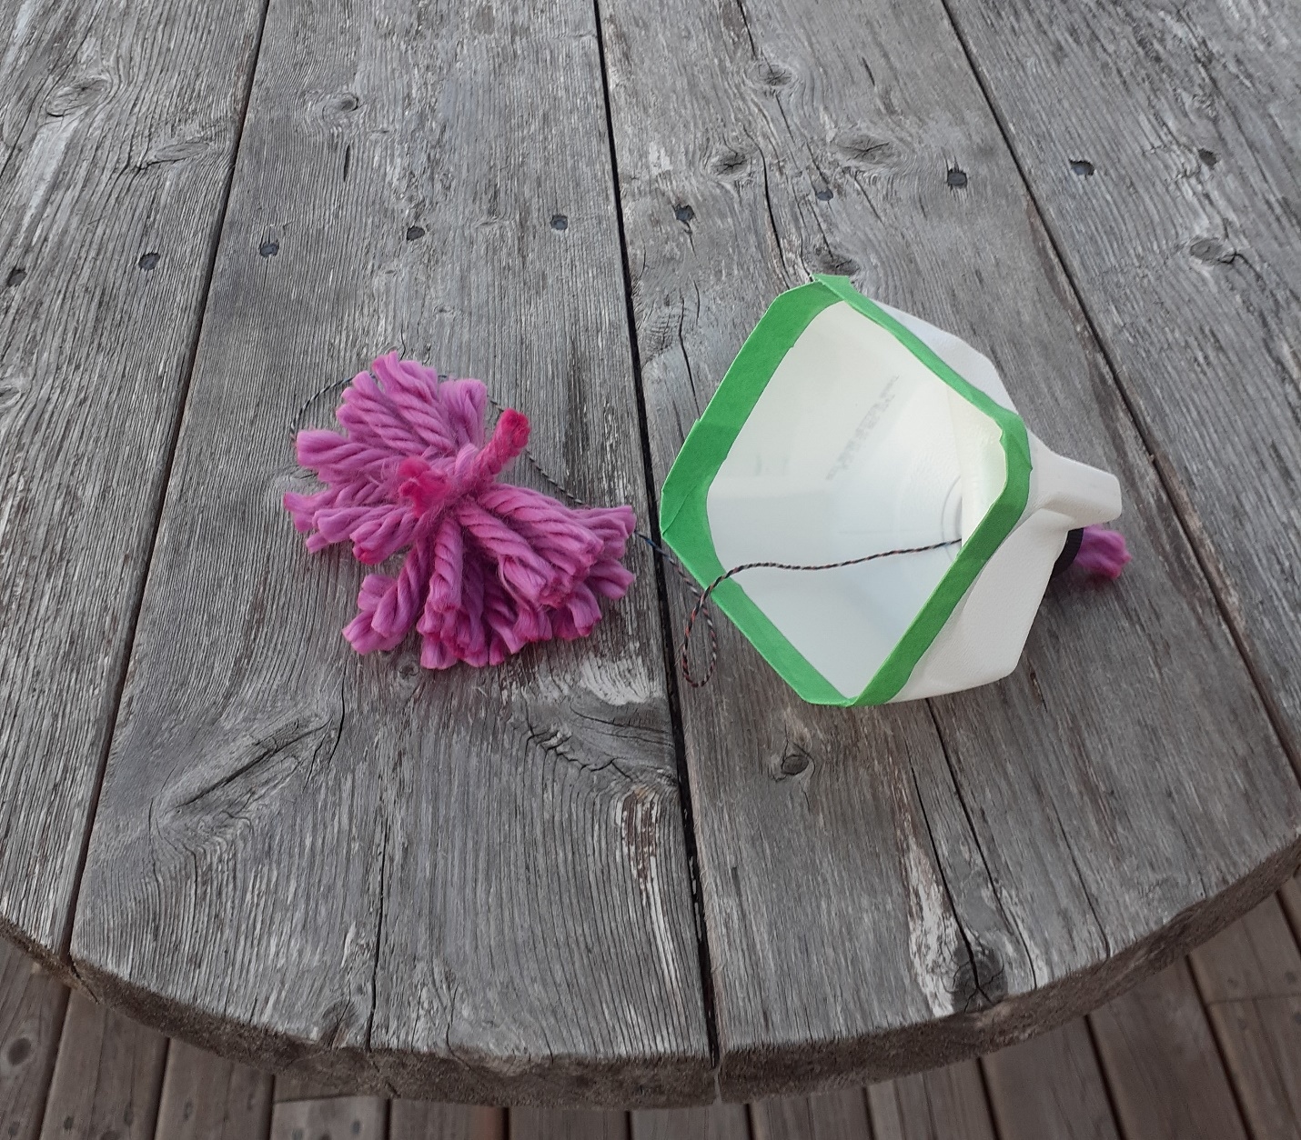
Stuffed Peppers.
When peppers were so reasonable in price this week I got a hunger for Stuffed Peppers.
½ lb. hamburger (browned)
1 cup cooked rice
¼ to ½ cup Salsa sauce
Handful of cheese
Clean peppers, cut off the top and clean out the seeds. Mix up the ingredients and fill the peppers. Top with a bit more cheese. Bake 350F for 40 minutes. Yum!
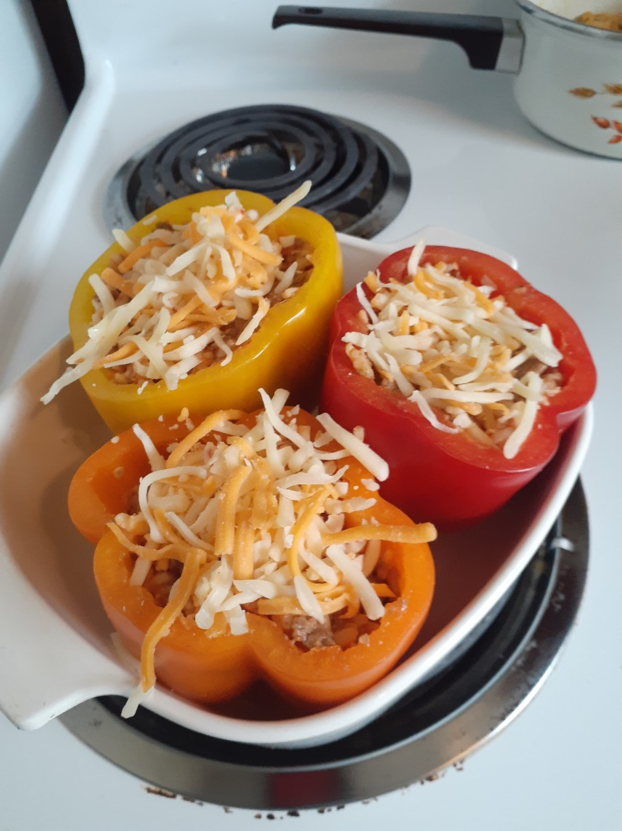
Till next week, Grandma is sending hugs



