May 31, 2022
Email: HYPERLINK "about:blank" endionspei@gmail.com Website: HYPERLINK "about:blank" nspeidiocese.ca/den
Facebook: HYPERLINK "about:blank" Environment Network Diocese of NS & PEI



Growing Forests is a new mission driven investment opportunity designed to preserve regional woodlots through acquisition and sustainable management. Growing Forests is launching a start-up investment round as a qualified Community Economic Development Investment Fund (CEDIF)
Why? 70 % of forests in NS are owned by 30,000 small private woodlot owners. In 2019, 50,000 acres of private forest was clearcut. This is 11 times the size of the Halifax peninsula. This investment opportunity provides these owners an alternative source of revenue that will manage the land in an ecological fashion that does not involve clearcuts.

Please email dale@growingforests.ca
for more information and for the Offering Document
You can also download the information and learn more about the project at https://www.growingforests.ca
The Offering has been extended to June 28th. You are asked to indicate your interest by the middle of June so your investment can clear the securities commission.

Climate Cafes provide an opportunity for individuals to share feelings about climate change and climate emergency. The process, developed by the Climate Psychology Alliance - UK, is facilitated by Nancy Blair who is active in the Diocesan Environment Network and Climate Ministry at Christ Church, Dartmouth. It is not always easy to find someone to talk to about climate change. The Climate Cafe provides a calm and supportive space to listen and to be listened to. The next café is Thursday June 9th, 7-830 pm in Christ Church Hall on Ochterloney in Dartmouth. Bring a mask; we follow diocesan covid regulations. https://www.christchurchdartmouth.com/climate-cafe.html
For information: Nancy Blair, nancyblaircounselling@gmail.com

Join us on June 8, for Youth-Led Climate Action: An Interfaith Conversation. Young Canadians of diverse faith backgrounds are addressing climate change and taking action to protect the environment. Hear from speakers about how climate change is affecting their lives and how their faith is inspiring their efforts to find solutions. These youth leaders will share the challenges and opportunities they've experienced as they work to green their local communities. The third webinar in our Climate Narratives series, Youth-Led Climate Action is an opportunity to position youth at the centre of the climate change conversation as they are often excluded from important decision-making tables that impact their futures.
Register Now!

About the Climate Narratives webinar series:For over 21 years, FCG has been harnessing the power of diverse faith and spiritual groups across Canada through education, capacity building, and collective action to build more resilient and sustainable communities. This year we started Climate Narratives, a webinar series that works closely with Canadian and global faith-based environmental partners to raise awareness around faith-based responses to environmental and climate issues and inspire Canadians to take urgent action in their communities.
Whether you're a seasoned environmentalist, a student, or just curious, this webinar is intended for anyone interested in furthering their commitment to working for the good of the climate, and we welcome your presence.

A Climate of Hope Conference with Faith and the Common Good , scheduled for June 4th, has been postponed until the fall. We will update you when a new date is announced.

Asking Trudeau and Finance Minister to cancel $10billion for insuring pipeline
Trudeau and his cabinet ministers just approved a $10 billion dollar loan guarantee for the Trans Mountain pipeline. That means the public is on the hook to backstop the ballooning costs of TMX despite the Trudeau government’s promises to stop spending taxpayer dollars on the project and to end fossil fuel subsidies. This is unacceptable. Canada can’t do its part to tackle the climate emergency while we’re still dumping billions of dollars into fossil fuel expansion.
Tell world leaders to protect our ocean and climate | Environmental Justice Foundation (ejfoundation.org)
The oceans are the blue beating hearts of our planet, but we are putting an insurmountable amount of pressure on our waters. Mangroves are being wiped out, coral reefs are bleaching and dying, and whale populations are on the brink of extinction, along with many other species. We need to act and make change globally in order to protect our oceans and halt climate breakdown. A global network of marine protected areas must cover at least 30% of the high seas no later than 2030. These areas must be truly protected, not designated as such on paper and left open to degradation as many have been. Add your name to this letter to tell our national governments that we must act and put ocean protection at the heart of climate action.
Petition · SAVE Silver Creek Wetland - STOP an environmental disaster on the shores of Collingwood! · Change.org
The last remaining intact coastal wetland of South Georgian Bay in Ontario is being threatened like never before by rampant overdevelopment. Songbirds, frogs, muskrats, minks, osprey, bald eagles, and egrets are some of the animals who live here and these wetlands provide a critical habitat for threatened and endangered species like the Spotted Turtle. Destroying this areameans the destruction of endangered wildlife habitat, heightened risks for severe flooding, and the permanent loss of our natural heritage. Many areas across Canada are facing this same situation. This petition is a way to stand together and say we must protect our wetlands!
Save the Noah's Ark of the South Pacific! - Rainforest Rescue (rainforest-rescue.org)
French Polynesia in the middle of the South Pacific is home to pristine ecosystems with unique vegetation. Many Polynesian atolls may soon disappear due to climate change, but the one here called Makatea Atoll rises more than 100 meters above the Pacific, protecting the island and its ecosystems from rising sea levels. This is why it is sometimes called Noah’s Ark of French Polynesia. It is the last remaining habitat of endangered species such as the Polynesian imperial pigeon. This astounding natural habitat is now in grave threat from Australian investors who want to mine phosphate on the island. This petition is to the governments there asking to protect the immediate and long-term future of Makatea Atoll.
Sign the petition to ban dirty ship fuels in the Arctic (stand.earth)
Ships in the Arctic are currently using the dirtiest fuel on the market: Heavy Fuel Oil (HFO). An HFO spill in the Arctic would be catastrophic for marine life and wildlife, local economies, Indigenous communities, and the planet. HFO produces high levels of toxins when burned, such as black carbon which accelerates climate change. HFO use has been banned in the Antarctic since 2011, the Artic needs that same protection. Canada has said it supports a ban but needs to take action. This petition is asking our government to step up their commitment and implement an immediate HFO ban in the Arctic.
Lepreau Licence Renewal – How Many Years will it be – 25, 20, 10, 5?
Check out a report ‘window’ on the Canadian Nuclear Safety Commission 3 days of public hearings on NB Power’s application for renewal of licence for Point Lepreau Nuclear Power Station. Much of all three Atlantic provinces fall within the IAEA’s recommended “Ingestion Planning Zone”. Where are you situated? https://crednb.ca/2022/05/28/report-the-point-lepreau-nuclear-reactor-licence-renewal-hearings

Community Gardens
The community of Blandford is getting MORE garden boxes. This week we saw the two tall boxes constructed. Then our Vice-Chair (Board of Directors for the community centre) was able to get a truck of compost donated by Louisiana Pacific. It’s not here yet but a local trucker has promised to pick it up and deliver it as a donation.
The best news came with a meeting down by the gardens. The same vice-chair, Marshall Hector, suggested we could recycle the three good but older gardens. We will whipper or grass trim the weeds that grew over the last two years. Raise the sides maybe three feet more and tell Blandford we need cardboard again.
Did I mention that a note on the Blandford Facebook page gave us more cardboard than was needed for the first two boxes?
With a couple of feet of cardboard over the weeds, then the new compost, any plant should grow things well.
The news today is that we have the wood for the new boxes, just need to pick it up from Chester.
Who else has community gardens? Do you grow for the Food Bank? Did you make salad gardens for families (4 tomato plants, 4 cucumbers, and a few spots of lettuce?) Does it just give a spot for people to gather and work in the dirt?
Will send more pics as it progresses.
Gardening
Being a fan of Nicki Jarbour’s gardening info, the garden boxes in my yard this year have 2 or 3 boards on one side of the boxes to hold netting for the peas and beans to grow on. Just a slight change from the bean and pea teepees but what a space saver. Oh, my peas just came through the ground today.
Has anyone grown cucumbers on netting?
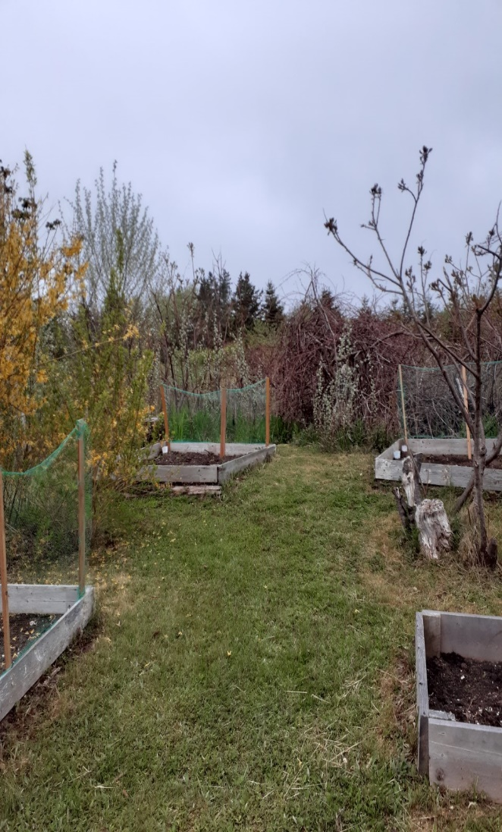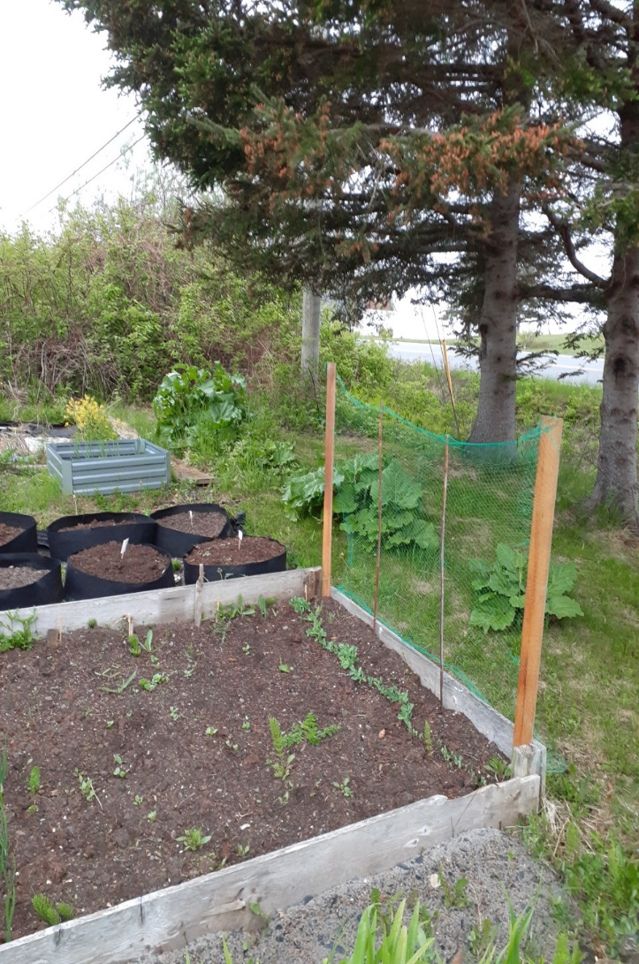

Craft
This is so easy.
Save the next empty (plastic) mayonnaise jar
Cut it about ¾ of the way to the top. (Yes regular scissors will cut it)
Cover the edge with tape and decorate the bottle
There is a pencil cup for all those pens and markers that like to scatter everywhere
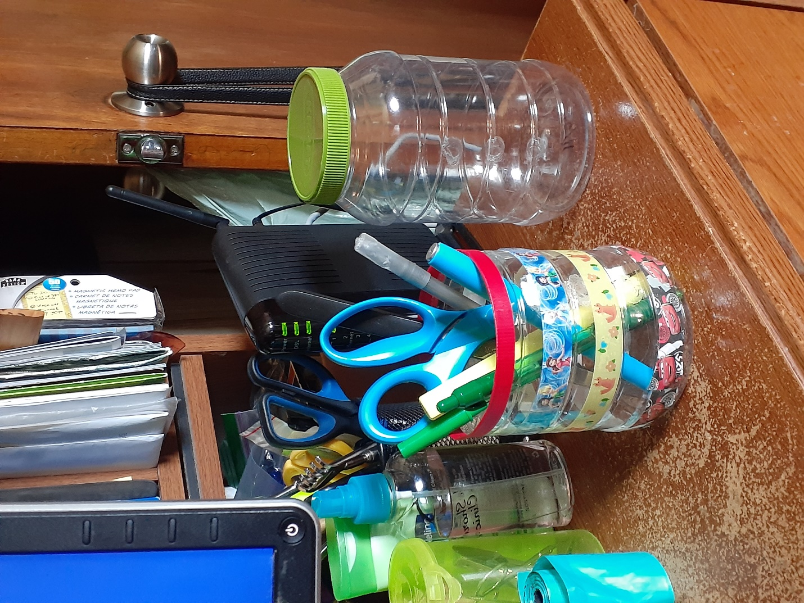

Something to eat
The fridge was full of apples from a sale so it was time for an Apple Crumble (aka Apple Betty). This basic recipe works well with Macintosh, Spartan, or any juicy or pie apple. I had Gala apples which came out dry even when adding extra water. Hence a generous dollop of yogurt on the side.
Apple Crumble
1 cup flour
1 ½ cup of oatmeal
2 cups or more of apples
3 tbsps. butter, margarine, etc.
A dash of cinnamon if you like it
Mix the butter into the oatmeal and flour mixture adding cinnamon.
Grease a dish, layer apples, half the dry mixture, apples again, and the last of the dry mixture. Bake 350 for 25-30 minutes. At 15 minutes look to see if it is juicy. If not add up to a cup of water to the dish.
Serve with yogurt, ice cream, squirty cream or eat alone.
