June 07, 2022
Email: HYPERLINK "about:blank" endionspei@gmail.com Website: HYPERLINK "about:blank" nspeidiocese.ca/den
Facebook: HYPERLINK "about:blank" Environment Network Diocese of NS & PEI



Growing Forests is a new mission driven investment opportunity designed to preserve regional woodlots through acquisition and sustainable management. Growing Forests is launching a start-up investment round as a qualified Community Economic Development Investment Fund (CEDIF)
Why? 70 % of forests in NS are owned by 30,000 small private woodlot owners. In 2019, 50,000 acres of private forest was clearcut. This is 11 times the size of the Halifax peninsula. This investment opportunity provides these owners an alternative source of revenue that will manage the land in an ecological fashion that does not involve clearcuts.

Please email dale@growingforests.ca
for more information and for the Offering Document
You can also download the information and learn more about the project at https://www.growingforests.ca
The Offering has been extended to June 28th. You are asked to indicate your interest by the middle of June so your investment can clear the securities commission.
Climate Cafes provide an opportunity for individuals to share feelings about climate change and climate emergency. The process, developed by the Climate Psychology Alliance - UK, is facilitated by Nancy Blair who is active in the Diocesan Environment Network and Climate Ministry at Christ Church, Dartmouth. It is not always easy to find someone to talk to about climate change. The Climate Cafe provides a calm and supportive space to listen and to be listened to. The next café is Thursday June 9th, 7-830 pm in Christ Church Hall on Ochterloney in Dartmouth. Bring a mask; we follow diocesan covid regulations. https://www.christchurchdartmouth.com/climate-cafe.html
For information: Nancy Blair, nancyblaircounselling@gmail.com
The Eisner Cove Wetlands, also known as the Southdale Wetlands is almost pristine wetland and forest approx.2 km from the Woodside Ferry in Dartmouth. Once public land, it was quietly sold in 2018. It is slated to be fast-tracked for affordable housing. Here are the concerns:
1.We are in a climate and biodiversity crisis. Wetlands are the very ecosystems we rely on to continue to draw down carbon from the atmosphere. Once disturbed, these wetlands will become a carbon chimney, emitting thousands of tonnes of greenhouse gasses, thus contributing to, instead of mitigating the crisis. In addition, the capacity of this ecosystem to sequester carbon will be destroyed. The result is a double liability, while in its current state this property is an enormous, important and irreplaceable asset.
2.According to a recent study carried out by Matt Betts et al (2022) between 34 million and 104 million individual birds have been lost due to clear-cutting and forest mismanagement between 1985 to 2020. Eisner Cove Wetland is a healthy, biodiverse ecosystem. Destroying this property with its mature forest and rich bird life would be ecocide
https://www.researchgate.net/publication/360244195_Betts_et_al_2022_Forest_degradation_Nature_EcolEvol

3.Englobe, the consultants hired by Clayton Development to carry out the Land Suitability Study, found no need to apply for an in-depth Environmental Assessment for this site. There was nothing special to see. Yet during bio blitzes, citizen scientists discovered what could be Black Ash. (Wetlands are prime habitat for Black Ash) Three experts have agreed that the evidence points clearly towards Black Ash, however conclusive identification is impossible until the leaves have completely unfurled. Black Ash is a Species-At-Risk in Nova Scotia and a tree highly valued by the Mi’kmaw Nation for its cultural and spiritual importance. We wonder what other species-at-risk have been completely overlooked in this approval process.

4.Clayton Developments have now applied for pre-approval tree removal and ground work to speed up the development process. If approval is granted, not only will the endangered Black Ash be harvested, but an important ecosystem will be destroyed.
Link to Protect Eisner Cove website
Link for email addresses and phone numbers

The Last Hope Camp is on a logging road in Annapolis County where people have been camping out - through the harsh winter months- since Dec 2nd to try to stop the provincial government from allowing WestFor to cut a 24 hectare 80 year old forest.
In 1958 a quarter of all the forests in Nova Scotia were 80 years old or older.
Now that figure is between 1 and 5%.)
Please write and/or phone the Minister of Natural Resources & Renewables, Tory Rushton, asking him not to allow the cutting of Last Hope Forest. Also please tell him that the responsibility for protecting and enhancing ecosystem health and biodiversity is HIS and cannot be assigned over to Westfor. Have you heard of the fox guarding the chicken coop? Write: mindnr@novascotia.ca

The Bridgewater Watershed Protection Alliance is seeking support for their submission to the Minister of Environment and Climate Change to have crown lands in the Petite Riviere Watershed (Lunenburg County) designated as a Wilderness Area. This group formed in March to oppose a proposed harvest of three parcels of crown land on Minamkeak Lake and also began to work on a Wilderness area designation submission. Please see the attached file
( Petite Watershed Wildreness Area Designation) for more information.

Participate - Climate of change The climate emergency is both an environmental and a social crisis, and a just transition can help build a better world for humanity and nature. This petition is for any global citizen and will be delivered to the European Commission President during COP 27 in Egypt in November, 2022. It is asking for policy changes that will safeguard a sustainable future while sharing the burden of change equitably and fairly. These policy changes include a shift towards a socially and ecologically just economy, boosting local resilience and global justice, enabling youth participation and integrating their views into political decision, and ensuring that global warming remains below 1.5°C. Sign your name to help stop climate change and to create a climate of change instead!
Environmental Defence Canada
Our country should be investing in low-carbon public transit, walkable communities, and climate change solutions. Despite this, the Ontario government plans to spend $6-10 billion dollars of public money to build a new highway. Highway 413 would increase harmful air pollution, destroy vital farmland, and create up to 17 million tonnes of carbon emissions by 2050 - the same year that we are supposed to reach net-zero emissions. Experts say this highway would save commuters less than a minute of driving on average. Our future and the needs of the environment should be the higher priority, this petition is asking you to lend your voice to say no to Highway 413.
Petition · Save Point Cartwright · Change.org
Point Cartwright Reserve is a unique and ancient place in Australia, and it needs to be better protected for its natural environment and cultural heritage. The area holds cultural and spiritual significance to the Kabi Kabi People, and the sandstone cliffs contain fossilised landscapes from the Jurassic Period. It is home to many mammals, marsupials, reptiles, and birds, including protected species of shorebirds that rely on the rocky shores. The forests in the reserve are classified as Critically Endangered and the beaches have the highest hatching rates for the endangered Loggerhead turtle on the Sunshine Coast. We need to stand together to ensure that the precious and needed natural areas of our world are protected. This petition is asking that the future of Point Cartwright Reserve is guaranteed, that it is rezoned and free from development, and that restoration and conservation strategies are implemented.
Lepreau Licence Renewal – How Many Years will it be – 25, 20, 10, 5? Check out a report ‘window’ on the Canadian Nuclear Safety Commission 3 days of public hearings on NB Power’s application for renewal of licence for Point Lepreau Nuclear Power Station. Much of all three Atlantic provinces fall within the IAEA’s recommended “Ingestion Planning Zone”. Where are you situated? https://crednb.ca/2022/05/28/report-the-point-lepreau-nuclear-reactor-licence-renewal-hearings

Wasting less
I saw an article recently on the David Suzuki’s site about wasting less. Arrogant me, puts my nose high in the air and thinks “I’m not wasting!”
Ah, then I read the article.
One suggestion was to only buy meat from butchers that use the butcher’s paper as it is biodegradable. There are very few stores that still do that. I would have to travel to the Valley where I know of one store. That means using added gasoline to get there plus buying in bulk. It doesn’t seem reasonable. Maybe I am just not trying hard enough. My nose goes down in a bit of shame. Really, we just need a way to recycle Styrofoam or find a new biodegradable way to package.
The article suggested cutting open plastic bottles of sanitizer or lotion to get more out of the package. Much to my children’s horror, I used a little saw to cut open lotion bottles and scape the lotion into pill bottles that then was put in purses, backpacks, wherever some hand cream may be needed. My nose goes back up.
We do carry SPORKS in the car so I can say NO to plastic cutlery. A couple sporks in a reusable bag takes little room and can be tossed in the dishpan at home.
I do take my own water bottle and tea mug on day trips. Quite a few places will rinse it out and fill it up again. Ever since our landfill stopped recycling coffee cups, I can’t throw a disposable cup away without reusing it another way. Recently the cups are a great place for transplants. So my nose was getting high again.
Some shops in metro allow you to bring your own bottle to fill with bulk items. Anyone try that yet? No, I haven’t but I do want to add the word, YET.
They did talk about not putting microfiber cloths in the landfill. I do boil them in the summer with a pot of water over the campfire. Boiling takes that clammy feeling away, makes them feel newer. Yeah! I also finish using them, 5-6 years later, with my semi-yearly waxing of the kitchen floor and do let them go to the landfill. So my nose would be bobbing here.
I do make a few cleaners. Mix a half cup white vinegar with the same of water and use this in a spray bottle for windows and mirrors. Now if you always bought cleaners you may need to mix hydrogen peroxide with water for the first few cleanings. It gets rid of that chemical film so the vinegar and water can make counters and windows sparkle.
The answer to my dilemma of pride and shame represents the journey we are on, trying to make our planet a better place to live. The important part of this journey is to keep learning while enjoying the journey.
Garden  Just in case you want to try it, I am waiting for my tomatoes and peppers to pop up in these cups. We are waiting for people to volunteer (3 of the 5 boxes are taken) while waiting for the boxes to be finished at the Community Gardens. One way or another we will have the garden boxes full. | 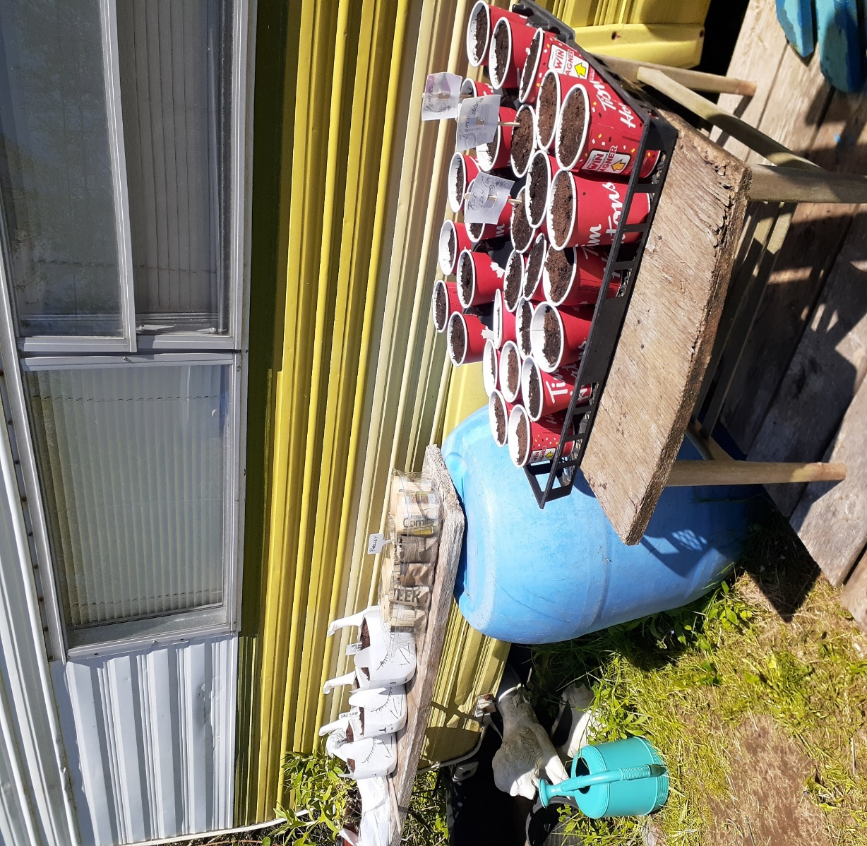

Craft  This one involves buying a can of reflective or even fluorescent paint from your local hardware store (cost $10-15). You will also need bottle caps or jar lids, big metal bottle tops.  Whenever I finish a pickle bottle I am not saving for another use, I put the bottle in my blue bag and the metal cap in a smaller bag. When my smaller bag is full, I tie it up and put that in the blue bag I have a good supply of pickle bottle caps  Paint the cap and find a way to place them to guide people down a path or prevent from driving into things  I am repurposing a few bent reflector | 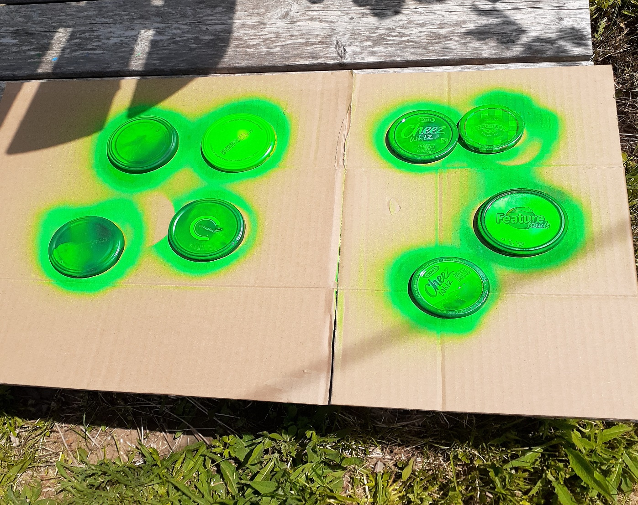  sticks for the driveway. I am nailing jar lids to the front of my garden boxes. When a light hit them after dark, they will light the way.  Did you know you can buy reflective spray paint for clothing that washes out? What a great thing for Halloween kids!

Something to Eat
While cleaning the freezer this week I found yet another package of zucchini. This is my summer go-to desert. Cook it in bread pans and it freezes great to take on picnics. Usually zucchini cake is chocolate but this is a
Spice Zucchini Cake
In one bowl put
2/3 cup vegetable oil (or margarine or butter)
Sugar – according to your diabetic state, I put in a scant cup of brown sugar but the original recipe calls for a cup of both brown and white)
2 tsp. vanilla
3 eggs (I usually use 1 egg and a few tblsp of egg whites in the box from the store)
1 to 2 cups of shredded zucchini
In a second bowl put
2 cups flour
2 tsp. baking powder
1 tsp or less of baking soda
2 tsp. cinnamon
½ tsp nutmeg
½ tsp. ginger
Mix the wet bowl into the dry bowl
Takes about 45 minutes to cook and makes the house smell delicious
Till next week, Grandma is sending hugs. Enjoy the outdoors.

Our Forests are the life-breath of our world and call on us to protect them with sustainable harvests and not indiscriminate clear-cuts. Environmentalists are not against the Forestry industry but stand against willful and widespread damages without thought to species that live within our forests.
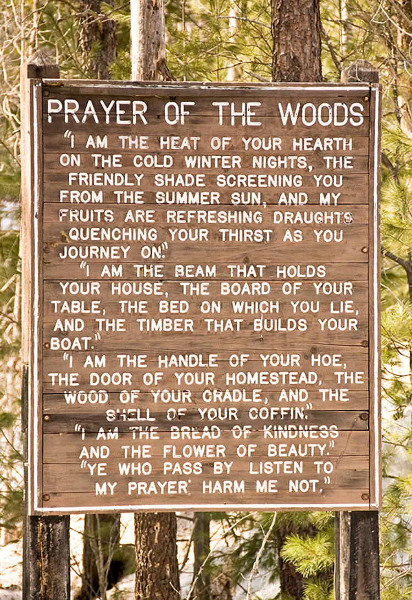
https://forestryandland.gov.scot/blog/national-tree-week-the-prayer-of-the-woods

