May 17, 2022
Email: HYPERLINK "about:blank" endionspei@gmail.com Website: HYPERLINK "about:blank" nspeidiocese.ca/den
Facebook: HYPERLINK "about:blank" Environment Network Diocese of NS & PEI



DEN Thursday gathering, May 26th, 7 pm – Preserving the Forests we call home An Investment opportunity.
Growing Forests is a new investment opportunity designed to preserve regional woodlots through acquisition and sustainable management. Growing Forests is launching a start-up investment round as a qualified Community Economic Development Investment Fund (CEDIF)
Please email dale@growingforests.ca
for more information and for the Offering Document
You can also download the information and learn more about the project at https://www.growingforests.ca
The Offering has been extended to June 28th.

Climate Cafes provide an opportunity for individuals to share feelings about climate change and climate emergency. The process, developed by the Climate Psychology Alliance - UK, is facilitated by Nancy Blair who is active in the Diocesan Environment Network and Climate Ministry at Christ Church, Dartmouth. It is not always easy to find someone to talk to about climate change. The Climate Cafe provides a calm and supportive space to listen and to be listened to. The next café is Thursday June 9th, 7-830 pm in Christ Church Hall on Ochterloney in Dartmouth. Bring a mask; we follow diocesan covid regulations. https://www.christchurchdartmouth.com/climate-cafe.html
For information: Nancy Blair, nancyblaircounselling@gmail.com
$65. Rain Barrels are another way to strive for water security and save money. There are a number of local groups fund raising selling water barrels. Click on https://rainbarrel.ca/

Scroll down the page to find a sale in your community of New Brunswick, Newfoundland and Nova Scotia. Save water WITH the bonus of using recycled/ repurposed food grade barrels. Please share this with all your friends. Each group fundraiser is for a worthy cause.

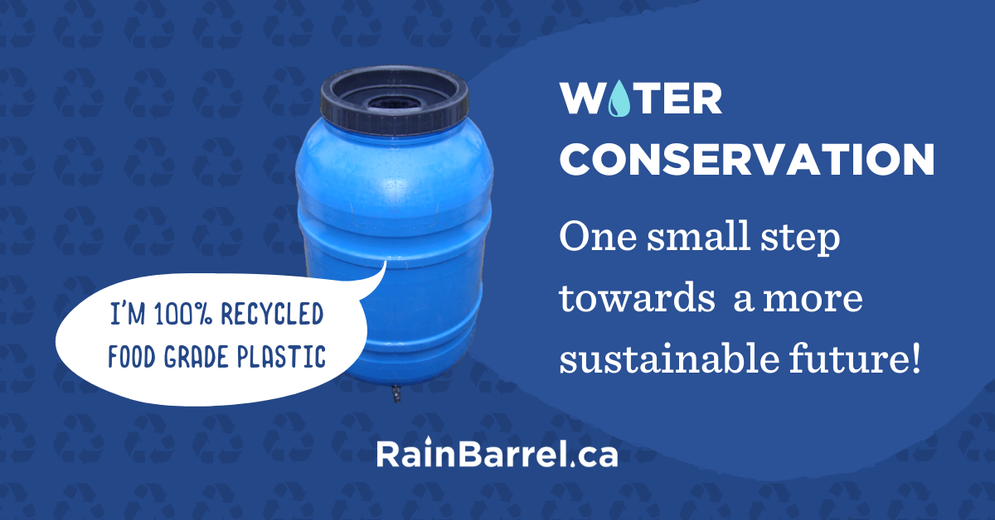

Removing open pen fish farms where wild salmon migrate

Wild salmon populations on the Pacific Coast are in serious trouble. That’s why we’re calling on Fisheries Minister Joyce Murray to complete the removal of open net-pen fish farms in the Discovery Islands, one of the most important wild salmon migration corridors. Science has shown open net-pen fish farms allow bacteria, viruses, parasites such as sea lice, and other pathogens to spread into coastal ecosystems. With wild salmon already suffering from a destabilized climate, minimizing disease and parasites from open net-pen fish farms is more important than ever.

WWF Petition against Dumping
Ships are dumping billions of litres of harmful waste in marine protected areas every year! An assessment found that ships generate 147 billion litres of operational waste in Canadian waters each year. That’s 59,000 Olympic-sized swimming pools, and 14.5 billion litres of this dangerous waste is dumped in protected areas. Most of this waste is scrubber washwater, which is produced by ship exhaust cleaning systems. It can be over 100,000 times more acidic than the surface of the ocean and also contains heavy metals and carcinogens. This worsens ocean acidification and harms marine life. We need to do better for our natural world and to protect it instead of harm it. Currently our government is defining what counts as “dumping”; we can send a message through this petition that says “no dumping” must mean no to all dumping and certainly not in protected areas.

Petition from Nature Canada to save Fraser River Delta
The Fraser River Delta is facing an imminent threat from the proposed mega-expansion of the Roberts Bank shipping terminal. Add your voice to save the 100+ species at risk of extinction that depend on it. Tell the Federal government you don’t support this project. It’s as simple as signing your name.

Halt Construction Of Trans Mountain Pipeline until there is a formal review
This petition is asking us to call on MPs to do a formal review of the Trans Mountain Pipeline. This pipeline is incompatible with efforts to limit global warming to 1.5ºC. It does not have consent from Indigenous nations along the pipeline route and a United Nations human rights committee has even reiterated its call for Canada to stop construction until is given. This pipeline will also increase tanker traffic through the Salish Sea by seven hundred percent, this will endanger the already struggling Southern Resident Orca whale population. Sign your name to say we need to stop subsiding fossil fuels and take climate change and environmental stewardship seriously.
Petition to Save 25 acres of Ancient Woodland in UK
Sandleford is astounding area in the UK that holds 7 ancient woodlands in close proximity and was the inspiration for the book Watership Down. These woodlands provide the sole habitat for many species of animals and plants, even protected ones such as the lapwing or hazel dormouse. These ancient trees and the historic hedgerow are all under threat due to plans to build more houses. The forests, animals, and land need us to stand up for them and not let this precious area that has stood for countless years fall to more development. This petition is going to the Secretary of State asking that it refuse the development and instead let the area be developed into a Special Area of Conservation.

Green Story – Enjoying the Trails
If you ever feel that the general public isn’t concerned about the environment, come take a walk on our trails. They were so popular here that the local hardboard plant donated land to make a new bigger parking lot.
It took a while to show people where that parking lot was. Cars were lined on both sides of the road the last two years where trunk 329 to Blandford exits the old Route 3 at East River Point. How many cars? I counted them one day. Nineteen cars on the side of the road and another dozen in the parking lot. Last Sunday I counted 27 in the parking lot plus the Hwy 103 carpool parking lot was half-filled.
People are outdoors, walking the rails to the trails route. They pack snacks and a water bottle in their backpack and just spend hours out in nature.
Another hint that tells us the public is concerned with environmental issues; the trails are clean of litter. (Shucks, another Earth Day Project Idea fouled!)
A great site to find these trails in PEI is https://www.princeedwardisland.ca/en/information/environment-energy-and-climate-action/walking-and-cycling-trails-on-public-land
In Nova Scotia try
https://www.alltrails.com/canada/nova-scotia/rails-trails
You can’t be much more green than to spend your spare time outdoors.
Gardening
Here is an idea that I loved. The community gardens were given a big basin to keep under a downspout to save water for the gardens. Otherwise, we carry our water in.
Well, there was “a hole in the bucket, Dear Li-ser, Dear Li-ser.” It upset me that we wouldn’t have a water source that year. I put out a call to the community in case someone might have another one in their shed somewhere. Instead, I got my answer in the form of, “Put a garbage bag inside the basin. The water shapes the bag to the shape of the basin and holds the water. That basin has lasted us since before the pandemic.
BREAKING NEWS. It looks as if MAYBE the Community Gardens in Blandford, behind the Community Centre, is being offered 4 stand-up gardens. Maybe they are called raised gardens. They are about waist-high or walker seated high, gardens. It looks like our Board of Directors might have a grant. There is a group willing to come to construct them and leave a pile of ground for us. An outside tap, that needs to be turned on inside the building has been discovered. Even if someone filled the basin and watered everything one day, the basin alone might water a couple of days

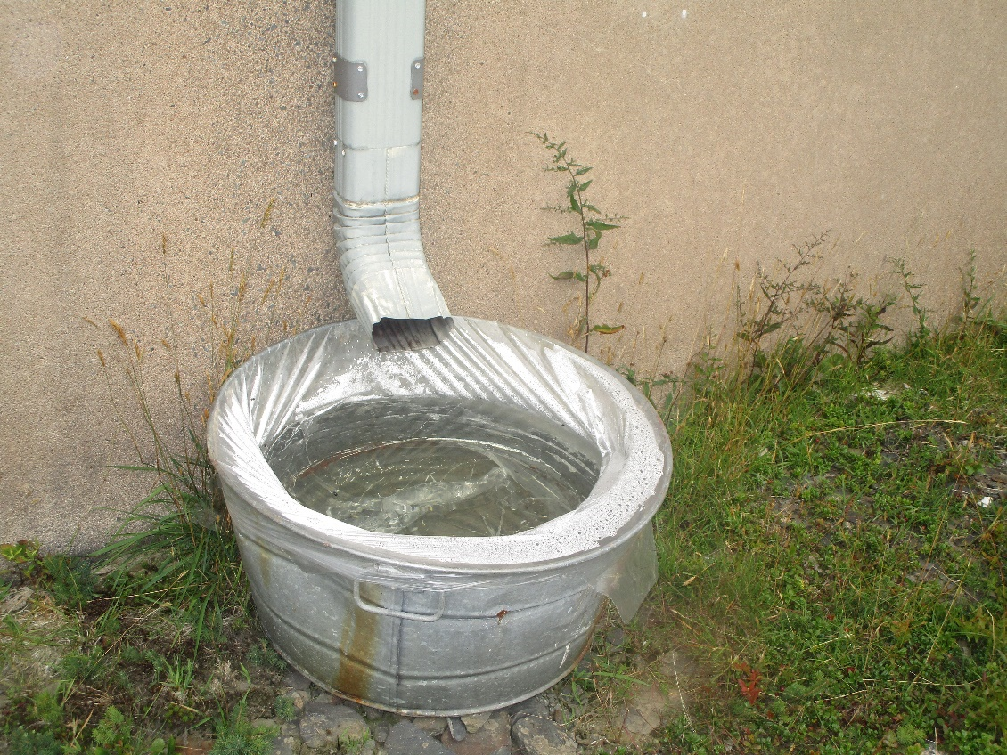
Craft - A Wind Sock
Cut a milk jug maybe a bit more than in half. Paint it or decorate it. Run a piece of tape around where it was cut. Use a one-hole punch and make about 8 holes around what is the bottom now.
Make 2 slits on the other end and attach a string for hanging,
Here is about the only time I miss plastic bags. Some still have black trash bags or even blue bags. Cut long strips of plastic. I cut straight across the top. Tie the plastic through the one-hole punches.
Try to hang it on a bottom branch of a tree or a flagpole or clothesline pole. Somewhere that the wind can catch it from all directions

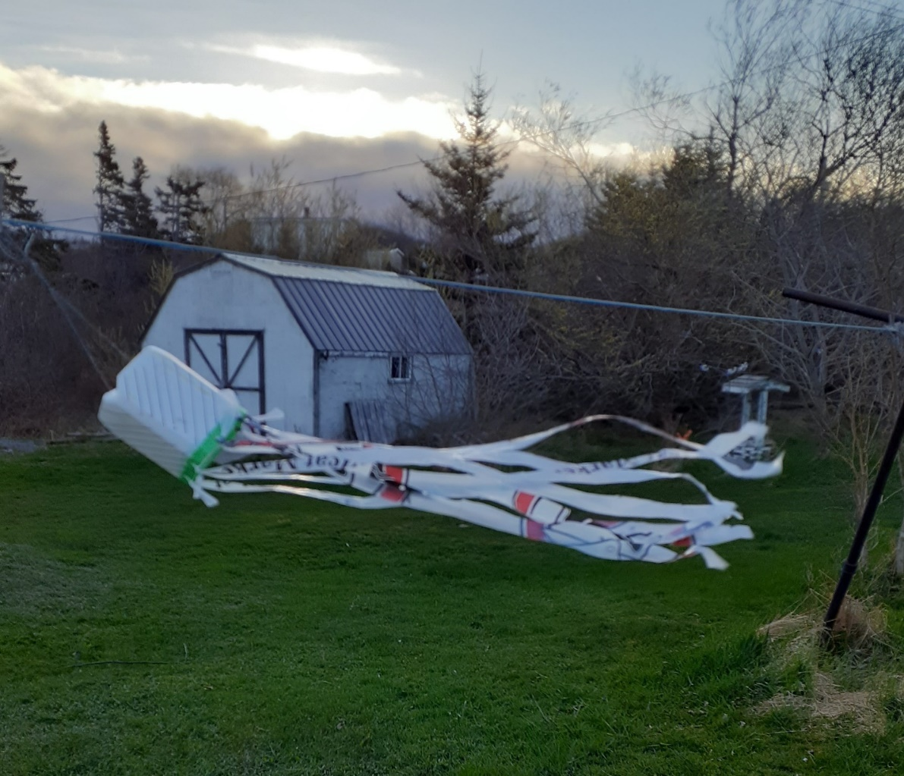

A Busy Day Dinner
Using one of those big frypans with a cover
Cook up a package of hamburger till the pink is gone, drain off the fat
Add to the frypan
A big can, I think 28 oz size, of diced tomatoes
A smaller can of tomato sauce
A small box or 2 cups of elbow macaroni
1 cup celery
1 cup green pepper
1 cup of onion
Salt, pepper, a dash of red pepper or chili powder
Look in your fridge for any leftover veggies or search your fridge freezer for those bits of vegetables put away for another meal
Bring it to a boil and then reduce it to a simmer for half an hour
Meanwhile, you have half an hour to finish what needs doing.

Till next week, Grandma is sending hugs



