May 03, 2022
Email: HYPERLINK "about:blank" endionspei@gmail.com Website: HYPERLINK "about:blank" nspeidiocese.ca/den
Facebook: HYPERLINK "about:blank" Environment Network Diocese of NS & PEI



DEN Thursday gathering, May 26th, 7 pm – Preserving the Forests we call home An Investment opportunity.
Growing Forests is a new investment opportunity designed to preserve regional woodlots through acquisition and sustainable management. Growing Forests is launching a start-up investment round as a qualified Community Economic Development Investment Fund (CEDIF)
Please email dale@growingforests.ca
for more information and for the Offering Document
You can also download the information and learn more about the project at https://www.growingforests.ca
The Offering has been extended to June 28th.
We are called by God to be good stewards of Creation.
Join us for weekly prayer in solidarity and renewal of our baptismal covenant:
“To strive to safeguard the integrity of creation and sustain and renew the life of the earth.”
Email endionspei@gmail.com for zoom link

The Council of Canadians invites you to become a part of the local and global movement for water security and justice by joining the Blue Communities Project – a joint initiative that furthers the work of local Water Watch coalitions across the country.
Learn what you can do as a community activist, public sector worker or municipal councillor to help protect the water commons – our shared water resources – in the face of increasing pressure to put water up for sale and privatize water services.
https://canadians.org/bluecommunities?utm_source=Council+of+Canadians&utm_campaign=0249c16ee5-EMAIL_CAMPAIGN_2021_01_27_08_08_COPY_01&utm_medium=email&utm_term=0_f477a42a0b-0249c16ee5-383712028&mc_cid=0249c16ee5&mc_eid=ada51a9353
Rain Barrels are another way to strive for water security. There are a number of local groups fund raising selling water barrels. Click on https://rainbarrel.ca/

Scroll down the page to find a sale in your community of New Brunswick, Newfoundland and Nova Scotia. Save water WITH the bonus of using recycled/ repurposed food grade barrels.

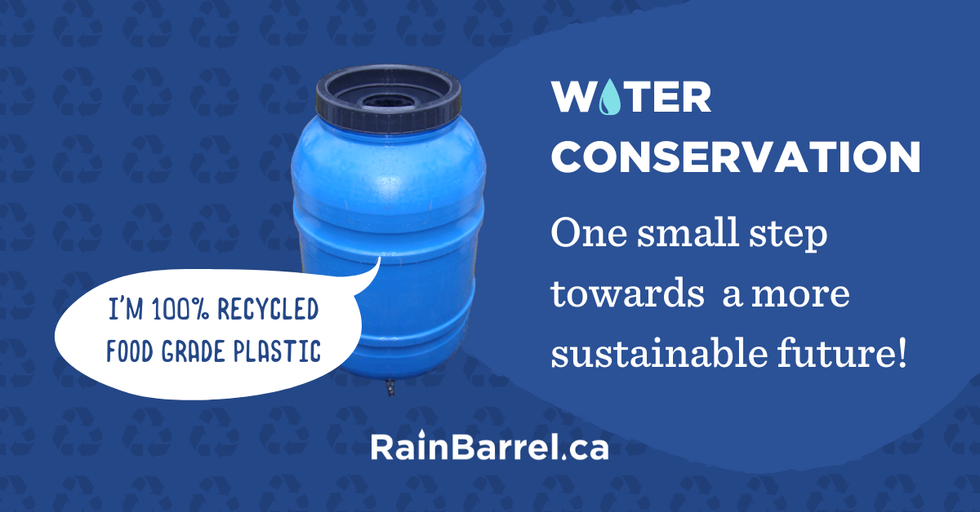

This is a great story – what are you doing to save heirloom species? Let us know!
https://www.npr.org/2022/04/24/1093167996/gardening-collard-greens-seed-savers-heirloom-collard-project-food-recipes?utm_campaign=npr&utm_term=nprnews&utm_source=facebook.com&utm_medium=social&fbclid=IwAR19tUlfBp5llLazJl31U-Jo4vyiwgs2iFsumumsEl45ZUL2phTAsyUfV6E

Petition to Parliament against Thermal Coal
We all probably know the dangers of thermal coal. Elizabeth May is presenting a petition to Parliament. May 10 is the deadline for signing.
- Thermal coal, the kind burned to make electricity, is the world’s dirtiest fossil fuel;
- Thermal coal creates half of the world’s carbon emissions and the pollution it creates kills more than 800,000 people every year;
- The government has a plan to phase out thermal coal exports, but it is outdated and insufficient;
- The world needs to move rapidly away from thermal coal to have any chance of limiting global warming to the Paris target of 1.5 degrees Celsius;
- The physical effects of climate change pose serious risks for Canadians, Canada’s wildlife and the Canadian economy including permafrost melt, droughts, heatwaves, wildfires, floods, sea level rise, increased vector-borne diseases, disruptions to supply chains, destruction of infrastructure and damage to key industries including agriculture and forestry; and
- Canada’s greenhouse gas emissions have increased since the Paris Agreement was signed, making it the worst performing of all G7 nations since the 2015 Conference of the Parties in Paris, France.
Animal Justice – Take Action (e-activist.com) Animal Justice and Wolf Awareness are calling on Health Canada to outlaw poisons used to kill wildlife in Canada. In Alberta and Saskatchewan, Strychnine and Compound 1080 are used to kill animals such as wolves, coyotes, skunks, and black bears. This causes inhumane extreme and prolonged suffering. It also allows other animals, including endangered species, to scavenge on the bodies of poisoned creatures, which causes more pain and death throughout the ecosystem. Safer and effective alternatives exist to prevent predation on farmed animals and to protect at risk species of caribou. This petition is asking the Health Minister Jean-Yves Duclos to end the cruel poisoning of wildlife in Canada.
petition: This Massive Canadian Bank Is Funding a Poisonous Pipeline That Will Rip Through Indigenous Lands and Precious Wildlife Habitat (thepetitionsite.com) Why are more pipelines being built in 2022? Coastal GasLink is currently constructing yet another massive, 416-mile pipeline, and the Royal Bank of Canada is funding it. This pipeline will run directly through Wet'suwet'en territory without the consent of tribal leaders. The risk of a leak would mean natural gas escapes from a pipeline and build into an explosive concentration that kills trees and vegetation, causes fires, and releases greenhouse gases into the atmosphere. Why is more infrastructure to extract and transport fossil fuels being constructed, and why is the Royal Bank of Canada funding it? Another question is why are we allowing it, sign your name to the petition that will be sent to RBC if you are asking any of these questions.
Petition to reverse doubling of Jessica's sentence Climate activists labelled as terrorists? Yes, this happened recently in the U.S. when the Department of Justice applied the terrorism enhancement which doubled Jessica Reznicek’s sentence (to 8 years in prison) and unless changed could have frightening consequences for anyone seeking to protect our earth and water from corporate destruction. Professor Julia Steinberger, a lead author with the UN’s Intergovernmental Panel on Climate Change, recently signed a letter with her other UN colleagues and over 400 other scientists & academics from 32 countries, that raises the alarm on this trend of activists being criminalized with longer prison sentences, police repression, and more. Part of the letter reads, "But around the world today, those who put their voices and bodies on the line to raise the alarm are being threatened and silenced by the very countries they seek to protect. We are gravely concerned about the increasing criminalization and targeting of climate protestors around the world." When hearing of Jessica's case Steinberger urged people to support Jessica saying, "As the climate and ecological crises escalate, so too will our activism. And so will the repression by governments corrupted by fossil fuel interests. Stand with Jessica Reznicek."
petition: Protect Joshua Trees (thepetitionsite.com) Joshua Trees provide critical food and habitat to animals in the Mojave Desert and these trees are crucial to the ecosystem. Yucca moths, for example, collect the tree’s pollen and lay their eggs on the flowers. The caterpillars eat the tree’s seeds, and without the Yucca moths the trees have a much harder time reproducing. This symbiotic relationship is seen throughout the natural world; it is vital that we do not let species die out. There is a current battle to protect the Joshua trees and have them listed under the Endangered Species Act (ESA). Scientists are offering clear evidence that the Joshua tree may go extinct by the end of the century due to climate change. Scientific modeling also suggests that the western Joshua tree in Joshua Tree National Park will lose upward of 90% of its current range by the end of the century. This petition is calling on the U.S. Fish and Wildlife Service to follow the science and the law and to protect the Joshua tree under the ESA.
Live Stream of Point Lepreau 25 year licence Public hearings in Saint John NB May 10-12, at nuclearsafety.gc.ca. The Coalition for Responsible Energy Development–NB and the Canadian Environmental Law Association submitted a joint ‘intervention’ and will be presenting at 1:30 on Wednesday May 11th. Their recommendations against the unprecedented licence period, cover concerns about: reduced public scrutiny of licencing, emergency ‘ingestion zone’ not matching IAEA guidelines; dated climate and environmental modelling; failure to consider imminent plans for Small Modular Reactors on the Lepreau site; and adequacy of Cyber security measures - given the current threat environment. All 244 submissions, are available at Download Hearing Documents - Canadian Nuclear Safety Commission. CRED-NB/CELA is listed as CMD 22 H2 194
Green Story - Highway Clean Up
Putting out a reminder to those in PEI, this year’s Highway clean-up date is May 14th. Pick up your Women’s Institute bags, available the first week of May from Access PEI. There even is a contest with the opportunity to win cash prizes at this year’s 50th EVENT (not anniversary) Covid may have set back this program a bit but at its lowest, 20 metric TONS of litter was collected in a year. Back in 2018, they collected 38.91 metric tons of trash.
Remember that 80% of the trash in our oceans comes from rivers and coastal roads. You can’t get much more coastal when you live on an island. Thank you Women’s Institute (WI) for being a champion of the environment.
Here in Nova Scotia, I want to recognize the work of a group called Scotian Shores.
They have been in the news a bit recently. Founded in 2020, starting as one family’s outrage at the litter on the shorelines and spreading their followers around the province, they are true “Ocean Warriors”. In 2021 over 100,000 pounds of debris were removed from the shoreline. So far in 2022, they have removed 25 thousand pounds.
Take a look at their website
https://www.scotianshores.com/
Editor’s Note – Another coastal clean up warrior can be found on the Facebook page Nova Scotia Beach Garbage Awareness. Using another group’s mantra Take 3 – strive to pick up at least 3 pieces of litter every time you are out.
Gardening
Does anyone have those reusable grocery bags that are made of fabric (or recycled bottles?) Grow a bag of potatoes on your doorstep. Just fill a bag with soil and plant your potatoes Water frequently, Come fall, dump plants and soil out and gather up clean dry potatoes. I found my bags the other day in the shed. I should try a few again this year.
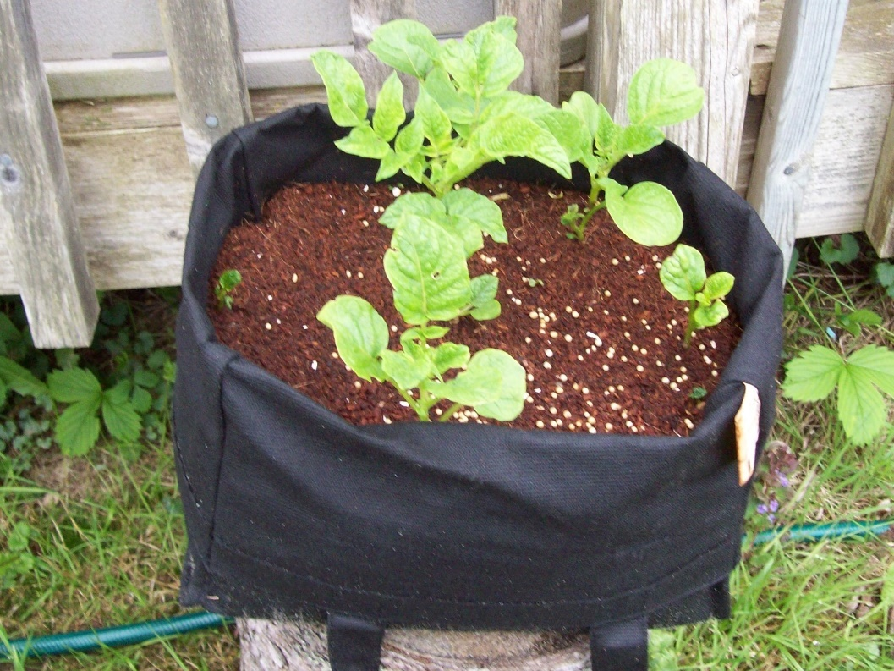

Craft
Is anyone willing to ADMIT they still use water bottles? I still do. Don’t worry. Grandma has her refillable water bottle, her thermos of tea, her steel straws, and even the bigger water container for picnics. In the bottom of my thermal bag will lay 4 water bottles on top of freezer packs. They are at least half-frozen and keep the picnic cool, BUT, if at an event and you see someone without water you can give them away. If not, they go back in the fridge for next time.
This taught me how fast water bottles could add up. So what to do with them?
First, recycle them. The companies that pick them up from the recycling places have a product in mind. Often it is simply making more water bottles but if they keep going in a loop, there is less harm.
Last year I kept the deer away from my gardens by making spiral wind catchers with water bottles. It worked until winter storms took the spirals and the deer ate my rhododendron again this spring. This year we are adding fish to the mobiles.
 | 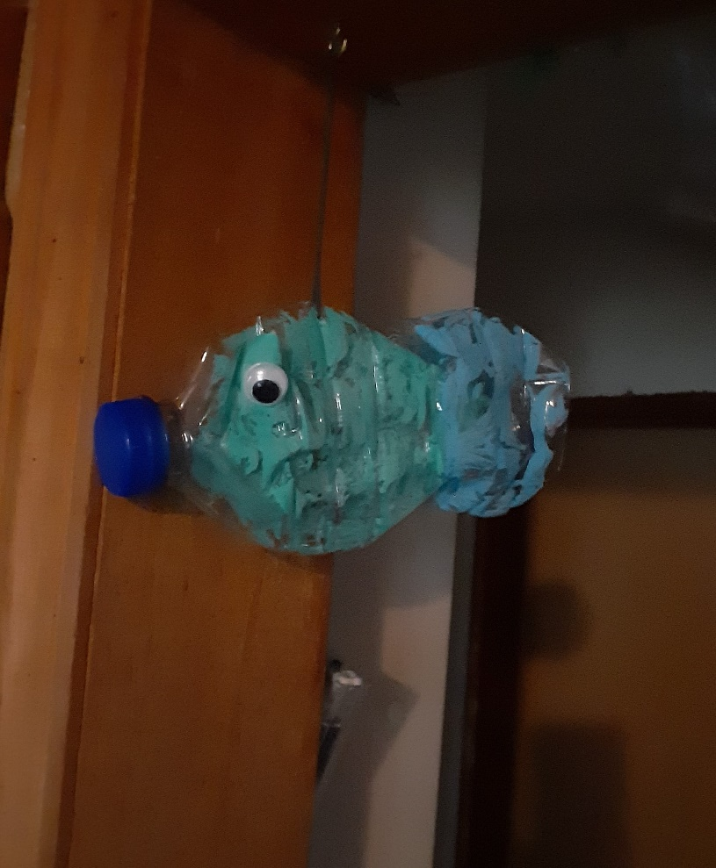
Water Bottle Fish
Take a water bottle and cut it a little more than halfway down the bottle.
Cut a slit across what was the bottle’s bottom. Squeeze or flatten both ends of the water bottle. Paint, and decorate your fish. When dry, fold the back of the bigger or front fish into that slit (bottle bottom) of the second piece. A little hot glue will keep them together if they are out in storms. If you have stick on eyes, use them; if not make a black circle inside a white circle straight on the fish or on paper to be glued
Grandma is going to find a way to hang them up to frighten the deer but they would look pretty anywhere.
Something to Eat
Our family loves bread. Big celebrations are not complete without rolls. Usually, Grandma makes the rolls. Sometimes Grandma doesn’t have a lot of time. This is where Grammie’s rolls started.
There once was a time when Grammie was still with us, I made these rolls for a family gathering. Grammie had store-bought rolls to add to the dinner. When the rolls came out, my 30-minute rolls, everyone thought they were Grammie’s. I didn’t correct them.
They are glorified tea biscuits. Good, wholesome, yummy, tea biscuits.
Although I wouldn’t DARE change the rolls that graced our table for eons, my mother could do no harm with that crowd. So, when I make them now, they are called Grammie’s rolls. Makes me smile every time.
Our Grammie’s Rolls
¼ cup margarine
1 ½ cup milk
1 tbsp. Sugar
Dash of salt if you use it
4 tsp baking powder
3-4 cups of flour
Turn your oven to 350F, these are ready fast.
Put everything except the flour in one bowl. Add the milk.
Divide into 12 pieces, roll in balls
Put them on a baking sheet and right into the oven for 20-25 minutes
You can brush them with butter if you like that shiny top look.

That is easy and you can have fresh bread with a meal.
Until next week, Grandma is sending hugs.

Come Holy Spirit
Creator God, God of Compassion,
We thank you that we gather together as your sons and daughters.
We thank you for the world that you have made.
For soil and streams, Mountains and music, Flowers and fauna,
Laughter and love, Dancing and daffodils, Flamingoes and food.
We thank you that we inhabit this world with non-human worshippers.
Elephants and eagles, Red kites and racoons. Monkeys and macaws.
To you be all honor, glory and praise.
Creator God, God of Compassion,
We are concerned about this world of yours ,
And this world of ours. It is our home.
In the face of the climate crisis our hearts are restless and our souls are sad.
Draw near to us as the healer of all hurts.9
God, we ask that you would lead and guide us
By the power and compassion of the Holy Spirit.
In these strange and difficult days, we ask that you would mould us and shape us into the image of your son, and our saviour Jesus.
May we, like him, be people of justice.
Come Holy Spirit, We need you.
Come Holy Spirit, Fill us afresh.
Come Holy Spirit, Empower us.
In Jesus’ name we pray, Amen.
https://static1.squarespace.com/static/51c038a6e4b0cf320a60969d/t/6092d29fd463680112ed85c7/1620234923937/Prayers+for+the+Climate+and+Ecological+Emergency.pdf


