April 19, 2022
Email: HYPERLINK "about:blank" endionspei@gmail.com Website: HYPERLINK "about:blank" nspeidiocese.ca/den
Facebook: HYPERLINK "about:blank" Environment Network Diocese of NS & PEI

April 22nd is Earth Day
What are you doing to celebrate our earth?
What vows are you making to save it?
Join DEN this week on the eve of Earth Day for a Viewing and Conversation about the documentary
"The Magnitude of All Things"
Thursday Apr 21, 2022 06:30 - 8:30 p.m. ADT
Join Zoom Meeting
https://us06web.zoom.us/j/89700369421?pwd=UWluam5CUlcxaUNsbWFoeVcvbEEvZz09
Meeting ID: 897 0036 9421
Passcode: 134949
One tap mobile
+19292056099,,89700369421#,,,,*134949# US (New York)
+12532158782,,89700369421#,,,,*134949# US (Tacoma)

Filmmaker Jennifer Abbott explores the emotional and psychological dimensions of the climate crisis and the relationship between grief and hope in times of personal and planetary change. The David Suzuki Foundations says "This powerful, moving film conveys the magnitude of the growing crisis that humans brought about by failing to understand our sacred duty to the one world that sustains us — as well as the magnitude of nature and life. As the Wonnarua traditional custodians say, “If this land hurts, we hurt.” It’s difficult to talk about the climate and extinction emergencies — but it’s critical. Yes, we may grieve for what we have done to this beautiful world that provides so much, but if we channel that grief into connecting with others who care enough to demand change, if we rethink our relationship with the natural world, we can face the present and build a better future."
Please consider joining us on the eve of Earth Day 2022.

With thanks to Rev. Charles Bull who has written this Climate Prayer to use for Earth Day, Season of Creation or a time(s) of your choosing:

Holy God,
whose Spirit breathes in the life of our planet:
we turn to you
in this time of climate change and ecological collapse.

We are sorry for the harm we have done to the earth,
and we humbly ask your forgiveness.
Help us to see with clear eyes
how the wonders of human progress
are causing the desolation of your living world.

Give us grace to renounce the systems of power and profit
that corrupt and destroy your creation.
Give us courage and compassion,
as we confront those who uphold them.

Bring healing to our hearts
that we may know and love all living things
as our own relations.
May we gratefully acknowledge our dependence on them,
and have the wisdom and fortitude
to live within our means,
as members of the earth community.

And in the power of your Spirit,
mobilize us with a realistic hope
for the future to which you call us.
In Jesus Christ we pray.
Amen.
Earth Day 2022 marks two years of For the Love of Creation collaboration.
Two years of faith-based reflection, conversation, advocacy, and activism in pursuit of climate justice. We've grown from a group of 20 national churches, religious orders, and faith-based organizations to nearly 40. We've convened conversations, celebrated policy wins, and reflected on our place in Canada's colonial reality. And, we continue to come together in the hopes of making a meaningful contribution towards a sustainable future for all life on the planet.
To learn more, visit fortheloveofcreation.ca. If your organization would like to explore greater participation or endorse FLC, please contact us at flc.pac@gmail.com

An exciting announcement at Christ Church as we announce a new partnership of ministry with the Diocesan Environmental Network (DEN). Christ Church will be the setting for a new ministry called the "Climate Cafe." Nancy Blair who has preached about climate change and crisis this past fall will be leading this ministry. Please see this link for more information and a video:
https://www.christchurchdartmouth.com/climate-cafe.html
The first Climate Café is scheduled for this Thursday, April 21st. 7- 830 pm.
The café is open to the community but you are required to register by contacting Christ Church
902.466.4270.The event is in person. The hall is large and you can be socially distanced. Masks are required.

Our Diocesan ACW having been praying for the women in the Diocese of Calgary since last fall. If you are interested in joining this virtual conference, email acwdiocesecalgary@gmail.com

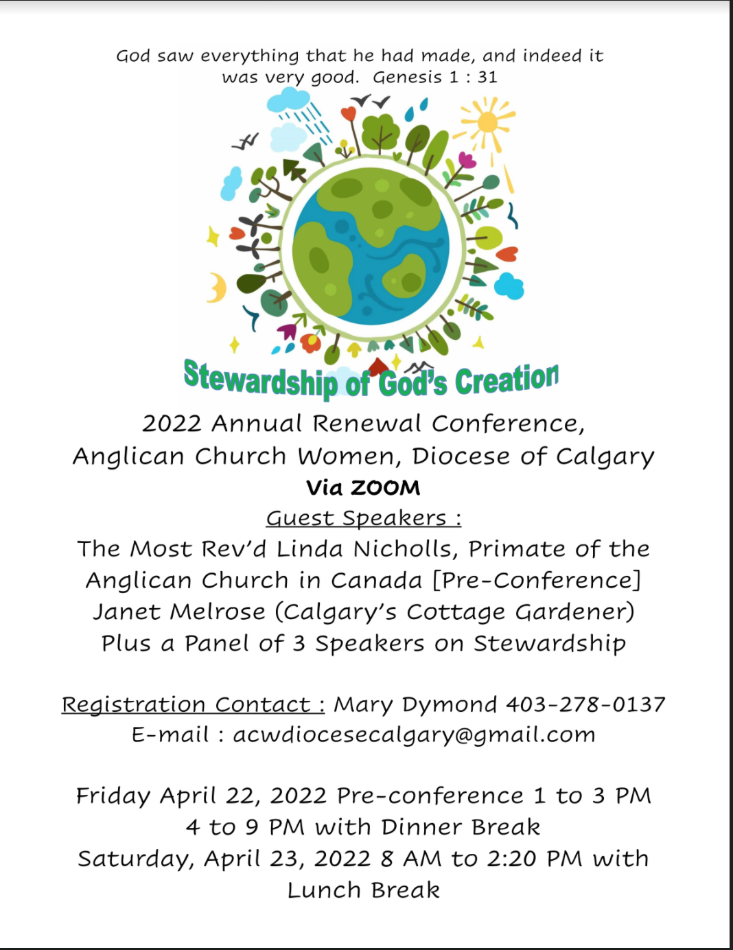

The Steering Committee for the South Shore Chapter of the Council of Canadians will be holding its Annual General Meeting (AGM) on Wednesday, April 27 at 7:00 pm at the Mahone Bay Centre (45 School St., Mahone Bay).
There will be brief reports on the last year of activities, followed by a screening of the video produced at the Just Transition Day of Action event. Following that, there will be a moderated discussion of the key areas touched on during the Day of Action: housing, public transportation, poverty, climate, and a green economy. It is exciting to have momentum from the Day of Action continuing into this event.
We require the wearing of masks at the AGM.

All welcome!
The Council of Canadians, Canada’s leading non-partisan social action organization, advocates for clean water, fair trade, green energy, public healthcare and a vibrant democracy. The South Shore Chapter promotes education and action on issues that affect us locally and globally. We acknowledge that we live and organize on unceded ancestral territory of the Mi’kmaw nation, and strive to align with the beliefs and values of Indigenous peoples in a spirit of reconciliation and shared struggle
www.facebook.com/SouthShoreCouncilofCanadians www.canadians.org

We are called by God to be good stewards of Creation.
Join us for weekly prayer in solidarity and renewal of our baptismal covenant:
“To strive to safeguard the integrity of creation and sustain and renew the life of the earth.”
Email endionspei@gmail.com for zoom link

Preserving the Forests we call home – Growing Forests is a new investment opportunity designed to preserve regional woodlots through acquisition and sustainable management. Growing Forests is launching a start-up investment round as a qualified Community Economic Development Investment Fund (CEDIF)
Please email dale@growingforests.ca
for more information and for the Offering Document.
You can also download the information and learn more about the project at https://www.growingforests.ca
The Offering has been extended to June 28th.
Dale has agreed to meet with us on a DEN Thursday gathering, May 26th, to explain this in more detail.

HRM Council just passed HalifACT, an ambitious and comprehensive climate policy costing an additional 3% in taxes. This is a proud moment for this city. Thank you to everyone who contacted their municipal councillors. Never say the struggle is not worth the effort! Here is what Mayor Savage had to say:

"I absolutely agree that now is not the right time to take action on climate. The right time was years ago, and we missed it. Everybody in the country, the province, this city - we missed it. But this is the best time that we have to address climate action. It's said, the best time to take on a wicked problem was years ago. The second best time is now. And I think it's now. And I think that this is something that we have to do.
...
It's tough times. But also, while we're doing things that we don't want to do, like raising tax... we should also be proud of the fact that we have the best climate action plan, in my view, of any city in Canada... Collectively we have the opportunity to do a very important thing. "

Save Sandy Lake
Sandy Lake and Sackville River form a popular nature space on the edge of Halifax's urban centre. It's home to birds, bugs, animals, mosses and more, all nestled among some of Nova Scotia’s last remaining old-growth forests. But on March 24 2022, the Provincial government’s Task Force on Housing picked the Sandy Lake – Sackville River area as one of its locations to fast-track for development. The very same area has been proposed for protection as part of Sandy Lake Regional Park. It shows up in multiple studies as a key area for wildlife corridors and is invaluable as intact, interconnected wild areas that help with the twin crises of climate change and biodiversity loss. We still have time to come together and save Sandy Lake and Sackville River! HRM Councillors have recently shown an interest in keeping this important wild area safe, but their views were over-ridden by the provincial Task Force’s decision. Send a message to the provincial authorities who made this decision, and ask that the Sandy Lake “special planning area” be removed from their housing development list and protected!
Sign now: Protect old growth forests from logging (stand.earth)

Protecting old growth forests is one of the most effective things we can do to mitigate the impacts of climate change. Healthy, old growth forests clean the air, shield us from fire and flooding, and store massive amounts of carbon. Now, less than 1% of the forests in B.C. are home to these old growth forests, which are still being commercially logged. The B.C. government committed to implementing all 14 recommendations from the old growth review panel. This included immediately banning logging for the most at-risk old growth forests. They haven't followed through, and this petition is urging the B.C. government to act to ban logging for the most at-risk old growth forests.
Sign the petition to tell Coca-Cola, Nestlé and PepsiCo to reduce their plastic pollution - Greenpeace Canada
Coca-Cola, Nestlé, and PepsiCo are big brands that are continuously at the top of the list of the world’s biggest plastic polluters. They claim to be taking action to curb plastic pollution, but fail to meet their goals, continue to invest in false solutions, and partner with oil companies to produce even more plastic. These companies have the power, and the responsibility, to reduce their plastic footprint and combat the climate crisis. They need to end their reliance on single-use plastic packaging and move away from fossil fuels, and when consumers speak out, big brands listen. Sign this petition in order to have a say and to demand that these giant companies reduce their plastic footprint at the source.

Nature Canada
Lake Ontario is a crucial home to species at risk and must be protected. This body of water supports rare species and provides stopover areas for migratory birds. Over 50 species of birds, reptiles, plants, and fish at risk depend on this lake, and yet Lake Ontario is one of the least protected of the Great Lakes. Land development, runoff pollution, invasive species, climate change, and a lack of protection mean an uncertain future unless we act now. Establishing a National Marine Conservation Area is needed and we can help protect this vital landscape by sending a letter showing support for the protection Lake Ontario’s biodiversity.

Tell NS govt to stop forest harvesting at Minamkeak Lake
CPAWS (Canadian Parks and Wilderness Society want people to write to the NS government (a draft letter is available) asking them to reject industrial forestry that would result in more than 100 hectares of forest being cut down on public lands at Minamkeak Lake (Bridgewater area) that provide vital habitat for endangered species.
Not a petition but good info from IPCC

The latest installment of the United Nations’ Intergovernmental Panel on Climate Change (IPCC) Sixth Assessment Report charts a path toward cutting emissions and reducing warming. As the panel makes abundantly clear: While an immediate, rapid phase-out of fossil fuels remains paramount, agriculture, forestry, and food systems solutions are a non-negotiable piece of the puzzle.

Editor’s Note: Last week’s Grandma’s column generated some interesting conversation around the efficacy of carbon capture and whether this was a way for the fossil fuel industry to effect a buy in of their products. Are we being fooled? Here is an interesting perspective sent to us by Rev. Charles Bull. https://youtu.be/UOd-Jgly9Us
Thank you to both Grandma and Charles for keeping our eyes open to possibilities.

Green Story - Pen and Marker recycling
Everything is starting to open, cautiously. I expect Grandma will be one of the last ones to go without a mask. As my cousin said this year, “I rather like going through a winter without a cold.”
Still, it is time to come out of our isolation and get back into living a bit more.
The Parish of Blandford had several recycling programs pre-pandemic. The first one to come back will be the pen, marker, highlighter, and mechanical pencil recycling.
At our community center we have a decent size box that people can drop off their dried-up writing instruments.
In the beginning it was a teracycle box. The idea was that when full you mailed it back to terra cycle and they turned that plastic into clipboards, cutting boards or bench ends.
Staples joined up with Teracycle and started having free recycling boxes in their store. There is no need to purchase the boxes anymore if you can get to a Staples store every few months. Staples recycles several products.
Another good Earth Month project may be to pick out one product they recycle and start with a collection at your church or community centre. Then find more points outside of that building to put your boxes.
Yes, we must be careful with the virus, but the germs can not live on surfaces for more than a few days. Grandma just brings along a clear bag, empties the box into the bag and lets it sit a week or more once she gets them home. The first ones I laid out in a cardboard box to count and sprayed them with the disinfectant spray. Maybe that was a bit of overkill, but it made me feel better.
The Parish of Blandford had EIGHT collection points prior to March 2020. In 2019 we passed in 3680 pens, markers, highlighters, and mechanical pencils. I somehow doubt we will get to a thousand units this year, but whatever the number, it is that many more that is not in a landfill. It is that much more that becomes a resource rather than trash. Which product can you decide to save?
Gardening
This is one idea I am borrowing straight from
https://www.extraspace.com/blog/wp-content/uploads/2018/07/cork-labels-diy-garden.jpg
I have been saving corks for years to make a cork mat. This is a much better idea. A permanent marker and those sticks for cake pops or even chopsticks. I’m using this idea in my gardens this year.

Craft - Newspaper Flowers
We need newspaper, (or flyers) string or a big twist tie or floral wire to hold the flowers together. That’s all.
If you have newspaper take a full sheet and cut it into 4 long pieces. Pile the four strips on top of each other. Fold the paper back and forth. Tie the bundle together in the middle.
Carefully pull back the first layer of paper on both sides of the middle
Pull up the next two pulling the last layer the opposite way.
Now if you want to get fancy, paint just the edges of the paper to give the flowers colour
If made with flyers, they show such pretty colours just by themselves.
You know Grandma likes service work. Make a bouquet and give it to someone in the community. Everyone loves flowers.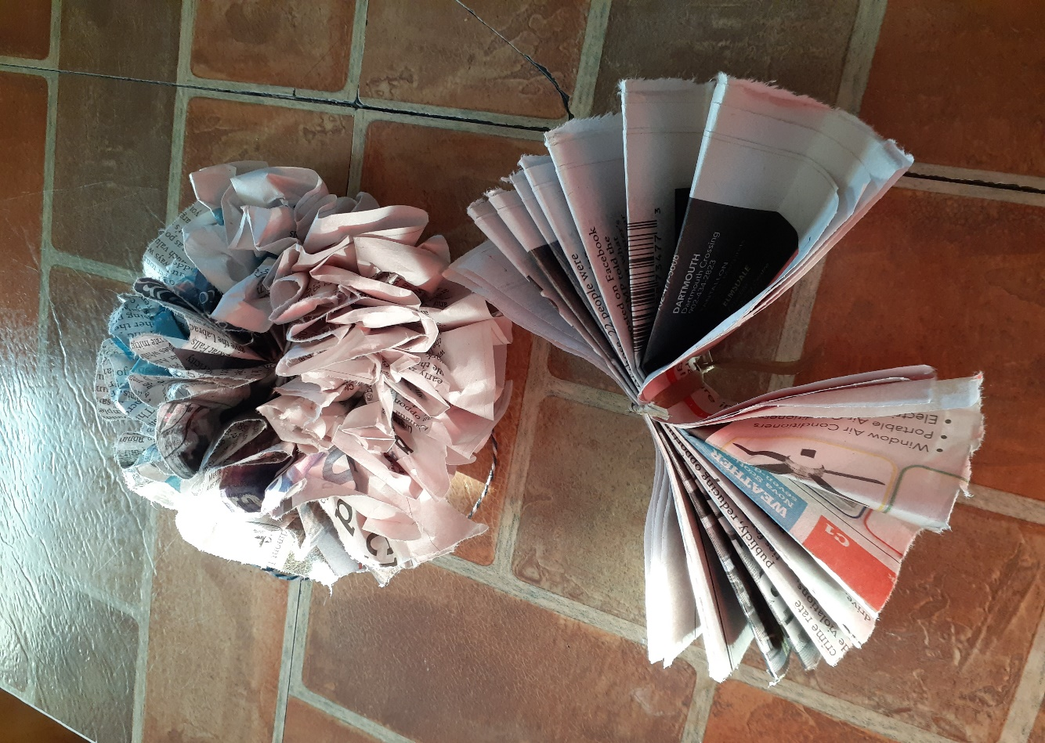

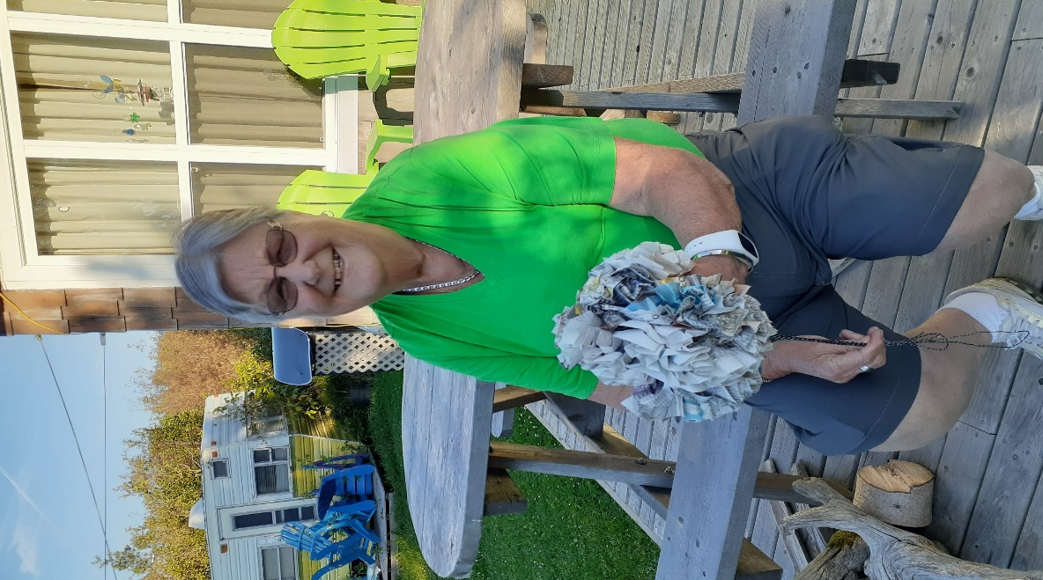

Something to eat
I have a new toy, an air fryer. My daughter tells me how she bakes cakes in hers if she can find a pan to fit in the fryer section. I often baked Cheesy egg breakfast, but it meant heating this big oven when I wasn’t cooking anything else. I felt ambitious enough to try the same recipe in an air fryer. Turned out so good with crusty bread and Rev. Louie’s strawberry jam.

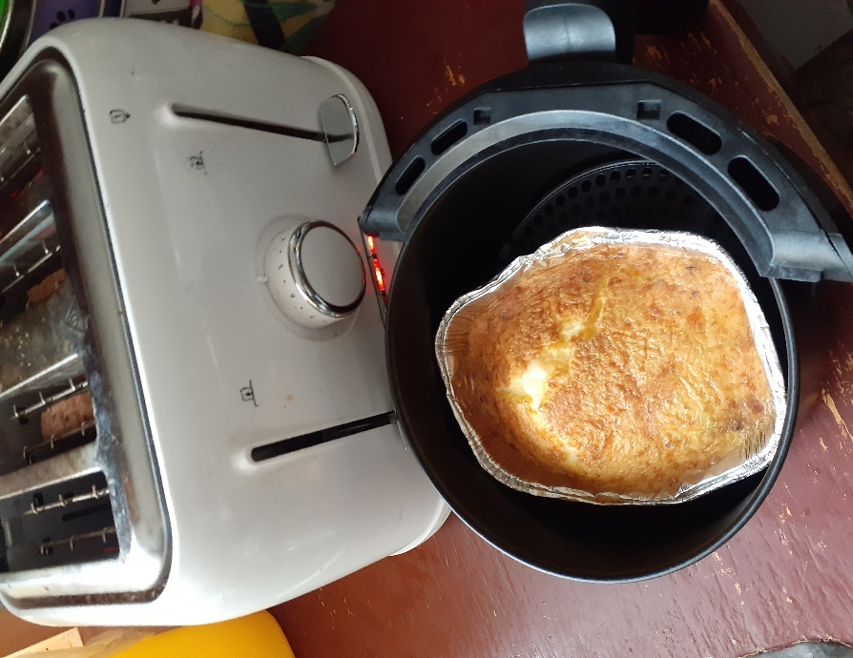


Cheesy Egg Breakfast
4 eggs
A handful of cheese
As much as 1 strip of bacon wrapped in paper towel and cooked 1 minute in the microwave
You can add tomatoes, onions, peppers, spinach if you have them.
Stir it up and put it in a little pan inside your air fryer. I cooked it at 400F for 10 minutes and then did another 4 minutes. Play with it.
This was so filling that eaten at 10, I was full till supper.
……………………………….
Comments
I wanted to tell you that someone commented on my article last week about CO2 collections. I wanted to thank them even if they didn’t agree with me. I didn’t agree with the article they sent or parts of it. That is a GOOD THING! You don’t have to agree with someone on a topic to both be working to help our planet. CO2 collectors is a silly idea, but it is an idea like fog catchers, half moon gardens, or the different water collection apparatus. If you don’t know they exist, then you can’t have an opinion on them. My job is to show you what is out there.
So, write, disagree, even argue (respectfully). It’s all good. It’s how we grow.
Grandma is sending hugs.
Prayers of the People
Earth Sunday

Creator God, teach us to see you
in the beauty of the universe,
for all things speak of you.
Awaken our praise and thankfulness
for everything that you have made.
Give us the grace to perceive that we are connected
to everything that is. Silence
In gratitude let us pray to the Lord
We give you thanks, O God.

God whom we love, we stand before you with open and humble hearts.
In our imagination, allow us to see and hear and feel
the beautiful expressions of the earth, that speak to each of us -
Mountains, rivers, prairie, oceans,
Forest, meadows, trees, flowers. Silence
In gratitude let us pray to the Lord
We give you thanks, O God.

God of love, show us our place in this world,
as kin to all the non-human creatures with whom we share the earth.
They came forth from your hand;
they are yours, filled with your presence and your tender love.
and not one of them is forgotten in your sight. Silence
In gratitude let us pray to the Lord
We give you thanks, O God.

Saving God, we give thanks for all human beings on the earth,
Created from dust, yet crowned with glory,
Those we know and those who are strangers;
Those near to us and those far away;
All of us beautiful, all of us flawed. Silence
In gratitude let us pray to the Lord
We give you thanks, O God.

God of abundance, we give thanks for the sun, for water, for soil, for air,
On which our lives depend moment by moment.
In silence we are aware of our frailty, our complete dependence
On our beloved Mother Earth who nurtures us
and sustains our every breath. Silence
In gratitude let us pray to the Lord
We give you thanks, O God

Creator God, we enjoy the abundant fruits of the earth,
Yet, we acknowledge that we in the developed world,
have often wasted the gifts of the earth, taking more than our share,
leaving our sisters and brothers in other places in poverty and need.
Renew our minds and transform us into servants of the earth,
so that her richness and bounty will sustain, not only us,
but generations to come after us.
In gratitude let us pray to the Lord
We give you thanks, O God.

©2018 Karen Turner, Diocese of Toronto Creation Matters Committee



