April 04, 2022
Email: HYPERLINK "about:blank" endionspei@gmail.com Website: HYPERLINK "about:blank" nspeidiocese.ca/den
Facebook: HYPERLINK "about:blank" Environment Network Diocese of NS & PEI

Click here to listen to song: https://www.youtube.com/watch?v=1HW5Yqsrduw

Click here to listen to song in full and download score: https://therealgroup.se/news/2019/12/13/resolution2020


RBC is Canada’s biggest bankroller of fossil fuels. According to a brand new report, RBC has actually increased their financing of fossil fuels bu $23. Billion last year – ebven as the climate emergency reached our doorsteps with disastrous heatwaves, wildfires and flooding. Events are planned across Canada on the day of their AGM.
Join the day of action against RBC's investments in climate-destroying fossil fuels and the ongoing violation of Indigenous sovereignty. As part of a massive wave of actions across the country, we will help shine a light on RBC's toxic investments and ensure their customers know where the money is going.
Thursday, April 7th, 1 pm.
RBC Royal Almon St. Branch,
5805 Almon St. Halifax.
Hosted by Rev. Charles Bull.

We are called by God to be good stewards of Creation.
Join us for weekly prayer in solidarity and renewal of our baptismal covenant:
“To strive to safeguard the integrity of creation and sustain and renew the life of the earth.”
Email endionspei@gmail.com for zoom link

Preserving the Forests we call home – We wanted to share good news we received about Growing Forests, a new investment opportunity designed to preserve regional woodlots through acquisition and sustainable management.

Growing Forests is launching a start-up investment round as a qualified Community Economic Development Investment Fund (CEDIF) The project offers woodlot owners an alternative to clearcutting when they are ready to sell their woodlots. And it offers the rest of us an opportunity to help make that possible.
The concept behind Growing Forests ticks all the boxes of climate solutions, local economic development, the multiple environmental benefits of truly sustainable forestry and keeping woodlands owned and benefiting Nova Scotians for the long term.
Please email dale@growingforests.ca for more information. You can also download the information and learn more about the project at https://www.growingforests.ca
The Offering has been extended to June 28th. This will allow them to host a series of local outreach events. Dale has agreed to meet with us on a DEN Thursday gathering. May 26th.

Stand.earth coordinates the Climate Safe Pensions Network, engaging in state and city pensions campaigns and mobilizing the power of the Stand community to pressure decision makers who control trillions of dollars. Stand is leading the way in the global movement to divest pensions and banks from oil and gas and has reached the historic mark of 40 trillion in assets divested from 1,500 institutions around the world. To put that huge number in perspective, 40 trillion is just under half of the world’s GDP.

With thanks to Rev. Charles Bull who has written this Climate Prayer to use for Earth Day, Season of Creation or a time(s) of your choosing:

Holy God,
whose Spirit breathes in the life of our planet:
we turn to you
in this time of climate change and ecological collapse.

We are sorry for the harm we have done to the earth,
and we humbly ask your forgiveness.
Help us to see with clear eyes
how the wonders of human progress
are causing the desolation of your living world.

Give us grace to renounce the systems of power and profit
that corrupt and destroy your creation.
Give us courage and compassion,
as we confront those who uphold them.

Bring healing to our hearts
that we may know and love all living things
as our own relations.
May we gratefully acknowledge our dependence on them,
and have the wisdom and fortitude
to live within our means,
as members of the earth community.

And in the power of your Spirit,
mobilize us with a realistic hope
for the future to which you call us.
In Jesus Christ we pray.
Amen.

Greenpeace Petition telling our banks to stop financing climate chaos
Royal Bank, Scotiabank, TD, BMO and CIBC are essentially using our money, our savings, to invest in the dirty business of fossil fuels while making public commitments to respect Indigenous rights and to act on climate change. In fact, they have steadily increased their support for fossil fuels – providing over $910 BILLION to fossil fuel companies since the Paris Climate Agreement in 2015, which demanded strong action to reduce climate catastrophes.
Make polluters pay for energy justice - 350
This petition from 350.org is calling on governments to make polluters pay their fair share to fund the transition to clean, safe energy. Catastrophic climate impacts are already here and the UN climate change panel says worse is to come unless we end our global addiction to fossil fuels. Those responsible for the problems created need to be held accountable, and governments need to charge them and make sustainable changes that do not reward those who harm the earth. Sign your name to tell world leaders that polluters need to pay for energy justice.
Letter Urging Governments to Decarbonize
Russia’s invasion of Ukraine has caused untold human suffering and revealed the power of fossil fuels as a weapon of war. Big Oil cheerleaders in Canada and elsewhere are leveraging the war to push for new fossil fuel infrastructure and exports. But pouring gas on this fire isn’t the solution. Now is the time to invest rapidly in a just transition away from fossil fuels, both to address the climate crisis and to loosen the grip of oil- and gas-producing nations on global security.
The Council of Canadians has written a letter to Prime Minister Justin Trudeau and German Chancellor Olaf Scholz plus other government officials asking them to do just this. (Canada and Germany have an existing agreement to cooperate on building renewable energy resources.) Even if you don't want to sign it, this letter has a lot of valuable information for all of us. In addition if you missed the webinar on March 23rd co-hosted by Council of Canadians with like-minded people from Germany to challenge the Canadian and German governments’ false narrative that LNG can be a climate and security solution, here's a link to it: Link to Webinar on Two Crises

Tell Amazon: Stop Polluting Our Planet With Plastic Packaging - Action Network
Amazon ships countless parcels every day and almost every Amazon order arrives wrapped in plastic packaging. In 2019, Amazon generated 465 million pounds of plastic packaging waste! More than 22 million pounds of this waste ended up polluting our planet’s oceans and waterways. This petition is a way to tell Amazon to stop polluting our world with its single-use plastic packaging.
Editor’s Note: Eva Evans is our Advocacy Editor and she sent this along today:
At the urging of the Sierra Club and another group, I made 2 phone calls to Ottawa this afternoon. One to Jonathan Wilkinson, Natural Resources Minister and one to the Prime Minister, urging them to reject the proposed Bay du Nord deep sea oil project off the coast of Newfoundland. I got a nice person in Minister's Wilkinson's office who said he was taking notes on my comments and would pass them on. Answering machine in the PM's office so I left a message. My 3 points were:
1) Bay du Nord would make it impossible for Canada to meet its emissions targets
2) Bay du Nord is a very environmentally dangerous project
3) It would lock Newfoundland and Labrador further into economic dependency on an industry that is winding down and leading to fewer jobs and revenues, especially if subsidies are removed which they should be.

Phone numbers Minister Wilkinson 1-613-995-1225 PM Trudeau 1-613-992-4211
Please consider calling. If I can, you can. Eva Evans

Lepreau Nuclear Power Application for 25-year licence renewal Interventions
New Brunswickers and others have submitted “Interventions” either in support of, or against, the approval of a licence to operate the Lepreau station until 2047. The Canadian Nuclear Safety Commission regulator (CNSC) will hold hearings on these interventions in Saint John NB on May 11 and 12, 2022, which will be live streamed. A comprehensive intervention against the 25 year application was submitted jointly by the Coalition for Responsible Energy Development – NB and the Canadian Environmental Law Association. It can be accessed through links from the CRED-NB website https://crednb.ca/2022/03/29/a-25-year-nuclear-licence-for-nb-power-cred-nb-and-cela-intervene/. The 40 recommendations include procedural as well as safety concerns, including the much wider ‘Ingestion Zone’ required in the event of a serious radioactive event. All interventions will be posted by CNSC.
https://www.hilltimes.com/2022/04/04/troublemaking-more-questions-about-canadas-plutonium-funding-and-nuclear-weapons-proliferation/351498
For further info, please go to https://crednb.ca

Green Story - FOOD WASTE DAY
I know I go on and on about Earth Day. Some places do activities for a whole Earth WEEK. I have even heard the term Earth MONTH.
I like it. It gives more room to think on different aspects of our planet. ONE of those things is WORLD FOOD WASTE DAY, which is April 27th for 2022. It is held the last Wednesday of Earth month each year.
The whole purpose is to find ways to stop food waste. This site even has a bunch of chefs preparing food in different ways to waste less. https://www.stopfoodwasteday.com/en/about.html
This week I learned about FEED IT FORWARD. https://feeditforward.ca/
They have 2 goals. First, they want to feed Canadians that are food insecure with perfectly good food that would have gone to landfills. Their second goal is to reduce food waste.
So how do they do that?
Just ONE of their projects is a “Pay what you can grocery store” They get rescue foods (that is another whole story) and put them out on their shelves. People pay what they can or just take home what they need for free.
They have a group of restaurants who would normally just throw out what wasn’t ordered at the end of the night. Instead, food is packaged and “sold” or given away from a food truck.
They have markets and gardeners that would be throwing away or plowing food in the ground. They give the excess to Feed It Forward to re-distribute.
They even have Community Freezers. Not everyone has a freezer. Maybe someone gives them 500 bags of frozen wild blueberries. These freezers would have space to hold them so people with no fridge or a smaller one can pick up food from the freezers to use.
Grandma is concerned with people going hungry. As I learn, I’ll tell you about new programs

Gardening
I saw a video this week about all kinds of little tricks for gardening. This one was so neat I had to share.
You need a length of roof gutters. Grandma has a long piece she has been cutting pieces off for projects for years.
You don’t even need drain holes in it (although you could if hanging them for a garden)
This garden hack involved filling them with potting soil and planting peas. Just raise one end a bit for drainage.
I know. You are thinking why bother? Put peas in the ground as early as April. Bear with me a bit.
This gardener was doing intensive gardening and just had removed a row of beans. This gardener made a ditch in his garden and then SLID the entire row of peas off the drain gutter into the row in the garden.
They would have little or no problem getting use to their new space and just kept on growing.
It took a week or three to get the pea seed to the growth they transplant. It took the same time to finish off what was growing in that space in the main garden. They harvested one plant, worked up the soil and replanted with half grown peas. Cut down on the garden space needed. Whatever was in that spot had 3 weeks to finish their growth. What an idea (from someone with seven garden boxes.) Brilliant!
Gardening
This is what 130 seed packets look like as you fill them
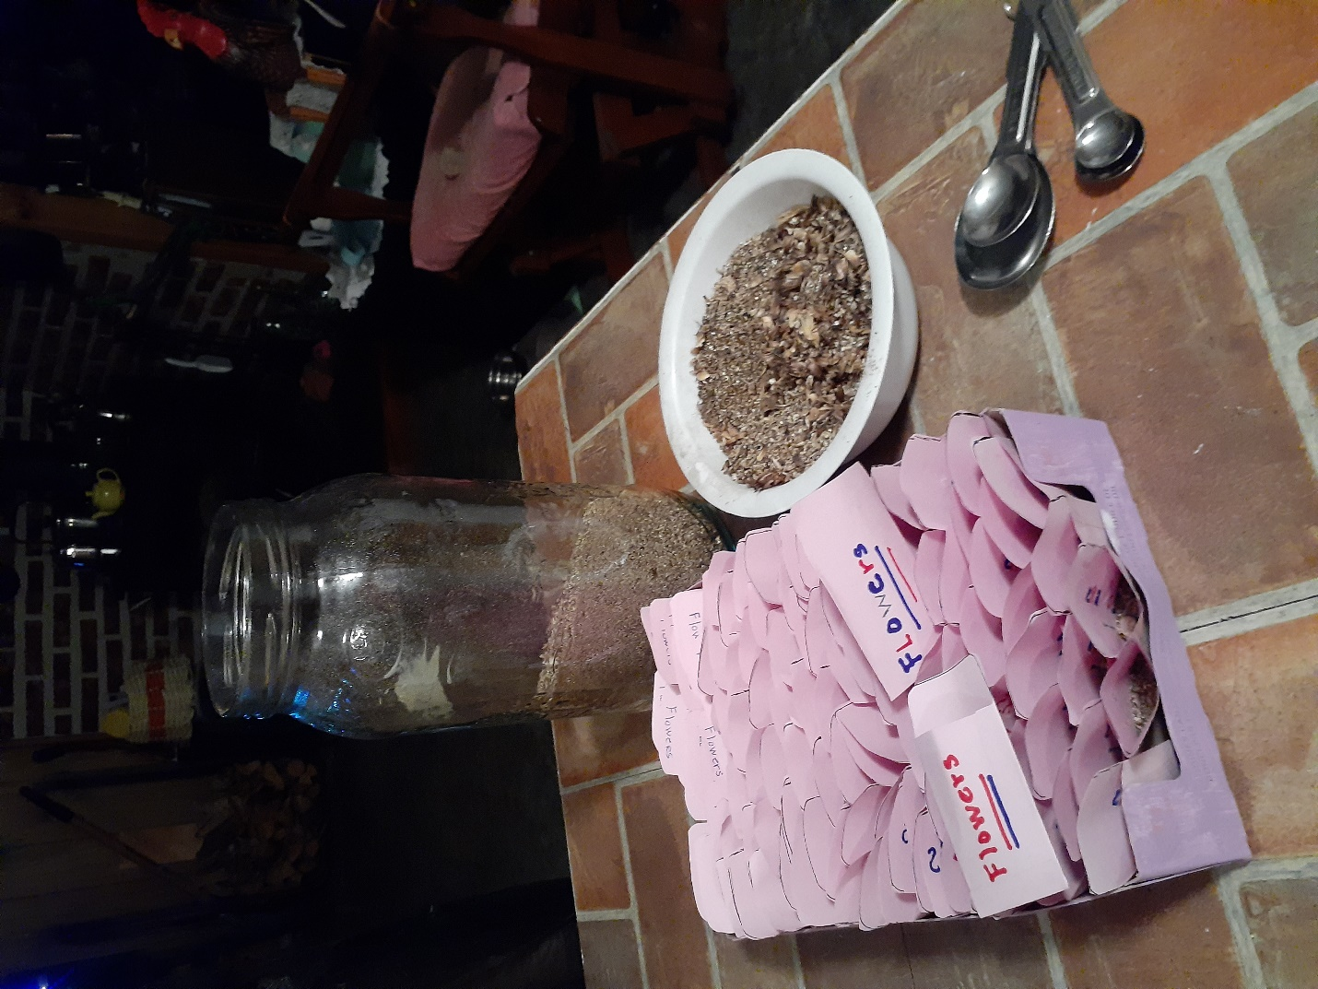
Pinwheels
I still had the supplies for pinwheels that we made at the Eco Conference at St. Marks in Halifax around September 2019. (Yes, I do horde craft supplies). After all, I am just USING UP supplies, or not wasting what was prepared for another event. So I thought I might make a few pinwheels for Earth Day or Rogation Day.
You will need
Paper
An old eraser cut into small pieces
Stickpins
A sheet of newspaper or flyers.
First, make your wand for the pinwheel. Take a whole sheet of newspaper or flyer and starting at one corner roll the paper around a pencil. Some may remember when we did the same thing to make newspaper fire starters. Loosen your paper a bit and let the pencil roll out. Tape the rolled newspaper and put it aside.
Get a square of paper. Remember we can make a letter-size sheet of paper into a square by folding the lower right corner of your paper over to the left side. Crease and cut off the excess
Fold the square the opposite way so the two creases make four sections on the paper.
Mark about an inch out on each crease from the center and cut from the outside into that mark near the center
Cut an eraser into small pieces, three for each pinwheel
Put the pin through one bit of the eraser to make a spacer. Holding your left thumb (or right thumb if left-handed) into the center of your paper, place the right hand corner of each triangle of paper into the middle and push the pin through all wings and the middle of the paper adding another piece of eraser back of the pinwheel loosely.
Push the pin through the newspaper wand and add another bit of eraser.
Now if you are overprotective like Grandma you push the pin through the last eraser bit and take pliers to bend it downward.
Find different materials to make your pinwheels like 2 inch brass brads.
Could you make the pinwheel from the flyer paper? What happens if you use Bristol board? What else could be used for the wand? How could we decorate the pinwheel to make colours swirl? All fun things to do anytime.


Something to Eat
Once upon a time Grandma had 4 teenagers in the house. They had BIG appetites and were always hungry; like 10 minutes after supper hungry. One thing they really liked for snacks were cheese patties. Grandma called them cheese patties and the 4 hungry teenagers nodded their heads and reached for seconds. They were really baked veggie patties that went in the oven with supper and made nutritious snacks.
Cheese (Veggie) Patties
In a food processer, blender or with a hand grater, grate
Potato
Carrot
Onion
Zucchini (frozen, thawed hours before or grated fresh)
Parsley
1 cup grated or powdered cheese. (Sometimes Parmesan or Feta or Cheddar)
1 cup flour
Italian Seasoning
Peel and grate all the veggies and sit them in a sieve to drain. You want them dry. If you use salt, sprinkle a little over the veggies and let them drain awhile. Yes, your potatoes turn brown, it won’t matter.
In a second bowl add flour, cheese and other dry ingredients
Mix the two bowls together and form into patties.
I like parchment paper and bake them at 350 for 20 minutes, turn over and bake another 15 minutes.
The secret is to make the flavour strong enough of a taste they think cheese instead of veggies. One winter I made these almost every second night and they disappeared. Baked patties can go in a burger bun or just eaten like a cookie.


