April 12, 2022
Email: HYPERLINK "about:blank" endionspei@gmail.com Website: HYPERLINK "about:blank" nspeidiocese.ca/den
Facebook: HYPERLINK "about:blank" Environment Network Diocese of NS & PEI

Click here to listen to song: https://www.youtube.com/watch?v=1HW5Yqsrduw

Click here to listen to song in full and download score: https://therealgroup.se/news/2019/12/13/resolution2020


​An exciting announcement at Christ Church as we announce a new partnership of ministry with the Diocesan Environmental Network (DEN). Christ Church will be the setting for a new ministry called the "Climate Cafe." Nancy Blair who has preached about climate change and crisis this past fall will be leading this ministry. Please see this link for more information and a video:
https://www.christchurchdartmouth.com/climate-cafe.html

We are called by God to be good stewards of Creation.
Join us for weekly prayer in solidarity and renewal of our baptismal covenant:
“To strive to safeguard the integrity of creation and sustain and renew the life of the earth.”
Email endionspei@gmail.com for zoom link

Preserving the Forests we call home – Growing Forests is a new investment opportunity designed to preserve regional woodlots through acquisition and sustainable management.
Growing Forests is launching a start-up investment round as a qualified Community Economic Development Investment Fund (CEDIF) The project offers woodlot owners an alternative to clearcutting when they are ready to sell their woodlots. And it offers the rest of us an opportunity to help make that possible.
The concept behind Growing Forests ticks all the boxes of climate solutions, local economic development, the multiple environmental benefits of truly sustainable forestry and keeping woodlands owned and benefiting Nova Scotians for the long term.
Please email dale@growingforests.ca for more information and for the Offering Document. You can also download the information and learn more about the project at https://www.growingforests.ca
The Offering has been extended to June 28th. Dale has agreed to meet with us on a DEN Thursday gathering, May 26th, to explain this in more detail.

With thanks to Rev. Charles Bull who has written this Climate Prayer to use for Earth Day, Season of Creation or a time(s) of your choosing:

Holy God,
whose Spirit breathes in the life of our planet:
we turn to you
in this time of climate change and ecological collapse.

We are sorry for the harm we have done to the earth,
and we humbly ask your forgiveness.
Help us to see with clear eyes
how the wonders of human progress
are causing the desolation of your living world.

Give us grace to renounce the systems of power and profit
that corrupt and destroy your creation.
Give us courage and compassion,
as we confront those who uphold them.

Bring healing to our hearts
that we may know and love all living things
as our own relations.
May we gratefully acknowledge our dependence on them,
and have the wisdom and fortitude
to live within our means,
as members of the earth community.

And in the power of your Spirit,
mobilize us with a realistic hope
for the future to which you call us.
In Jesus Christ we pray.
Amen.

Bruce Langhus has sent us a new link for the book club:
Join Zoom Meeting
https://us02web.zoom.us/j/81934683153?pwd=Tjg5Z2tSbG91dlhUYVBLenkzZWFlQT09

Meeting ID: 819 3468 3153
Passcode: 997372
Thank you to Eva Evans for alerting us to this podcast:
What On Earth with Laura Lynch - April 10, 2022: Do Ottawa's actions speak louder than its words?

https://www.cbc.ca/listen/live-radio/1-429/clip/15905819

Green Story - CO2 Collectors

Grandma totally disliked Chemistry in school. I mean 1997, High School Chemistry. (Grandma went back to High School and university when her kids were in school.) All those molecules! I still hear my chemistry teacher saying, “What goes into the oven comes out of the oven, just in a different form.”

I may have disliked it, but, I learned it. It is stuck in my brain and as soon as someone talks about putting this and that together, I see chemical components.

I will never be, nor wish to be, a rocket scientist. What I learned this week made me understand jet fuel better. I mean really, who bothers to learn about jet fuel?

It all started with an article on carbon emissions. There were stats about how much carbon was released into the atmosphere.

We all know carbon dioxide is a cause of greenhouse gases, climate warming, icebergs melting, and the list goes on.

So WHAT IF, we could find a use for all that carbon dioxide and turn it into a product?

Just gather CO2 and use it to make something.

Hopefully, that something won’t do any more harm to the planet. This is where I get a bit leery.

The idea is to use CO2 to make hydrogen which is the main component in jet fuel.

Up come the molecule components in my brain, and yeah, it is possible. Actually kind of simple under the right conditions.

My point is, are jet planes flying around the world a good thing? I guess until we can get personal transporters we will be using jets although Covid taught us to work remotely.

I want to know what else we could use CO2 for besides jet fuel.

They call it carbon capture and utilization here. I like the term,
https://www.vox.com/energy-and-environment/2019/11/13/20839531/climate-change-industry-co2-carbon-capture-utilization-storage-ccu

Some machines pull CO2 out of the air. Look at this
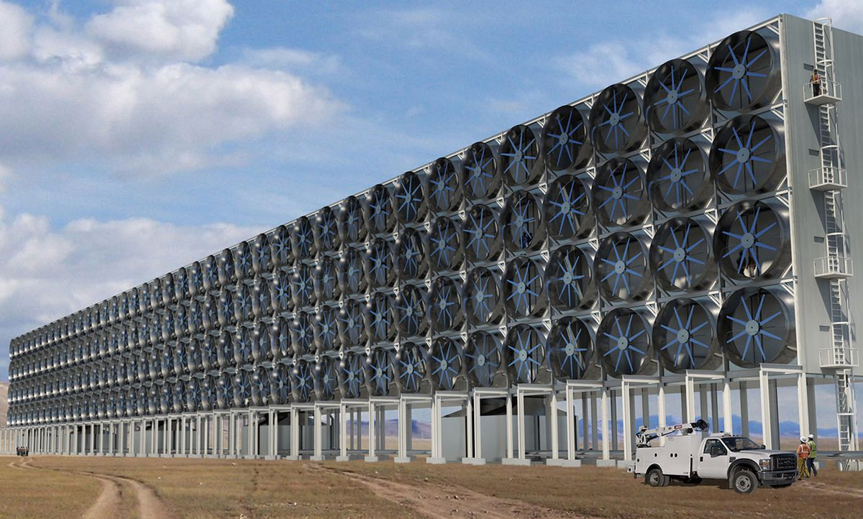

This shows more products
https://www.greenbiz.com/article/5-surprising-products-companies-are-making-carbon-dioxide

I always wonder why this stuff isn’t on the front page of newspapers? Why isn’t it on the TV News channels?

I hate to say it, but, I think it isn’t known because it is a SOLUTION. News stories want stories where there is a PROBLEM. Something they can say “Oh, poor you. Our planet is doomed. There is nothing we can do!” Rubbish! Total Rubbish! (in an environmentally sustainable way)

I admit that probably someone made that CO2 collector because they saw a way to make a product to sell, to make MONEY. Then it was worth building and calling it saving the planet. Let people laud how much good they are doing for the environment.

I don’t care. It is because we stand as protectors of this planet that we should clap our hands and praise them to the mountain tops. Whatever the reason, CO2 collectors will do good. Now I need to go learn more about these machines. Thanks be.

Gardening
For those that use the large litre or gallon water bottles, it is time to start saving them. Cut off the bottom and put them over the transplants when you set them out; just in case there might be a frost.

It is also time to start working at getting ONE box garden ready so you can plant your peas and potatoes in April

Craft
Ever wonder how Grandma keeps finding crafts for you to try? Most times it is something I had done before with my kids or my Guide group when younger. Sometimes I find something new on the internet and do it myself to show you. Then sometimes it is a bit of both.

My daughter made friendship bracelets when she was young. I loved them! They were so simple but one type looked like a zipper. I went looking on the internet and sure enough, I found zipper weaving.

They were making a key fob, weaving yarn tied to a key ring, but the same weaving. I copied what they were doing and took a picture of it.

If you ever see a craft that looks fun to do, tell Grandma at claudiaazinck@gmail.com

You need two different colours of yarn, about the same weight. I cut them about a yard long.

Find the middle of each string and loop it through the key circle, drawing the string up through the loop.

Take the right strand of wool, pass it over the middle two strands, and put it behind the two strands and up in the hole between the first and the middle two strands. Do the same to the left-hand strand of yarn. Repeat. Tie it off at the end to make bracelets.

It is easier to see in a video
https://www.youtube.com/watch?v=6dwHqofl0-0
Or a bunch of ways to braid
https://www.youtube.com/watch?v=Qrn01JeAnQk

Something to eat - Sheet Cakes
Again, “when I was a kid”, my mother’s and her sisters got together some Sundays. The sheet cake was transported in the car, still in the pan, toothpicks on top and carefully placed between two brown paper bags resting on the back seat shelf of the car. It was a way to feed husbands and kids a snack so both would go off and leave the “girls” to talk.
Including my recipe for “Cookie Pan Brownies” that we loved. Especially with a Boiled Icing.
Cookie Pan Brownies
1 cup butter (if you have any older cream, sour cream, cream cheese or cottage cheese, add it in and add a little extra of everything else)
½ cup cocoa
1 cup sugar (some prefer 2 cups but it is good with one cup)
4 eggs (if you have them, 2 eggs will work)
2 tsp vanilla
1 tsp baking soda
Mix it up and spread it on a well-greased cookie sheet or put parchment paper on a pan. Takes about 25 minutes to bake at 350F
My Mom use to add walnuts to her batter

Regular Chocolate Frosting
¼ cup shortening
¼ cup milk
¼ cup cocoa
3 cups icing sugar. Mix up and spread.

Boiled icing, In a pot combine
1 cup sugar
1/3 cup water
1 tbsp. corn syrup
Vanilla and a dash of salt
Boil this for a few minutes, then pour over a couple of egg whites waiting in a side bowl and mix. Some people add a couple of tablespoons of icing sugar but I like the glossy icing. As it is still runny, pour over the cooled sheet cake, allowing it to spread to all corners. It will harden in a few minutes.

Picture Grandma this weekend putting together the planting kits. The lawnmower comes out of the shed and the folding table is set up. Everything is laid out. Hopefully, a few neighbours may drop by but it never takes too long to put the kits together.

AND THEN, Grandma thought, what other kinds of sheet cakes can we make, hmm………
I have pumpkin in the freezer
https://www.thepioneerwoman.com/food-cooking/recipes/a11885/pumpkin-sheet-cake/
The Pineapple zucchini looked good
https://www.thepioneerwoman.com/food-cooking/recipes/a11628/stop-the-presses/
Grandma sort of over-bought peanut butter last year
https://www.thepioneerwoman.com/food-cooking/recipes/a11398/peanut-butter-cake-with-chocolate-icing/
Can’t stop without showing a lemon cake version
https://www.howsweeteats.com/2018/02/lemon-sheet-cake/
Remember service work. There always is a neighbour close enough that will help with the extra cake. I have quite a few that have learned I can’t cook small.

Yes, I have to make one this weekend if time allows.
Till next week, Grandma is sending hugs
claudiaazinck@gmail.com

Do Not Romanticise Reality
God of Creation, God of Compassion,
Help us not to romanticise reality, But look it straight in the eye,
So that we may behold the climate chaos that many now endure
And many more will endure.

God of Creation, God of Compassion, Help us not to retreat into denialism,
Living in our panelled houses Whilst the temple of your world is in ruins.
Help us to see that Climate breakdown acts as a threat multiplier.

As Conflicts Increase, Food supplies fail, Climate grief increases,
Locusts swarm, Icebergs melt, Seas acidify, Extinctions multiply,
Children go hungry, Floods and Fires wreck the land
And Humanity faces an existential threat.

This is not the way it was meant to be, Lord have mercy.

God of Creation, God of Compassion, Let us not look away
But help us to lament And grieve And know that the kingdom of your Son is Calling.

God of Creation…Help us not to romanticise reality But to look it in the eye,
That we would be those committed To justice and peace.

God of Creation… Help us, like your Son, to speak truth to those corrupted by power.
Help us, like your Son, To stand up for the oppressed.
God of Creation, God of Compassion, Help us not to romanticise reality.
We ask that, as our hearts break, We may rest in your extravagant love And Holy embrace.
We thank you that whatever befalls We can bathe in your kindness And receive your healing. God of Creation, God of Compassion, Help us not to romanticise reality. But let us also know that hope is on the way, For your son will transform reality. There is not a hurt he will not heal. Maranatha, Come, Lord Jesus! Amen

https://static1.squarespace.com/static/51c038a6e4b0cf320a60969d/t/6092d29fd463680112ed85c7/1620234923937/Prayers+for+the+Climate+and+Ecological+Emergency.pdf



