March 15, 2022
Email: HYPERLINK "about:blank" endionspei@gmail.com Website: HYPERLINK "about:blank" nspeidiocese.ca/den
Facebook: HYPERLINK "about:blank" Environment Network Diocese of NS & PEI

To celebrate DEN’s 10th Anniversary
we are inviting you to join us in a
Global Movement to Sing for the Earth

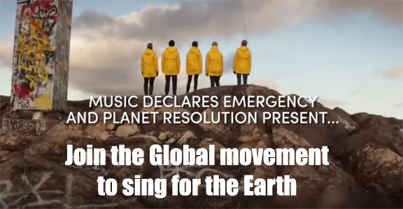

DEN is inviting everyone to join together to sing the Resolution Song. Have your choir or your faith community and your friends sing together, record it and send it to us.

We will compile it into one video to be released for Earth Day, April 22, 2022.

A video of the song can be found here https://www.youtube.com/watch?v=1HW5Yqsrduw

For other versions, search #resolution Song

Here is the link to the score background and another video:

https://therealgroup.se/news/2019/12/13/resolution2020

Grandma’s Going Green says – “We have so many green stories right here. Let’s get the word out so everyone thinks (in 10 years) DEN is the greatest environment group around.” Send us your good news and green stories and we will make sure to highlight them here! Thanks Grandma for the great idea!



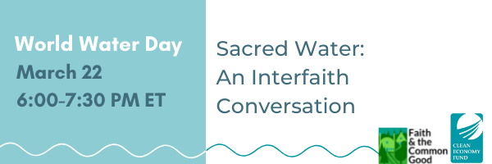
Join Faith & the Common Good on World Water Day, March 22, for Sacred Water: An Interfaith Conversation, to learn about what diverse faith and spiritual traditions have to teach us concerning the importance of water and how we can deepen our connection with it. Sacred Water is the second webinar in our Climate Narratives webinar series to raise awareness around faith-based responses to environmental issues. We aim to create a space for values-centred conversations and to highlight the contributions of faith-based groups working to build more resilient communities.
RSVP today to receive Zoom information! csidhu@faithcommongood.org

Day of Action for a Just Transition in Moncton, NB - NEW RAIN DELAY DATE Saturday, Mar. 19, 12:00 PM
At the office of Liberal MP Ginette Petitpas Taylor
272 St. George St. #110
Moncton, New Brunswick, E1C1W5, Canada

Justin Trudeau promised a Just Transition Act nearly 3 years ago. However he has been all talk and no action. A Just Transition will take strong action on the climate emergency while creating millions of good, green jobs in a way that is fair, inclusive and leaving no one behind. Join us on Saturday March 12 at noon as we rally in Moncton at the office of MP Ginette Petitpas Taylor to demand immediate action to build a bold Just Transition to a safe and fair green economy!

"Two crises, one root: conflict, climate emergency, and LNG."
Germany - Europe's largest gas consumer and trader - is looking for ways to cut loose from its dependency on Russian fossil fuels. On several fronts, fossil fuel cheerleaders in Canada are using the need to interrupt Russia’s power as justification for pushing new Canadian fossil fuel infrastructure and exports. Corporations and political parties are seizing the war on Ukraine as their opportunity to bring in policy measures and financial support for the declining fossil fuel industry.
This is the Shock Doctrine at work: corporations and their lobbyists are using this crisis to ram through policies and decisions they already had on their wish lists.
Fossil fuel projects that will be years in the making will not affect this current war, but increasing liquified natural gas (LNG) exports, or any new fossil fuel infrastructure, will only worsen our looming climate crisis. Now is the time to invest rapidly in a just transition away from fossil fuels, both to address the climate crisis and to loosen the grip of oil and gas producing nations on global security.
Register Here to join this webinar on Wednesday, March 23rd 2 pm Atlantic
Speakers will challenge the Canadian and German government’s false narrative that LNG can be a climate and security solution, and will argue that Germany and Canada must not make the mistake of buying into this narrative.
Join long-time campaigners Robin Tress (Council of Canadians), Sascha Boden (Environmental Action Germany), Andy Gheorghiu (European freelance climate campaigner) and facilitator Cat Abreu (Destination Zero) for a conversation about what the current war in Ukraine means for climate action, and what climate justice movements are doing to stop fossil fuel expansion and build a just transition towards a decarbonized future amidst the conflict. * The webinar will be in English only, due to logistical constraints.

We are called by God to be good stewards of Creation.
Join us for weekly prayer in solidarity and renewal of our baptismal covenant:
“To strive to safeguard the integrity of creation and sustain and renew the life of the earth.”

Preserving the Forests we call home – We wanted to share good news we received about Growing Forests, a new investment opportunity designed to preserve regional woodlots through acquisition and sustainable management.

Growing Forests is launching a start-up investment round as a qualified Community Economic Development Investment Fund (CEDIF) The project offers woodlot owners an alternative to clearcutting when they are ready to sell their woodlots. And it offers the rest of us an opportunity to help make that possible.
The concept behind Growing Forests ticks all the boxes of climate solutions, local economic development, the multiple environmental benefits of truly sustainable forestry and keeping woodlands owned and benefiting Nova Scotians for the long term.
DEN can send you the information sheet we received which provides more detailed information or you can download the information and learn more about the project at https://www.growingforests.ca

"Still Hopeful - Lessons from a Lifetime of Activism" a new book by Maude Barlow.
If ever you get discouraged about the state of things or the lack of support for some of the issues we are working on, take a moment, and listen to Maude's podcast in the link below. It's so uplifting and reinforces that what we do is exactly what we should be doing because taking action is "the right thing to do!"
https://www.cbc.ca/listen/live-radio/1-57-the-sunday-magazine/clip/15898878-maude-barlow-reflects-lifetime-activism-keys-giving

Bumble Bee Watch eNews – Check out this great resource to identify bees and to learn photography tips.
https://myemail.constantcontact.com/Bumble-Bee-Watch-eNews.html?soid=1102968923571&aid=relkc_6wzVA

Based on the above Lenten Resource, Ecogrief and Creation Hope, join us for tonight for the second of 6 sessions exploring deep changes in our world and our anxiety about these changes.
We will look at the Bible to provide some guidance in our struggles, recognizing that the Biblical text is acquainted with our griefs and our anxieties The Bible is a book with stories about climate crisis, creational breakdown, and the challenge of hope in bleak times. This curriculum seeks to draw on that ancient wisdom and re-engage with our love for God’s creation and all of God’s creatures
The entire curriculum is to be found here: https://www.toronto.anglican.ca/wp-content/uploads/2022/02/LentCurriculum2022.pdf
Every Tuesday night in Lent, starting at 7pm. All are welcome. Join us by Zoom:
https://us02web.zoom.us/j/81991962887?pwd=YXI3UjZWRXRvWWErcktCQnN3S3puQT09.
Discussion Questions for this week:
1 Think on the news of Ukraine in the past 3 weeks. What combination of grief and loss do you have? What has been lost to you?
2 If you can imagine God grieving the loss of that place as well, discuss how this this changes or deepens your understanding of the Creator. Does God mourn the loss of the mammoth?

3 Share or reflect on how your sadness and grief makes you feel. Does it make you want to give up? Does it make you angry? Does it make you want to do more to preserve other places and other beings? Does the Flood story provide any comfort to you as you think about your grief?

4 God decides to exterminate humanity because of a design flaw; how does this affect God? Did the Flood remove the flaw?

Petition from Environmental Defence to Limit Emissions from Oil and Gas Companies
Oil and gas companies are Canada’s worst climate culprits - producing more emissions than any other sector in the country. Even amid the climate crisis, they have big plans to increase fossil fuel production, and they're fighting tooth and nail to kill a promising new federal policy that's in the works to cap emissions from the oil and gas sector. If the federal government bends to their demands, Canada will remain one of the worst contributors to global warming. It’s time to tell the federal government that we support a strong oil and gas emissions cap - and they should too.
Reverse the trend (regulatecarads.com)
25% of Canada's greenhouse gas emissions are from the transportation sector. Our country has committed to 100% zero-emission vehicle sales by 2035, and yet we have no regulations to govern advertising on gas-powered cars. There are no requirements for ads to display a vehicle’s fuel consumption or GHG emissions, and no standard for protecting nature and the environment. This petition asks our government to restrict and tighten automobile advertising and its policies. If we are to make this move together and follow through with our climate goals, than we need to reverse the trend on automotive advertising.
Cambodia: Ten years in prison for protecting nature? Release them NOW! - Rainforest Rescue (rainforest-rescue.org)
Six members of the Mother Nature Cambodia environmental movement have been imprisoned for peacefully campaigning to protect and preserve Tamok lake. The Tamok lake and wetlands are one of the last extensive landscapes near the capital of Cambodia. The area provides a habitat for many bird species, more than 300 families rely on the lake for their livelihoods, and it is a natural flood protection area that helps millions of people during heavy rains. This area was placed under protection in 2016, but since then it has been handed over to private investors seeking to “develop” the area. Intimidation and persecution of activists has increased dramatically in recent years. This petition hopes to secure these environmental defender’s release and to show the world stands with those who protect it.
Take Action - Canada - Last of the Right Whales
This petition is asking our Prime Minster to protect the North Atlantic right whales. These are less than 360 left, these whales are one of the most endangered whales in the world. Fishing gear and collisions with vessels are the leading causes of death. Nearly 86% of right whales have been entangled in fishing gear at least once in their lives. More needs to be done to ensure this species has a chance to recover and to survive, and we can encourage our government to do what is right for the North Atlantic right whales.
petition: These 20 corporations are responsible for most of the world's plastic waste. They must switch to sustainable alternatives now! (thepetitionsite.com)
The vast majority of plastic waste is being created by just 20 companies. Around the world, these corporations are involved in either producing fossil fuels or chemicals or both. Plastic is made of oil and gas, creating plastic means a continuation of the reliance on fossil fuels. Experts are anticipating that nearly 10% of global greenhouse gas emissions will come from plastics within the next 30 years. We do not have to go this route but can instead demand these companies use eco-friendly, biodegradable options instead.
For anyone living in HRM: HalifACT – Acting on Climate Together
Climate change is a looming worry for anyone who cares about God’s creation and the world our grandchildren are inheriting. One way to reduce the anxiety is by doing something concrete about it, and here is a simple thing anyone living in HRM can do. On March 23 Halifax Regional Council will be voting on whether to fully fund a program called HalifACT. This program, two years in the making, is HRM’s comprehensive response to climate change, by reducing carbon emissions and by adapting to the changes that are coming. Two years ago, council passed HalifACT unanimously, but then they didn’t fund it!
Now is our chance to see that this urgently needed program receives the funding it needs. We can make a difference by urging our municipal councillors to do what it takes to fully fund HalifACT now. Call and leave a telephone message or better yet, drop an email. It doesn’t have to be long. If you email, CC Mayor Savage and the Clerk’s Office, so your message will be officially recorded, and all the councillors will see it.
Questions? Everything you need to know can be found at https://ecologyaction.ca/tell-your-councillor-fund-climate-action-now
Here you can find links to contact details and to a nifty two pager all about HalifACT.
N.B. The meeting is Wednesday March 23.
Every letter has a big impact. Together we can make a difference!

Green Story
We need local green stories. Please don’t try to tell me that there is little to talk about around here. I know the stories are close by. I want to hear about PEI and NS green stories.
They are all around us.
For example, any 4-H project reeks of “environmental” news.
In PEI, there is a website just for 4-H events. Check it out at https://shoutout.wix.com/so/09NvjRLZN?languageTag=en#/main

You know Grandma loves PEI so let her know when events are planned. She just might visit. Did you know there is a coalition for the Protection of PEI water?

https://peiwater.com/category/events/
Did you know there is a Great NS Clean-Up Event? I want to organize that another year. Get info at https://shoutout.wix.com/so/09NvjRLZN?languageTag=en#/main
Planet Friendly has a listing of NS Events
http://www.planetfriendly.net/calendar/?list=environmental-events-in-nova-scotia
Somewhere someone may be having a flea market or bake sale to get funding for their green club or project. Let us know! Please!

We have so many green stories right here. Let’s get the word out so everyone thinks (in 10 years) DEN is the greatest environment group around.

Homemade Cleaner.
Does anyone else have dirty looking grouts around their tiles?
½ cup baking soda
¼ cup hydrogen peroxide
1 tsp. dish soap
Mix and brush into grout indents. Let it sit maybe half an hour, more if you get busy. Scrub with a brush and rinse. Much whiter and costs so little

Craft - Milk Jug Planters
Might be time to save a couple of milk jugs. Just two milk jugs are enough to keep Nana and I in lettuce for the summer.
Cut part of the jug away leaving a good high “pot” with two ears sticking up and the handle intact.
The handle becomes a tail and a good way to move the jugs around
The main part of the jug is your planter. Put a few slashes or holes in the bottom.
Draw a few marks to shape ears and a few squiggles for a nose. Draw big eyes and eyelashes so it looks like a kitty cat or bunny sleeping
These could be put on a doorstep. If lettuce was the only thing growing in the summer, at least there was a mini garden helping the environment.
Here is a gaggle of milk jug planters waiting to go to Planting night in 2018.
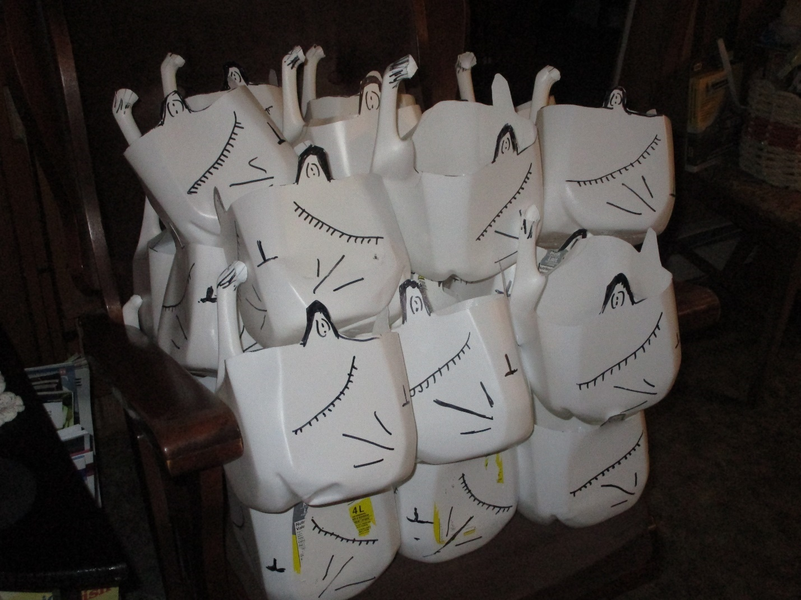

Something to eat
It may be hard to imagine Grandma had extra cottage cheese and egg whites in the house. As you may have guessed, Grandma hates to waste anything. You can freeze cottage cheese and those boxes of egg whites but luckily her freezers are full so I needed to find something to use them up. I remembered my grandmother who always had “curds” in her fridge. I hunted down the recipe and had such fun making her buns. My Grandma would add extra sugar and a bit of cinnamon. These are the type of bun that you can open the dough and put a bit of jam inside BEFORE you bake them

Quick Cottage Cheese Buns (Curd Buns to my family)
1 ½ cups cottage cheese (a bit less than a pint-size container)
4 eggs (I used 2 and 1/3 of a box of egg whites)
½ tsp vanilla extract (Oops, I forgot that)
¼ cup sugar
½ tsp baking powder
1 tsp baking soda
½ tsp vinegar
Get a bowl out and mix the cottage cheese, eggs, sugar and vanilla
In a small dish, mix baking soda and vinegar and add to the mixture
Add flour and baking powder next
It will be sticky and a bit hard to work. The recipe said to cut it into 24 pieces, shape it into balls and bake for 20 minutes. I made about 15 balls and baked them.
Oh yes, this will be repeated.

Grandma is signing off for this week. Let me know if you try something and how it turned out. My website is under construction so for the time being write Carole at the DEN email or myself at claudiaazinck@gmail.com.
Till next week, Grandma is sending hugs



