March 01, 2022
Email: HYPERLINK "about:blank" endionspei@gmail.com Website: HYPERLINK "about:blank" nspeidiocese.ca/den
Facebook: HYPERLINK "about:blank" Environment Network Diocese of NS & PEI



Thanks to those who shared their ideas and passion with us at our first Strategic Doing session. Now we need to use that conversation as a base to build on to make DEN the best possible example of stewardship and living out our mission:
"To strive to safeguard the integrity of creation and sustain and renew the life of the earth."

Join us as we continue the conversation on ways to support, encourage and serve people, parishes and organizations in their efforts to care for the planet through prayer, education and action.

Thursday, March 10, 2022 at 7 pm.

Please feel free to invite others.
Zoom link: https://us02web.zoom.us/j/88965401267?pwd=b3lpZXl3am14S0JPbWZMYjJlT1R2QT09

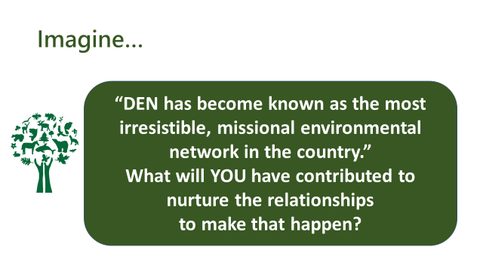


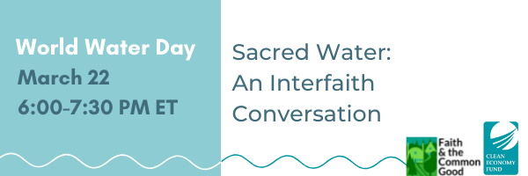
Join Faith & the Common Good on World Water Day, March 22, for Sacred Water: An Interfaith Conversation, to learn about what diverse faith and spiritual traditions have to teach us concerning the importance of water and how we can deepen our connection with it. Sacred Water is the second webinar in our Climate Narratives webinar series to raise awareness around faith-based responses to environmental issues. We aim to create a space for values-centred conversations and to highlight the contributions of faith-based groups working to build more resilient communities.
RSVP today to receive Zoom information! csidhu@faithcommongood.org

Diversity and Equity Committee (DEC) Conversation Series – Panel Discussion on:

Climate Justice is Social Justice: Paradigm Shift to an
Anti-Colonial Ecosocial Worldview
THURSDAY, MARCH 3, 2022 | 5:30 PM - 8:00 PM (Atlantic Time)

Contact swdec@dal.ca for Zoom link



https://mailchi.mp/canadainvasives/nisaw2022webinars?e=cd538931a1



Will you join us for the discussion on where our movement goes from here?
Date: Tuesday, March 1
Time: 4pm PT / 5pm MT / 6pm CT / 7pm ET / 8pm AT / 8:30pm NT
Where: On Zoom
We are called by God to be good stewards of Creation.
Join us for weekly prayer in solidarity and renewal of our baptismal covenant:
“To strive to safeguard the integrity of creation and sustain and renew the life of the earth.”

 | 
  This faith-in-action campaign raises awareness about climate change and mobilizes people across Canada to reduce household greenhouse gas emissions, engage in learning and relationship building, and collect signatures as a demonstration of support for increased federal climate action.
  Publicize the campaign in your faith community, encourage dialogue about reconciliation and climate justice, and collect campaign letters
  Please contact Karri [karri@cpj.ca] with any questions about the campaign

Wisdom of the Elders

Join Indigenous Ministers Tony and John Snow for the 2022 Indigenous Lenten Series to explore traditional teachings and discern our calling during these challenging times.

Register to receive the Zoom link via email.

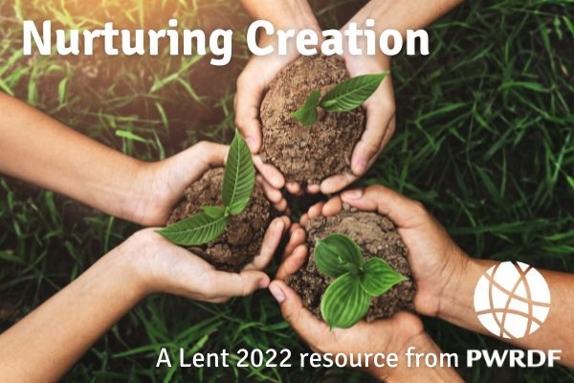 | Creation Care: Climate Action  Each day the writers invite you to read a selected scripture, reflect on it and pray with them.  Learn more about this resource:  pwrdf.org/Lent2022  Subscribe to receive your daily reflection

NEW Resource for Lent 2022: “Ecological Grief and Creational Hope – A Lent Curriculum for All Ages”
Ecological Grief and Creational Hope (full colour PDF)
This six-week resource explores the biblical themes of creation’s groaning and lament as well as its hope for redemption. Each week includes a Scripture passage with questions for reflection and discussion, prayers, suggested activities and action ideas, as well as links to explore further. The questions and activities can be adapted for individual, family, group, or parish use, with specific suggestions for children and youth.
https://www.toronto.anglican.ca/diocesan-life/social-justice-advocacy/creation-care/

Based on the above Lenten Resource, Ecogrief and Creation Hope, join us for 6 sessions exploring deep changes in our world and our anxiety about these changes.
The entire curriculum is to be found here: https://www.toronto.anglican.ca/wp-content/uploads/2022/02/LentCurriculum2022.pdf
Every Tuesday night in Lent, starting at 7pm. All are welcome. Join us by Zoom:
https://us02web.zoom.us/j/81991962887?pwd=YXI3UjZWRXRvWWErcktCQnN3S3puQT09

February 23rd Green Burial Café Notes
Here are some resources and key points from the last Green Burial Café sent to us by Green Burial NS.
- How to Guide for Natural Cemetery in Nova Scotia, written by GBNS members: https://deathmatters.ca/services/green-burial-nova-scotia/how-to-guide/
- To find a speaker on Green Burial or to register as a speaker, visit the Green Burial Council's page for the Speakers Bureau: https://www.greenburialcouncil.org/speakers_bureau.html
- Last Dance Shrouds' website as example of shrouds: https://www.lastdanceshrouds.com/
- For resources on home funeral and after-death body care information, visit the National Home Funeral Alliances' website: https://www.homefuneralalliance.org/

petition: Tell Canada to step in and protect Ontario's threatened caribou (thepetitionsite.com)
Threatened caribou habitat is being cleared in northern Ontario. The provincial government is pushing ahead with logging and mining, and choosing to rewrite laws that favour developers over the legal protections of vulnerable wildlife, including the boreal caribou. For years Ontario has not protected caribou habitat under the Species At Risk Act, another extension date has just passed and now it is time for Canadians to insist that the federal government ensure protection laws are met!
Amnesty International USA | Amnesty International USA (amnestyusa.org)
Around the world, Indigenous leaders are standing up to protect the unique biodiversity and nature of their areas. Bernardo Caal Xol is one of these leaders in Guatemala. By trying to protect a sacred river from development, he ended up arrested, threatened, and punished. He has been sentenced to over 7 years in prison for speaking out against the destruction of the river. We have a chance to help him, his family, the community, and the environment by signing Amnesty International’s letter and petition asking to free him.
REDUCE & REUSE | Greenpeace Canada
Greenpeace is asking us to tell our Minister of the Environment and Climate Change that reduction and reuse are the keys for Canada’s zero plastic waste strategy. Globally over the last 70 years, the plastics industry has only been able to recycle 9% of the plastic produced. Reducing at source, reusing, and having a wider ban on non-essential single-use plastics is what will make a dent in the issues our world faces today. Our federal government announced a long-awaited list of single-use plastics to be banned, but it only included six items. We need bold action that is free from industries reach in order to transition to a circular and zero waste economy. Sign your name to have a say in supporting this movement and direction!
Info for HRM residents
The Ecology Action Centre tell us that Halifax Regional Council is making decisions right now about this year’s budget. We need your help telling them to spend what's needed to protect our communities from the climate emergency. We already have an ambitious climate action plan called HalifACT, now we need to make sure it gets funded!⁠ Contact your councillor now, or if you’d like some coaching and support on how to express what you want to say, register below for our free online letter writing workshop - coming up on Wednesday, March 2
Recently Trans Mountain revealed the new cost of its pipeline expansion — $21.4 billion. That’s almost TRIPLE the price it was when Trudeau first bought it. The federal government says despite the project’s cost hike, they won’t spend any more public money to complete it. They’re turning to banks or private lenders instead. This is a huge win. First, it means that together we’ve made it politically impossible to keep throwing public money at Trans Mountain. And second, the government’s plan to find outside funding means people like you and me will have more power over this project’s future.

Growth
Every week Grandma goes looking for something new to tell you about, in the world of Environment. Then comes the week when nothing inspires me
I did read about the tides getting higher in PEI, be it through erosion or ocean warming. It needs more study.
Everything was kind of BLAH this week. That may be a good thing.
Sometimes we get caught up in finding something “new”, we forget all the “good” in what we already have.
“Old” can be VERY good.
DEN is 10 years old. I remember that first night Rev. Marian asked me to come into Messy Church and teach the children to plant. She was telling me about this new group Bishop Sue wanted her to lead. It was the same year Grandmas Going Green started. Few were concerned about the environment, but we all knew it would become a central focus in years to come.
I looked at our church Annual Session last week and thought “We are all older, now.” Those old folks are the ones keeping our church doors open and encouraging the younger ones so interested in the environment.
Maybe the conversation now includes “environment” come Sunday morning. If so, the “environment” is in good company.
If you should need a bit of hope in all this “older” doom and gloom, I have something to cheer you up. Here are Paityn and Cameron Gates cutting out and gluing 300 seed packets for the Parish Planting kits. Photo courtesy of proud Momma, Amanda Gates.
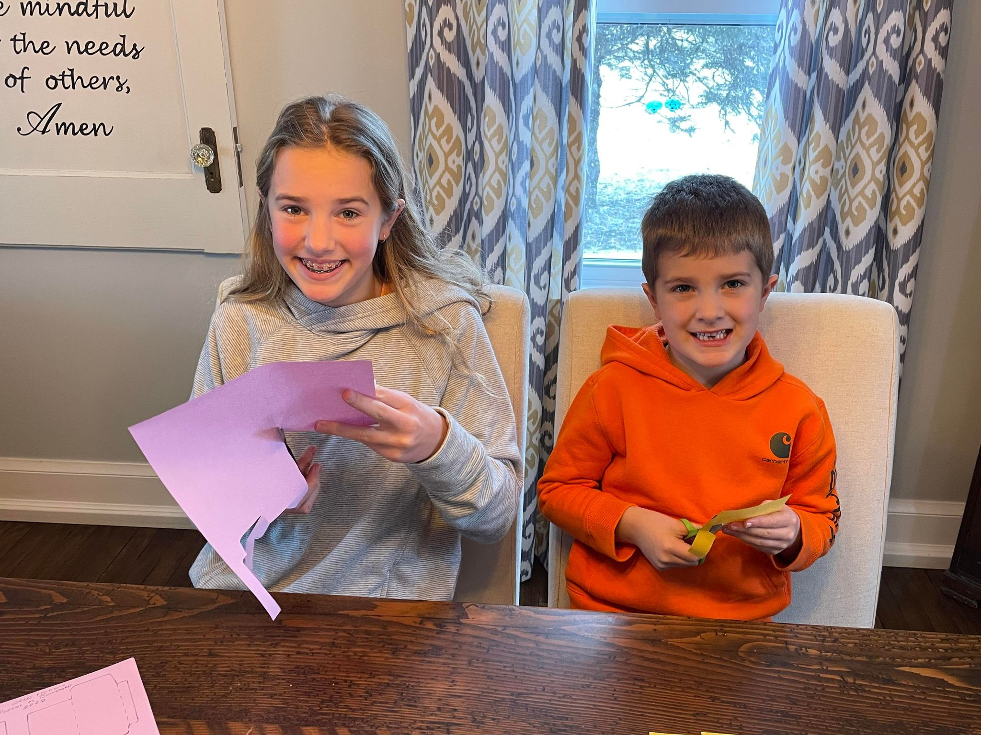

Planting Kits
The planting kits are nearing completion. I need to get the SEEDS next. I can’t ask the lady who handwrites every seed packet to do her job until I know what I can get for seed. I can’t ask the family writing on every plant marker to do their job either. Note to self; order seeds from mail order in January instead of waiting for the stores to have them.
Hopefully, the soil packets will be ready by next week. The egg cartons are going out this week.
Now, how to put together the kit
In half an egg carton place a snack bag of soil, 3 seed packets, and 3 markers. Place egg carton in a box bottom brown paper bag. Fold the top and punch a one-hole punch. Tie on your tag saying something like “A Planting kit from (your group)”
Now to get ready for rogation. I will really show my project next week. Happy Planting
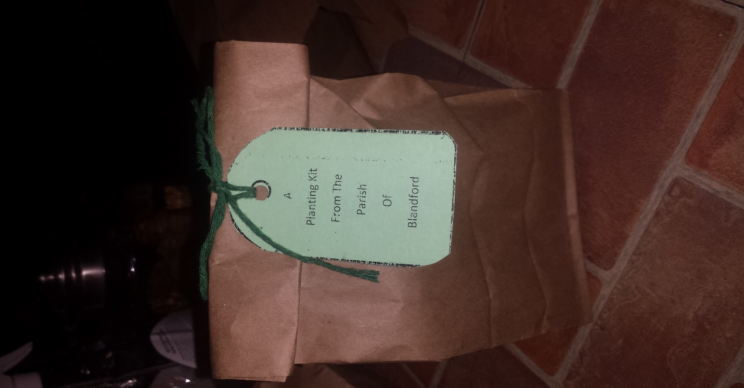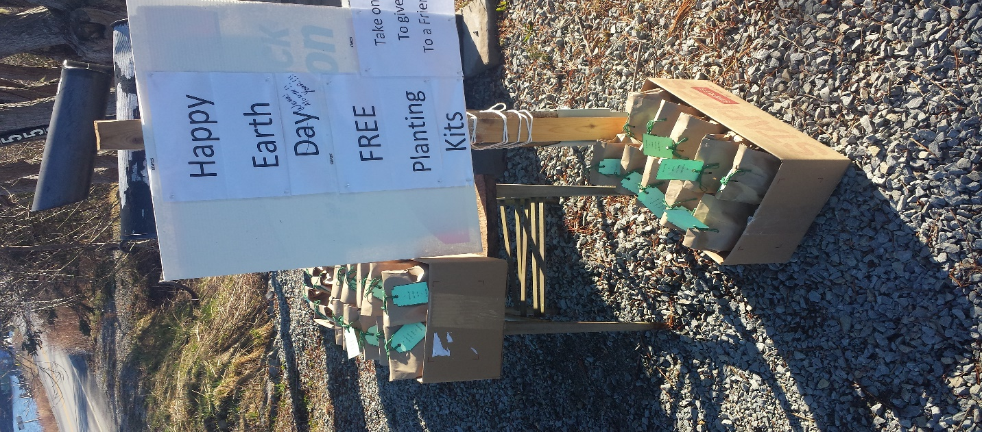

LENT
Is everyone ready to give up something for Lent? I give up clutter each year. It tends to come back and I need another go at it each spring.
A container a day is my motto. Doesn’t have to be big but it needs to be something that isn’t needed or could do someone else good.
Going through dresser drawers and closets is good. What about the bookcase? Are there books you could donate to the local library? Our local garage accepts towels and sheets to use for grease rags. See what is in your linen closet that could go?
Go through cleaners and if there is a bunch of half-used ones, then use them up and put the container in your blue bag.
My office is the worst. I use a lot of paper. Then I use the backs of prints as scrap paper. A purge of just what I keep renders me more paper than I need. I started printing on the back of the paper for home things. It cuts down on the pile of scrap paper to a reasonable amount.
Just find a spot and start cleaning. You can give up dust in a few places like ceiling fans. You can give up whatever you call that makes grout in the bathroom dirty looking. Get rid of five things in your junk drawer. Have fun making your “environment” better
Craft
This week we are making Easter Baskets. Why? We are going to be allowed services and I want to decorate my church and yell “SPRING IS HERE”, Of course, there are so many more serious things to celebrate first. I do keep quite somber till Easter morning. Then lookout. I will be as giddy as kids pumped up on sugar before service.
I am making my Easter baskets from coloured copy paper. I did try one with a newspaper but it was a bit flimsy
Make your sheet of paper square by taking the bottom right-hand corner across to the left side of the paper, fold and cut off the excess.
Take a ruler and mark inward 2 inches on each side. Make folds along with these marks
Cut from each corner point cut to where the two-fold marks intersect.
Fold up your sides either gluing or taping the flaps to the corresponding side.
Use that excess piece you cut off the top of the copy paper. Fold in half, cut apart and then tape 2 ends together. This is your handle.
I have some Easter grass to stuff each basket. A few candies in each basket will help the children on their Easter hunt after service.
Happy Easter All !!!!!!!!!!!!
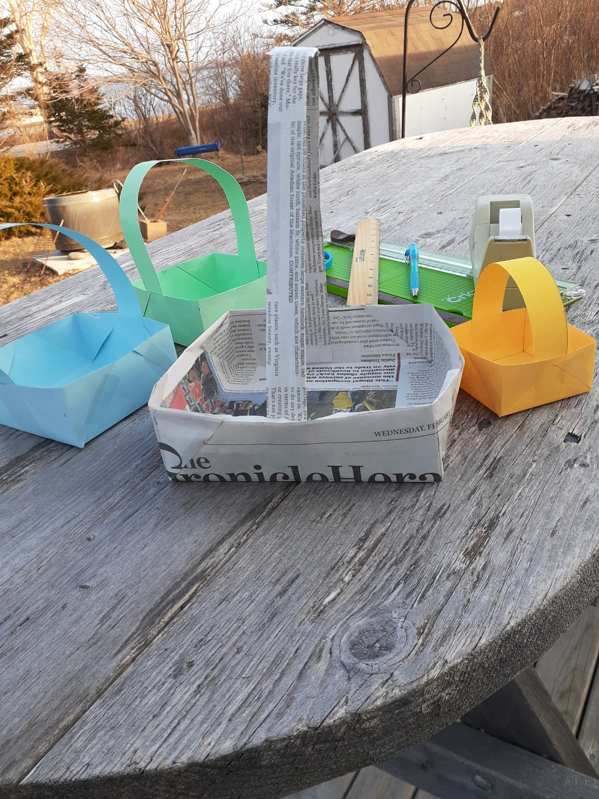
The internet gives a good tutorial
https://in.pinterest.com/pin/343118065364809431/

Something to eat
Some meals just go better with hot from the oven bread or biscuits. Grandma still doesn’t always have time to make bread and regular roll-out biscuits. These can be whipped up after peeling vegetables and be ready for the table when all else is cooked
Drop Biscuits
2 cups flour
1 tbsp. baking powder
Pinch of salt if you use it
½ cup shortening, butter, or margarine
1 cup milk
Put flour and shortening in a bowl. Using a pastry cutter or two knives cut the fat into crumbles. Add baking powder and salt. Stir in milk (can substitute sour cream, cottage cheese, regular cream, or part and part with milk).
Drop by big spoonfuls on a baking sheet. Bake 350 or more 12-15 minutes or till bottoms are browned.

Gracious God, we pray for all persons suffering from war.
May they be held in your loving care and protection and given the strength to endure great suffering and hardship. Transform the hearts and minds of all those who perpetuate violence and oppression. Grant wisdom to world leaders in advancing efforts toward world peace; may they not be compromised by self-interest and blind indifference. We ask all this in the name of your Son Jesus, and the Holy Spirit, now and forever.
Amen.
https://www.chausa.org/prayers/cha-prayer-library/prayer/a-prayer-for-persons-suffering-from-war

