February 22, 2022
Email: HYPERLINK "about:blank" endionspei@gmail.com Website: HYPERLINK "about:blank" nspeidiocese.ca/den
Facebook: HYPERLINK "about:blank" Environment Network Diocese of NS & PEI



WOW! Did we ever have a great gathering online recently of passionate people sharing their ideas and dreams of where we go from here.

Since then a small group met to look at all the responses and ideas and to decide how to frame the next part of Strategic Doing which is WHERE SHOULD WE GO.

Want to share your ideas before that next gathering? Please send them!!!

endiospei@gmail.com
DEN wants to hear from you and is inviting you to our next gathering on March 10 - Diocesan Environment Network 10th Anniversary “Strategic Doing” conversation 7 pm by Zoom
https://us02web.zoom.us/j/88965401267?pwd=b3lpZXl3am14S0JPbWZMYjJlT1R2QT09

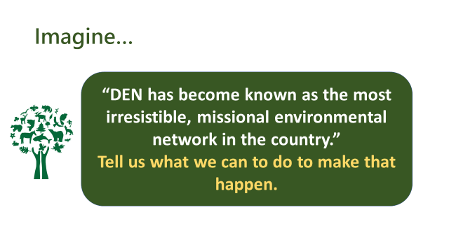

Good news from Greenpeace with thanks for all you have helped them accomplish:
Coca-Cola has announced it will make up to 25% of its packaging reusable by 2030. As the world’s biggest plastic polluter, this announcement from Coke is a major victory in our campaign challenging Big Brands to invest in reuse and refill systems to tackle the climate and plastic crisis.
Do we need Coke to do more to make a full switch to reuse-refill models and cut its overall reliance on plastic and waste-generating materials? 110%, yes! And we’ll continue insisting that they do. But coming from a company that sells 120 billion plastic bottles a year, this news sets a powerful precedent for other big brands, like Pepsi, Unilever and Nestlé, to follow suit.
Hundreds of thousands of people across Canada have been part of our campaign for investment in reusable and refillable packaging and a drastic reduction in single-use plastic. Thank you for moving us towards this goal!

Growing momentum for a circular economy in Canada

A few weeks ago, a Quebec provincial committee (BAPE) concluded that Quebec must stop relying primarily on recycling if it wants to succeed in reducing the amount of waste it generates. The BAPE also recommended reviewing the mission of the government corporation, Recyc-Québec, so that it places reduction, reuse and the circular economy "at the heart of its objectives."
Meanwhile, on the opposite side of the country, a group of experts has published a new report criticizing BC's “CleanBC” plan, which relies on recycling to reduce greenhouse gas emissions. Instead, these experts call on the province to move beyond conventional recycling and focus on reducing emissions by using more sustainable materials.
For years, Greenpeace Canada has campaigned for a move away from recycling as the solution to the plastic crisis towards a focus on reusable packaging – and the idea is gaining traction. To learn more about Greenpeace Canada’s calls for action, check out our 2021 report: Plastic Recycling: That's not a thing. Editor’s Note: this report is worth your time to read.

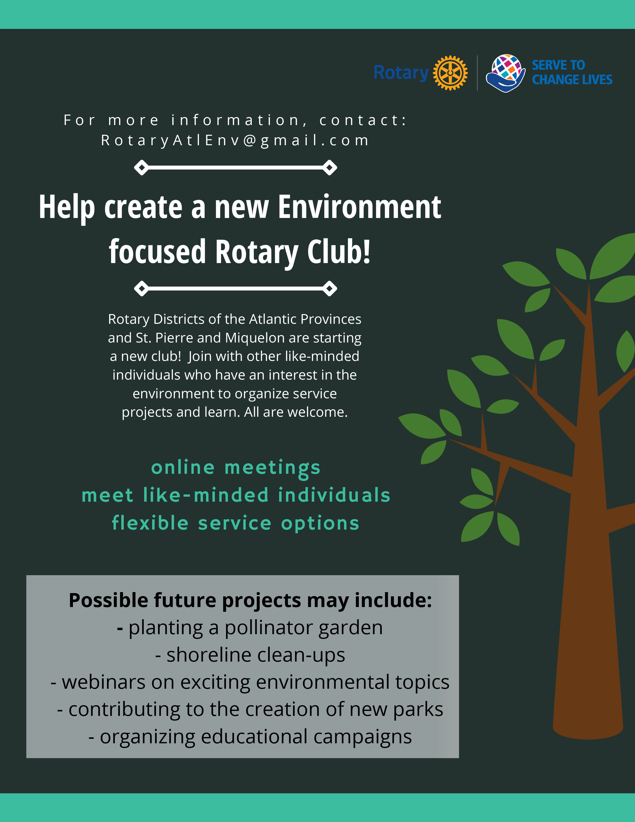



Thank you to Nancy Blair for sending us this great website full of wonderful ways to “join Canadians from coast to coast to help nature with Nature Conservancy of Canada’s SMALL ACTS OF CONSERVATION. Great resource for all of us but especially for adults to do with younger ones. What will you discover?

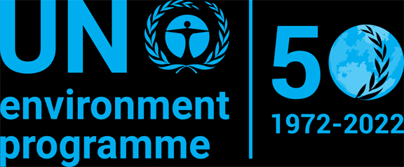

Faith for Earth Dialogue at the United Nations Environment Assembly Feb 28 to March 2. 2022

Strengthening Actions for Nations to Achieve Sustainable Development Goals

For more information: https://www.unep.org/events/unep-event/faith-earth-dialogue-unea-52?fbclid=IwAR0X3KHe-IN8y4hM_EQ_1hh52PENh7_8bEGWas3sEvvqFZco8IVgggCsokE

To register: https://indico.un.org/event/1000610/

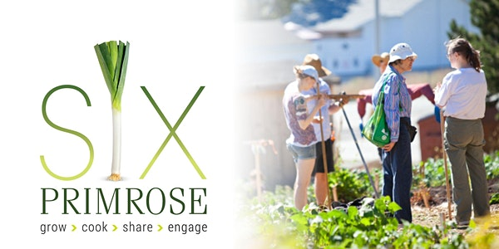Join the Christ Church Pastoral Ministry Committee for a screening of the documentary Six Primrose, which tells the story of how food brought a Dartmouth community together. It celebrates community spirit and the individuals that make “The North Grove” a vibrant and essential part of its neighbourhood. For more information:

https://www.eventbrite.ca/e/a-viewing-of-six-primrose-tickets-261159754857?fbclid=IwAR3E5X3mdJbjcdSrlWUSP6KO0Ygzu8s2pBcTOOR7-n4RQ_FUGfLlvxkNh_A

You are invited to view the film at your leisure at home between February 21st and the 28th and then join us on March 3rd for a discussion on how issues of food insecurity, poverty, and isolation are affecting our community, what we are doing to address them, and how you can get involved.
We are called by God to be good stewards of Creation.
Join us for weekly prayer in solidarity and renewal of our baptismal covenant:
“To strive to safeguard the integrity of creation and sustain and renew the life of the earth.”

NEW Resource for Lent 2022: “Ecological Grief and Creational Hope – A Lent Curriculum for All Ages”
Ecological Grief and Creational Hope (full colour PDF)
This six-week resource explores the biblical themes of creation’s groaning and lament as well as its hope for redemption. Each week includes a Scripture passage with questions for reflection and discussion, prayers, suggested activities and action ideas, as well as links to explore further. The questions and activities can be adapted for individual, family, group, or parish use, with specific suggestions for children and youth.
This six-week resource explores the biblical themes of creation’s groaning and lament as well as its hope for redemption. Each week includes a Scripture passage with questions for reflection and discussion, prayers, suggested activities and action ideas, as well as links to explore further. The questions and activities can be adapted for individual, family, group, or parish use, with specific suggestions for children and youth.
https://www.toronto.anglican.ca/diocesan-life/social-justice-advocacy/creation-care/
Demand that the bankers of the Coastal Gaslink pipeline respect Indigenous rights and divest. (stand.earth)
The Coastal GasLink pipeline is a 670-kilometre fracked gas pipeline proposed through Wet'suwet'en territory in British Columbia. It is the largest private fracked gas investment in Canadian history. At the start of this month, 100 non-governmental organizations released a letter to the 27 banks financing the Coastal GasLink pipeline. They are calling on the banks to divest and withdraw all financial support for this project on human rights, environmental, and climate grounds. Add your name to the petition and encourage these banks to stop funding these environmental and human rights violations.

Petition to Stop Funding so called Carbon Capture
Instead of funding real climate solutions like wind and solar, or training workers for the rapidly growing clean energy economy, the Canadian government is dumping billions of our dollars into fossil fuel company greenwashing like carbon capture. Shell’s taxpayer-funded carbon capture plant is emitting 1.2 million cars' worth of emissions more than it’s capturing. Now the federal government is considering putting even more of your money behind it and similar facilities.

Nature Canada
Window collisions are the second-highest direct human cause of bird deaths in Canada. A shocking twenty-five million migratory birds die from window collisions across our country every year. Nature Canada has crafted a letter to help implement guidelines and make sure the Bird Friendly Building Standards get put into Ontario’s Building Code. Sign the letter to help make it as clear as glass that migratory birds deserve protection.

Sign the petition and ask supermarkets to ditch throwaway plastic packaging - Greenpeace Canada
Canada generates 3.25 million tonnes of plastic waste each year! This is equivalent to the weight of over 140,000 full garbage trucks. In many cases 90% of this waste is not recycled, but incinerated, sits in landfills, or ends up littered in the environment. This has devastating effects for nature. Much of the plastic waste comes from packaging within the food industry. Supermarkets do have the power to reduce the amount of single-use plastic used, and we have the power to ask and push them to do this. Sign your name to show your support in asking Canada’s major supermarkets to ditch throwaway plastic packaging.

petition: Yet Another Oil Spill is Poisoning Water that Wildlife and People in the Amazon Rely On (thepetitionsite.com)
In late January 2022, a pipeline owned by the private company OCP Ecuador became damaged during a mudslide. Countless barrels of oil are spilling out and polluting multiple acres of a protected Amazonian rainforest area. It took just a few days to reach the Coca River, one of the Ecuadorian Amazon's largest rivers. This means the water is undrinkable and unusable, fish are inedible, and the innocent animals of the rainforest are suffering as their environment is rendered inhabitable and full of poisons. Information on the magnitude of the spill is not being shared. Indigenous community groups are demanding the government create and publicize what it intends to do to provide food and water, and to know more about cleanup efforts to contain and remove the deadly pollution. Sign the petition support them and the precious life the region holds.

This Editor urges you to check out Grandma’s Going Green Planting kit ideas from this issue and past ones. These are a wonderful way to involve the whole community and excite young ones with the idea of growing their own vegetables and/or flowers.
Back to clothes
Grandma loves to reuse ANYTHING till it just is plain more than worn out. An example is a shoe rack I have. It started as a place to put the Grandbabies' books for when they visited. When I found a more permanent place for books it became my shoe rack for a decade. It started to fall apart so I put together a new one this weekend. As I was walking it to the shed thinking of trash day I realized I could duct tape the shelves sturdier and put plants to grow on them. It is just the right size for one of my big clear garbage bags to go over it. Why throw it out?
The following website had great ideas. Here are two of them that I want to try
FROM https://www.lifestorage.com/blog/storage/10-innovative-clothes-storage-ideas-when-you-have-no-closet/

Have all your light scarfs in one place on a clothes hanger. I saw something better in a friend’s closet. She had hooks on the back wall of her closet where there was space for her scarfs and handbags to hang.

This is a pic of Grandma copying the idea

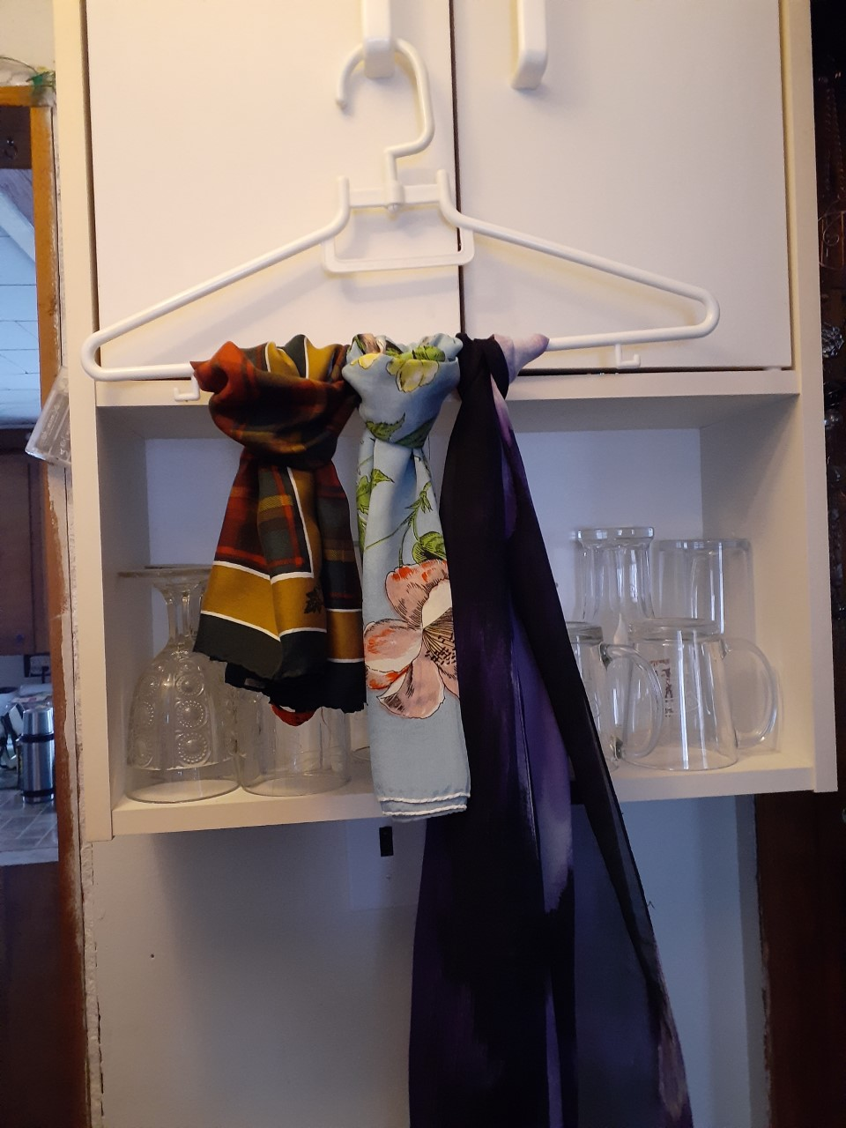

I love this idea. Have an old bookcase in the basement. Paint it up and put it in your bedroom for everyday things that are easy to reach. You can attach a curtain rod and hang a drape if you don’t like clothes exposed.
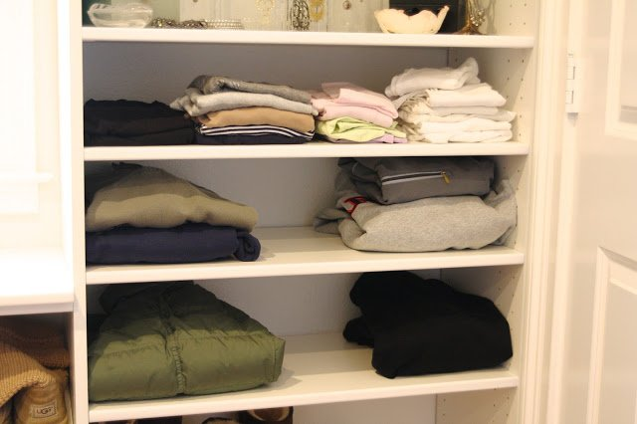

Planting Kits Continued
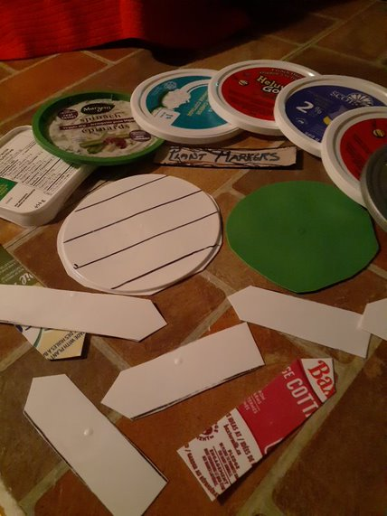
All year long Grandma saves the plastic tops from margarine, cream cheese, cottage cheese, sour cream type of containers.
I made my plant marker pattern 10 years ago and luckily that little piece of boxboard hasn’t worn out. You just need a piece of boxboard about an inch wide and 6 inches long
Cut off the rims of the lids. Trace 2-3 marker sides on the lid and cut them out with scissors. Make one end straight and the other end pointy. That’s it.
I usually save enough lids on my own to do the planting kits. Not so this year.
We have had a wonderful surprise this week. The Lion’s Club in Fox Point has asked for 50 kits to give away. It was like a ray of sunshine. This is what we use to do before the pandemic.
So now I need to make a minimum of 125 kits. I was aiming at 100 knowing probably 75 would be gone on Earth Day and then there are always a few more needed for Rogation Sunday. Rogation may have to be a different planting project.
Meanwhile, I have enough markers for 75 kits, hopefully, a hundred kits by March. I want the markers to be reusable, repurposing, or as green as we can make them. I know milk jugs are made of plastic but the markers don’t stay on them. What to do? What to do? Any other ideas please write us to help another year.
This year I am getting popsicle sticks, (biodegradable) and have them for extra plant markers.
I told you of one family that is making the seed envelopes. Another family has volunteered to fill the soil bags. Great job for a couple of pre-schoolers. This is turning into a community project. Tell me about your plans even if you are making even 2 kits for your grandbabies for an Easter gift. Let’s see pictures.
Craft

When you first see this you may think of Christmas decorations. They certainly could be used for this.
Use colours of pink, purple, yellow, and pastel anything and you have Easter decorations. Some people have an Easter tree.
Use a glass or mug to draw a circle on cardboard
Cut out the circles.
Cut notches in the circle, across from each other. Put in the first notch and go directly across from it and make the next and so on.
Use yarn to make stars, squares, triangles, and more. Make several shapes on each ornament
You can make a hole and attach a string to hang them up or have a bunch in a basket. Makes great giveaways after service.

Something to eat.
Did you ever come across a recipe titled “30-minute supper” and think “no way is that done in 30 minutes” OK it has 10 minutes of prep of basically lining everything up but still, 30 minutes?
Well, that is a challenge! And away we go!
The good thing is that Grandma sort of likes to be proven wrong! Especially with food. It was titled ONE POT CHICKEN RAVIOLI. I didn’t like the title as ravioli is stuffed pasta and usually tomato base. Let’s change it to
ONE-POT CREAMY CHICKEN PASTA
Minced chicken or (chicken hamburger to my Grandbabies.) (1 lb.)
A few strips of bacon cut in pieces
Garlic
Onion
2 cup chicken stock (I add bouillon cubes or envelopes to hot water)
Pasta: pina, macaroni, whatever you have in the house.
½ cup cream
½ cup Parmesan cheese
The original recipe had fancy things in it like this type of wine and that type of shallot but the above makes it fine and if you are lucky to have spinach leaves in the house add a few at the end for colour.
Cook garlic and bacon, add minced chicken and cook about 5 minutes till the chicken meat turns darker.
Add the liquids and the noodles dry and bring to a boil and let simmer for 8-10 minutes.
Stir in Parmesan cheese last and add spinach if available.
OK. It took me 35 minutes but still a quick meal. Either a salad on the side or bread and butter makes a perfect meal.

Till next week, Grandma is sending hugs

In the Midst of Winter
Lord:
In the midst of Winter, when the days are cold and wind can pierce remind us of the warmth of your love.
In the midst of Winter, when days are short, dawn comes late, and dusk arrives early remind us that in the darkness your light still shines.
In the midst of Winter, when the flowers of spring still lie hidden in the earth, when leaves are off the trees, and the world can seem bleak
remind us that Easter is but a short time away.
And when in our lives we feel as if we are experiencing a season of winter, reach out to us with the power of your resurrection so that we may feel the warmth of your love and see your light that alone can take away the darkness of our soul.
- Cal Wick
https://www.xavier.edu/jesuitresource/online-resources/prayer-index/winter-prayers

