February 15, 2022
Email: HYPERLINK "about:blank" endionspei@gmail.com Website: HYPERLINK "about:blank" nspeidiocese.ca/den
Facebook: HYPERLINK "about:blank" Environment Network Diocese of NS & PEI



WOW! Did we ever have a great gathering online last Thursday of passionate people sharing their ideas and dreams of where we go from here.

With great thanks, Louisa Horne led us in a fast paced, spirited discussion on Strategic Doing beginning with the statement “DEN has become known as the most irresistible, missional environment network in the country”. That was the first part of our “Strategic Doing” followed by an awesome sharing of ideas on what that might look like and and what we did to make that happen. In other words, WHAT COULD WE DO. The next step is WHAT SHOULD WE DO. Stay tuned for more ways to be inspired by this dream and to become involved in the next step.

Want to share your ideas before that next gathering? Please send them!!!

endiospei@gmail.com

DEN wants to hear from you.

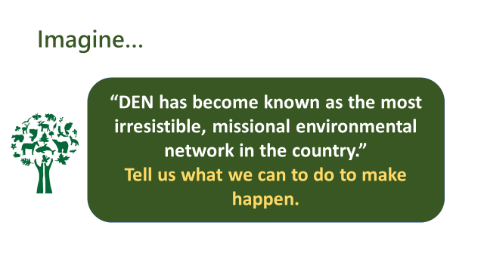

.







Faith for Earth Dialogue at the United Nations Environment Assembly Feb 28 to March 2. 2022

Strengthening Actions for Nations to Achieve Sustainable Development Goals

For more information: https://www.unep.org/events/unep-event/faith-earth-dialogue-unea-52?fbclid=IwAR0X3KHe-IN8y4hM_EQ_1hh52PENh7_8bEGWas3sEvvqFZco8IVgggCsokE

To register: https://indico.un.org/event/1000610/

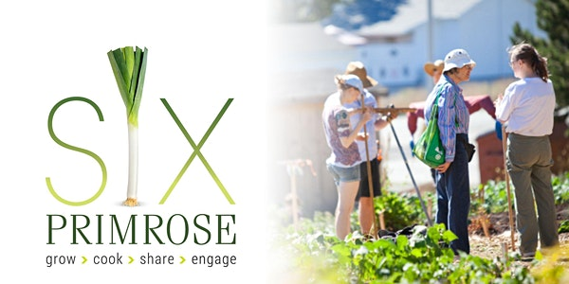Join the Christ Church Pastoral Ministry Committee for a screening of the documentary Six Primrose, which tells the story of how food brought a Dartmouth community together. It celebrates community spirit and the individuals that make “The North Grove” a vibrant and essential part of its neighbourhood. For more information:

https://www.eventbrite.ca/e/a-viewing-of-six-primrose-tickets-261159754857?fbclid=IwAR3E5X3mdJbjcdSrlWUSP6KO0Ygzu8s2pBcTOOR7-n4RQ_FUGfLlvxkNh_A

We are called by God to be good stewards of Creation.
Join us for weekly prayer in solidarity and renewal of our baptismal covenant:
“To strive to safeguard the integrity of creation and sustain and renew the life of the earth.”

Community Forests International has a new publication – Call to Action: A Resource Guide to Support Environmental Organizations in Decolonization Work. To quote the guide:
This Project is
- A reminder that everyone has the responsibility to fight for Indigenous autonomy, justice and equity
- A document that highlights some of the resources and tools created by experts and knowledge holders, with a focus on Indigenous-created sources.
- A recognition that environmentalists, especially those working with land, have a role in reconciliation that is different from others
- An advocate for earning and sustaining allyship, beyond tokenism and statements without commitment.

The full guide can be found here:

https://ehjq7z4yg93.exactdn.com/wp-content/uploads/2022/01/A-Resource-Guide-to-Support-Environmental-Organizations-in-Decolonization-Work.pdf

NEW Resource for Lent 2022: “Ecological Grief and Creational Hope – A Lent Curriculum for All Ages”
Ecological Grief and Creational Hope (full colour PDF)
This six-week resource explores the biblical themes of creation’s groaning and lament as well as its hope for redemption. Each week includes a Scripture passage with questions for reflection and discussion, prayers, suggested activities and action ideas, as well as links to explore further. The questions and activities can be adapted for individual, family, group, or parish use, with specific suggestions for children and youth.
This six-week resource explores the biblical themes of creation’s groaning and lament as well as its hope for redemption. Each week includes a Scripture passage with questions for reflection and discussion, prayers, suggested activities and action ideas, as well as links to explore further. The questions and activities can be adapted for individual, family, group, or parish use, with specific suggestions for children and youth.
https://www.toronto.anglican.ca/diocesan-life/social-justice-advocacy/creation-care/
From Ecojustice – “Yesterday, the federal government tabled Bill S-5 before the Senate. If passed, this bill will finally reform the Canadian Environmental Protection Act (CEPA).
After several false dawns, we now have an opportunity to modernize a law that is supposed to protect me and you from dangerous environmental pollution and toxic chemicals.
We’ve been here before — during the last parliamentary session, the federal government tabled a bill to reform CEPA but it died on the order paper once the federal election was called.
But we did not give up hope that people in Canada could win the right to better protection from pollution. And yesterday, that hope was validated.” To Read more:
https://ecojustice.ca/case/working-to-bring-cepa-into-the-21st-century/?utm_medium=email&utm_source=engagingnetworks&utm_campaign=bn_2022.02.10&utm_content=2022.02.10+CEPA+Bill+tabled+Feb+2022+B

Environmental Defence Canada
The Great Lakes are a source of drinking water for over 30 million people in the US and Canada. They contain 21 % of the world’s surface freshwater and 84 % of North America’s freshwater. Line 5 is a 68-year-old, deteriorating pipeline operated by Enbridge Energy. It sits at the bottom of the Straits of Macknic between Lake Michigan and Lake Huron, and it carries 87 million liters of oil and gas per day. It is in the worst place for an oil spill to occur and could contaminate up to 1200 km of the Great Lakes shoreline. This petition is asking the Canadian government to put health and preservation ahead of short-term financial interests, to prioritize green infrastructure, and to respect Indigenous rights by shutting down Line 5.

Plastics petition | WWF (panda.org)
Marine plastics pollution has serious consequences for people’s well-being and their livelihoods and it has devastating impacts on life in our oceans. Plastic remains in our environment for hundreds, perhaps thousands of years, and it is the cause of injury and death to fish, sea turtles, whales, birds, coral reefs, and much more. Every single country is part of this plastics crisis, and every single one must be part of the solution. This petition is working to help make a legally binding UN agreement to stop the leakage of plastics into our oceans by 2030. Governments are meeting on Feb 28th for the UN Environment Assembly and this petition could help call on the world to act and stop marine plastic pollution.

Petition · Ban the Farming and Sale of Octopuses · Change.org
Octopuses and their cousins in the cephalopod class of invertebrates have a cognitive and emotional range resembling the higher mammals and other sentient vertebrates. There are also studies suggesting that octopuses are likely to feel and respond to pain in a similar way to mammals. There is a danger of commercial octopus farms becoming operational globally by 2022 or 2023. Preliminary studies suggest that any attempt to farm octopuses and related species at scale will create enormous environmental stress. This petition is asking the governments of Canada and Spain to not pursue any commercial octopus farms and instead to institute a ban on the farming of cephalopods.

Stop the destruction of Borneo's proboscis monkey forest! - Rainforest Rescue (rainforest-rescue.org)
Borneo is home to amazing creatures from clouded leopards to sun bears, hornbills, marbled cats, proboscis monkeys, and pangolins, plus many other endangered species. The endangered wildlife here is currently losing its habitat, and the reason for this is the production of biodiesel and chemical products from palm oil. Companies are clearing coastal forests and have already destroyed hectares of rainforests, despite pledging to eliminate deforestation. Please add your name to this petition to say the clear-cutting needs to stop and the protection of wildlife and the restoration of forests needs to happen!

Mushrooms in Coffee Grounds

I can’t wait to tell you the story of two guys, Alejandro Velez and Nikhil Arora from California.

In 2009, they were students in one of their last classes before graduating with a Business degree from Berkley. A random fact was thrown out about growing mushrooms in coffee grounds

The two friends asked their local coffee shop if they could have their coffee grounds for a day. They made up a few buckets of “soil”, and planted mushrooms, in a few buckets. Placing the buckets in the closet of Alejandro fraternity room, they went off for spring break. When they came back, ONE of the buckets had grown mushrooms.

Admitting they knew nothing; they went to their local grocery store asking the managers if this would be a product they would consider buying it.

It just so happens that one of the executives from Whole Foods (think Sobeys or Superstore) was told about their project. He said if they could make this method work, he would sell the product

It started with gathering the coffee grounds from one coffee shop daily. They collected the grounds in what looked like green bins. They constructed shelves and grew mushrooms. They learned to package and through mistakes, they invented a “grow your own mushroom” kit.

The coffee shop chain (Pete’s) saw them as waste management and slowly they started gathering coffee grounds every morning from more and more of their chain of shops. Nicki and Alejandro thought this was great. They got their growing medium for free and got paid to take it away.

Pete’s knew they made planting kits and asked them to carry a coupon in their kits for $2 off a coffee order. The lads suggested why not sell the mushroom kits in their coffee shops. It showed the full circle from their product, to waste, to the growing medium, to the kit that came back to the shop.

Whole Foods was buying their mushrooms and wanted the kits too. They put the kits in four different departments in their stores.

Meanwhile, back at the shop, the spent coffee grounds were piling up in the back. They needed a way to get rid of the used coffee grounds. They offered it to the public free of charge and people came in droves to get it for their gardens.

The lads sent their employees out to ask what they were doing with the grounds They came back having received free lessons in soil composition. One guy said, “You should package this. People would buy it.” So, they did.

In 2011 they collected, used, and redistributed ONE MILLION POUNDS of coffee grounds.

In 2012 they collected twenty thousand pounds of used coffee grounds per WEEK.

They say they knew nothing about gardening and a lot came to them through luck. No way, they worked hard to make their sustainable business work and still haven’t stopped. Look at their website and there are tin cans and cardboard boxes for planting kits. They have seeds and kits for veggies and flowers.

This is a bit like what planting night in the village of Blandford looked like before the pandemic. We came together and planted a night in all kinds of reusable containers. We made bird feeders and the kids ran the trail putting them out on branches. Everyone went home with the beginning of gardens.

This is just one way to use what would be considered waste. Even collecting coffee grounds from one shop for one week for soil composition in a community garden would be a great project. Think about what else we could do to help our communities by using what is considered waste.

Putting in a few references.

Their website https://backtotheroots.com/

Their Ted talk from 2012 (remember they started in university in 2009) https://www.trendhunter.com/trends/back-to-the-roots

Then Google, how to grow mushrooms from coffee grounds and see a whole library of information that is available now. It wasn’t when they started.

Planting kits continued

This week let’s work on either the package tags or seed packages.

There are many free templates for seed packages out there. All you need is a few seeds for the kits so a small package works.

In our Parish we do not have custom printed envelopes, nor did we buy coin envelopes but rather, we make our own. Grandma just finished delivering sheets of seed envelope templates to Paityn and Cameron Gates’s Mom. They will cut out and glue the packs together for our entire project.

The first pandemic year Grandma did everything herself. It was the only way when the pandemic started. It was a lot of work. It also kept other people from doing a community project. Now many people help create and Grandma (and Nana) put the packs together.

One member of the congregation hand writes the type of seed that is in each package. I am aiming for 100 packs this year so that means 300 envelopes, handwritten.

I will need someone to cut 50 egg cartons in two as Grandma’s thumbs get too sore. Maybe someone will fill 100 snack bags with soil or write the plant names on 300 markers. There need to be 100 labels for the outside of the kit packs.

We put everything in a brown paper lunch bag (get box bottom bags.) We fold the top, put in a one-hole punch. I printed “A planting kit from the Parish of Blandford” on the tag and tied it to the bag. It makes a tidy package to give away.

If you are thinking of doing half a dozen kits for a few friends or grandbabies, it will be a lot less of a concern but will start a lifetime of gardening memories.

Have fun researching seed packets

Seed Packet: Six to a page

If you like the size but not how it is printed, trace the outline of the packet on plain paper and then photocopy.

https://saltinmycoffee.com/wp-content/uploads/2020/04/Seedpacket6saltinmycoffeeTM.pdf

12 to a page but these are super tiny

https://saltinmycoffee.com/wp-content/uploads/2020/04/MiniSeedpacket12saltinmycoffeeTM.pdf

The label or tag for the outside of the package is found here

https://patternuniverse.com/download/luggage-tag-pattern/

How is your collection of margarine or similar tubs coming? I’ll show you plant markers another week. Below are the envelopes that were used in the 2019 kits

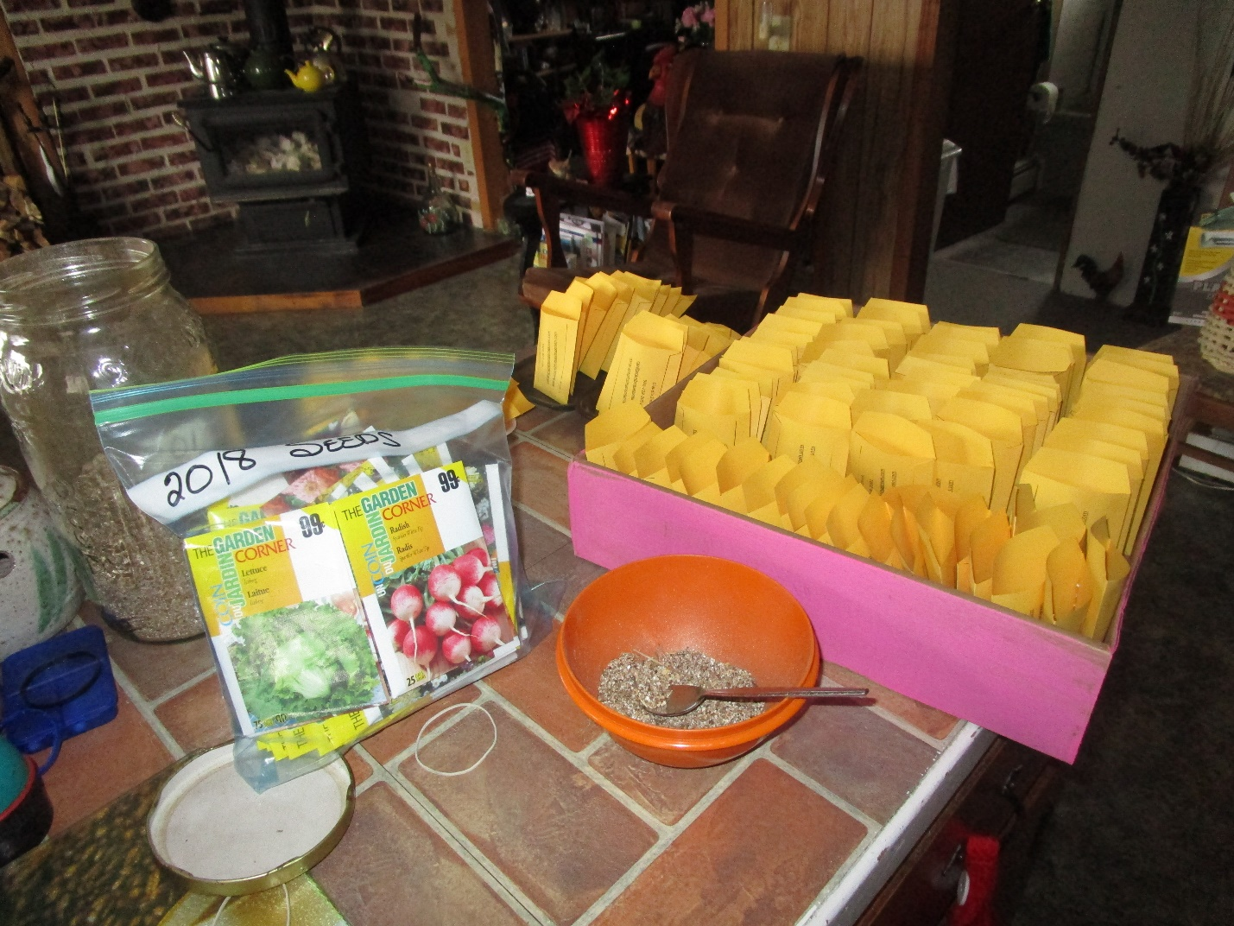

Easy toy, Indoors or out, a Cup and Ball toy.

This is a great way to use your leftover Styrofoam cups. You will need

A cup

A string

A bead or similar waited object like a washer.

Decorate your cup

Punch a hole in the bottom and thread through string knotting it on the outside to keep it in place. Tie bead or washer to the other end of the string.

Keeping hold of the cup, wave it in the air trying to get the bead or washer to land inside the cup.

So easy and keeps little ones amused for a time.

https://www.pinterest.ca/pin/131097039125332406/



To be DIY on a bigger scale you can use empty milk or water jugs, They used balloons here but I am thinking a small stuffed animal may work as well.

https://meaningfulmama.com/day-199-diy-cup-and-ball-ball-toss.html

Something to Eat

My friend from the Acadian shore calls them crepes, I am told in PEI they are called Potato Galettes where my family knew them as either potato pancakes or Savory Pancakes

First, peel and boil half a dozen good-sized potatoes, mash them and set aside

Add half a cup of butter and an egg and stir that into the potatoes

Here is where things change

My friend up the French shore likes them plain. He adds cream and maybe a bit of cinnamon

My PEI friend grates a zucchini and throws in dillweed.

My family added summer savory, parsley with a bit of finely chopped onion and peppers.

Whichever way, make your patty cakes and fry them in a couple of tablespoons of olive oil, Great at breakfast and any other meal.

Till next week

Grandma is sending hugs.

For Times of Transition
God of Love,
You are with us in every transition and change.
As we enter into this new era with excitement and even some anxiety,
we recall your deep compassion, presence, and abounding love.
We thank you for the gifts, talents and skills with which you have blessed us.
We thank you for the experiences that have brought us to this moment.
We thank you for the work of others that gives breadth and depth to our own work.
Be with us as we move forward, rejoicing with you and supporting one another.
We ask this in your Holy Name.
- Joseph P. Shadle
https://www.xavier.edu/jesuitresource/online-resources/prayer-index/transition-prayers#:~:text=For%20Times%20of%20Transition,-God%20of%20Love&text=we%20recall%20your%20deep%20compassion,depth%20to%20our%20own%20work.

