February 08, 2022
Email: HYPERLINK "about:blank" endionspei@gmail.com Website: HYPERLINK "about:blank" nspeidiocese.ca/den
Facebook: HYPERLINK "about:blank" Environment Network Diocese of NS & PEI



March 2022 is the 10th anniversary of the Diocesan Environment Network!
A time to celebrate AND a time to focus on the next 10 years. We want you to be part of it.
It’s a special time in our evolution as a network, carrying out God’s call to care for creation.
Let’s come together for a conversation about refreshing DEN and dream new dreams to ensure a long life for both DEN and our planet.
Hoping you can join us at our “strategic doing” session on Zoom, this Thursday Feb. 10 at 7pm.
Join Zoom Meeting
https://us02web.zoom.us/j/87231865145?pwd=NkdXRTJweExvQlJ4MVd3TmlRQlRVUT09

DEN celebrates 10 years and Kairos celebrates 20. To read more form the Kairos Times, click here:

https://secure.kairoscanada.org/index.php?q=civicrm/mailing/view&reset=1&id=1235


We are called by God to be good stewards of Creation.
Join us for weekly prayer in solidarity and renewal of our baptismal covenant:
“To strive to safeguard the integrity of creation and sustain and renew the life of the earth.”

NOVA SCOTIA POWER AND SOLAR

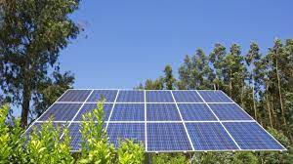

https://haligonia.ca/province-will-block-ns-powers-solar-power-charges-284644/?fbclid=IwAR1csQCupN2fUsplHOsevBoJyt4kBwxljt34qFdeEGtDB5UiKtJ_xobC_2I


To be successful, the transition must involve workers and communities who will be impacted. All levels of government need to engage with their citizens to ensure that environmental, social, and economic policies will support a more equitable future for all. Canadians need to be well-positioned to benefit from the opportunities that will arise as the world builds a low-carbon economy.
This virtual conference will provide an opportunity to learn how other countries are implementing their just transition strategies and hear from community leaders, researchers, and advocates from Alberta and across Canada about the challenges and opportunities for various sectors on the vanguard of this transition. We welcome all concerned Canadians who want to become engaged in the implementation of a just transition.
REGISTER
https://subline.ualberta.ca/portals/59

Grandma’s Going Green is beginning to gather supplies for her planting kits.
Even having a dozen to give away to any age group is a way to encourage a way to help our planet. My kits contain half an egg carton, a snack bag of soil, 3 small seed packets made from coloured paper, and three plant markers from plastic lids. The idea is to assemble a kit to give away on Earth Day. We gave away 80 last year and are aiming for 100 for 2022.
SO, just start gathering egg cartons and the plastic lids from margarine and yogurt tubs. Sending a picture. Just start gathering now. If you see seed sales before we talk again, think of buying easy growing seeds like lettuce, radish and cucumber
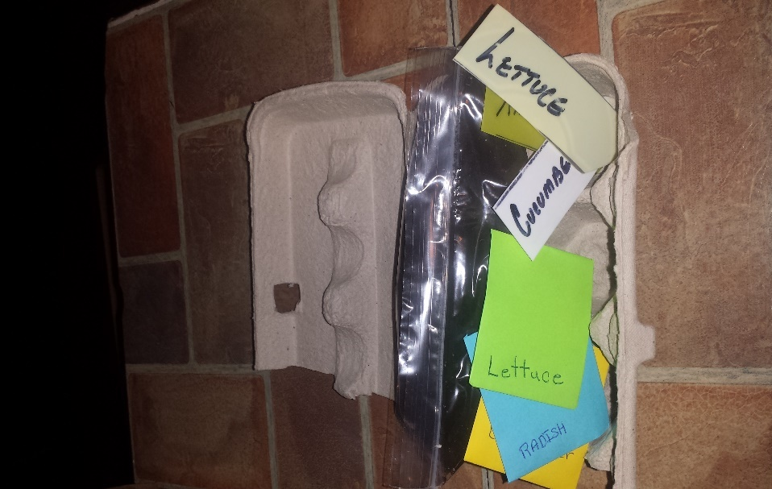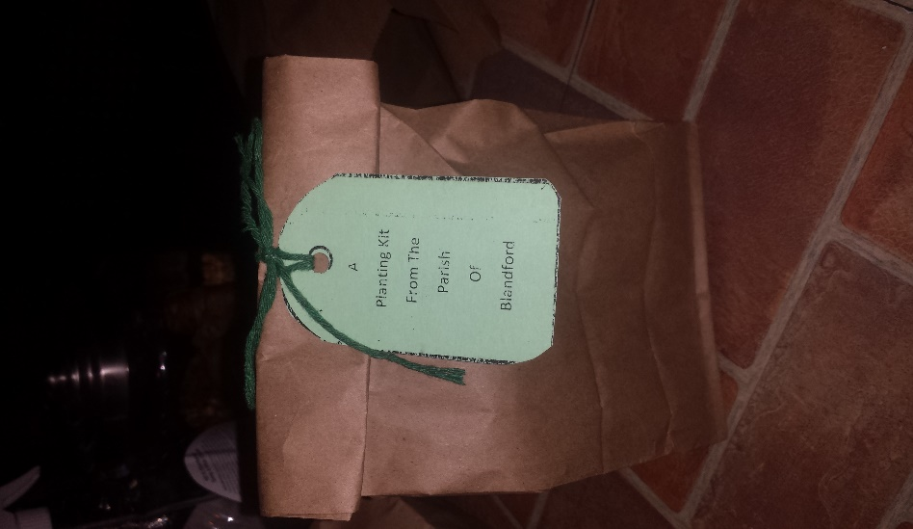
NEW Resource for Lent 2022: “Ecological Grief and Creational Hope – A Lent Curriculum for All Ages”
Ecological Grief and Creational Hope (full colour PDF)
This six-week resource explores the biblical themes of creation’s groaning and lament as well as its hope for redemption. Each week includes a Scripture passage with questions for reflection and discussion, prayers, suggested activities and action ideas, as well as links to explore further. The questions and activities can be adapted for individual, family, group, or parish use, with specific suggestions for children and youth.
 | This six-week resource explores the biblical themes of creation’s groaning and lament as well as its hope for redemption. Each week includes a Scripture passage with questions for reflection and discussion, prayers, suggested activities and action ideas, as well as links to explore further. The questions and activities can be adapted for individual, family, group, or parish use, with specific suggestions for children and youth.
https://www.toronto.anglican.ca/diocesan-life/social-justice-advocacy/creation-care/
Meet the Water Keepers of Columbia – PWRDF “It’s crucial in Colombia. The country is home to half of the world’s moorlands, which provide 70% of its potable water and feeds the subsidiary rivers that sustain the Amazon and Orinoco rivers as they meet the Atlantic Ocean.” To read more:
https://pwrdf.org/meet-the-water-keepers-of-colombia/

Environmental Defence Canada Environmental Racism is a reality in Canada. For too long, Indigenous, Black, and other racialized communities have experienced harmful industrial pollution and toxic chemical exposures in their communities and homes. This has resulted in high rates of respiratory illnesses, cancer, reproductive diseases, and other health problems. There are examples of this stretching across our country. Let’s have our voices also stretch across this country by telling the Minister of Environment, Steven Guilbeault, that we need a national strategy to address the harms caused by environmental racism.
Note that if one hits 'show', the letter is there already written.

Petition on TransMountain Pipeline Updated climate science from international bodies has confirmed that the Trans Mountain pipeline is incompatible with efforts to limit global warming to 1.5ºC. Over the past year, construction of the new Trans Mountain pipeline has been hampered by the pandemic and climate change-driven extreme weather. Record breaking heat, wildfires, flooding and, most recently, rerouted rivers and landslides have left sections of construction buried under landslides or washed away. Two years ago, the construction of the pipeline was an estimated $12.6 billion, but that final price will be much higher due to the flooding and delays, some experts believe it will be over $20 billion dollars. All Canadians are owners of the pipeline – after all, Trans Mountain is paid for by taxpayers’ money. So we deserve to at the very least know the real cost of the pipeline before billions more public dollars go into a project that will put communities and the climate further at risk. This petition calls on Trudeau’s government to stop the construction of the pipeline until a formal review of the cost of pipeline is done.

Suzuki Petition to End Fossil Fuel Subsidies
Canada’s finance minister is weighing priorities for the next federal budget. Let’s send a clear message that Budget 2022 must end subsidies and other public financing for fossil fuel companies! Direct taxpayer handouts are just the tip of the iceberg. Our government also backs generous financing arrangements — like loan guarantees — to keep fossil fuel production on life support. Coal, oil and gas are fuelling the climate crisis, with devastating impacts on nature and communities. The next federal budget must chart a course to a green and just future.

Keep the oil industry out of Africa’s natural treasures! - Rainforest Rescue (rainforest-rescue.org) ReconAfrica is a Canadian oil and gas company engaged in the exploration and development of oil and gas in Northeast Namibia and Northwest Botswana. This exploitation would be a catastrophe – not only for the global climate, but for wildlife, water resources, and the livelihoods of local Indigenous Peoples. It would not only threaten bodies of water in the dry savannas but also threaten the Okavango Delta, which has a huge population of elephants, hippos, rhinos, and birds. We have an obligation to protect and care for life and nature, and this petition asks us to put that ahead of profit and exploitation.

Prosecute Brazilian President Bolsonaro for genocide! - Rainforest Rescue (rainforest-rescue.org)
Human rights activists are calling on the International Criminal Court to investigate President Bolsonaro for inciting crimes against humanity and for the murder of 300 Indigenous people. The Bolsonaro government has openly attacked Brazil’s Indigenous Peoples and their land on the pretext of economic development. His declared aim is to exploit their protected areas in order to open their forests to mining companies, loggers, soy farmers, cattle breeders, and the sugar cane industry. The cycle and demand of these products are driven by markets outside of Brazil and the protection of the Amazon Rainforest affects us all. This petition is a chance to show we are connected and to join in with our names and support.

petition: Hunters Slaughtered Another 20 Wolves. Why Aren’t They Protected By The Endangered Species Act? (thepetitionsite.com)
This petition is asking us to help get wolves relisted under the endangered species act. In the U.S. gray wolves were officially stripped of their federal protections in 2020, and since then there has been a dramatic rise in them being killed by hunters. Recently, another 20 gray wolves were slaughtered because they left Yellowstone Park. These creatures are part of creation and they have a right to exist. This petition is a chance to help by demanding that the U.S. Fish and Wildlife Service act to protect gray wolves

Bricks from plastic
Just in case you didn’t see this on your Facebook page, I want to tell you about Nzambi Matee, a lady in Kenya. She is a materials engineer by education. It was more of her disgust with all the plastic laying around her city that got her started.
She uses plastic that can’t be recycled again or plastic never recycled. Think of plastic buckets, tubs, toys, etc.
The plastic is chipped into small pieces and mixed with sand and heated into a brick. It is very lite to lift but is 7 times tougher than concrete.
Her company has taken 20 tons of plastic out of the city since 2017. Her factory can make 1500 bricks a day. She is constantly running out of stock. She hopes to increase the factory and begin construction blocks that would build low cost housing.
This is a brilliant idea. I do have a few videos for you
Sometimes look for the video inside the articles
https://hackaday.com/2021/02/07/these-plastic-pavers-are-earth-savers/
https://www.thesized.com/woman-non-recyclable-plastic-bricks-stronger-concrete/
https://www.facebook.com/watch/?v=1362834504089519
https://www.cbsnews.com/video/innovative-young-kenyan-scientist-is-turning-nairobis-mountain-of-plastic-waste-into-paving-bricks/

And again Grandma says - Plastic is not bad; it is how we treat plastic that is BAD. Those trash heaps are terrible. Plastic clogging rivers and polluting the ocean is downright painful to see. BUT and IF we used plastic correctly and recycled until we can’t any more, plastic is a resource. There would not be garbage heaps and plastic would not be a problem. We need people like Nzambi to find ways to use plastic until left over plastic is wanted so much, everyone is recycling every bit they can.

Cell Phone Holder Craft Grandma used to keep her cell phone on top of the upright freezer. I had formed the “habit” of doing so. It was always THERE. I knew where to find it. Then I was told that as the freezer sends out some cold on its surface, I shouldn’t leave my cell phone there. The battery will go dead sooner due to the cold.
Grandma has tried other spots to leave her cell phone and the cell phone keeps going back to the freezer. Habit is that strong a thing
I went looking for something to keep the cell up off the surface of the freezer at the same time I was looking for toilet tissue roll crafts.
I found both.
Now this is a picture of Grandma’s cell phone holder, BUT, I know you guys can decorate one much more pretty. Try making a couple and giving one to a friend or neighbour.
You need a toilet tissue tube or part of a paper towel roll,
Cut a slot, wide and long enough to fit your phone
Decorate
Position 4 push pins for feet and slip phone into it’s cradle
Easy Peasy and useful

Directions can be seen here
https://theseamanmom.com/easy-diy-phone-holder-with-toilet-paper-rolls/

Something to eat - Roaster Rice
Written on one of those “page a day” calendar leaves, dated in 1990, is written the recipe for Roaster Rice. I remember the lady in the carpool who told us about it and who, in pencil, wrote out the recipe for me. It has been a staple in our house. When the kids were small, I sometimes doubled the recipe just to have left overs. Now it makes more than we can eat so there are left over bags in the fridge to make a quick meal. Some people cut up and brown those stir fry strips of beef and add it to the mixture. It is minus 14 today, a perfect day to have the oven on to help warm the house.
2 cups plain rice
3 cups water
1 can of mushrooms and the water in the can
½ cup vegetable oil
½ cup soya sauce
1 envelope onion soup mix or cut up an onion
Green or red peppers. Chopped celery Any left over veggies in house.
Mix it all together in a roaster pan and bake either 350F for an hour or 200F for 2 or more hours until the rice puffs.
Freezes well
It’s Friday (as this was written) and Grandma can’t wait to get off work. There’s a new recipe to try, I need to get my seed envelope sheets ready to give to my youth worker to cut out and glue. Another area of this room will get cleaned. There is a movie we want to watch. Best of all, come Sunday, we get to go back to church. I’ll be the one ringing the bells at St. Barnabas in the Parish of Blandford, come 10AM. You are always welcome.
In these gloomy days of winter with bad news all around and the encampment on day 68; with mega corporations attempting to rape the land and your wallets; with governments deaf, this editor recommends a reflection by Rev. Nadia Bolz-Weber. It may be about our exhaustion from the pandemic but it also reads well for our exhaustion about environmental issues. She ends her reflection with this prayer from the movie Don’t Look Up:
“….. Almighty Creator, we ask for your grace tonight, despite our pride, your forgiveness, despite our doubt. Most of all, Lord, we ask for your love to soothe us through these dark times. May we face whatever is to come in your divine will with courage and open hearts of acceptance.”
To read the full reflection:
https://thecorners.substack.com/p/between-exhaustion-and-the-deep?fbclid=IwAR1S9uJMHJF1DXh5ohy0VGgYEzqn-yPVqOhlZBejtAfefsb-qzAgPp-QkeI

