February 01, 2022
Email: HYPERLINK "about:blank" endionspei@gmail.com Website: HYPERLINK "about:blank" nspeidiocese.ca/den
Facebook: HYPERLINK "about:blank" Environment Network Diocese of NS & PEI


Countries around the world are transitioning their economies to reduce carbon emissions and slow the impact of the climate crisis. In Canada, the federal government is consulting on what should be included in its promised Just Transition Act. The science is clear — and Canadians know the need to transition to a cleaner economy is urgent.
To be successful, the transition must involve workers and communities who will be impacted. All levels of government need to engage with their citizens to ensure that environmental, social, and economic policies will support a more equitable future for all. Canadians need to be well-positioned to benefit from the opportunities that will arise as the world builds a low-carbon economy.
This virtual conference will provide an opportunity to learn how other countries are implementing their just transition strategies and hear from community leaders, researchers, and advocates from Alberta and across Canada about the challenges and opportunities for various sectors on the vanguard of this transition. We welcome all concerned Canadians who want to become engaged in the implementation of a just transition.
REGISTER
https://subline.ualberta.ca/portals/59

Editor’s Note: Please scroll down to Grandma’s Going Green to read her article on Half Moon Gardens. It is wonderful how Grandma finds techniques to solve environmental concerns with common-sense approaches.

Thank you to Rev. Charles Bull for sending us the link to a video called Joanna Macy: Climate Crisis as a Spiritual Path. To quote: This 20 minute interview with Joanna Macy will help answer an essential question: How are we going to live our lives fully, with inner peace and courage (and even joy) as we confront a world that is destroying itself?

For those in HRM: HalifACT is a climate action plan for HRM, an excellent plan adopted unanimously in June 2020: "a community response to the climate crisis, a plan for a healthy and resilient future". The problem is it is not being funded sufficently and is falling behind in its implementation. To read the plan go to HRM website for HalifACT

Just Transition Recently, more than 400 scientists, academics, and energy experts wrote an open letter to the federal government warning against a CCS tax credit, which they said would constitute “a substantial new fossil fuel subsidy.”

Petition from Council of Canadians against CCS

Carbon capture and storage (CCS) is touted by the Oil and Gas lobby as a way of cutting emissions, by capturing carbon before it escapes into the air. But hundreds of climate experts are sounding the alarm: CCS is flawed — in fact, it actually increases emissions. And it’s economically risky and hasn’t been proven at scale. Petition from Leadnow:
Petition against CCS

Eisner Cove Wetland Housing is needed in HRM but this proposal will result in "significant environmental impacts to the Eisner Cove Wetland including, but not limited to: the loss of a valuable ecological space; run-off into the watercourse; increased local flooding; the destruction of habitat for flora and fauna; and the loss of a treasured community space."

Petition for Wetlands in Dartmouth

Rainforests in Indonesia The rainforests of Sumatra, Indonesia, are some of the last remaining in the world, and the only place where elephants, tigers, rhinos and orangutans live together. But they’re being intentionally burned and bulldozed to clear forest for Conflict Palm Oil and pulp plantations – a big problem for both the health of local communities, the rainforests, and for our climate.
Petition for Rainforests in Indonesia

Declare a Climate Emergency in Fredericton Fredericton chapter of Council of Canadians and other supporting groups ask you to encourage Fredericton City Council to declare a Climate Emergency as well as implement the Community Energy and Emissions Plan(approved by council in May 2021). This is the link to the petition: Fredericton, Declare a Climate Emergency (google.com)
The city of Fredericton has the plans to guide them but must change its policies to fully implement these plans. Action is needed now in order to address the current climate crisis. Fredericton City Council needs to hear our concerns on this issue. 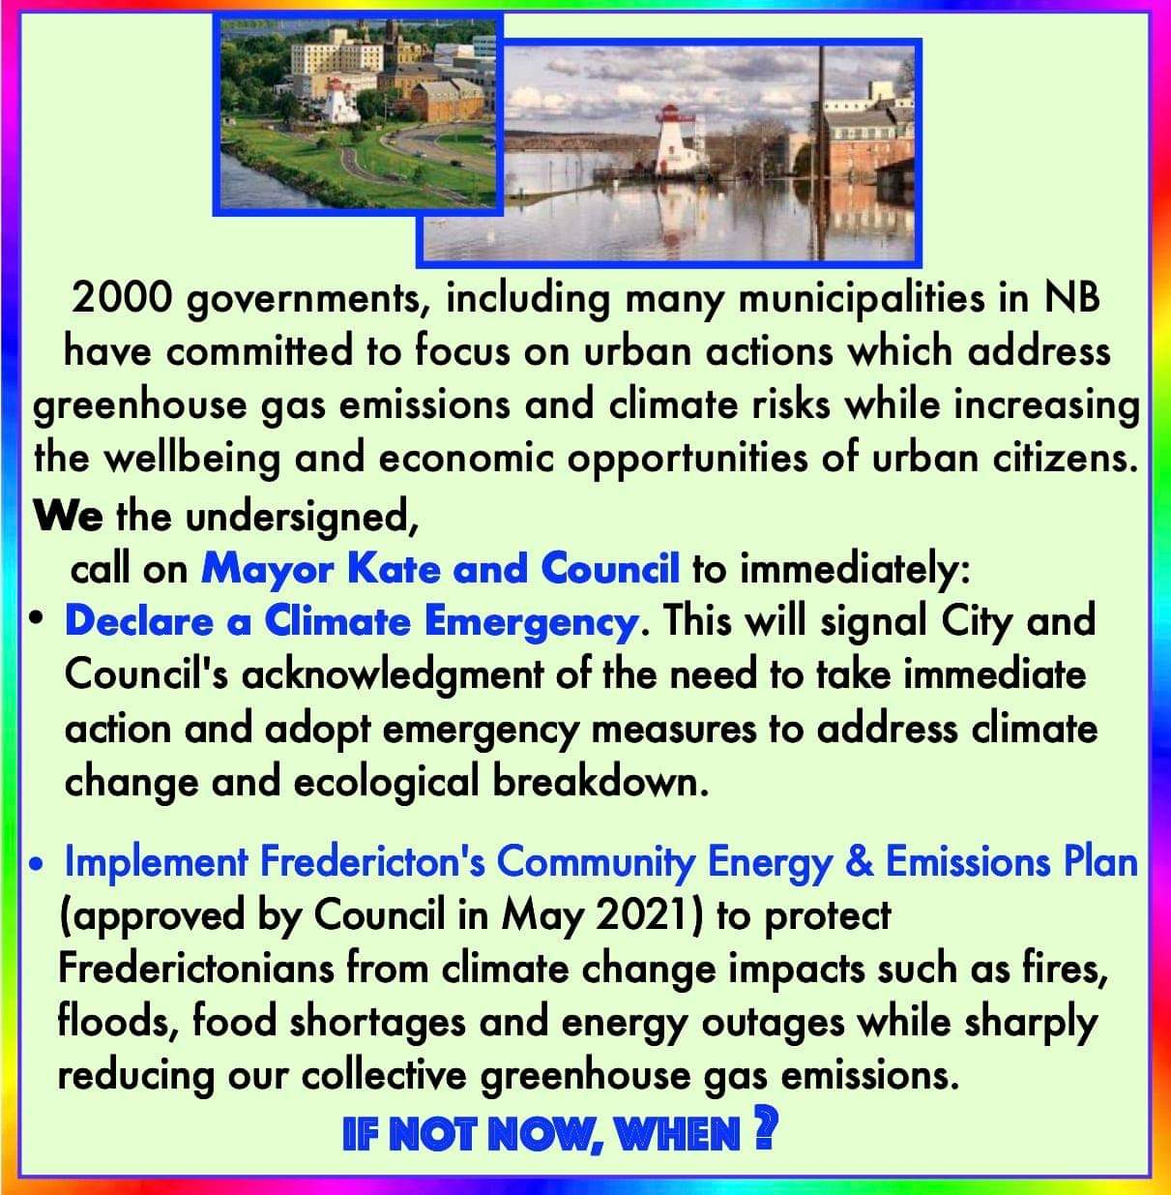
If you are a resident of Fredericton please sign and share this petition. Be part of the solution!

Half Moon Gardens
Grandma had to go to the Hardware Store for a few supplies this week. It is barely the second week of January and there, at the beginning of the shelves where the Christmas decorations were, was a display of planting supplies. Transplant pots and kits, watering cans, and even fertilizer.
Grandma loved the enthusiasm of a new planting year. She always believes the best time to order seeds is in the middle of a snowstorm. It brings hope for new everything.
So maybe Grandma isn’t too far off to talk about gardening in January. Last year I bored my friends with all my talk of fog fences. Finally, I made my fog catcher and have plans to improve it. This year, my buddies will be hearing of half-moon gardens.
Half-moon gardens are semicircle-shaped gardens with soil built up on the downhill side of an arc. It keeps water in the garden.
This method is used where there use to be famine. I even see pictures of where there is volcanic ash and the land is being renewed with half-moon gardens
I once asked where I could find techniques used by people in third-world countries. I was told, “Why bother to learn these things?” as these countries were so far behind in technology, they could offer nothing in knowledge to us, in the rich technical west.
People improvise and find ways to accomplish what needs doing, no matter where they live and what resources they have, to work with.
I expect that somewhere a farmer saw that crops grew in a spot of his land that had a horizontal ridge going down a hill. Making a few more ridges allowed crops to grow better.
Maybe we don’t have water-deprived land here in Nova Scotia and PEI. I seem to recall long dry August days when I am trying to finish growing water-loving plants. Wouldn’t this work well for watermelon? The semi-circle area may allow heat-loving plants a chance to finish growing.
It is worth a try. Anyone that came to my yard last summer knows my fog fence was partway up my hill, in an old box garden. The sides of the box were gone and I had covered the ground to kill weeds and let farrow for a year What a good spot to try half moon gardening this summer. Does anyone else have a slope in their yard and want to try?
Small-scale farming ideas from ANYWHERE in the world can be adapted to backyard gardens in our Diocese.
As usual, I have some reading material
A “How To Do” article from Canadian Mennonite
https://canadianmennonite.org/stories/%E2%80%98half-moon%E2%80%99-agriculture-helps-african-farmers
A West African Project
https://www.researchgate.net/figure/Zai-A-and-half-moon-B-rain-water-harvesting-techniques-for-soil-and-water_fig1_323954881
A twitter site that shows this and more
https://twitter.com/wfp/status/1143504364323127298
An Alberta Farmer article on half moons
https://www.albertafarmexpress.ca/news/half-moon-holes-produce-crops-in-sub-saharan-desert/
Pictures where volcanic ash is being turned into gardens
https://thewaterchannel.tv/thewaterblog/moon-water-harvesting-for-volcanic-wines-in-lanzarote/

Craft – Castles (Editor’s note – with apologies to Grandma, we are a week late posting this craft. If you have small children in your life, save this for a rainy weekend project)
I have been saving this craft for January. You may need to work on it a few days before finished. The journey of a craft is the fun part
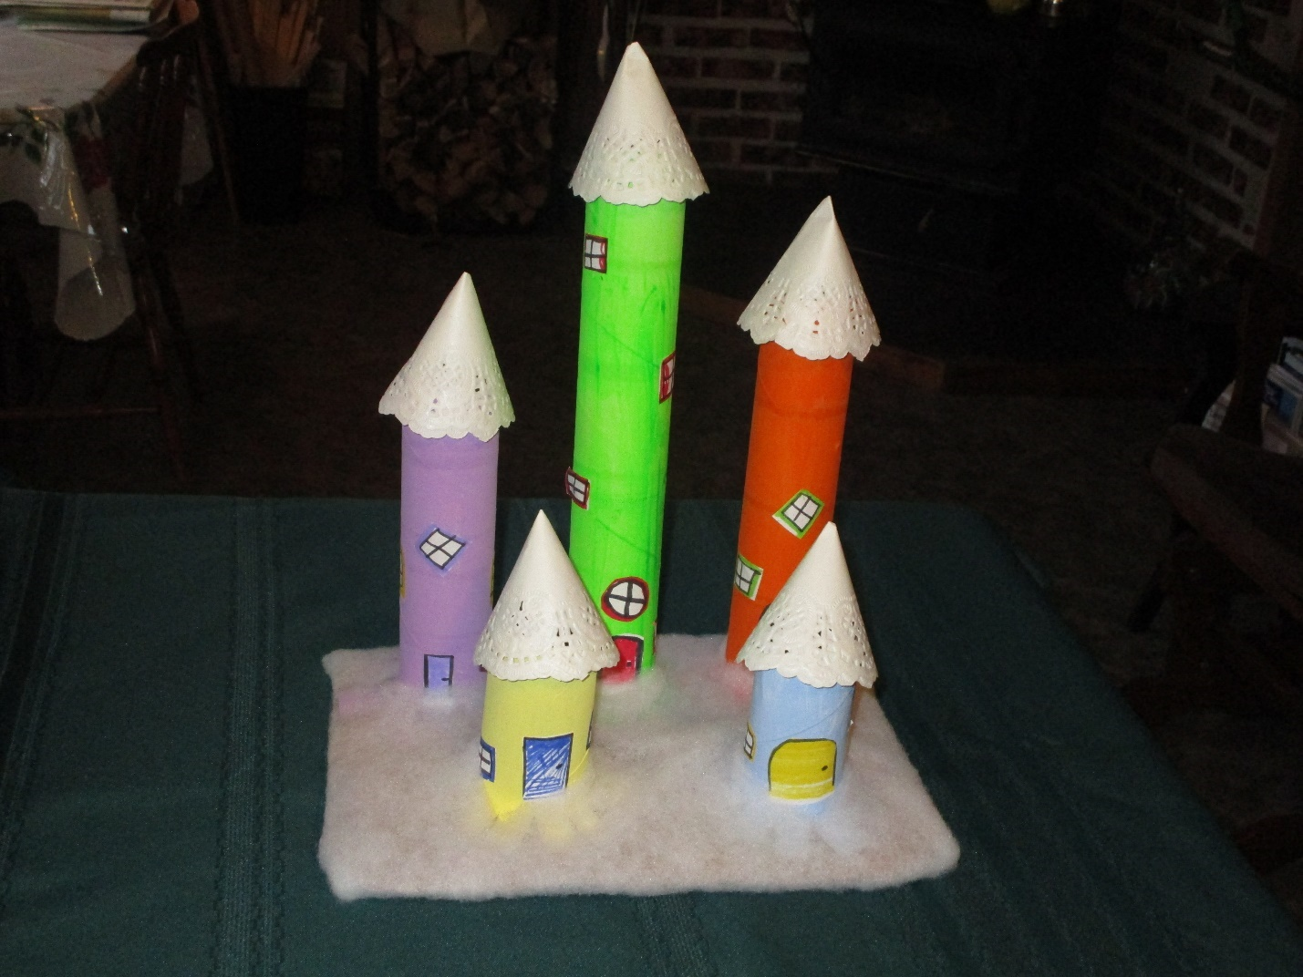
CASTLES
To make a dream castle fit for any Princess or Prince Charming you will need
Paper towels rolls (or two toilet tissue rolls taped together)
A sheet of paper, coloured pencils, scissors, glue
A piece of corrugated cardboard or equal base material
Quilt batting, stuffing or even crumpled paper or paper towel for cloud base or do you want the base to look like ground or grass? A paper doily premade or make one for the turret top
Days before, paint the tubes in interesting or traditional colours
Flange the bottom of the paper towel tubes. (Flange means cutting up the tube to make wedges that can be stapled or glued to the base.)
While waiting for that to dry, take the sheet of paper and draw a door and windows for each tower. Colour in curtains. Cut these out and glue to you tower.
You can make a turret by drawing a circle (trace around a glass). Fold the circle in half and shape to a cone to make the top of the tower. Paper doily turret tops make a fancy look.
Using quilt or craft stuffing, cover the base the towers are sitting on, which hides the flanges. Easy and simple, here is a place the unicorns can gallop or graze in the meadow nearby. I am told that paper towel rolls or rolled newspaper can work just as well to make forts.

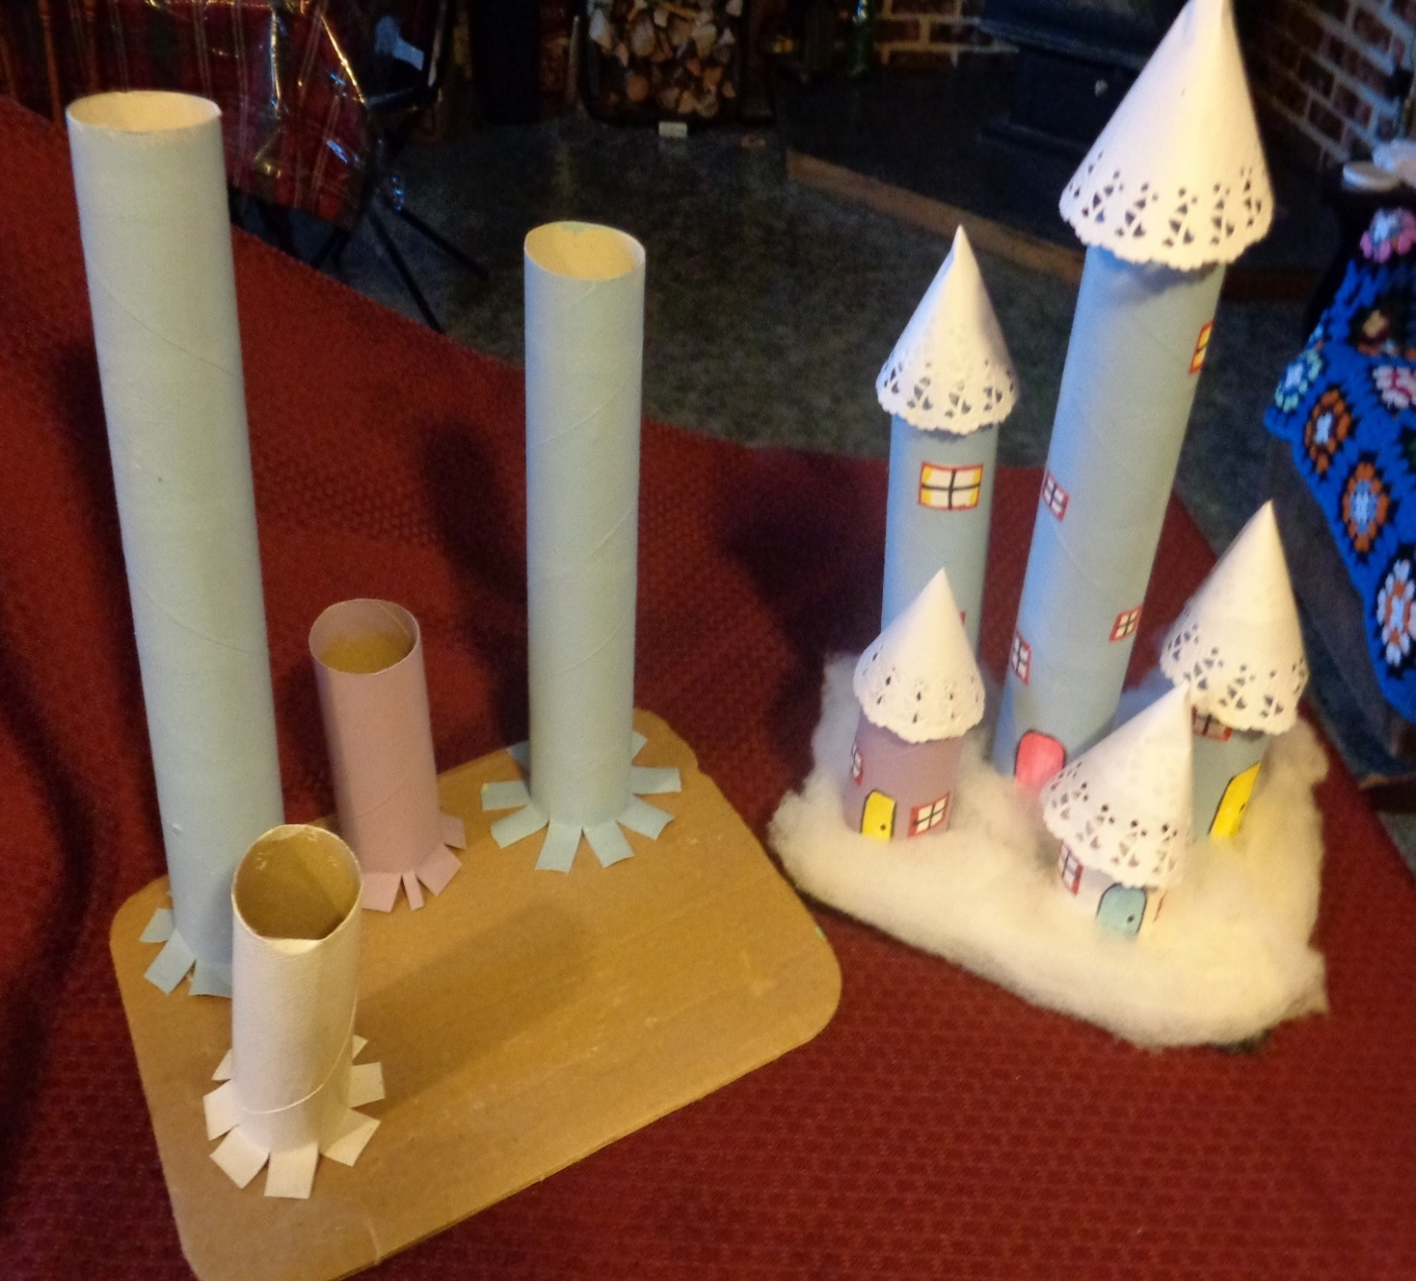
Something to eat
Grandma is lucky enough to have a cookbook that takes any vegetable and gives you several recipes, for both meals and sweets, where that veggie is dominant.
So, I chose carrots
The hard part was choosing what I wanted to cook. Grandma always looks for leftovers to use up. I knew I had “older” corn flakes and was thinking of cereal cookies earlier. Instead, I found CARROT BURGERS. They were such fun to make
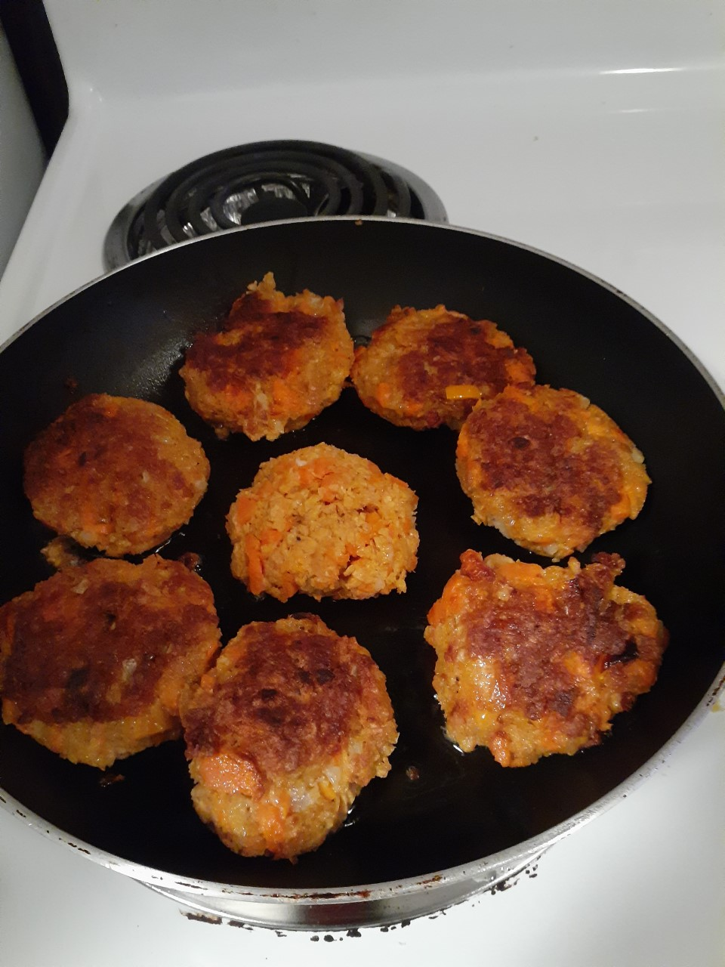
CARROT BURGERS
Boil up 3-4 carrots and mash them (1 ½ cups)
Put in a bowl with
2 cups crushed corn flakes (about 4 cups before crushed)
¼ cup diced green pepper
Onion, pepper, and salt if you use it
Mix together and make about 6 to 8 patties
Heat 2 tbsp oil in a pan and fry them up
Now I used them as the vegetable that night, but, you can put them in a hamburger bun to eat them.
Oh, now I need church to start up again so when we attend St. Cuthbert’s and have our Parish Café get together after service (hopefully) I could heat up a platter and put them in those little slider buns
So easy. So good.
Till next week, Grandma is sending hugs

