November 30, 2021
Email: endionspei@gmail.com Website: nspeidiocese.ca/den
Facebook: Environment Network Diocese of NS & PEI
Welcome to our weekly Enews.

This will be our last Enews until the New Year.

We wish you the blessings of Hope, Love, Joy and Peace in this Season of Advent.
May the Christmas Season fill you with the Blessings of Love, Laughter, Health and Happiness.
May the New Year bring a renewal of the earth through all our efforts.





Thursday Night DEN Gatherings – Our last Thursday Gathering of 2021 will be this week, December 2, 2021 - An Advent Reflection with Rev. Elizabeth Huether
Please join us from 7-8 pm and use the same link as usual. If you do not have it, email endionspei@gmail.com
Nancy Blair, our Thursday Gatherings Moderator, thanks all who joined us in the Thursday Gatherings this fall and all who presented. It has been an informative and fun session.
Praying with the DEN Community - Each Friday at 9:30 we host Morning Prayer live streamed on Zoom. Prayers take shape from different traditions and focus on various aspects of our relationship with Creation. To obtain the link, please email endionspei@gmail.com
Last week we shared with you the links used in a Nature Canada webinar. Rabbi David Ellis noted we did not feature information from a Jewish perspective. We were thrilled to receive this link concerning a “deep commitment to protecting our pollinators through hands-on, nature based Jewish Education and activism.” Please learn more about Shoresh and their Community supported beekeeping: https://shop.shoresh.ca/ourstory

Another excellent link is https://hazon.org/
Hazon is “building a movement that strengthens Jewish life and contributes to a more environmentally sustainable world for all”
Thank you Rabbi David for this information and for sharing in our collective faith that together we can make a difference.

Important Message to BC Government
While B.C. is in the midst of a climate emergency, the RCMP — armed with snipers, canine units, and other military-grade equipment — is raiding sovereign Indigenous territory to ram through a fossil fuel pipeline which will only worsen the climate crisis. After the raid, RCMP burned the cabins at Coyote Camp to the ground mirroring a long standing tactic colonial forces have used to violently remove indigenous people from their land on Wet'suwet'en territories and beyond. After being locked up for three to five days under abusive conditions, all 30 plus Indigenous land defenders, legal observers, and journalists are now out of jail with conditions that attempt to limit access to Wet'suwet'en land and a February 14th court date. With all eyes on BC, a flood of emails from across the country could send a message to Premier Horgan and Minister Cullen that the spotlight won’t go away until they call off the RCMP and halt CGL construction.
In two scathing written rulings, B.C. Supreme Court’s Justice Douglas Thompson determined the vast exclusion zones and media restrictions set up by RCMP officers were unlawful and “seriously and substantially” impacted important liberties. If you didn't send this one last week to the federal minister of Public Safety, please consider doing so today.
Message to Federal Minister of Public Safety re the RCMP

Petition to save Fairview Forest, P.Q.
This community group, set up to save the Fairview Forest, recently finished their 52nd week of gathering to protest. They are demanding that the 50 acres of mature forest and wetland be protected instead of clear-cut for development. All across Canada different groups are fighting to save their forests, and signing petitions is one way to show that we stand together. Their website also offers a letter writing campaign that can be found here: Take Action! – Save Fairview Forest! (sauvonslaforetfairview.org)

Petition to Protect the Okapi Wildlife Reserve
The world is an amazing place filled with unique diversity! This is a gift, but often we prioritize other things. The okapi is a creature living in Central Africa that is closely related to the giraffe but with the stipes of a zebra. Another name for the okapi is the forest giraffe. There are only 30,000 in the world, and this number dwindles as human expansion grows. The Okapi Wildlife Reserve is a World Heritage Site in the Democratic Republic of Congo. Many okapis live here, along with chimpanzees and other rare and endangered animals. Unfortunately, interest in mining is growing here and it comes with many devastating consequences! This petition is asking the government to enforce the environmental laws and to protect the Okapi Wildlife Reserve.

Petition to Ban Single Use Plastics from David Suzuki Foundation
Almost 8,000 tonnes of plastic waste ends up in Canada’s landfills, incinerators, lakes, parks, and oceans….every single day! Our government has promised to do away with non-essential, single-use plastics. We also need the plastics industry to get behind that federal mission. This petition is asking the Canadian government to stop plastic pollution at its source and to move forward by the end of the year with a regulatory ban on non-essential, single-use plastics.

Petition to save Urban Forest in Coquitlam, B.C.
This petition is another plea to save one of Canada’s forests. In the middle of Coquitlam, B.C., there is an urban forest that is home to many breeding bird species and that acts as a wildlife corridor. This forest is one of the last relatively undisturbed natural areas in central Coquitlam, but it has been losing ground as its trees fall to make room for human development. In 2012, approximately 150 large trees were cut down. This petition is asking for that to not happen again, for the City of Coquitlam to keep this forest standing, to allow independent ecological surveys, and to recognize that this is in the best interest of the wildlife and the residents.

Exciting news that the Owl’s Head land “offer to purchase” has been withdrawn. We congratulate everyone who worked so tirelessly on this campaign to save this incredible biodiverse property. The mission now is for permanent legal protection. If you need more information as to why this area needs protecting, please see:
https://saveowlshead.org/

Editor’s Note: Congratulations to Grandma, aka Claudia Zinck, who has won a Call Centre Nova Scotia Community Spirit Award. Claudia tells us writing for this newsletter was part of the reason she won. Congratulations Claudia! You deserve this!
Wind Farms and Agriculture
Last week I showed you how farmers were using the land under solar panels to raise crops.
Grandma thought about wind farms. Windmills are so high in the air and require little space on the ground. Does a windmill affect crops grown near them?
They do.
One group studied the effects on soya beans and corn. Beans of any type will always fight moisture. Moisture makes mould. Mould ruins a bean crop. Anything that reduces the moisture in a bean field is an advantage.
Windmills do that.
If you grew beans in your garden and picked them early morning you know how damp they are. You also will learn that the beans “rust” from being picked when wet. So, if you have a bean field under a windmill, what will happen?
Just regular wind blowing across a field removes moisture and helps dry the beans at the end of a season. Add a windmill, constantly rotating, and you have a moisture removing machine.
Similar to solar panels, windmills help agriculture. All that is needed are people that can figure out which vegetable grows best in different locations.
We want a dry area to finish off beans but, we may not want to grow beets under a windmill. Beets grow underground and need moisture. Would the windmills make it too dry? Grandma doesn’t know for sure, yet. That is why we need farmers and scientists to figure these things out.
The “environment” is not a stand-alone entity. It is part of a circle and is affected by so many different elements. We need people from different backgrounds to help our planet find the best way to help. We are all interconnected.
As usual, I have some reading materials to expand on this general principle.
https://www.agupdate.com/agriview/news/crop/wind-farms-impact-crops/article_bb057e6c-e58b-5990-b4d5-62640803121f.html
https://canwea.ca/communities/land-use/
CRAFT - Christmas Ornament
In the countdown to the big day, it is almost time to decorate. I found a new ornament to make from paper.
Grandma used some colour copy paper but construction paper would work well. Cut 1 inch (25 cm) wide and 12 to 14 inches long, strips of paper. I started with the green and gold, a total of 10 strips (Then try shorter strips and maybe 12 to 16 strips thick.)
Fold one strip in half so you can see where the middle is.
Stacking all the strips together, staple on that middle fold.
Glue the end of the first strip, bend it back to the middle and press to stick together. The second strip gets bent into the spot at the bottom of the first piece and so on.
After I made the first one, I wondered if I could make them out of newspaper. I could. You could spray paint them causing a stiffening effect. Then I tried flyers. The colours were nice and the paper was a bit stronger. What else could we make these ornaments from? If you have the materials keep trying to change the basic idea and make lovely decorations to share with neighbours.
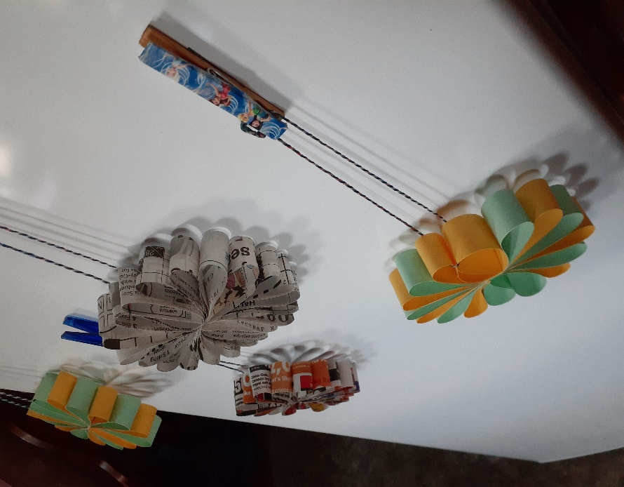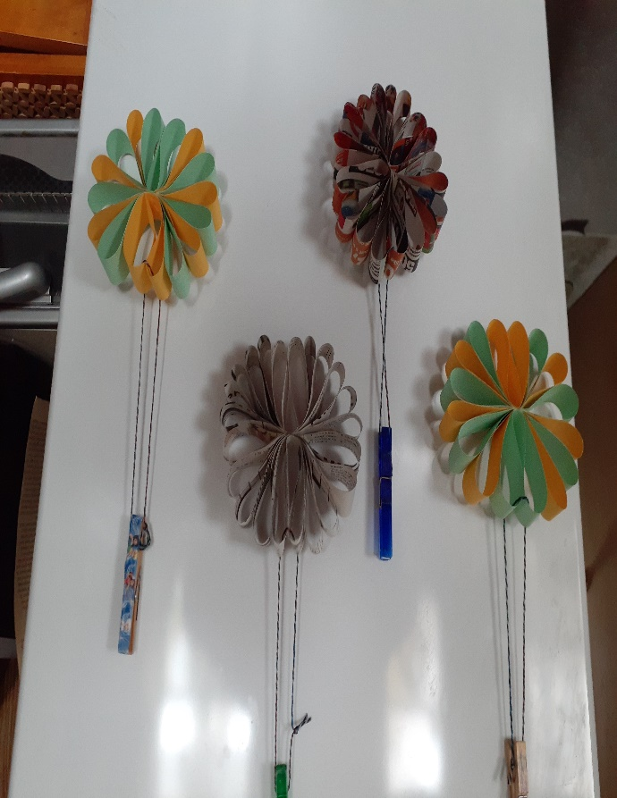
Something to eat
Getting ready for Christmas means baking. I am including my sugar cookies. This was my mother’s recipe and was always available most any time of year. We just sprinkled red or green sugar on them at Christmas.
A double batch makes over a hundred medium-sized cookies.
Sugar Cookies
In one bowl
4 cups flour
2 tsp. baking powder
¼ tsp baking soda

In a bigger bowl, mix together
1 cup butter or margarine
2 cups sugar
2 eggs
2tsp vanilla
Mix the flour mixture into the butter mixture adding about ¼ cup of milk
Roll out the dough, cut out the shapes and fill cookie sheets. Sprinkle sugar on each cookie
Bake 350F for about 8 minutes
Take out when the bottoms are turning brown even if they still look a bit raw.
If I use butter and add a bit of cream instead of milk they are often called shortbreads. They aren’t shortbreads, but I will take the compliment.
We are less than a month away from the big day!. This week I almost finished filling in each category of WANT, NEED, WEAR and READ for my family. I like getting the gifts out of way, (I start collecting in January) so I can enjoy decorating the home and church and being with the children, be they mine or from the community.
Till next week, Grandma is sending hugs,

A Prayer When the Waters are Rising
Lord, all around us the waters are rising.
I feel so helpless, for I cannot stop the rain from falling or the waters from rising.
I feel so powerless, for the current is strong and my body is tired.
I feel so empty, for our possessions are floating away or anchored in the muddy water.
Lord, all around us the waters are rising.
Grant me your strength, since mine is somewhere downstream.
Grant me your patience, since mine is drowning.
Grant me your perspective, since my loss is in replaceable things, not irreplaceable grace.
Give me eyes to see how precious your gifts are: family and friends, faith and mercy.
And Lord, when the waters rise around me in my spirit, and my faith and hope are swept downstream,
help me to remember how you got me through this flood. In Your Son's name.
Amen.
The Rev. John G. Hamilton, FPC, Rochelle,Ill.
https://www.pcusa.org/site_media/media/uploads/pda/pdfs/prayersintimesoftroubleanddisaster.pdf

