November 23, 2021
Email: endionspei@gmail.com Website: nspeidiocese.ca/den
Facebook: Environment Network Diocese of NS & PEI
Welcome to our weekly Enews.
The Diocesan Environment Network (DEN) of the Anglican Diocese of NS & PEI, was formed in response to the Fifth Mark of Mission and the latest addition to our Baptismal Covenant which has become our Mission Statement.
“To strive to safeguard the integrity of creation and sustain and renew the life of the earth.”
To do this we educate and encourage stewardship through social media and liturgies, connect with other environment groups, pray together, celebrate art with each other and grieve together.



Thursday Night DEN Gatherings – there will be no gathering on Nov.25.
The last Thursday Gathering of 2021 - December 2, 2021 -An Advent Reflection

Our last Thursday Gathering of the year will be on Thursday, December 2nd, 7-8 PM. Rev. Elizabeth Huether of PEI will be our guest speaker. I hope you will join us. Thank you to everyone who joined in the Thursday Gatherings this fall.
Nancy Blair (Thursday Gatherings Moderator)

Praying with the DEN Community - Each Friday at 9:30 we host Morning Prayer live streamed on Zoom. Prayers take shape from different traditions and focus on various aspects of our relationship with Creation. To obtain the link, please email endionspei@gmail.com
It's not too late to join the DEN Book Group in our study and discussion of
JULIEN OF NORWICH:
WISDOM IN A TIME OF PANDEMIC…AND BEYOND
BY MATTHEW FOX
Wednesdays at noon, 1200 – 100 pm, November 3 to December 15 via Zoom
We have revised the schedule somewhat and on Wednesday November 17 we will
discuss Chapter 3 "Nature and God are one" and Chapter 4 "The Divine Feminine and the Motherhood of God".
Please contact Stellalord8@gmail.com for more information or the full schedule and discussion questions and
brucelanghus@gmail.com to be added to the book group mailing list. It is not too late to join in.
Last week Nature Canada, Indigenous and faith leaders joined together for a conversation on Nature-based Climate Solutions!
Following are all the links that were shared in the chat that you may find helpful:
Nature Canada
- National Nature-based Climate Solutions project map
- Towards local action on nature-based climate solutions - Toolkit
- Contact: naturebasedsolutions@naturecanada.ca
KAIROS
- www.fortheloveofcreation.ca
- Water Song: Unlearning colonial geographic boundaries towards alignment with watersheds and reconciliation
- Reconciliation in the Watershed workshop reflection
- Contact Beth blorimer@kairoscanda.org
Faith & the Common Good
- Videos including 2020 Winter Webinar Series - The Birds and Bees of Sustainable Gardening: https://www.faithcommongood.org/2020_winter_webinar_series
- Guides including Developing Native Plant Garden Guide: https://www.faithcommongood.org/guides
- Tip sheets including Outdoor Greening Fact Sheets for faith communities:https://www.faithcommongood.org/tip_sheets
- Case Studies including the Outdoor Greening program and the Ottawa Interfaith Sustainable Garden Network program: https://www.faithcommongood.org/case_studies
- Contact Michelle: msingh@faithcommongood.org
EnviroMuslims
- Greening Canadian Mosques: https://www.faithcommongood.org/gcm
- People Planet Pages Book Club: https://www.instagram.com/peopleplanetpages/?hl=en
- Our Climate, Our Stories: https://www.enviromuslims.ca/our-climate-our-stories/
- Contact Saba: enviromuslims@gmail.com
EcoSikh
- https://www.Ecosikh.ca
- https://www.youtube.com/watch?v=caf1XK8Ny1U
- Contact Roop: roop@ecosikh.ca
GreenUmmah
- https://www.greenummah.ca
- Contact Iman: info@greenummah.ca

Petition to Premier Houston to end new offshore oil &gas
As humanity faces a “code red” climate emergency, the Canadian Association of Petroleum Producers (CAPP) is pushing hard to expand offshore exploration and drilling here in Atlantic Canada. Further offshore oil and gas development will put our climate and some of our most important fishing grounds, as well as the communities that depend on them, at unacceptable risk.
Send a message to the Big 5 Banks now! (greenpeace.ca)
Canadian banks play a major role in how our country is developed. The values and needs of our country, environment, and future should be included as it is us who invest in the banks. Right now, RBC, TD, Scotiabank, BMO, and CIBC are all banks that take our money and savings and put them into fossil fuel development. This petition is asking us to stand with Indigenous communities and to send an email to the CEO’s of these banks to tell them to stop supporting fossil fuel colonialism and development.
Petition · Save B​.​C. Wolves · Change.org
In many different countries, wolves are being targeted and killed, and unfortunately Canada is among these countries. Wolves are integral to the ecosystem and they deserve protection. In B.C., wolves are targeting for aerial killing and expanded legalized hunting and trapping.Habitat destruction and human encroachment have hurt the caribou in the area, but blaming and harming wolves is not the answer. This petition is going to the government of British Colombia and asking them to find other solutions and stop their wolf-kill program.

Letter to Canada's Minister of Public Safety
On Friday, award-winning photojournalist Amber Bracken was arrested by the RCMP while on assignment for The Narwhal on Wet’suwet’en territory in northwest B.C. As of Sunday afternoon, Amber is being held in a jail cell in Prince George — along with freelance filmmaker Michael Toledano. These arrests mark just the latest in a long string of illegal RCMP actions against journalists. Journalism is not a crime and the RCMP need to be held accountable for their repeated violations of the rights of the Canadian journalists. The arrested journalists have long been covering the conflict at Wet’suwet’en and the crucial justice, Indigenous rights and environmental issues it raises.
Just Transition – Report from DEN member, Margaret Sagar
“South Shore Council of Canadians notified me that they were gathering outside newly elected Conservative MP Rick Perkins office at noon on Wednesday November 17, 2021 to present a copy of petition for Just Transition to his office. I decided that I could join them and deliver the 25 signatures on paper petition from St James United Church Goodwood (Crossroads Pastoral Charge). (thank you, Diana, for delivering them to me at short notice!) There was a small gathering (20 or so.) Marilyn Keddy and Marion Moore received the petition to add to the 200+ they already had. Final count was 250. They put some of St James with others as they were glad to have signatures from this end of the Constituency. Others were from Bridgewater and Lunenburg. There were a few brief speeches. I asked if I could say something from a faith perspective and was invited to do so. I emphasized the moral responsibility of government to respond with urgency to the climate crisis. The Council had been trying to get an appointment to meet with MP for several weeks, 5 phone calls at least. He was too busy. However, we were able to enter the office and speak initially to a Secretary/receptionist. Then another assistant Stephen appeared- and also spoke with him. I was able to say my piece again to him. The delegation handed over one set of petition and asked that if he was not going to respond by reading it in the House then please would he return the original petition so that it could be submitted to another MP who would commit to doing that. Since Stephen asked me if there was a Just Transition Act ready for the House, I am not sure he knew much about this. It has been promised soon. The South Shore C of C would welcome more petitions, especially from faith communities. If you have contacts with anybody in the South Shore please ask them to carry out this request. All info on Council of Canadians web site.
https://canadians.org/update/hundreds-urge-trudeau-prioritize-just-transition-act-new-parliament
And of course, any petitions to any MP’s welcome. 11 across Canada have committed to date to present in House, including Andy Fillmore.”

Finally an action NOT to take: refrain from Black Friday and CyberMonday unnecessary buying. Hyper-consumption increases greenhouse gas emissions. It uses up valuable land, water and energy. And it worsens the climate crisis. We have to change our ways. . . from David Suzuki Foundation

Two Petitions for Owls Head
Here is an example of a paper petition. This is critical as the legislature does not recognize online ones. Collect 12 signatures and mail to your local MLA.
PETITION TO THE NOVA SCOTIA LEGISLATIVE ASSEMBLY:
We are calling on the government of Nova Scotia to designate as protected Owls Head Provincial Park and all of the provincial parks, nature reserves, and wilderness areas awaiting designation.
Approximately half of what Nova Scotians consider provincial parks are not formally protected. Of our 206 provincial parks, approximately 100 are still awaiting designation. Between undesignated provincial parks, nature reserves, and wilderness areas, there are nearly 200 properties in need of formal protection. In light of the twin crises of biodiversity loss and climate change, we must formally protect these important ecosystems without delay.
Since the large majority of Nova Scotia’s coastline is privately owned, citizens understand that it’s important to preserve both coastal access and coastal ecosystems. Owls Head Provincial Park is a biodiverse coastal headland on the Eastern Shore and an integral component of our protected areas network. It has a history of promised protections dating back to the 1970s. Owls Head Provincial Park has a “globally rare” coastal Broom Crowberry plant ecosystem. It also contains significant wetlands, a wildlife corridor, and habitat for over 85 species of birds, including endangered barn swallows and piping plovers.
In March 2019, the Nova Scotia government secretly removed Owls Head Provincial Park from Our Parks and Protected Areas Plan. Even though that plan was a result of years of public consultations, the delisting took place behind closed doors with ZERO public consultation or notice. The government also secretly entered into a Letter of Offer to sell this site, which had been identified as a Tier 1 (top priority) conservation property. The public only became aware of the secret delisting and offer to sell Owls Head Provincial Park as a result of a whistleblower, freedom of information requests, and investigative journalist Michael Gorman. Nova Scotians are rightfully concerned about the park, the process, and the precedent.
We, the undersigned, call on the government of Nova Scotia to formally protect Owls Head Provincial Park and all of the remaining properties awaiting designation, without delay.
Print Name | Date Signed | Address | Signature
For more information, follow this campaign on:
Facebook: https://www.facebook.com/groups/saveowlshead/about
Instagram: https://www.instagram.com/saveowlshead/
Twitter: https://twitter.com/SaveOwlsHead
Website: https://saveowlshead.org

New Regulator shuts down questions on fish farm oversight in Nova Scotia:
https://www.cbc.ca/news/canada/nova-scotia/new-regulator-shuts-down-questions-on-fish-farm-oversight-in-nova-scotia-1.6251589?fbclid=IwAR0c2ROYn_wFYFL61Y7CV-_d7OWlHnlDwYnzNJO3c1_-rbOPMqR49B5huoQ
There is a great deal of concern about the statement that the newly created Aquaculture Review Board is “not a board of inquiry into the appropriateness or inappropriateness of aquaculture in the province." If you disagree, you are being asked to let that be known to the Minister of Fisheries and Aquaculture, Steve Craig.
Phone number: 902-424-8953
Fax number: 902-428-3145
Address: Department of Fisheries and Aquaculture, 6th floor (Suite 607), WTCC, 1800 Argyle Street, Halifax, Nova Scotia B3J 2R5
Email: MINDFA@novascotia.ca
Link: http://www.novascotia.ca/fish/

Thanks to Nancy Blair for alerting us to this interesting article about what we need now in terms of social movements and the climate crisis.
https://www.larger.us/ideas/the-climate-movement-we-need/
Agrivoltaic
Here is a new word for you, Agrivoltaic. Did you run for a dictionary? Good. It is a great place to start. This one, however, is a new word that may not be in the books yet. You may want to try Google.
It means a space that contains both agriculture and energy collection.
Under a solar array, gardens are planted. The solar panels work first as a roof for a greenhouse effect for young plants in spring. The shade from the panels cut down on water loss. The plants that are grown here make bigger leaves which means more food per plant.
One of the problems that owners of solar arrays faced in the early years were that they needed to hire people to cut the weeds under the solar panels. If they didn’t, the plants would grow up around the panels or across the panels themselves, eliminating their efficiency
If plants wanted to grow there, why not plant there?
It meant changing our idea of how high off-the-ground solar panels should be. How high do you think?
High enough to drive tractors under the tallest ones!
This would cause a bit more work when a solar panel needs repair. Remember seeing our electrical workers on those cranes that are attached to those white trucks. The same thing can be used here.
A vertical money-maker structure is positioned over an agri crop. Then that crop grows better, makes bigger plants, and remains healthy. The farmer now has 2 crops. First, he sells electricity as a cash crop. Then he sells whatever he grew under the solar panels.
As simple a thing as raising the posts for those solar panels a few more feet has changed the way many farmers have come back from nearly selling their farms.
Raising a panel post is not rocket science. Thinking of a way to increase crops on a farm; simply said, that is brilliant!!!
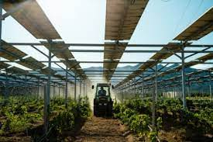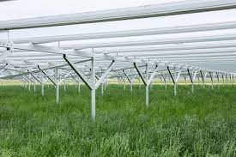
https://solarimpulse.com/solutions-explorer/dynamic-agrivoltaic-system
https://www.jackssolargarden.com/
CRAFT
Keeping with the Christmas theme I am including how to make a homemade gift cardholder.
Although these are great to tuck a card in for a gift, they are also great for coupons, family coupons.
Pretend you have chores to do in your home. I expect any brother or sister would have some also. A nice Christmas gift might be a card that states you will do that chore. Younger siblings, maybe give a coupon to read 5 storybooks. This way you are spreading Christmas out over the year.
Gift Card Holders
I made a template for my cardholder by measuring a card and adding a bit more. It is approximate 8 inches long with the last two inches slanted like an envelope.
Once the pattern is made from paper, find boxboards such as cereal and biscuit boxes to use as your cardholder. Use the plain brown side as the inside of the holder. Cover the outside with wrapping paper. Fold to shape and tape. Once you place the card inside, tie a little ribbon around it to keep it shut.
Plain colours work for both Birthday and gifts throughout the year whereas colourful Christmas wrap works best in December.
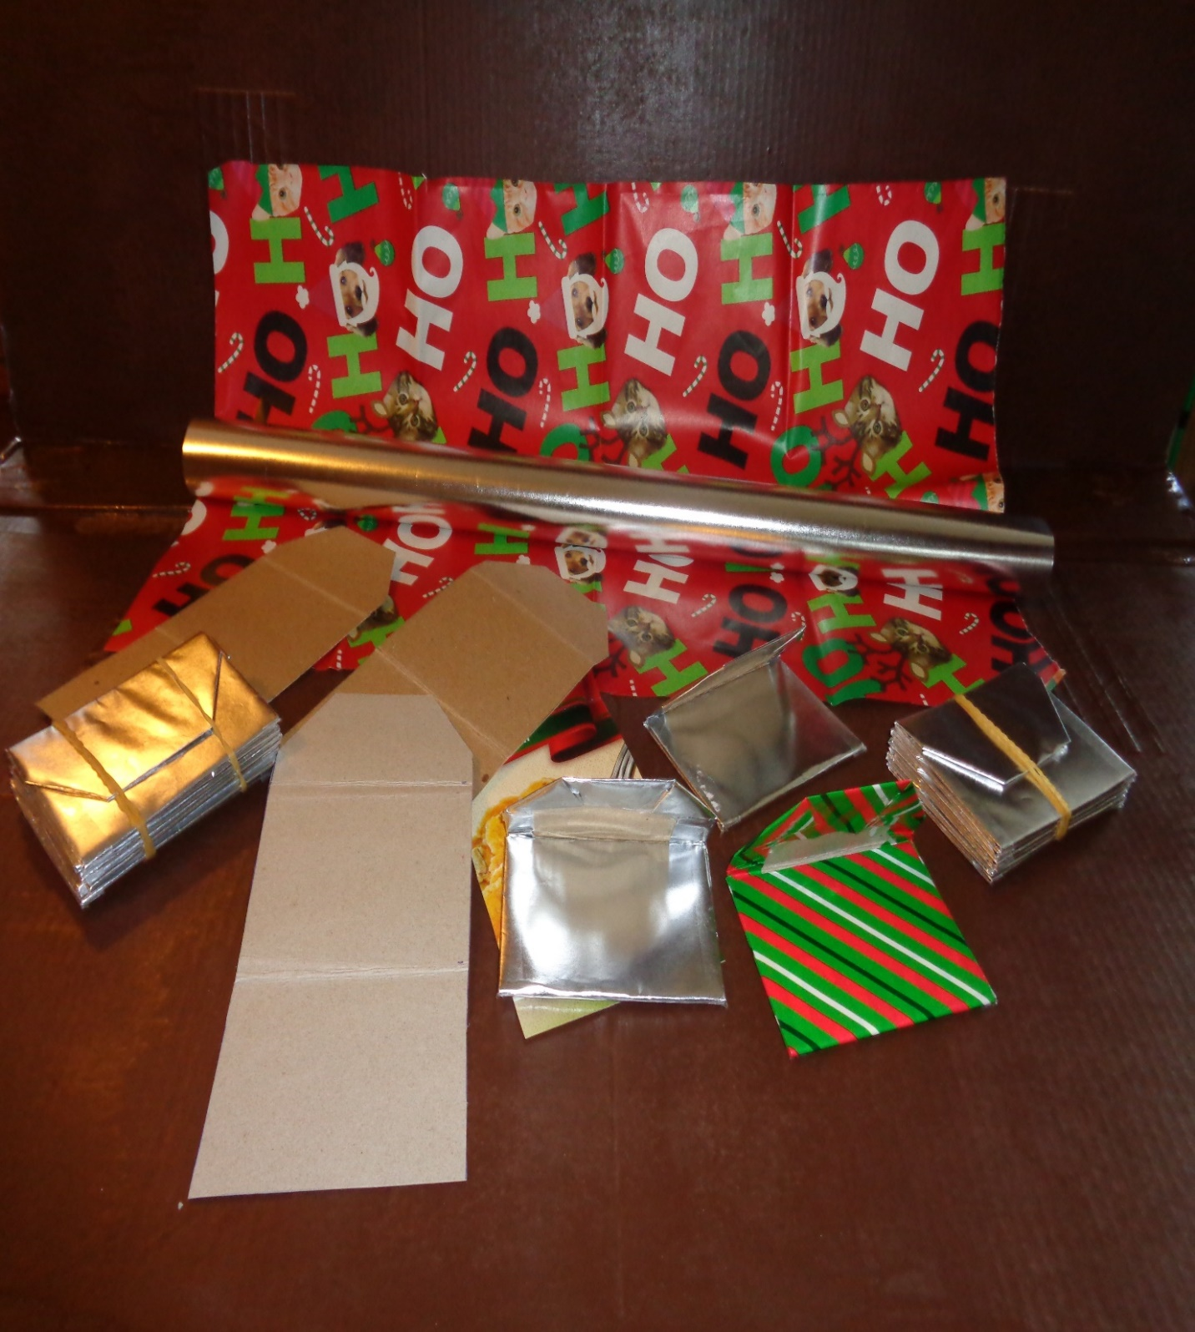
Something to Eat - Meatloaf
If there ever was a rescue food near the holidays, it is meatloaf. We are making extra meals this month. Luckily Grandma has one of those baking pans that have 8 little loaf pans in one pan. It works great when I make sweet loaves for my baskets. It is fantastic for individual servings of “whatever”. Before I had my fancy pan I used loaf pans and cut the meatloaves into induvial chunks and froze them.
Meatloaf is good by itself with mashed potatoes and veggies. It is good for the protein in many other dishes, drizzled with sauces or added with noodles. Better yet it makes a great sandwich, hot or cold. Hot hamburger sandwiches are so yummy.
My recipe has rough amounts for ingredients. The end results are hamburger meat mixed with veggies and spices and thickened to make a solid “loaf” of meat. Remember minced or burger also comes in pork or turkey flavors. More recipes to follow
Meat Loaf
1 large pack or a few smaller packs put together. Think 2-3 pounds or 1-1.5 kilos
Tomatoes, I still use ketchup (half a cup) but add a tin of tomato paste
Onion, a good-sized one chopped up
Spices: salt, pepper, Italian seasoning, or just some savory and garlic
If it is in your fridge add a dash of BBQ sauce, Worchester sauce, or A1 sauce.
1 tin tomato soup
Breadcrumbs or oatmeal to thicken
Put it all in a bowl and mix. The easiest way to mix is to scrub your hands and get in there and squash everything together
Put in loaf pans and cook 350F for 35-45 minutes according to the size of your pans. While you are cooking these cut up a few potatoes, carrots, turnip, etc., and roast on a greased sheet or pan to finish off the first meal.
Use one for supper that night and freeze the rest for the Christmas rush.
When you have 15 minutes, clean a part of your freezer looking for the older dates. Maybe it is pork chops or a small roast. Start thinking of ways to make even 2 meals from what is available
When we had yard sales (or I was comfortable being at them) I would buy casserole dishes. It didn’t matter the colour or shape. I use these for extra meals. Never hurts to have meals ready when someone in the community needs a helping hand. If it was one of these yard sale casseroles that went out, I just don’t worry if it comes back. They do come back. One week a few years ago I went from hardly any on my extra shelf to overflowing again.
Till next week. Grandma is sending hugs.
A prayer for our earth
All-powerful God, you are present in the whole universe and in the smallest of your creatures.
You embrace with your tenderness all that exists.
Pour out upon us the power of your love,
that we may protect life and beauty.
Fill us with peace, that we may live
as brothers and sisters, harming no one.
O God of the poor,
help us to rescue the abandoned and forgotten of this earth, so precious in your eyes.
Bring healing to our lives,
that we may protect the world and not prey on it,
that we may sow beauty, not pollution and destruction. Touch the hearts
of those who look only for gain
at the expense of the poor and the earth.
Teach us to discover the worth of each thing,
to be filled with awe and contemplation,
to recognize that we are profoundly united
with every creature as we journey towards your infinite light.
We thank you for being with us each day.
Encourage us, we pray, in our struggle
for justice, love and peace.
https://www.faithclimateactionweek.org/prayers-and-climate-blessings/

