November 16, 2021
Email: endionspei@gmail.com Website: nspeidiocese.ca/den
Facebook: Environment Network Diocese of NS & PEI
Welcome to our weekly Enews.
The Diocesan Environment Network (DEN) of the Anglican Diocese of NS & PEI, was formed in response to the Fifth Mark of Mission and the latest addition to our Baptismal Covenant which has become our Mission Statement.
“To strive to safeguard the integrity of creation and sustain and renew the life of the earth.”
To do this we educate and encourage stewardship through social media and liturgies, connect with other environment groups, pray together, celebrate art with each other and grieve together.



Thursday Night DEN Gatherings – there will be no gatherings on Nov.18th or 25th.
The last Thursday Gathering of 2021 - December 2, 2021 -An Advent Reflection

Our last Thursday Gathering of the year will be on Thursday, December 2nd, 7-8 PM. Rev. Elizabeth Huether of PEI will be our guest speaker. I hope you will join us. Thank you to everyone who joined in the Thursday Gatherings this fall.
Nancy Blair (Thursday Gatherings Moderator)

Praying with the DEN Community - Each Friday at 9:30 we host Morning Prayer live streamed on Zoom. Prayers take shape from different traditions and focus on various aspects of our relationship with Creation. To obtain the link, please email endionspei@gmail.com
It's not too late to join the DEN Book Group in our study and discussion of
JULIEN OF NORWICH:
WISDOM IN A TIME OF PANDEMIC…AND BEYOND
BY MATTHEW FOX
Wednesdays at noon, 1200 – 100 pm, November 3 to December 15 via Zoom
We have revised the schedule somewhat and on Wednesday November 17 we will
discuss Chapter 3 "Nature and God are one" and Chapter 4 "The Divine Feminine and the Motherhood of God".
Please contact Stellalord8@gmail.com for more information or the full schedule and discussion questions and
brucelanghus@gmail.com to be added to the book group mailing list. It is not too late to join in.
Do you know a young person struggling with Climate Anxiety?
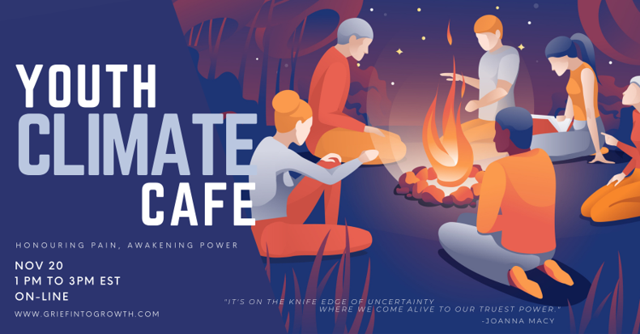
We’re writing about our upcoming Youth Climate Cafe. You may have heard of the recent global survey of 10,000 young people, exploring their responses to the climate crisis. 59% reported that they were very or extremely worried about climate change, and more than 50% felt sad, anxious, angry, powerless, helpless, and guilty.
It’s vitally important that young people have places to be heard, validated and supported, and so we're offering our first Youth Climate Cafe on November 20th, on-line, from 1-3 pm (with a long break halfway). It will follow the spiral of the Work that Reconnects and offer youth a safe space for reflection, interaction with peers, and an introduction to a set of tools to help navigate climate anxiety.
Who is this for? Young people age 14-18 who:
- are generally aware of what is happening with climate change and the various responses/possible solutions;
- may be experiencing feelings of sadness, anxiety, anger, powerlessness or guilt with respect to global challenges;
- are looking for a sense of hope, power and community as they engage with these concerns.
Note that this isn’t a space to focus on the details of the climate crisis or the solutions, but to explore our emotional responses and the wisdom they offer, and to practice ways of resourcing to inform our lives and actions.

You can find all the event details here: https://www.griefintogrowth.com/event-details/youth-climate-cafe
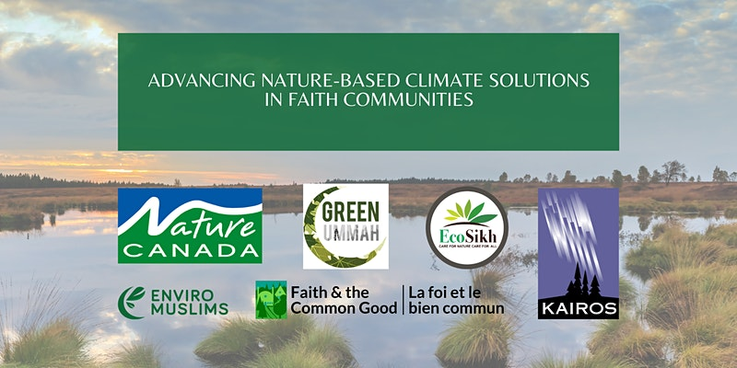
Join Nature Canada, Indigenous and faith leaders for a conversation on Nature-based Climate Solutions! TONIGHT
We would like to invite you to this interactive Zoom gathering on Tuesday, November 16 from 6:30-9:00 pm EDT, to build knowledge and capacity for action by faith-based communities on nature-based climate solutions.
For more information and to register:
https://www.eventbrite.ca/e/advancing-nature-based-climate-solutions-in-faith-communities-tickets-183527464587

Letter against offshore oil and gas exploration

As humanity faces a “code red” climate emergency, the Canadian Association of Petroleum Producers (CAPP), a powerful industry lobbying group, is pushing hard to expand offshore exploration and drilling here in Atlantic Canada. Further offshore oil and gas development will put our climate and some of our most important fishing grounds, as well as the communities that depend on them, at unacceptable risk.
Petition for Just Transition Act
COP26 has finished. Big Oil flooded Glasgow with over 500 delegates, outnumbering the summit’s official Indigenous constituency by nearly two to one. Fossil fuel lobbyists outnumbered delegates from any single country. The decisions Canada’s politicians make in the months ahead are directly linked to the future of those island nations and our whole shared planet. People and planet must be put ahead of corporate profits. 350.org are going to hold a rally outside the PM’s office and deliver all those signatures directly to his door on the day Parliament resumes to make the biggest impact possible. Can you sign the petition now and help us hit 10k before the action?

Endangered Mainland moose habitat is being destroyed as you read this. One government after another has failed to follow its own law. The Endangered Species Act requires the government to identify core habitat for any species within a year of it being listed as endangered. Eighteen years later it still hasn’t happened.Rocky Point Lake is one of the areas in Southwest Nova Scotia land defenders protected with blockades last year – until they were arrested. The Assembly of Nova Scotia Mi’kmaw Chiefs has demanded the cutting stop. They have demanded consultation and asserted stewardship rights. This government is ignoring their demands. Extinction Rebellion are asking people to visit your MLA’s office this coming week, November 15-19th. Ask them to do everything in their power to stop the cut right now. Demand the government respect Mi’kmaw rights. Make an appointment and follow up. Wherever we live in the province, this is our business. Call WestFor and Minister Tory Rushton. Ask them to stop the harvesting at Rocky Point Lake right now. WestFor is the sawmill consortium in charge of cutting on crown land in Western Nova Scotia. Their number for concerns and comments is 902-210-7073. Tory Rushton is the Minister of Natural Resources and Renewables. His number at DNRR is 902-424-5935. His constituency number is 902-597-4039. Join us for a rally outside the DNRR offices at 1701 Hollis St, Halifax on Wednesday, November 24th at 1pm. The moose are coming to town. . .

Petition to Protect Waters from Mining
This petition is asking President Biden to take more action in protecting the boundary waters in Minnesota. There are two mining leases that are still open and would leak sulfuric acid and toxic heavy metals into a watershed, contaminating Ojibwe land and the wildlife and natural beauty of the area. Canadians can have a say and help to protect the waters that we all rely on.
Petition to Protect Polar Bears
In the beginning of November, polar bears are starting their migration to their winter habitat. Without aggressive climate change mitigation, polar bears will not survive. Melting ice and a warming planet are not the only things disturbing the natural cycle of polar bears, human interactions are also a major threat. Those on the front lines have developed initiatives such as a bear-spotting hotline and a removal of human food sources. This petition asks our government to provide more funding to those who are working to help protect the polar bears' journey.

Two Petitions for Owls Head
Here is an example of a paper petition. This is critical as the legislature does not recognize online ones. Collect 12 signatures and mail to your local MLA.
PETITION TO THE NOVA SCOTIA LEGISLATIVE ASSEMBLY:
We are calling on the government of Nova Scotia to designate as protected Owls Head Provincial Park and all of the provincial parks, nature reserves, and wilderness areas awaiting designation.
Approximately half of what Nova Scotians consider provincial parks are not formally protected. Of our 206 provincial parks, approximately 100 are still awaiting designation. Between undesignated provincial parks, nature reserves, and wilderness areas, there are nearly 200 properties in need of formal protection. In light of the twin crises of biodiversity loss and climate change, we must formally protect these important ecosystems without delay.
Since the large majority of Nova Scotia’s coastline is privately owned, citizens understand that it’s important to preserve both coastal access and coastal ecosystems. Owls Head Provincial Park is a biodiverse coastal headland on the Eastern Shore and an integral component of our protected areas network. It has a history of promised protections dating back to the 1970s. Owls Head Provincial Park has a “globally rare” coastal Broom Crowberry plant ecosystem. It also contains significant wetlands, a wildlife corridor, and habitat for over 85 species of birds, including endangered barn swallows and piping plovers.
In March 2019, the Nova Scotia government secretly removed Owls Head Provincial Park from Our Parks and Protected Areas Plan. Even though that plan was a result of years of public consultations, the delisting took place behind closed doors with ZERO public consultation or notice. The government also secretly entered into a Letter of Offer to sell this site, which had been identified as a Tier 1 (top priority) conservation property. The public only became aware of the secret delisting and offer to sell Owls Head Provincial Park as a result of a whistleblower, freedom of information requests, and investigative journalist Michael Gorman. Nova Scotians are rightfully concerned about the park, the process, and the precedent.
We, the undersigned, call on the government of Nova Scotia to formally protect Owls Head Provincial Park and all of the remaining properties awaiting designation, without delay.
Print Name | Date Signed | Address | Signature
For more information, follow this campaign on:
Facebook: https://www.facebook.com/groups/saveowlshead/about
Instagram: https://www.instagram.com/saveowlshead/
Twitter: https://twitter.com/SaveOwlsHead
Website: https://saveowlshead.org
Eye Opening piece on Facebook by Sydnee Lynn who grew up on this land. Look for the post shared by RobBright.
https://www.facebook.com/groups/1028161757303350/?hoisted_section_header_type=recently_seen&multi_permalinks=4500830360036455

FROM : https://novascotia.ca/news/release/?id=20211108001
The Province is updating the policy that protects old-growth forests on Crown land and is seeking public feedback.
The current policy has been in place since 2012. The revised draft policy incorporates advancements in technology and research over the past decade.
“Old-growth forests are an important part of the province’s biodiversity and must be maintained and protected,” said Natural Resources and Renewables Minister Tory Rushton. “Crown land belongs to all of us. We’ve heard from stakeholder groups about the draft policy, and now we want to give the public the chance to provide their feedback as we look to change the way Crown land is managed in this province.”
The draft policy can be found here: https://novascotia.ca/old-forest-policy-consultation/ . Written submissions will be accepted until December 8.
Old-growth forests will be included in the conservation zone of the ecological forestry triad model, as recommended in Prof. William Lahey’s report on forestry practices in Nova Scotia.
Once finalized, the new policy will be incorporated into the department’s process to review and approve harvest applications.
https://novascotia.ca/old-forest-policy-consultation/?fbclid=IwAR3CCl6WfIEKtsy_CXtrsw-oSqXVTTj9qzs9aEWoLJq84pE7SEYyqmjkR4A
“….people know the climate crisis is serious, and that not enough is being done to tackle it. So the real question………….. is this: Can we allow ourselves to be changed by what we already know?” writes Tynette Deveaux in her blog by that name. Tynette asks us: How will you be changed by what you know?
Read more here:
https://www.sierraclub.ca/en/civicrm/mailing/view?id=2365&reset=1&fbclid=IwAR2fcUERPjNA8o5H7-v0I_DagQR9Wfd2D_BRrQejMe-aCf_FJq8IpefNLmk

Kudos to two of our DEN members! Louisa Horne was interviewed for CBC’s podcast White Coat, Black Arts The Dose on Why Tapping into your 5 senses with a walk in the woods can counter climate anxiety. Read the article here:
https://www.cbc.ca/radio/whitecoat/eco-climate-anxiety-antidote-1.6237103

and listen to one of our DEN coordinators, Nancy Blair, speak on Eco-Anxiety.
Holiday Prep
Finally, the gardens can wait till next year. Even the bean poles are in the shed. This is the month I work between extra cleaning and just organizing for the holidays.
Cleaning comes easy when you are a fan of www.flylady.net Once upon a time, this lady felt overwhelmed just trying to keep her house as tidy as she wanted. She made up a system that when followed, leaves you with a clean house and extra time for something you want to do. It works! Each week has a zone in your house to concentrate on with a list of chores. At the end of the month you start over again realizing you have decluttered a lot and less work is needed to clean. Try it sometime.
Then comes the holiday gift-giving organization. Grandma has a few plastic tubs where all year long she finds items and tucks them away. I know the pandemic slowed down shopping. It taught me I can do shopping all at once. I just follow the rule for my closest family with
Something you want
Something you need
Something to wear, and
Something to read.
There are struggles to find something in each category for each person. The teenager will read anime or cartoon books. The big guy will read a hunting or car magazine. That first year “out on your own” person could use a box of shampoo, deodorant, liquid soap etc.
When that fails to meet gift needs, consider making memories. Movie tickets or a card to dine out, especially if it involves a group, just may work.
Parents, consider doing a toy purge before the next gifts come in. Is there something your little one outgrew? Local hospitals will accept toys for their playrooms. Maybe a local church is having a new-to-you sale. In Metro, the Diabetes society will even pick up items (pandemic rules allowing). Clean out what you have to allow new in your life
The baking and decorating are next month’s concerns, It is time to get gift wraps ready. Time to save certain size boxes, even paint them so they will just require a ribbon. I am including how to make gift bags from newspaper but consider saving potatoes chip bags. Gently turn the bag inside out to show off that silver lining. Scrub them up with soap and water. Folding the top, punching a couple holes and adding a ribbon rope makes the best homemade gift bag.
All these things help the planet. We all could name a product we could buy but if everyone just reused or re-purposed one thing then we are HELPING the planet. Big things start in small packages.
Newspaper Gift Bags
Although I am sure we all save and re-use gift bags, it also nice to know how to make your own. These are made with two full sheets of newspaper, an empty cereal box, tape, a one-hole punch and some ribbon or twine.
Wrap the cereal box in newspaper allowing over hang at the bottom to fold in and tape. Tape where the newspaper finished wrapping around the box. Pull the cereal box out. I usually fold inwards at the top to make a smooth finish. Punch two holes on each side and attach the ribbon or twine.
At this point the artist comes out. Colour with markers, crayons or paint. Colour a picture from a coloring book and glue it to one or both sides of the bag. Make the bag from butcher paper or recycled gift wrap or just the comic pages of a newspaper.
After Christmas, pull off the ribbons and use the bags for fire starters
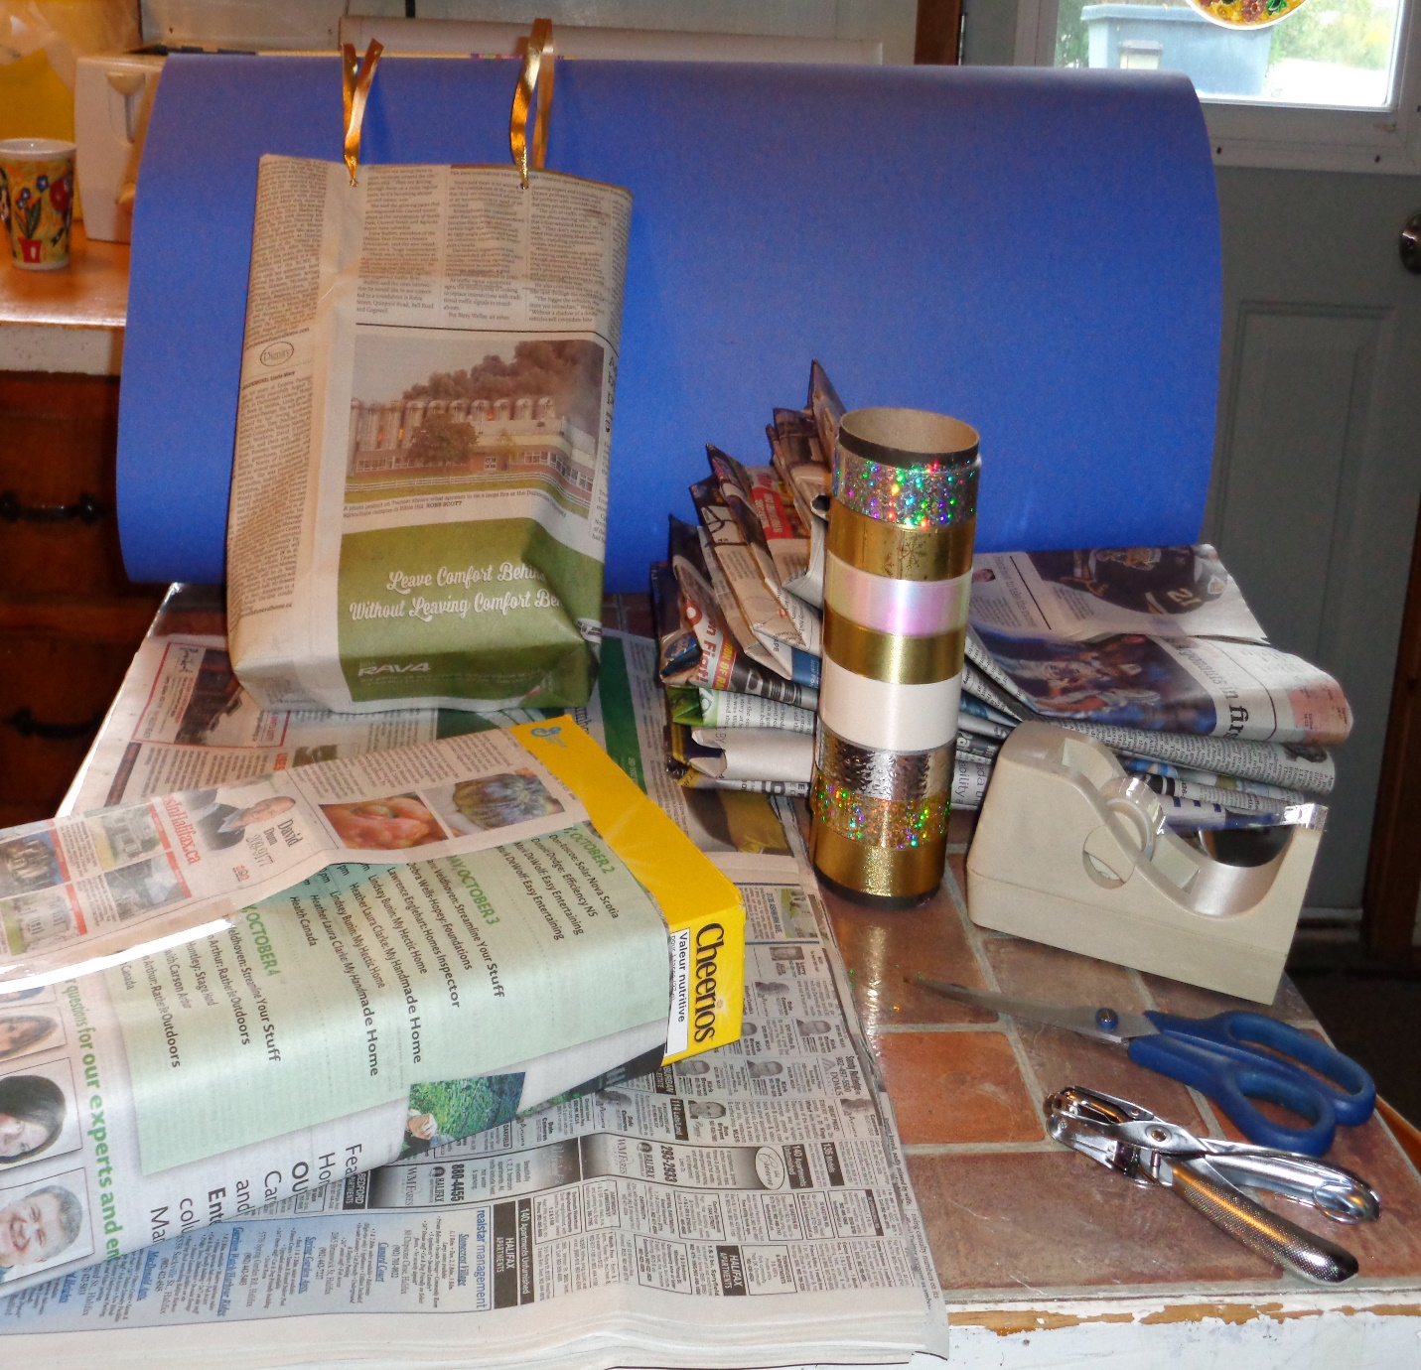
Something to eat
From now on the days will get busy. I am including my Chilli Mac and Cheese recipe. Mix this together in a slow cooker and plug this in after breakfast before you start the big project or leave to do chores. If you have a big family this will feed them. For just Nana and I this makes one meal that night and freezes another three meals for later. Goes great with a side salad. It is a great meal to send to that neighbour down the street living alone.

Chilli Mac and Cheese.
1 big Package hamburger
1 onion
2-4 cloves garlic
Peppers, around a cup
1 tin red kidney beans
1 tin black beans
2 cups grated cheese
1 can tomato paste
1 can diced tomatoes
2 cups macaroni (or any pasta)
A mixture of ½ tsp. oregano and red pepper and 2 heaping tsp. of chilli powder

Brown the hamburger, drain fat, dump in the crock pot.
Add everything else (unless when prepping the night before, leave out the macaroni until you plug it in). If there is any extra older cheese in your fridge cut it up small and throw it in. One grandbaby likes to add a handful of shredded cheese to his bowl while it is still hot. Cook 6 hours on low or 4 hours on high in a slow cooker. Come supper, just ladle it up. Makes the house smell great to come home to.

Prayer of Stewardship by Catholic Relief Services
God of all Creation,
At the beginning of time
You placed a single mandate on humankind
To be stewards of Creation
To replenish and nurture all generations
What you have made
We kneel today amid that same Creation-
A world that is, in many ways, more splendid than ever
But, in too many ways, scarred beyond recognition
Turn us from our unmindfulness
Help our tough be light
Help us renew the worlds that supports us
So we may once more know Creation
As it was in the beginning
A https://www.faithclimateactionweek.org/prayers-and-climate-blessings/men

