November 9, 2021
Email: endionspei@gmail.com Website: nspeidiocese.ca/den
Facebook: Environment Network Diocese of NS & PEI
Welcome to our weekly Enews.
The Diocesan Environment Network (DEN) of the Anglican Diocese of NS & PEI, was formed in response to the Fifth Mark of Mission and the latest addition to our Baptismal Covenant which has become our Mission Statement.
“To strive to safeguard the integrity of creation and sustain and renew the life of the earth.”
To do this we educate and encourage stewardship through social media and liturgies, connect with other environment groups, pray together, celebrate art with each other and grieve together.



Thursday Night DEN Gatherings – November 11th – Cancelled in honour of Remembrance Day.

Praying with the DEN Community - Each Friday at 9:30 we host Morning Prayer live streamed on Zoom. Prayers take shape from different traditions and focus on various aspects of our relationship with Creation. To obtain the link, please email endionspei@gmail.com
UN Climate Change Conference – Programme of Events from the COP26 Green Zone. https://ukcop26.org/the-conference/green-zone-programme-of-events/?mc_cid=a84d0a5ea2&mc_eid=8928db02a

It's not too late to join the DEN Book Group in our study and discussion of
JULIEN OF NORWICH:
WISDOM IN A TIME OF PANDEMIC…AND BEYOND
BY MATTHEW FOX
Wednesdays at noon, 1200 – 100 pm, November 3 to December 15 via Zoom
Why and how does Revelations of Divine Love by Julien of Norwich, the 14th century anchoress speak to so many people today? What can she (through the eyes of Michael Fox) tell us about our reactions during a time of pandemic and climate change in the context of what she reveals about God's love for all of creation (including us)?
Please contact Bruce Langhus <brucelanghus@gmail.com> to be put on the Book Group Mailing
List for the zoom link and Stella Lord <stellalord8@gmail.com> if you would like more information and/or the book study outline, including the Introduction to Julien.

This live-streamed, participatory series looks at a wide range of systems and materials used in natural buildings, and is grounded in permaculture design principals. Participants will receive an introduction to major elements of natural building design and construction, and have opportunities to share questions about projects they may be working on. The journey begins with where to site a building, and moves through wall systems, roof and foundation options, and natural finishes.
The program is a mix of lecture and experiential learning. Each week there will be out-of-class work to practice ideas being explored in-class. At the end of the series students will understand: what to look for in siting a building; heating, cooling and energy options; pros/cons and characteristics of different natural materials for wall, roof and foundation systems. Space is limited. Please call Charles should you have any questions. (902) 829-2264, or the Deanery 902-845-1888
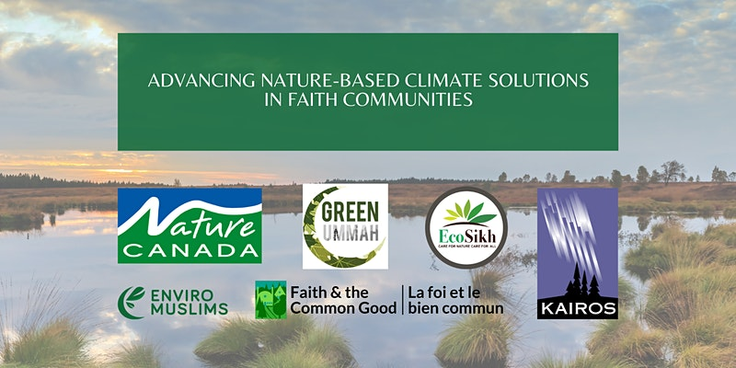
Join Nature Canada, Indigenous and faith leaders for a conversation on Nature-based Climate Solutions!
We would like to invite you to this interactive Zoom gathering on Tuesday, November 16 from 6:30-9:00 pm EDT, to build knowledge and capacity for action by faith-based communities on nature-based climate solutions.
For more information and to register:
https://www.eventbrite.ca/e/advancing-nature-based-climate-solutions-in-faith-communities-tickets-183527464587

Canada’s healthcare emissions are the third-largest in the world per capita. WHO has an initiative for resilient and low-carbon health systems. Dr. Courtney Howard from CAPE (Canadian Association of Physicians for the Environment) is in Glasgow at COP26 and asked newly appointed Minister of Environment and Climate Change Steven Guilbeault if Canada would sign on to the WHO pledge to decarbonize healthcare. Apparently, Minister Guilbeault could be willing but needs the support of the Minister of Health, Jean-Yves Duclos. CAPE is asking citizens to let our Ministers of Health and of the Environment and Climate Change know that you believe Canada should sign the WHO initiative for resilient and low-carbon health systems? Sample email below:
Dear Ministers Duclos and Guilbeault,
I prioritize the health of people in Canada and around the world. Functional health care depends on a stable climate, and Canada’s health care system contributes the third-highest emissions per capita in the world. We can do better. We ask that you demonstrate a commitment to sustainable, climate-leading health care by signing the WHO initiative for resilient and low-carbon health systems today.
All the best,
[Your Name]
[Your postal code]
The email addresses are: ministre-minister@ec.gc.ca and Jean-Yves.Duclos@parl.gc.ca

Two Petitions for Owls Head
On Nov 3rd, 2021, Bill 19, a private member's bill, was defeated. The Owls Head Act was a bill that would have strengthened the protections of pending provincial parks and wilderness areas in Nova Scotia. It would have ensured that these properties (not yet legally protected) couldn’t be delisted without public consultation. The group Save Owls Head Provincial Park urge us to sign both petitions (an easy electronic one and the formal one to the legislature - a paper one - get your friends and neighbours to sign and mail in) The link to both petitions is above. Following is a link to further information. For more information: https://saveowlshead.org/about/faq/
Here is an example of a petition. Collect 12 signatures and mail to your local MLA.
PETITION TO THE NOVA SCOTIA LEGISLATIVE ASSEMBLY:
We are calling on the government of Nova Scotia to designate as protected Owls Head Provincial Park and all of the provincial parks, nature reserves, and wilderness areas awaiting designation.
Approximately half of what Nova Scotians consider provincial parks are not formally protected. Of our 206 provincial parks, approximately 100 are still awaiting designation. Between undesignated provincial parks, nature reserves, and wilderness areas, there are nearly 200 properties in need of formal protection. In light of the twin crises of biodiversity loss and climate change, we must formally protect these important ecosystems without delay.
Since the large majority of Nova Scotia’s coastline is privately owned, citizens understand that it’s important to preserve both coastal access and coastal ecosystems. Owls Head Provincial Park is a biodiverse coastal headland on the Eastern Shore and an integral component of our protected areas network. It has a history of promised protections dating back to the 1970s. Owls Head Provincial Park has a “globally rare” coastal Broom Crowberry plant ecosystem. It also contains significant wetlands, a wildlife corridor, and habitat for over 85 species of birds, including endangered barn swallows and piping plovers.
In March 2019, the Nova Scotia government secretly removed Owls Head Provincial Park from Our Parks and Protected Areas Plan. Even though that plan was a result of years of public consultations, the delisting took place behind closed doors with ZERO public consultation or notice. The government also secretly entered into a Letter of Offer to sell this site, which had been identified as a Tier 1 (top priority) conservation property. The public only became aware of the secret delisting and offer to sell Owls Head Provincial Park as a result of a whistleblower, freedom of information requests, and investigative journalist Michael Gorman. Nova Scotians are rightfully concerned about the park, the process, and the precedent.
We, the undersigned, call on the government of Nova Scotia to formally protect Owls Head Provincial Park and all of the remaining properties awaiting designation, without delay.
Print Name | Date Signed | Address | Signature
For more information, follow this campaign on:
Facebook: https://www.facebook.com/groups/saveowlshead/about
Instagram: https://www.instagram.com/saveowlshead/
Twitter: https://twitter.com/SaveOwlsHead
Website: https://saveowlshead.org
Glass
This week a line from a TV show telling how glass can take a million years to break down, got Grandma thinking about glass as a resource.
I read this week; “Recycling one glass bottle saves enough energy to power a normal light bulb for about four hours.
(https://www.conserve-energy-future.com/environment-facts.php)
That means that the difference between making a glass bottle from its’ original elements to a bottle and making a glass bottle from recycled glass, saves enough energy to keep a light on for 4 hours. That’s ONE bottle. Picture even a big pickle bottle. Right now Grandma is thinking of all the pickle bottles in her basement waiting to carry soup to a neighbour.
That laptop that you are probably reading this article from could be powered a good half hour by the energy saved from recycling one glass bottle
Remember how cardboard can be made into new cardboard SIX times before it would need to be considered waste? Glass on the other hand is 100% recyclable and can be recycled over and over again forever.
https://www.gpi.org/glass-recycling-facts
Nova Scotia has a healthy container recycling return rate of 83%. That includes plastic and cans besides glass beverage bottles but 83% is extremely high. The encouragement of a pay back for the deposit we pay every time we purchase a drink accounts as the main reason for this success.
Prince Edward Island realized very early, back when disposable bottles first came out, how much litter and trash was found on their island paradise. Until recently plastic bottles were not allowed on PEI. Milk bottles, pop bottles were all refillable. To pay a deposit and get it back when you recycle was a common practise. Maybe that is why, when plastic arrived, Islanders just took those to the recycler like they did the glass pop bottles. In fact, 98% of beverage containers are recycled on Prince Edward Island.
If one of my Grandbabies came home with an 83% to 98% on their test score, I would be jumping for joy.
In a world that wants to point a finger at all the bad things with the environment, Grandma loves to celebrate the good things. When it comes to recycling in the Diocese of NS and PEI, we’ve got this! Good on us.
https://www.wasterecyclingmag.ca/feature/p-e-i-s-beverage-container-program/
https://divertns.ca/beverage-containers
Mason Jar Sewing Kit
Grandma wanted to make this herself this week. Let’s just say “life got in the way”
Get a mason jar with a lid and ring. What size jar is up to you. I like the half pint size as it will hold full size thread.
Taking the lid and ring off, assemble something to be the padding for the pin cushion top. This could be a bit of left over batting, left over foam from a craft or a cut-up or balled-up part of an old t-shirt.
Make a circle a good inch bigger than your lid.
Lay your stuffing on the top of the lid and with a glue gun, fold in the excess on the bottom and glue it down.
I sometimes cut out a circle the size of the lid and glue it to the bottom just to cover where we tucked in the fabric. It makes it more tidy but then few will ever see it.
Push your pin cushion up through the ring of the mason jar.
Fill the jar with your sewing kits and screw on your pin cushion top.
This makes a great Christmas gift.
I found pictures of this craft at the below sites:
https://www.instructables.com/Mason-Jar-Pincushions/
https://blog.megannielsen.com/2013/03/tutorial-mason-jar-pin-cushion/
Video
https://www.youtube.com/watch?v=UNtf7KHCdJk
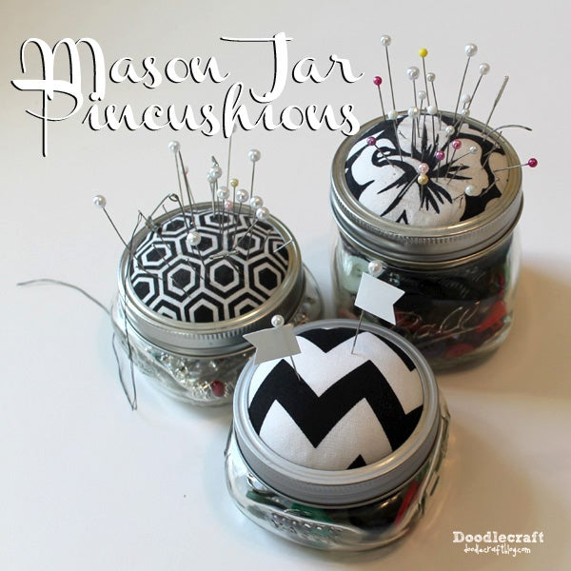

Something to eat
Grandma is starting to get recipes together in a spot for the Christmas baking. You see, there are people in communities that simply don’t have family around them. Even if they do have family, maybe it is a widower or bachelor that could use a tray of sweets on the holidays.
One of my newest recipes is Butter Tart Squares. Oh, I do buy tart shells and fill them with mincemeat or blueberry sauce. I just get hungry for butter tarts and don’t want to mix up the tart filling.
Butter Tart Squares
2 cups flour
4 tbsp icing sugar
1 cup butter or margarine
A bit of cold water
Mix this up and put it in the bottom of a 9 x 13 pan. Some like to line the pan with parchment paper to make it easier to take out
Make your filling
½ cup butter or margarine
3 cups brown sugar
4 eggs (I only use 2)
2 tsp vinegar
1 tbsp vanilla
A handful or two of raisins
Bake about 25 minutes. Cool to room temperature and then refrigerate a couple hours before serving

The Spirit of God is Always with Us at This Time, in This Place
We awaken in our time to a Universe which is holy,
to creation which is not an event in the past, but a living event of the present.
We enter a new mode of human presence where we are not merely observers,
but where each of us is a participant in this moment of evolution.
Like all other creatures, we carry with us Wisdom and Values, the dynamics of the Universe.
But unlike other creatures, we must choose whether and how we will live in harmony
within this sacred web of creation.
May we be open to the Source of All Being, Our God within and among us!
We have the capacity to wonder,
and to celebrate this great mystery of existence within such a magnificent Universe!
In us the Universe enters into a great celebration of itself.
We are part of the Dance, the Great Work, the Great liturgy which is the Universe unfolding.
Glory to You, O God, Source of All Being!
This great Liturgy finds expression at this moment in us,
gathered here in a posture of prayerful openness, with listening hearts, loving spirits and a holy wonder.
May the sacred web that unites us with each other, our God and all creation,
ignite communities of light and hope throughout the Earth.
May we be open to the Source of All Being, Our God within and among us!
Together We Pray:
O Gracious, gentle Spirit of Love,
Your energy permeates the Universe,
Igniting Earth with
Your Goodness, Truth and Beauty.
Open our minds and hearts
To a deeper awareness
Of our interconnectedness with You,
Each other and all creation.
May we experience
Your unique presence
Within the sacred web of creation.
- Author Unknown
https://www.xavier.edu/jesuitresource/online-resources/prayer-index/morning-and-new-beginnings-prayers

